**Micropile Wall Supporting a Complex Environmental Excavation**

Matthew Janes, M.E.Sc., P.Eng., Isherwood Associates

Abstract: Case 1 (non-reticulated) micropiles are commonly used to stabilise earth for bearing applications. They may also be effectively used as a shoring solution. In Victoria BC a complex environmental clean-up problem was solved using a capped, Case 1 micropile wall. The site was bordered by a major thoroughfare with a buried high voltage power duct on the uphill side and a salmon bearing stream within a municipal park on the downhill side. Mineral oil coolant had leaked from the duct and contaminated the soils beneath the road way and were now leaching into the stream. BC Hydro required a clean-up of the embankment soils, a leachate collection system to capture pollutants until an alternate power supply to the city could be completed (permitting de-commissioning of the leaking duct) and a cut off wall to prevent future contamination of the stream. The site was further complicated by overhead power and communication lines within the construction footprint. Excavation depths of up to 4.5 m were required (14.8 ft) to the planned contaminant depth, with the real risk of chasing product deeper. A Case 1 micropile wall was installed within the narrow construction easement between the duct and the overhead power lines. A double row of 8 m long vertical injection anchors were installed on 400 mm c/c spacing. A single row of raked (1H:2V) micropiles were incorporated with a reinforced concrete pile cap. Excavation of the micropile face to 4.5 m depth was easily conducted with effective soil arching between the micropiles. The space between the micropiles allowed for free flow of groundwater and leachate into a gravel and geotextile leachate collection system that was constructed on the face of the micropile wall. Behind the leachate collection system a mechanically stabilised earth embankment was installed with a ‘living wall façade’. A living wall façade incorporates buried live roots and organics to form a living wall facing on the finished exposed face. The back side of the mechanically stabilised earth structure, adjacent to the leachate collection system, was constructed with a low strength concrete wall formed in 1 m lifts. The geogrid used in the mechanically stabilised earth wall was anchored into the low strength concrete wall. This provided an impermeable wall behind the leachate collection system, ensuring contaminants would not find their way to the stream and a future shoring wall (in the opposite direction) for future removal of the BC Hydro duct, roadway and contaminated soils beneath which is planned over the coming 2-3 years.

**Introduction**

In Victoria, British Columbia, a complex environmental clean-up problem was solved using a capped, Case 1 micropile wall. The ravine site was bordered by a major thoroughfare with a buried 300 kV power duct on the uphill side and a salmon bearing stream within a municipal park on the downhill side. Mineral oil coolant had leaked from the duct contaminating the soils beneath the road way and were now leaching into the stream. BC Hydro, the project owner, required a low impact clean-up of the soils and restoration of the lands to a state that was harmonious with the existing park environment. A previous clean-up using a shotcrete wall had failed to provide a final product that met with public approval. BC Hydro was tasked with removal of the contaminated soils without disruption of the roadway, the existing duct or the salmon bearing stream. This limited equipment choices, methods and schedule.

The embankment clean up required removal of contaminated soils, installation of a leachate collection system to capture pollutants until an alternative power supply to the city could be completed (permitting de-commissioning of the leaking duct) and a cut off wall to prevent future contamination of the stream. The site was further complicated by overhead power and communication lines within the construction footprint. Excavation depths of up to 4.5 m (14.8 ft) were required to reach the proven base of the contaminant, with the real risk of chasing product deeper. Of particular importance to BC Hydro was the restoration of the slope to a naturally vegetated state that would not be disturbed during future remediation of the roadway and replacement of the duct.

The proposed design called for a Case 1 injection anchor micropile wall to be installed within the narrow construction easement between the duct and the overhead power lines. Small installation equipment was needed to prevent damage to the existing ravine and minimise impact. Following top down excavation of the embankment, a drainage wall, impermeable wall and a mechanically stabilised earth slope was planned. The façade of the mechanically stabilised earth wall was designed as a ‘living shoring face’ or ‘living earth wall.’ This design was conducted by others, but is shown and referenced for its remarkable success in meeting the owner’s objectives.

**Geotechnical**

In typical fashion for environmental sites, copious soils borings were conducted, all logged by a biologist, with no regard to geotechnical information. The 34 borings did not include geotechnical tests for strength, grain size distribution, water content or Atterberg limits. Soils consisted of granular and roadway compacted fills to 1 m depth, overlying native soils of firm silts with some clay to a depth of 4.3 to 4.5 m. This formation is described as blocky and brown to grey, indicating weathering within the upper layers. Beneath the silt lay soft grey clay through to the depth of glacial till at 12 or more meters (40 ft.).

Past experience in the Victoria, BC area would indicate the upper silts are unsaturated and provide SPT blow counts on the order of 10 to 17/300mm (12”). It was anticipated the lower grey clays would provide the following properties: SPT blows of 6 to 8/300 mm, shear vanes strength of 25 to 30 kPa (4 psi) with remolded strength of 10 to 16 kPa (2 psi), Liquid limit 40+%, Plastic limit 16-18% and water content 30+%. CPT results may indicate a Qt of 8 Bar. Typically the clays are slightly over consolidated within the upper zones but within a few meters depth the OCR reduces to 1.0.



Figure 1. Geotechnical cross section from the Environmental Investigation

**Design**

The photograph below shows the site from the SW looking NE. A very narrow shoulder adjacent to Interurban Road formed the top of slope construction easement. A steep, vegetated slope leads down to Colquitz Creek which resides within a municipal park. The creek had to be protected from siltation or other construction activity as it is a salmon bearing stream. Access for equipment and removal of spoil was permitted across the creek and through the park trails, as no easement or laydown area was available along Interurban Road. The buried hydro duct carrying high voltage lines lies directly beneath the pavement edge at a depth of 1.5 m (5 ft.).

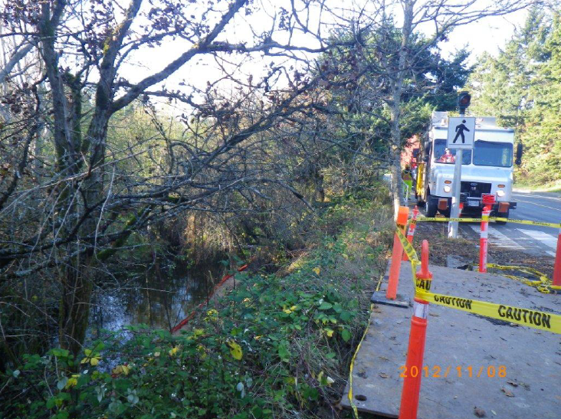

Figure 2. Site photo showing the easement and existing Colquitz Creek embankment.

The plan below shows the general layout of the site with Interurban Road , a buried storm sewer and the BC Hydro transmission duct (shaded) running parallel to the crest of the slope. The roadway edge was excavated with a 1:1 slope to expose the top of the duct and confirm its depth and location. The required excavation extended 30 m (100 ft.) along the top of the slope and 21 m (70 ft.) at the base. The length of the proposed micropile wall and cap was 26 m (85 ft.). The red line demarcates the perimeter of the base of the proposed excavation at a depth of over 5 m (16 ft.) from original grade.

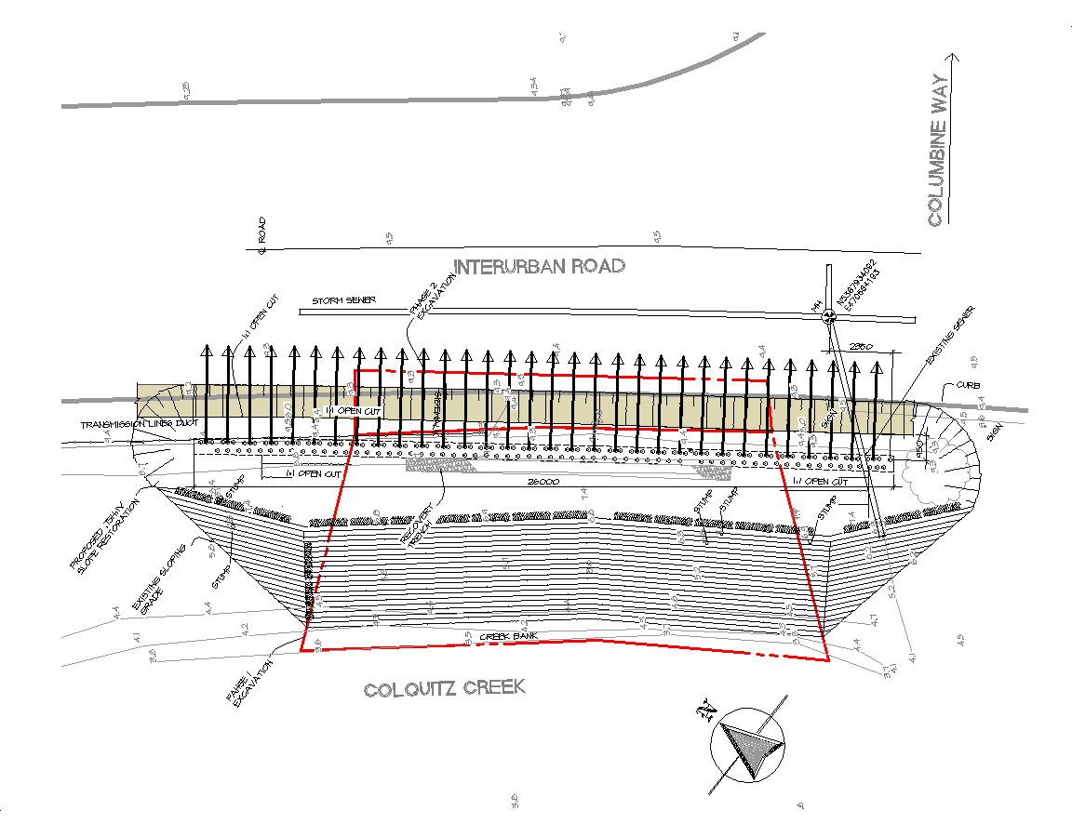

Figure 3. Plan view of site and proposed works.

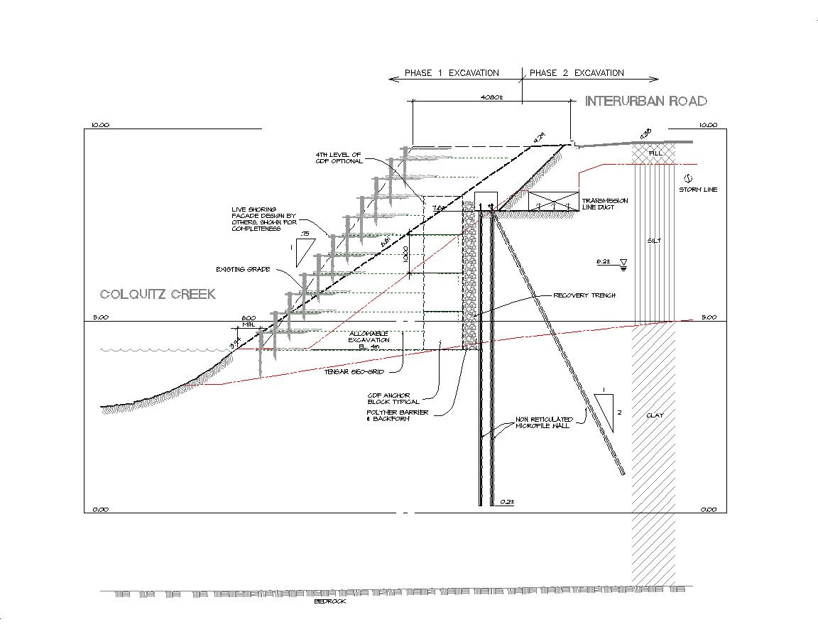

Figure 4. Section showing proposed works, Interurban Rd and utilities.

The section above shows the overall easement with the original and final slopes, and the original 1:1 excavation which exposed the BC Hydro duct. This cut located the duct, permitted inspection and ensured the contractor maintained the required 1000 mm (3 ft.) clearance between the edge of the duct and micropile installation. The drawing shows the double row of vertical micropiles spaced 400 mm (16”) c/c along the wall and 300 mm (12”) front to back. Every 800 mm (32”) a raked micropile, at 1H:2V, was drilled. The concrete cap encapsulated the micropile heads and created a truss structure. The section shows the Control Density Fill (weak concrete or CDF) wall, leachate collection system (recovery trench) and aquitard barrier. The CDF wall was tied into the geotextile of the reinforced earth slope and façade. Note the phase 1 and phase 2 excavation zones. By creating more real estate (with a steeper final slope) BC Hydro will later be able to excavate the roadway and existing high voltage duct while relying upon the reinforced slope and CDF face as shoring with no disturbance to the restored Colquitz Creek bank.

Finally the section shows the living wall façade which consists of a slope dressed with willow saplings and other organic structures to generate a stable slope face which blends with the native foliage. The façade is built up in layers and relies upon a deep root network to ensure a stabilised face as steep as 3V to 1H.

As with all environmental projects the risk of excavation beyond the specified design depth was probable. Thus the design assumed excavation to a meter below design depth (6.0 m or 20 ft.) without need to augment the original wall design. This extended the excavation into the base soft grey clays. The anticipated reduction in available passive toe resistance and low soil strength resulted in increased pile lengths, moments and shears and drove the high density of micropiles.

The double row of micropiles may be designed classically using composite design in bending and shear, assuming a low strength material acting in shear between the micropiles and the micropile steel acting as compression and tension members. Essentially, the soil is are relied upon to keep the compression and tension steel apart and the pile cap and bond length along the pile toes are relied upon to dissipate the bending stresses.

**FLAC Analysis**

The proposed design was modeled using FLAC 3D. A 1 m (3 ft.) section of the wall was modeled (emulating a 2D analysis), with individual micropile elements. This allows review of the assumption of soil arching between the micropiles. In addition micropile axial load and bending moment is provided. The FLAC predictions of micropile axial force and bending moment are provided in Figures 5 and 6 below.

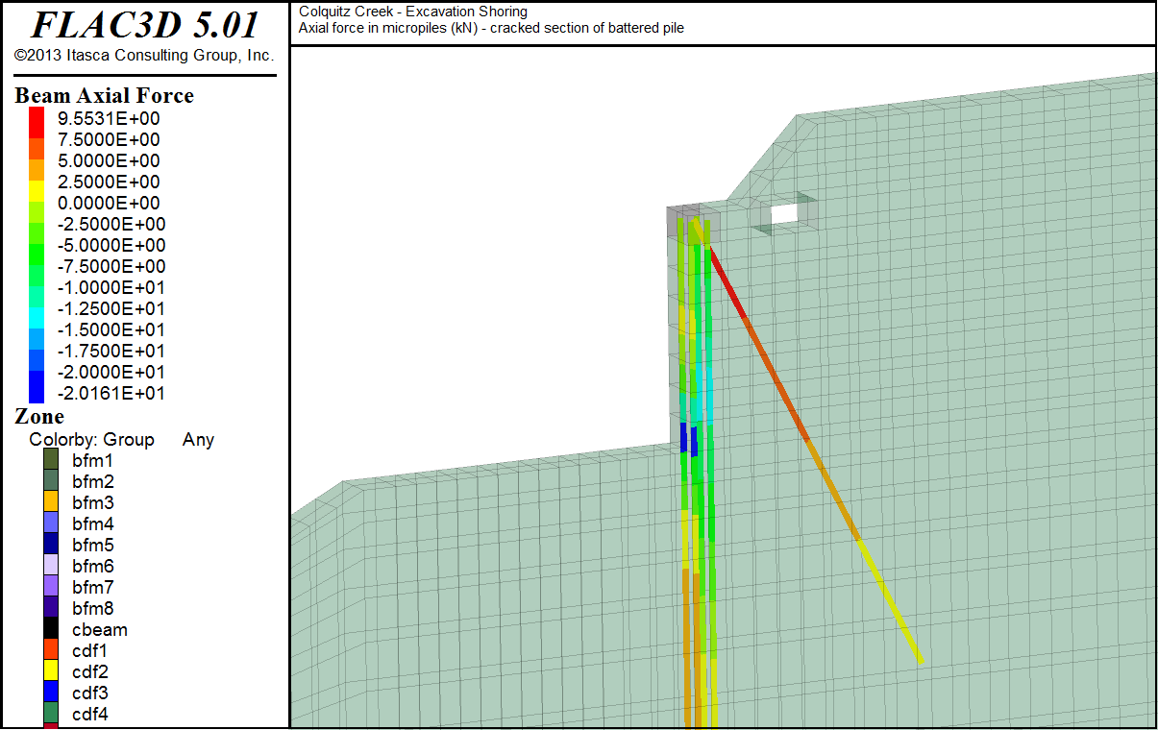

Figure 5. FLAC prediction of micropile axial loading.

Figure 5 provides prediction of the axial load within the micropiles. The FLAC analysis predicts a compressive axial load of -20.2 kN (4.5 kips) (compression) within the front face piles and -13 kN (2.9 kips) within the rear face piles. The maximum force in the raked piles is 8.5 kN (1.9 kips) (tension). Pile spacing of 400 mm for the excavation face and 800 mm for the raked piles provides a total excavation face compression load of 83.0 kN/m (5.7 kip/ft.) and raked pile load of 10.6 kN/m (0.7 kip/ft.). The micropiles experience a combination of bending due to excavation face loading and axial compression or tension due to the truss action of the wall. Simple classical truss (only) analysis predicts axial compression in the face of 108 kN (24.3 kips) and tension in the raked pile of 122 kN (27.4 kips).

Figure 6 predicts the maximum micropile bending moment occurs within the front row of piles at the base of the excavation. The magnitude is on the order of 1.6 kN-m (1.2 kip-ft.) for front row micropiles and 0.5 kN-m (0.4 kip-ft.) for the rear row, with piles spaced at 400 mm c/c, for a total moment 5.25 kN-m/m (1.7 kip-ft./ft.) of wall (sum of both rows). But this only tells part of the story. Upon review of the axial loading we can calculate an axial force couple of 25.4 kNm/m (8.2 kip-ft./ft.). Classical pressure envelope analysis predicts a bending moment on the order of 68 - 80 kNm/m, depending upon assumptions. Thus the FEA predicts bending moments and axial loads well below the classical methods. The FEA takes advantage of combined bending and truss action of the wall and likely less conservative soil parameters than those used for classical analysis. The Young’s Modulus selected for the clay soils was 100 MPa (14.5 ksi).

Parametric analysis indicated the performance of the wall was heavily influenced by the selection of soil modulus and cohesion. The estimated pile stresses are well below yield. Estimated wall deflection is less than 1 mm (0.04”) for the soil parameters selected.

Table 1. Soil Parameters used for FLAC analysis.



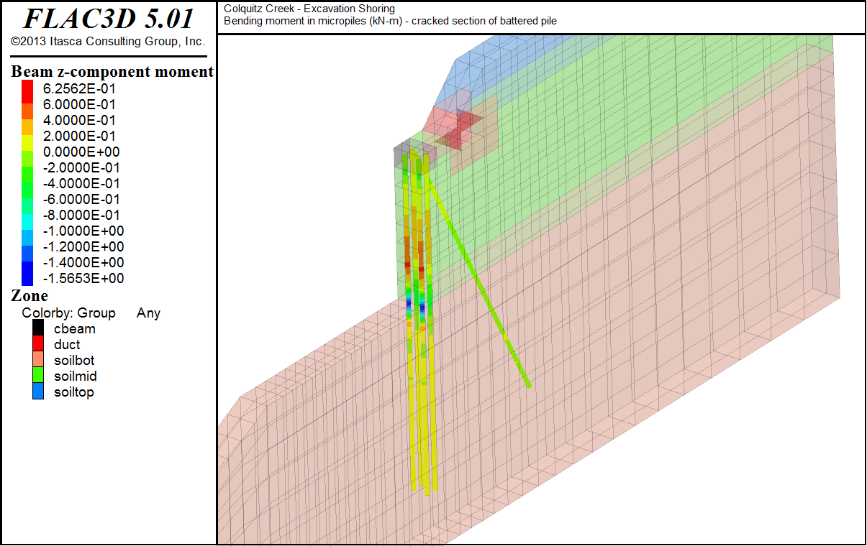

Figure 6. FLAC prediction of micropile bending moment, Compression positive.

**Construction**

Excavation of the upper slope permitted widening of the working platform and establishment of a working trench along the alignment of the micropile cap. An air drill was used to advance hollow core anchor bar of R38 size with a 90 mm (3.5”) hole which the contractor used in lieu of 30M bars in 150 mm (6”) dia holes on the original design. The trench contained the drill spoil and grout overbreak, which was collected and vacuumed into waiting trucks for disposal off site. Micropiles were advanced to a depth of 8.0 m (26.2 ft.) below grade for a total design toe length of 3.2 m (10.5 ft.). The raked piles were placed at a 2V:1H batter. This angle maintained clearance from the overhead wires during installation and provided an adequate lateral component of resistance.

A steel cage and concrete was placed around the micropile tops to generate anchorage and moment connection. Figures 7 and 8 provide details of the pile cap configuration. The cap generates combined action and trestle behaviour in the micropiles. The micropiles within the face of the wall provide reinforcement of the excavated face and encourage soil arching between the tightly spaced micropiles. The front and back orientation form the compression and tension ‘flanges’ of a composite beam to provide bending resistance of the wall face. The raked micropiles act as a tension member offering both lateral resistance at the pile cap and coupled action with the front row piles in compression) to resist overturning.

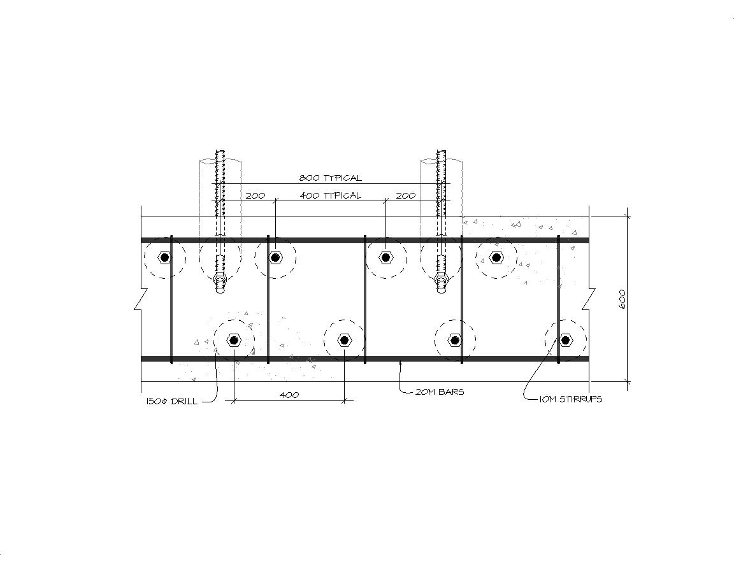

Figure 7. Micropile cap layout showing micropile spacing.

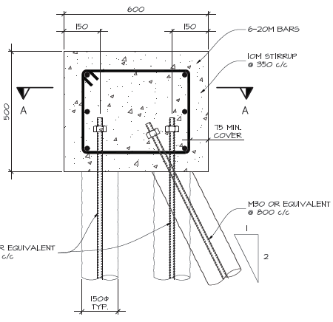

Figure 8. Micropile cap section.

The construction sequence is shown in photos 9 through 12. Photo 9 shows the air drill working within the confined easement at the top of the wall. The photo shows the steep creek embankment and the creek at the base. Note there is no evidence of drill spoil or grout loss on the existing slope. Great care was taken in both procedures and design to minimise the chance of fouling the stream. Photo 10 shows the completed micropiles within the construction trench and the steel cage for the pile cap. In the distance is shown the creek diversion with galvanised corrugated steel pipe and gravel overlay. Silt curtains placed up and down stream prevent siltation due to the placement of gravel or travel of the excavation spoil into the stream. Within the foreground a vertical corrugated pipe is seen. This provides access to a survey point mounted atop the B C Hydro duct. Optical survey indicated the duct moved less than 2 mm laterally or vertically (the accuracy of the survey). This compares favourably to the FLAC predictions of less than 1 mm.

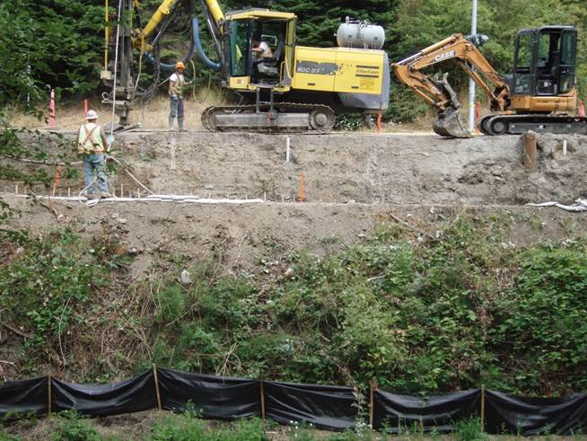

Figure 9. Drilling the micropiles at the crest of the partially excavated slope.

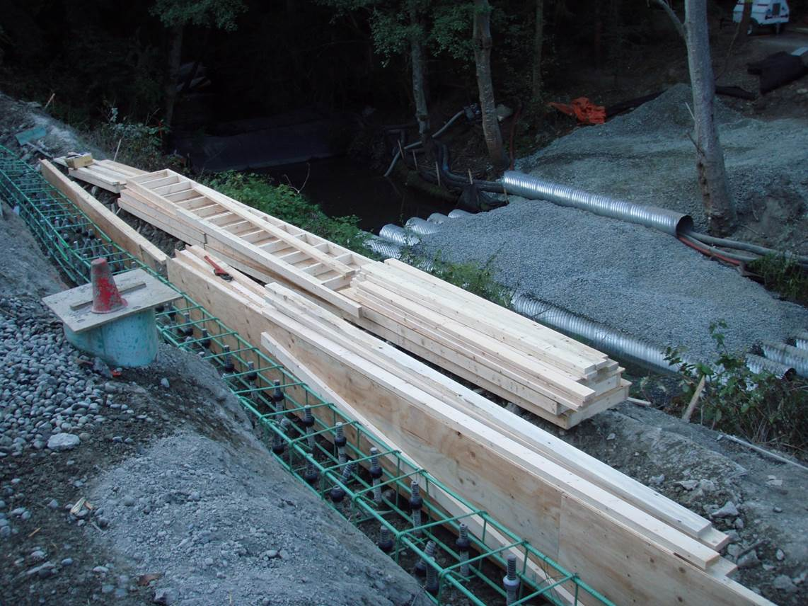

Figure 10. The completed micropiles, cap steel and cap forms during assembly.

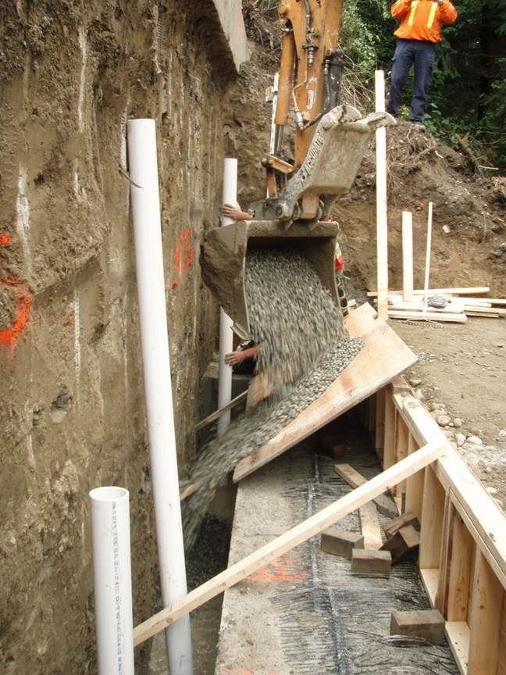

Figure 11. Placing the leachate collection gravel with the vertical collection pipes. CDF wall placed.

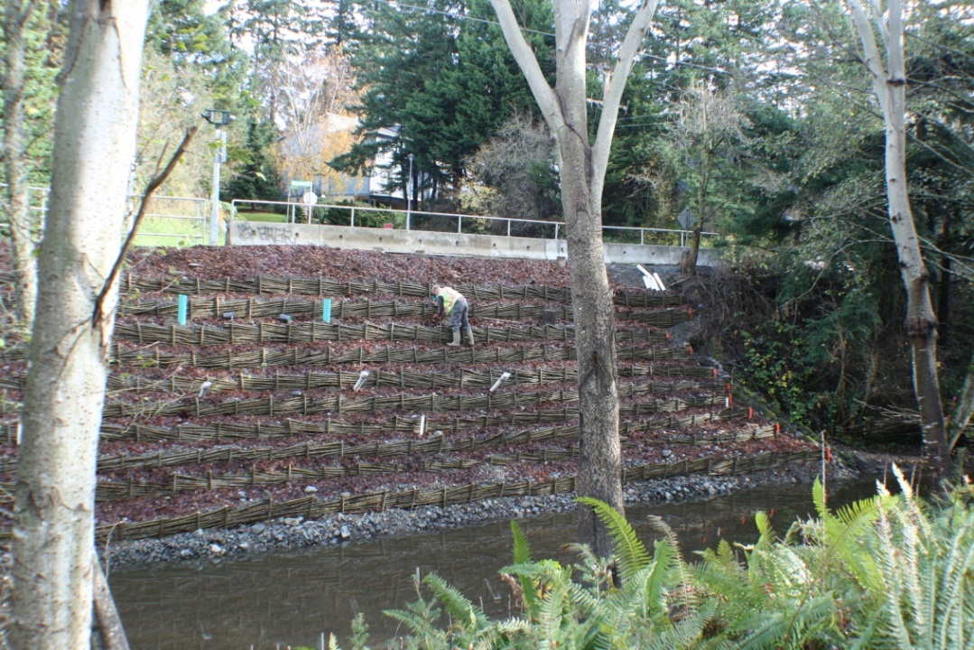

Figure 12. Completing the living earth wall.

**Conclusion**

The design and execution of the Colquitz Creek remediation successfully met the mandate of the owner, BC Hydro to implement a solution which protected both their assets and the assets of the community by cleaning and restoring the Colquitz Creek embankment to a park like setting while protecting the creek from harm.