SELF-DRILLING HOLLOW BARS:
GROUND ANCHOR, TENSION PILE or SOIL NAIL?

Chris Irvin - Technical Director, DYWIDAG-SYSTEMS INTERNATIONAL

ABSTRACT

Self-drilling hollow bars have gained wide recognition for their use as a drilled-in solution for a range of applications over the last 15-20 years, but their use as ground anchors, tension piles or soil nails is often misunderstood. Reclassification of a ground anchor as a tension pile is to misunderstand the restraint mechanism of a prestressed anchor, and the designation of a 300 kN soil nail is beyond reasonable contexts of a soil nail classification.
By defining the applications of: ground anchors, tension piles and soil nails, as well as other applications, this paper seeks to clarify the use of self-drilling hollow bars. The paper also offers guidance on: corrosion protection requirements, suitable ground conditions, practicality of installation, drilling equipment, and testing options.
Self-drilling hollow bars are able to offer installation benefits over conventional drilled systems, as well as provide solutions in difficult ground conditions, but it is important to identify the most suitable applications.

APPLICATIONS for SELF-DRILLING HOLLOW BARS

Self-drilling hollow bars were primarily developed as a loose overburden drilling system, where the bar can be drilled through loose or collapsing soils without the need for a casing and with the drill bit left in the hole. Originally bar diameters were quite small, ranging from 25mm to 51mm, with uses being somewhat limited.
As hollow bar systems have evolved, their application has broadened to encompass a range of applications, including soil nails (figure 1), rock bolts, spiles, resin injection conduits, micropiles (tension and compression) and ground anchors (figure 2).
However, it should be emphasised that the suitability of hollow bars for each application varies depending on ground conditions, loading requirements, cost and durability. Table 1, below, summarises the applications, together with details of loadings, risk and corrosion protection options.

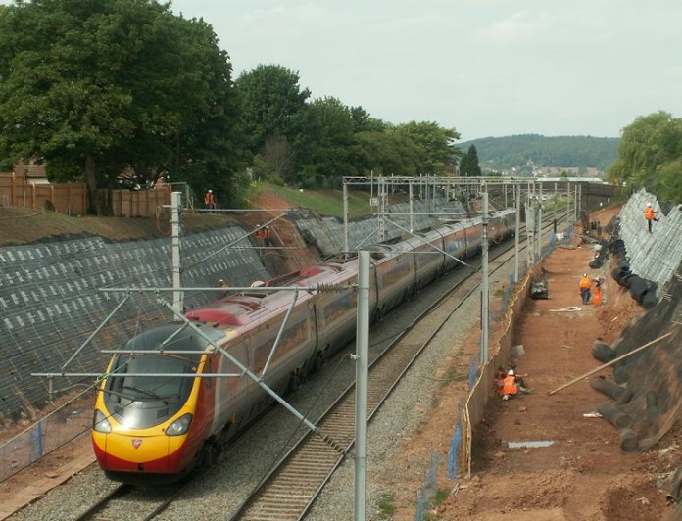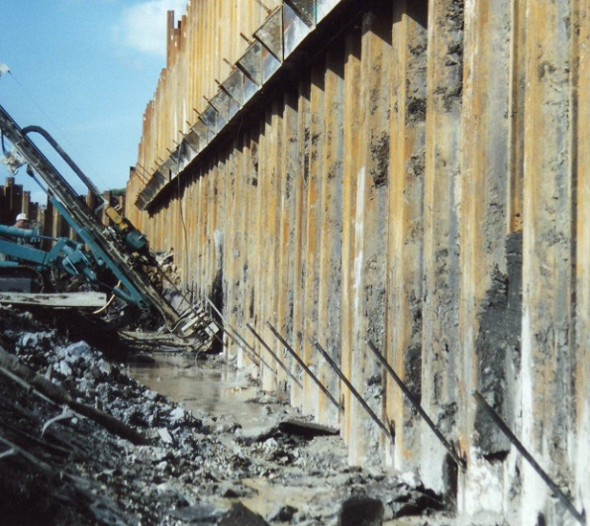
Figure 1. Hollow bar soil nails Figure 2. Temporary ground anchors
Table 1. Classification of Hollow Bar Applications and Corrosion Risk
Application | Load Classification  (indicative) | Mode of Loading | Corrosion Risk | Technical Standard
Soil Nail | Lightly loaded  30-150 kN | Passive  (fully bonded) | Low risk  (built-in system redundancy) | EN14490 BS 8006-2
Rock Bolt  (external) | Lightly loaded  30-100 kN | Passive  (fully bonded) | Low risk  (built-in system redundancy)
Micropile  (compression) | 100-1500+ kN | Passive  (fully bonded) | Lower corrosion risk, due to compression loading. Buckling risk | EN14199  DIN 4128
Micropile  (tension) | 100-3500+ kN | Passive  (fully bonded) | Medium risk, dependent on loading, application and aggressivity levels | EN14199
Ground Anchor | 100-3500+ kN | Active  (debonded, prestressed free length) | Medium to higher risk, dependent on loading, application and aggressivity levels | EN1537  DIN 4125  BS 8081

Soil Nails

Soil nails are generally classified as lightly loaded, low risk, passive installations, with an element of redundancy usually built in to the design, further endorsing the low risk installation classification.
The loading for soil nails is based on the low strength of the material, i.e. the soil, within which they are placed. The achievable loads of soil nails within soil are generally low (30-150 kN), hence there is no need for a bar of excessive tensile strength.
The passive classification is based on the soil nail acting as an unstressed reinforcing element, connecting the active wedge zone to the stable zone. Loadings in the nail are induced through settlement of the wedge zone as it mobilises restraint against the stable zone. In addition, further loading is transferred to the soil nail by the facing which confines the surface of the slope. Facings comprise either a flexible facing (reinforced geogrid or slope protection mesh) or a hard facing (soil panel or shotcrete) which are attached to the soil nail through the provision of a bearing plate and nut. Soil nails are typically arranged on a diamond grid to ensure even distribution of the reinforcement within the slope.
The low risk classification considers the above points of low loads and passive reinforcement, as well as redundancy within the design. Soil nailed slopes typically feature large quantities of soil nails, where the design has some built-in redundancy. Therefore if a couple of nails fail within the lifespan of the works, there should be sufficient residual capacity within the overall solution to ensure stability of the slope. Failed nails can be replaced under a maintenance regime.
Exceptions to the low risk classification for soil nails include installations within the close proximity of a structure or where the soil is known to have high aggressivity levels.
Self-drilling hollow bars are ideal for soil nailing (see figure 1) as the soil is generally soft, allowing a slender bar to penetrate with relative ease. Soils are also often prone to partial collapse within the borehole e.g. in granular soils or on railway embankments where mixed fill conditions exist. Hollow bar systems are able to cope with this collapse as they are a drilled-in system, as opposed to a placed bar, ensuring placement of the reinforcement to full depth, without the need for a casing. Cased boreholes are time consuming, require more powerful drilling equipment and are often costly to install. Self-drilled hollow bars are able to overcome most problems in loose soils as they combine drilling, placement of reinforcement and grouting of the bore all in a single operation.

Corrosion Protection Options for Soil Nails

Where a low risk classification can be justified, corrosion protection options include:
- Sacrificial Corrosion Allowance: Additional steel section is allowed for within the soil nail, to provide a corrosion allowance. Sacrificial corrosion allowance is calculated on the basis of
- Working load
- Lifespan
- Aggressivity levels of the soil and surrounding environment

Aggressivity levels are normally calculated by applying a score or ranking to the variables of the environment, e.g. pH levels, moisture content, soluble sulphates, Redox potential etc., in accordance with TRL 380, EN 14490, BS 8006-2.

- Galvanizing: Either fully galvanized (in accordance with EN 1461) or top bar galvanized at the soil / air interface, see figure 3. Galvanizing is an effective coating for rotary installed hollow bars as it offers good abrasion resistance during the drilling process, but it should be emphasised that Galvanizing is only a supplementary protection, as lifespans are limited from 5-15 years for buried installations, depending on levels of aggressivity.

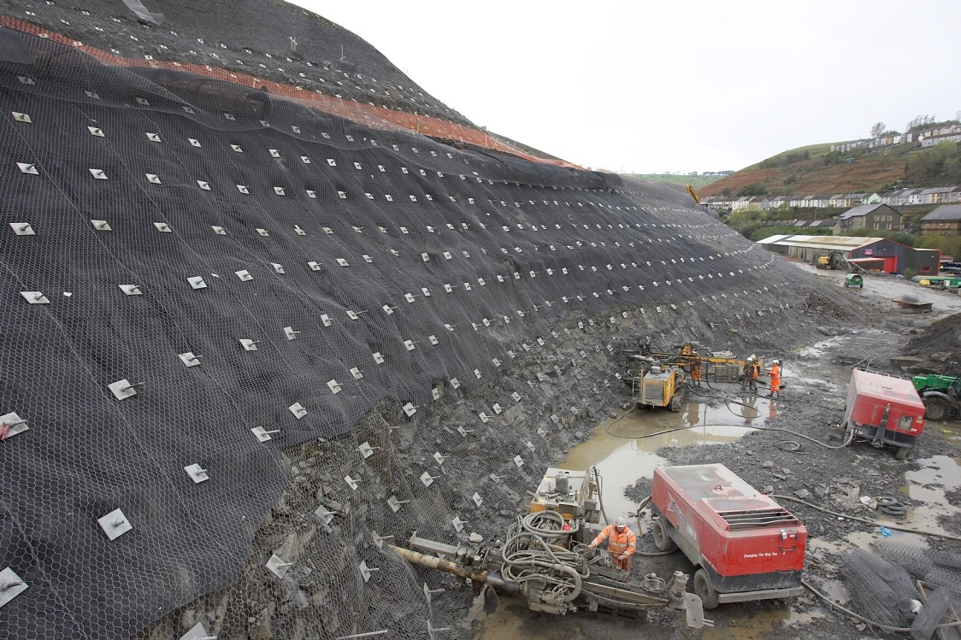
Figure 3. Hollow bar soil nails with top bar galvanizing, for slope stabilisation
- Duplex Coatings: These dual coatings comprise of galvanizing overlaid with a either a baked polyester layer or an epoxy coating. Both systems are of limited effect, as the external coating has poor abrasion resistance which is normally compromised during rotary installation, resulting in the galvanized coating being exposed. In particular, the coating is worn off the high point of the threads during drilling (see figure 4, below), or when the rod is clamped for release from the drill head, the jaws or clamps bite through the soft coating.

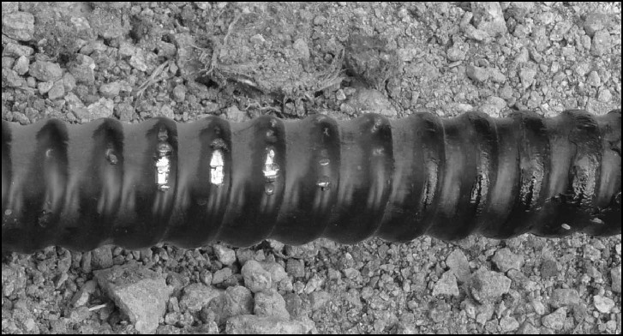
Figure 4. Duplex coating on hollow bar, showing exposed galvanized coating on top of the thread.
Angle Compensation of Bearing Plates for Soil Nails

This detail is often overlooked on soil nailed slopes. On steep slopes or cuttings of 60⁰ +, with soil nails installed at 10-15⁰ off the horizontal, the amount of angle compensation between the soil nail and square angle of the bearing plate is minimal (15-20⁰), but on shallower slopes of 30⁰ the angle compensation can be significant (50-55⁰).
Where angle compensation is significant, between the installed nail and the bearing plate, lipping can occur, where the bearing plate does not fully seat against the slope face (see figure 5). The solution is an oversize slot in the plate, spanned by an articulating wedge boss (see figure 6). The wedge boss fulfils the angle compensation, but also allows articulation of the plate on undulating slope faces.

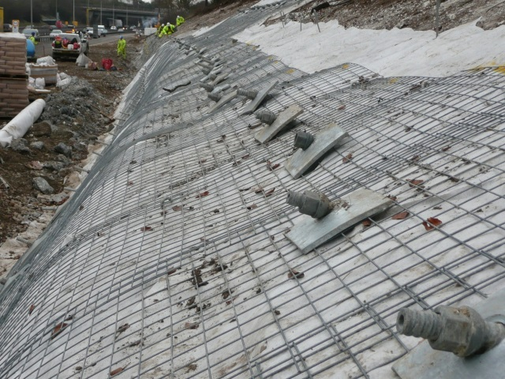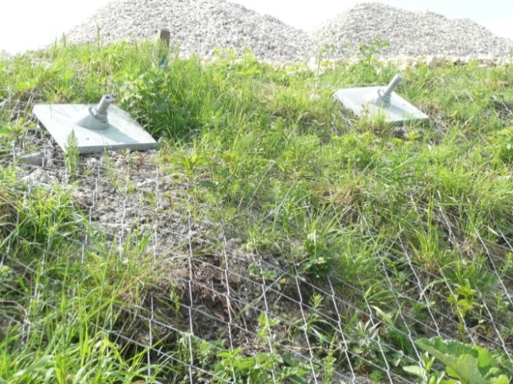
Figure 5. Lipping of bearing plates Figure 6. Articulating wedge boss

MICROPILES AND MINI PILES

The piles referred to within this paper are based on hollow bar micropiles and single bar mini piles comprising a central threadbar (GEWI or similar). Their main applications are uplift restraint, tieback in lower risk applications and compression piles.
The distinction between a micropile and a mini pile is often blurred, a micropile originally being that of diameters up to 250mm and a mini pile being of diameters up to 400mm. Currently self-drilled hollow bars installed with simultaneous drill and grout are often referred to as micropiles, whereas drilled and placed systems (single threadbar reinforcement or mini cage reinforcement) are referred to as mini piles. Both micropiles and mini piles are separate from piling, which utilises larger diameter bores, cage reinforcement, and aggregate based concrete.

Micropiles (Compression)

Hollow bar compression micropiles (figure 7) typically have a lower corrosion potential than tension piles, therefore are generally regarded as lower risk. Potential for buckling does exist and should be addressed separately.
The compression loading is considered a lower corrosion risk as the grout column is compressed, avoiding the potential for tension cracks to propagate and provide paths for corrosion. Also the head termination (bearing plate sandwiched between two nuts) is typically cast into the pilecap or ground beam, reducing the potential for corrosion. Corrosion protection options include: sacrificial corrosion allowance, galvanizing and borehole grout.
Potential for buckling should be addressed on micropiles or single bar mini piles in compression, as the low section modulus, in comparison to that of re-bar cage reinforced bored mini piles or large diameter tubular piles, results in lower bending stiffness.
The top section of the pile shaft is normally the most critical in respect of potential for buckling, as the ground is weakest at this point, often comprising of made ground. For self-drilled hollow bar micropiles it is possible to provide additional stiffness to the pile shaft with an external steel tube or casing (figure 8), inserted over the micropile following drilling and grouting. The annulus around the bar enables a steel tube to be placed over the top section whilst the grout is still wet.

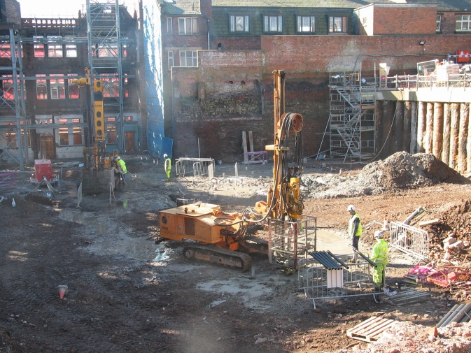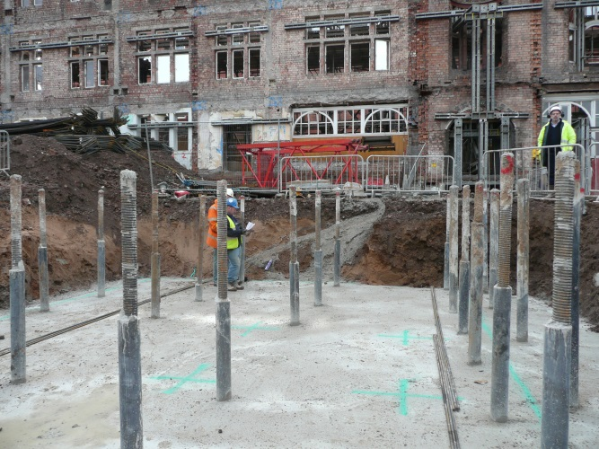
Figure 7. Installation of hollow bar micropiles. Figure 8. External sleeve on micropiles
Micropiles (Tension)

Applications for tension piles, either hollow bar micropiles or solid threadbar minipiles, can vary considerably. The term tension pile is often applied to any grouted bar in tension within the ground which is not a soil nail or prestressed ground anchor.
Their uses range from low capacity piles for support of shallow excavations, raking piles for restraint of structures, to sheet pile tiebacks (figure 9) and heavily loaded tension piles for uplift restraint of deep basements.
Hollow bar or solid threadbar for tension piles is generally preferred to standard reinforcing bars, as they can be cut and coupled at any point, as well as having a nut and plate termination at the top. The nut and plate termination provide a robust mechanism for load transfer between the axially loaded tension pile and pile cap or structure.
Tension piles often have a higher risk classification than compression loaded piles, based on their tension loading and the consequences of failure.

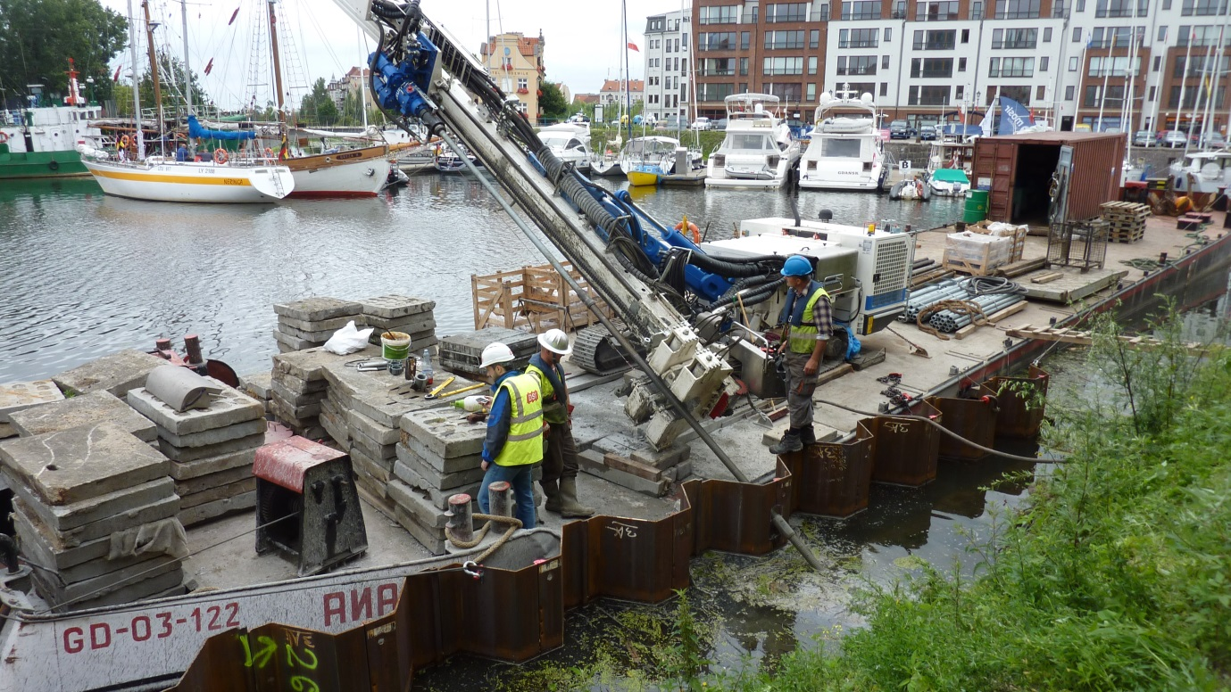
Figure 9. Hollow bar tension piles for sheet pile tieback

Corrosion Protection Options for Micropiles in Tension

As stated above, the range of applications for tension piles can vary, therefore the appropriate level of corrosion protection should be carefully assessed, based on aggressivity levels, load and lifespan.
For lightly loaded tension piles (up to 250-300 kN) one is generally able to
build in sufficient sacrificial corrosion allowance or redundancy to accommodate any uncertainty. For these low risk applications, the self-drilling hollow bar is ideal, as it offers all the installation benefits and speed over conventional drilled systems.
For heavier loaded tension piles, the application of hollow bars may still be justified, subject to consideration of risk and required lifespan. The following corrosion protection options are available for tension piles:
- Sacrificial corrosion allowance:
The same principle as stated above for soil nails. Whilst widely used on soil nails or rock bolts, the application of sacrificial corrosion allowance for tension piles requires more careful assessment, given the higher loadings and greater risk.
- Galvanized coatings:
As above for soil nails, limited lifespans of 5-15 years for buried installations.
- Borehole grout, to provide grout cover protection:
Regularly considered as corrosion protection for tension piles, but needs to be carefully assessed on the following basis:
- Partial collapse of boreholes will compromise grout cover.
- Contamination with ground water or other ingress reduces the effectiveness of the borehole grout as a protection barrier.
- Installation sensitive. Ground conditions and installation techniques vary, therefore grout encapsulations and respective cover will differ between installations. Examples of exhumed bars with grout bulbs are no guarantee of consistent cover of grout over the bar from site to site or with different contractor equipment.
- Protection at the mouth of the borehole or at the underside of the bearing plate. This section of the bar is known to be the area of highest risk, where oxygen combines with moisture to promote corrosion in the bar. For sub horizontal installations, it is very difficult to ensure the liquid grout does not settle to the underside of the bar, presenting an area of exposed bar for corrosion.
- Double corrosion protection featuring a bar within a factory pregrouted plastic duct. Only available on placed bar systems in open or cased boreholes, not suitable for hollow bars installed with rotary percussion. Double corrosion protection offers the highest level of protection as the quality and integrity can be verified through the factory production process. It is routinely specified for permanent tension piles and ground anchors.

Difference Between Tension Piles and Ground Anchors

The difference between ground anchors and tension piles relates to the mode of loading and the restraint mechanism. Ground anchors are stressed installations, which ensure no movement of the structure under service loadings. Not so tension piles, which are passive installations, where the structure will move under service loadings, as the pile seeks to mobilise restraint deeper in the ground, (see figure 10 below).
Ground anchors provide the facility to prestress the bar through the inclusion of a free length. The free length comprises a smooth duct over the bar (sealed top and bottom) with cover tubes over the couplers. It enables the extension characteristic of steel to be stressed out of the bar at the time of installation, once the grout has sufficiently cured. The stressed load is maintained within the anchor through the process of locking-off using a jack and a nut against a bearing plate.
Where one can accept movement on a global basis, e.g. a basement slab, tension piles are suitable, but where potential for differential movement exists, prestressed ground anchors are the only solution.

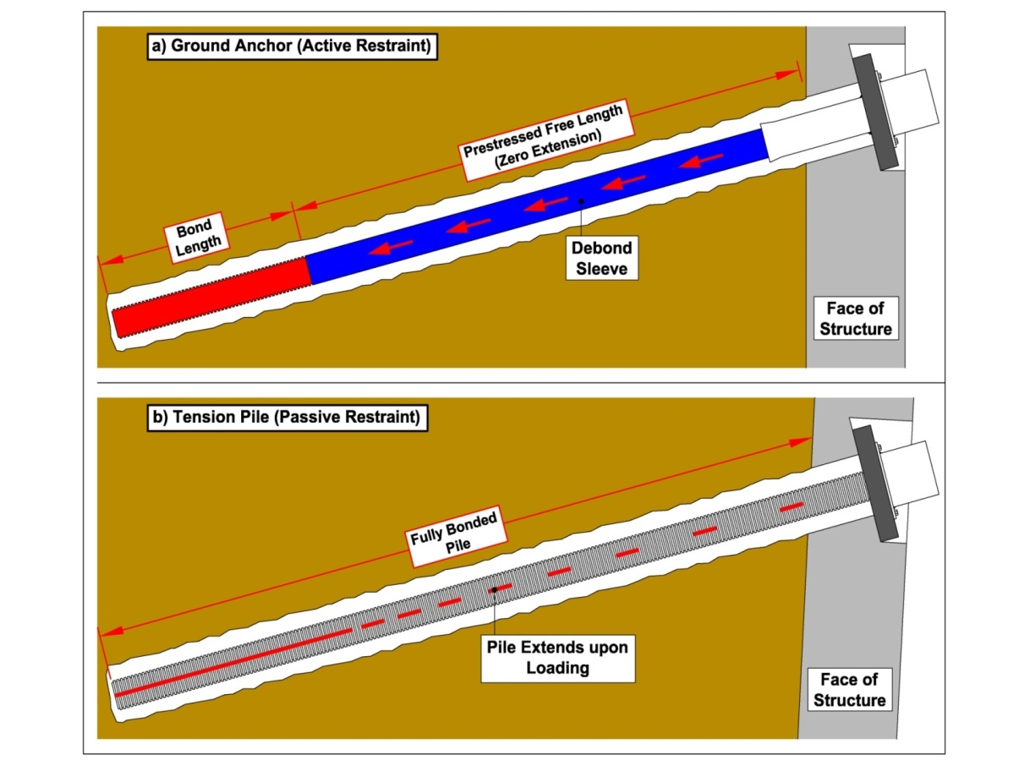
Figure 10. Difference between ground anchors and tension piles

Ground Anchors

As summarised above, ground anchors are stressed installations, typically designed to ensure minimal or no movement under service loadings. Self-drilling hollow bars offer several installation advantages for ground anchoring, but their application needs to be carefully considered as follows:

Temporary Ground Anchors

Hollow bar is often the product of choice for temporary works. Its installation method of combining drilling & grouting enables anchors to be installed into a range of ground conditions, sometimes unforeseen at the time of initial site investigation, and self-drilling systems are able to overcome problems with collapsing soils. Hollow bars are also able to offer a limited prestress function, through the inclusion of bedond sleeves between the couplers. It is not possible to provide bedond sleeves over the couplers, as rotary percussive installation precludes such sleeves. Furthermore, rod handling and rod release of sleeved hollow bar sections using jaw clamps requires specialist measures.

Permanent Ground Anchors

The use of hollow bars as permanent anchors is debatable. To be able to make a suitable judgement, one needs to consider the criteria outlined above in tension piles, namely: load, aggressivity and lifespan, with a further acknowledgment of the amount of prestress locked-off in the anchor.
Whilst the hollow bar has clear installation benefits over that of a drilled and
placed system (i.e. bar or strand anchor) it cannot offer the same level of durability as factory sheathed and grouted anchor systems, see figures 11 and 12.

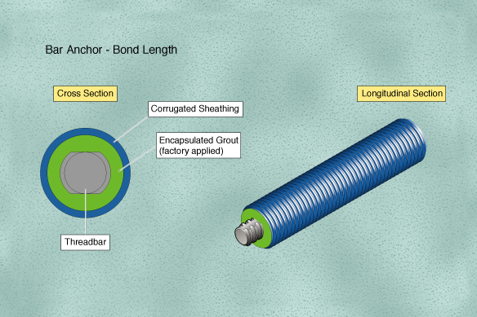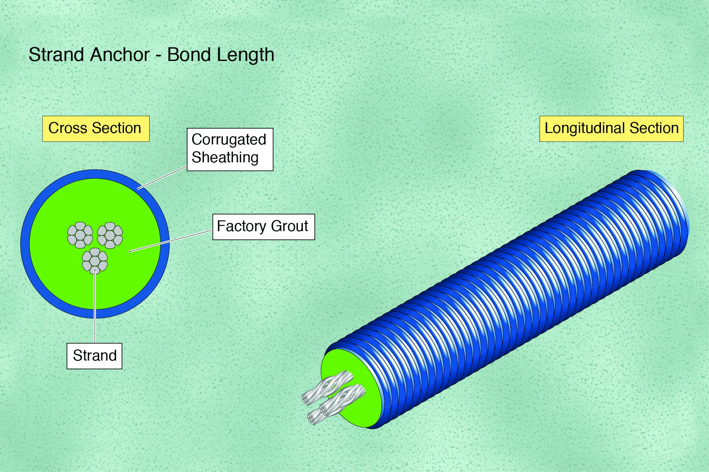
Figure 11. Bar anchor protection Figure 12. Strand Anchor protection

GROUND CONDITIONS SUITABLE FOR HOLLOW BARS AND SOLID BARS

Both hollow bars and solid threadbars are coupled systems, therefore installation issues relate to ground conditions and the stability of the borehole, not to headroom restraints.
In loose or collapsing ground, the self-drilled hollow bar is often the preferred solution as it overcomes the requirement for a casing, is quicker to install and can be grouted in a single pass. In water bearing gravels, where casings can easily become stuck, hollow bar systems can offer a practical solution.
Whilst the range of drill bits broadens the applications for hollow bars it does not necessarily follow that hollow bars are suitable for all ground conditions. Drill bit options range from open blade two-stage drill bits for soil (figure 13) to tungsten carbide button drill bits for forming rock sockets (figure 14), as well as other intermediate drill bits.

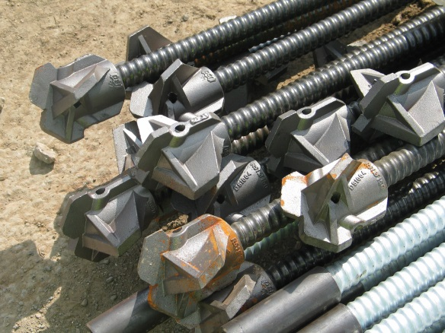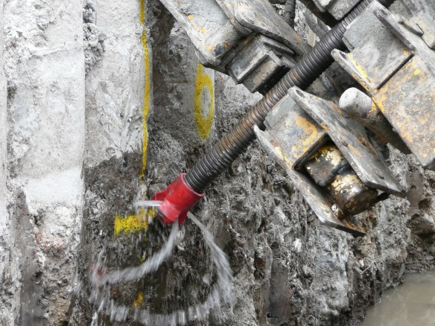
Figure 13. Two-stage retroflush drill bits Figure 14. Tungsten Carbide drill bit

In competent rock conditions, the solid threadbar (GEWI or similar) is normally preferred over hollow bar systems, as the borehole is more efficiently drilled using DTH methods. Drill bits used with hollow bar systems are lost drill bits, therefore are value engineered with lower tungsten carbide content and less robust design than standard rock bits, consequently their performance in the drilling of rock is compromised. They are suitable for forming single rock sockets up to about 5m
depth, but not for greater depths in rock.
In wet clays, a solid threadbar is often preferred to a hollow bar, due to the problems associated with drilling of hollow bars in clay. In wet sticky clays, drill arisings get stuck in the hole, resulting in blockages and loss of flush. Open-hole drilling with augers followed by the installation of a solid bar is typically the solution.
Hollow bar systems can be installed in wet clays if a special drill bit with a jetting nozzle is used. This system utilises a high pressure flush, comprising of a high water cement ratio (w/c 0.9 or similar), to create a jet at the drill bit which liquefies the clay in order to flush it out of the borehole. In addition the borehole diameter is significantly enlarged. The system requires a specialist high pressure grout pump, together with the ability to handle large volumes of flush (with suspended clay particles) at the mouth of the borehole and on the surface.

Bond Stress of Hollow Bars: “T” Thread Versus Rope Thread

The subject of which hollow bar threadform offers the highest bond is one of much discussion. The first consideration on all installations (soil nails, micropiles,
ground anchors) should be where the failure typically occurs, either:
- bar / grout interface, or
- grout / ground interface.
Failures at the bar / grout interface are almost unheard of on bar systems
with their deep threadform, larger section couplers, and for hollow bars, a drill bit on the end of the installation.
It is the grout / ground interface where failure normally occurs. The ground is generally the weakest element and prone to failure once the load in the bar / grouted borehole overcomes the ground strength. Therefore hollow bars utilising the same borehole diameter, but with different threadforms, will typically fail at the same load.
Separate to the above, load performance tests were carried out by the Technical University of Munich to compare the bond stress between two hollow bars of similar diameter but with a “T” thread (Ø 30mm) and a Rope thread (Ø 32mm).

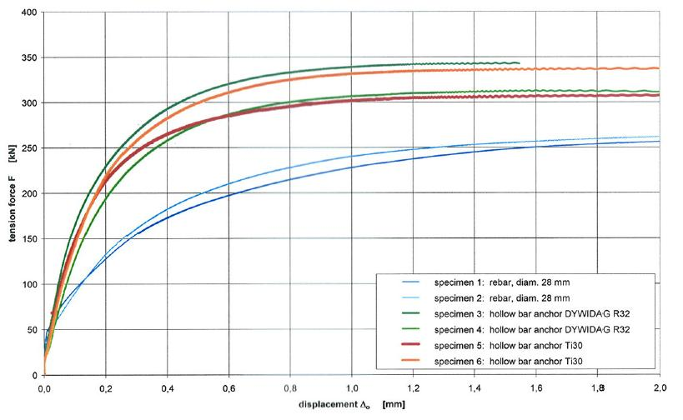
Figure 15. Comparison of bond stress performance for “T” thread and Rope thread

In summary, it is the grout / ground interface which is the limiting factor on load performance, not the bar / grout interface.

INSTALLATION EQUIPMENT AND DRILLING TECHNIQUES

The selection of the most suitable equipment for hollow bar installation depends on the application. For soil nails and rock bolts, the borehole sizes tend to be relatively small and installation depths quite short, whereas for micropiles and ground anchors larger diameters and greater depths are more common.
For soil nails, there are often large quantities of nails and at different locations on the face of the slope, therefore a drill boom which can be positioned quickly at each soil nail position and one that has sufficient reach is often preferred, typically an excavator mounted drill boom (see figure 16). As the drilling power and feed pressures are normally low for soil nails, the lack of rigidity within the excavator boom is not normally an issue. Excavator mounted drill booms ensure quick positioning of the drill at each nail location, with delays kept to a minimum. For deep cuttings or nail positions in remote locations, a long reach excavator can be utilised (figure 17), provided that there is sufficient stability in the working platform for these heavier machines, particularly at the slope crest.

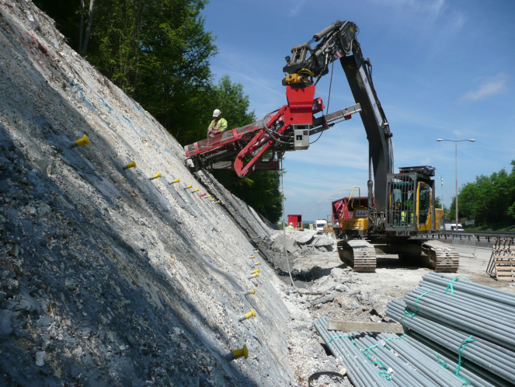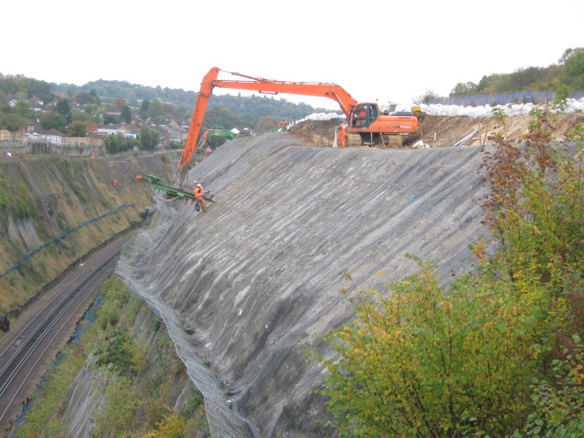
Figure 16. Excavator mounted drill boom Figure 17. Long reach excavator drilling

For rock bolt installation, two categories are considered:
- rock bolts for tunnels and portal stability,
- rock bolts for slope protection mesh, rock face stabilisation and catch fences.
For tunnels and portals, installation equipment typically comprises boomers (figure 18) or specialist drilling equipment. These rigs are purpose built, have powerful hydraulics and are able to operate a number of drill booms simultaneously. Where hollow bar rock bolts are installed by boomers, production rates are significant.
For slope protection mesh or rock face stability applications, roped access is often required. These drill rigs are mounted on wheeled Dachs frames (A frames), which are suspended on winch cables over the rock face, figure 19. Whilst these rigs can be positioned in almost any location, rig movements are laborious and time consuming, furthermore feed pressures are limited by the low weight of the drill frame and rotation torques are generally only sufficient for small diameter boreholes.

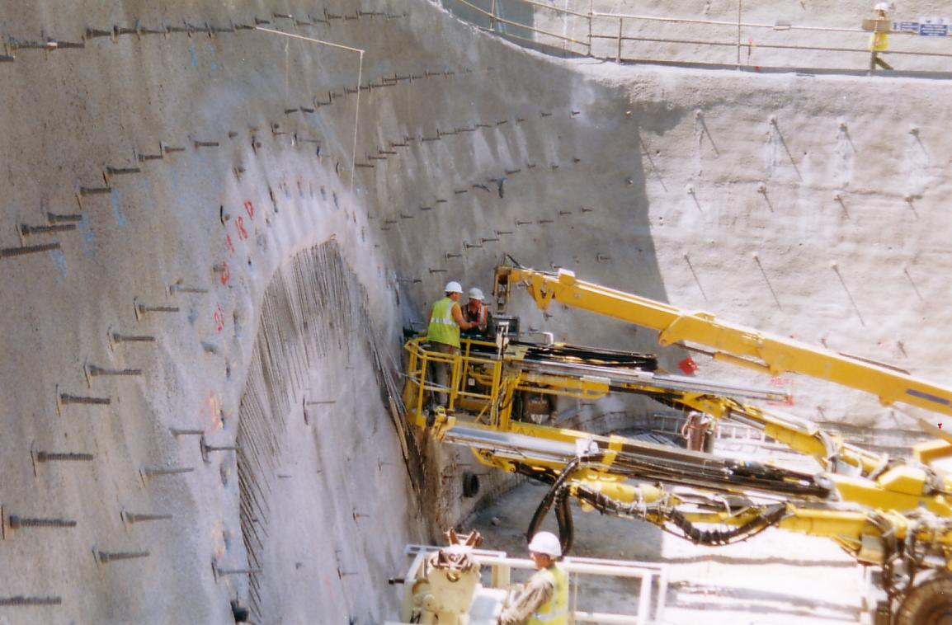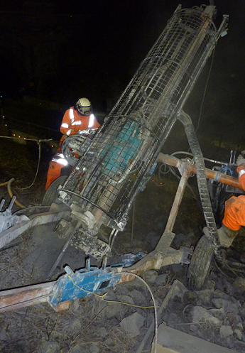
Figure 18. Portal rock bolts installed with boomer Figure 19. A frame drill rig

Installation of micropiles and ground anchors normally requires larger diameter boreholes to greater depths. In these cases greater power with respect to rotational torque and feed pressure is required. For these installations a crawler mounted drill rig is often employed (figure 20). Crawler drill rigs can range from 8-16t in weight. They offer a stable drilling platform, plenty of power and offer longer drill boom stroke lengths, ensuring the use of 4m or longer drill rod sections.
Where longer rod sections can be used, the amount of couplers can be reduced, ensuring quicker installation times and a more rigid drill string. Crawler rigs also typically feature twin jaw clamps (figure 21) at the base of the drill boom, enabling tool joints to be released with ease on larger diameter hollow bars.

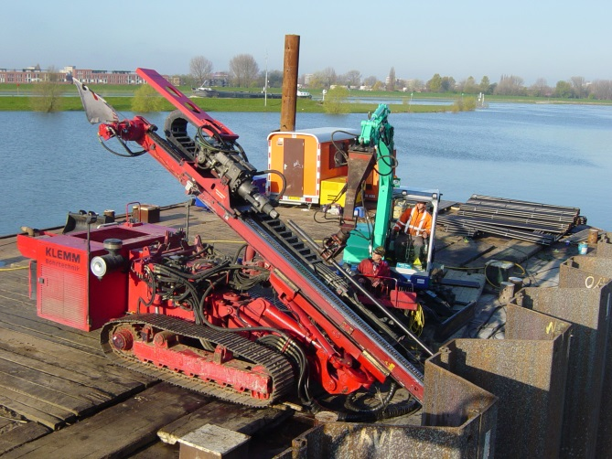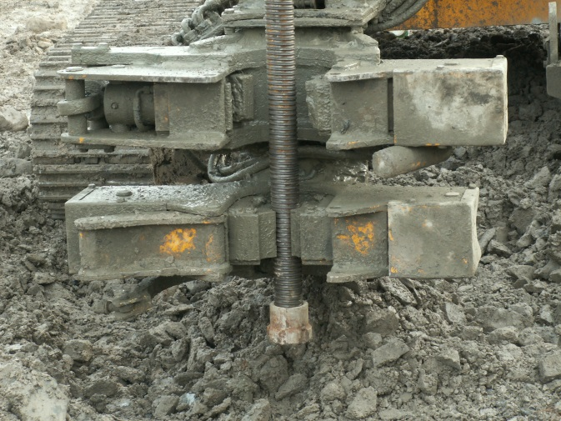
Figure 20. Crawler rig, tieback installation Figure 21. Jaw clamps for rod release

Rotary Percussive Top Hammers (Drifters)

The rotary percussive top hammer or drifter is the one piece of equipment which sets hollow bar installation apart from other drilling methods, i.e. rotary. The drifter enables an aggressive drilling action which is able to handle obstructions, hard ground and rock efficiently, when used in conjunction with the correct diameter hollow bar and suitable drill bit.
Drifters are available in a range of sizes to suit A frame drill booms up to crawler rigs (figures 22 and 23). Both air powered and hydraulic powered versions are available, although hydraulic versions are now the unit of choice. Drifters are expensive pieces of equipment, but are indispensable for 98% of installations.

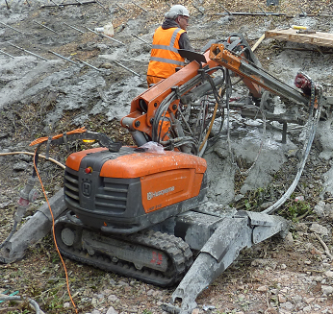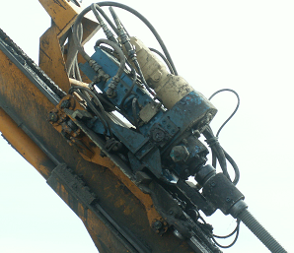
Figure 22. Lightweight drifter Figure 23. Heavy drifter for larger hollow bars

Drilling Techniques

There are three functions for drilling, stated in order of priority:
- Rotation: 120-150 RPM. This is the key drilling function as it ensures the borehole is cut as part of the drilling process.
- Percussion: 300-600 BPM. This function is provided by the hammer (drifter). The impact action of percussive drilling enables drilling efficiency in hard ground or rock as well as assisting with directional stability of the drill string.
- Feed: Also known as rate of advance. Rate of feed is critical to ensuring that the hollow bar does not get pushed into the ground faster than it can be drilled. Fine feed is the key, with rates of advance not exceeding 1 metre per minute in soils and much less in harder ground or rock.

Flushing and Grouting Options

The installation technique for hollow bars comprises both the drilling function and the flushing function. The drilling process is an obvious requirement for installation but flush can be just as important, as loss of flush will generally result in the build-up of material in front of the drill bit causing stalling and even refusal.
Flush options depend on the ground conditions, drilling equipment and the type of application, they include:
- Air flush. Often used in clays, open rock faces or with lightweight drilling equipment.
- Water flush. Used in hard ground or rock conditions where rates of penetration are slow and would result in excessive grout wastage, as well as inclined boreholes, e.g. in tunnelling.
- Grout flush, also known as simultaneous drill and grout. Ideal for loose overburden, gravels and mixed fills. In these ground conditions, the grout becomes a part injection / part flush system.

Simultaneous drill and grout ensures grout is placed at all points of the borehole as drilling is advanced (figure 24), permeating the local soil strata and producing bulbing in the softer sections of the borehole, for increased bond strength.
Reaming of the bottom rod section (rotating whilst withdrawing and re-inserting the drilled bar with grout flush) at full depth will further enhance bond performance, as the ground strength is typically highest at this point, deeper in the ground.

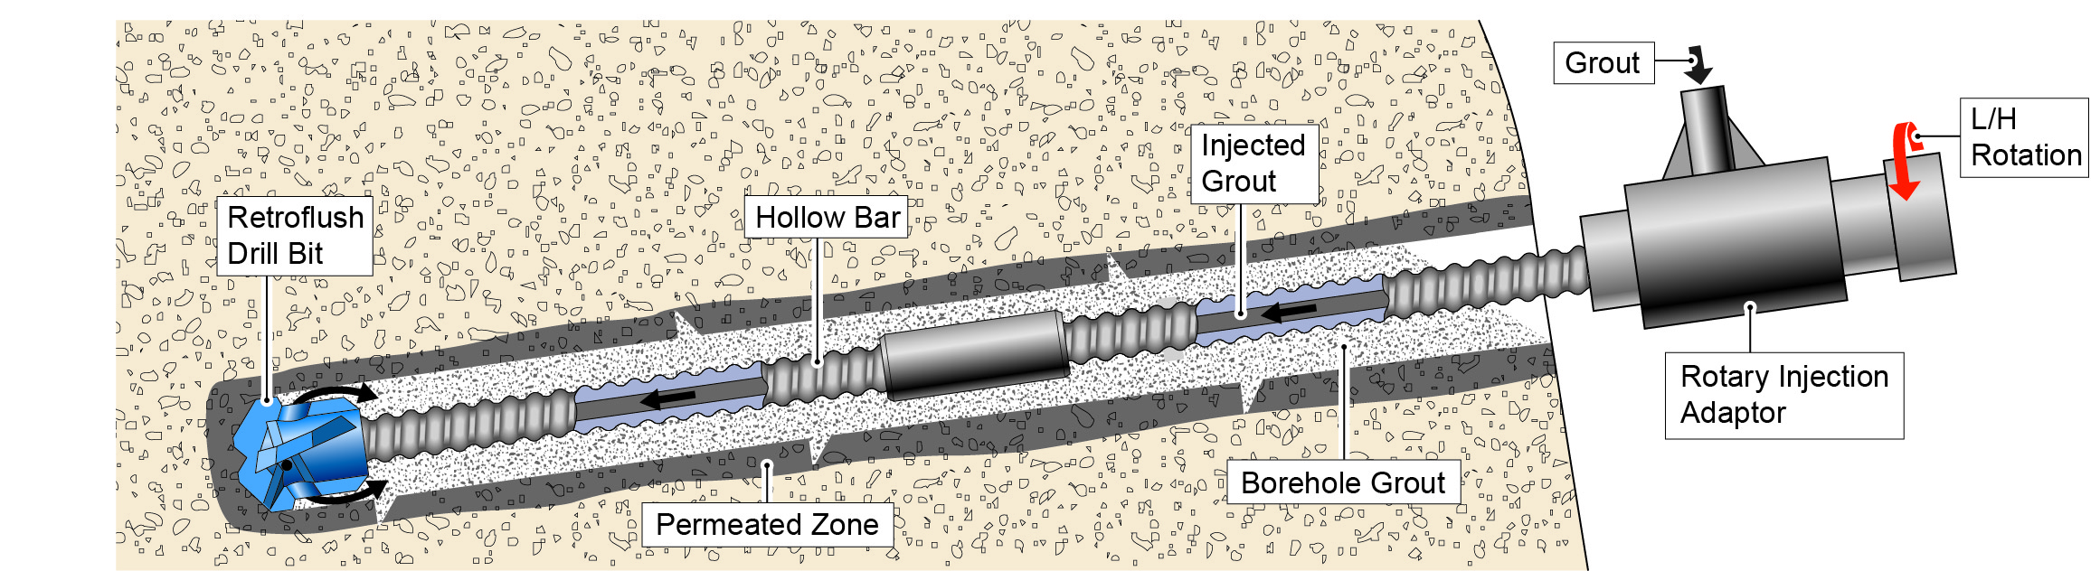
Figure 24. Simultaneous drill and grout installation for hollow bars

Rotary injection adaptors (figure 25) are required for simultaneous drill and grout installation. This unit enables grout to be pumped through a rotating shaft, into the bore of the hollow bar during drilling. The unit is placed just below the hammer and is designed to resist the high impact energy of the hammer together with the torque demands.
The rotary percussive drilling action will typically ensure a rougher borehole for grout bond, than rotary drilled holes. The level of grout permeation within the borehole is dependent on the ground conditions, drilling process and grouting pressure. Figure 26 provides an indicative section of a hollow bar installed using the simultaneous drill and grout technique.

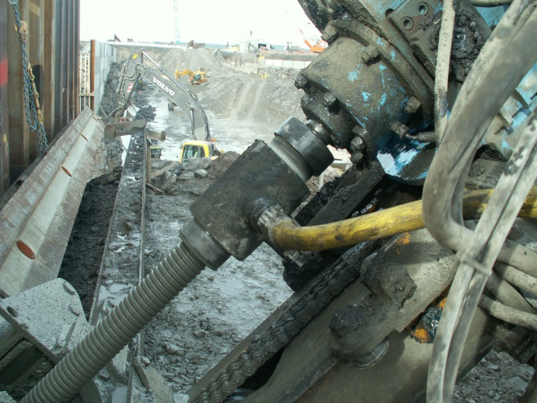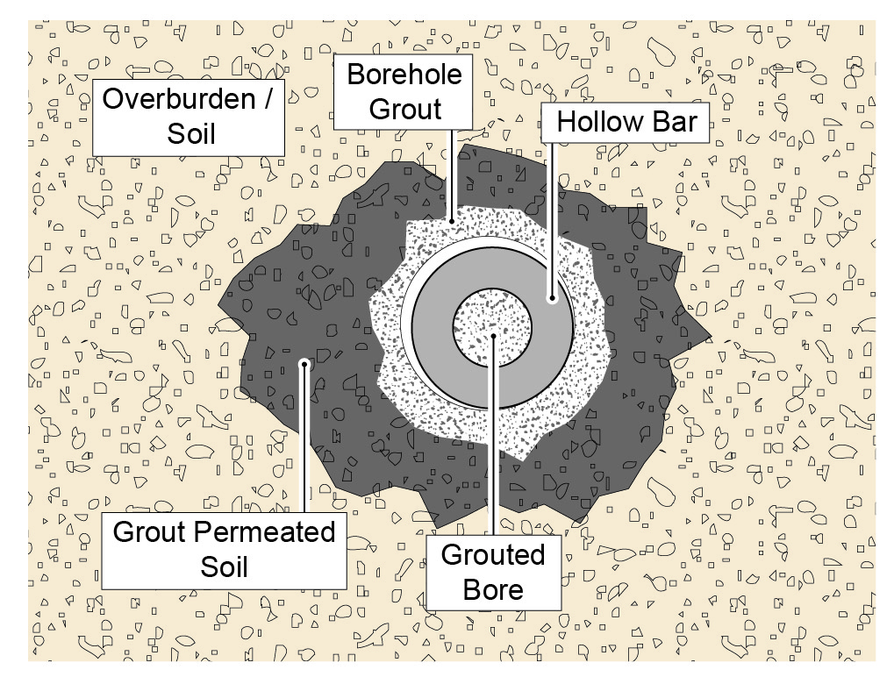
Figure 25. Rotary injection adaptor Figure 26. Section of grouted borehole

STRESSING AND TESTING OPTIONS

The choice of stressing and testing procedures depend on the application, e.g. soil nail, tension pile or ground anchor etc. It is important to note that hollow bars are drilled installations, therefore it is not possible to fit inflatable packers or bond isolators (comprising foam collars) to the bars, as these would be destroyed during rotary installation.
As the hollow bar is a drilled installation, it is very difficult to control the placement of grout to a specific level, i.e. up to the slip circle. For simultaneous drill and grout installations, grout is placed as soon as the bar enters the ground, and for water or air flush installations followed by a subsequent grout injection, it is almost impossible to place the grout to a designated level. Therefore, load testing of a hollow bar in a fully grouted borehole can be difficult as one needs to discount the bond contribution generated from the section of the borehole within the wedge zone, as load generated within this zone cannot be considered.
The use of debond sleeves for the load testing of hollow bars is often selected as the solution to the above problem, but it is not correct. Any load on the bar will transfer through the debond sleeve to the lower section of the borehole, loading the lower section grout bulb. This grout bulb will strut against the grout in the upper section of the borehole (surrounding the debond sleeve), resulting in the full length of the grouted borehole, i.e. the geotechnical bond, being tested. This results in a distorted higher load being registered, which does not reflect the achievable load within the stable zone of the borehole.
For soil nail testing, it is recommended to use the long and the short nail testing comparison (figure 27). This test method employs two sacrificial soil nails side by side, both installed with the same grouting method. For testing, both nails are pulled to failure, with the load of the short nail being subtracted from the long nail, to give the true load within the stable zone. For this test to work properly, it is important that grout within the proximity of the borehole mouth is washed back (particularly in gravels), otherwise is will tend to strut against the underside of the reaction pad for the jack, leading to incorrect higher loadings.

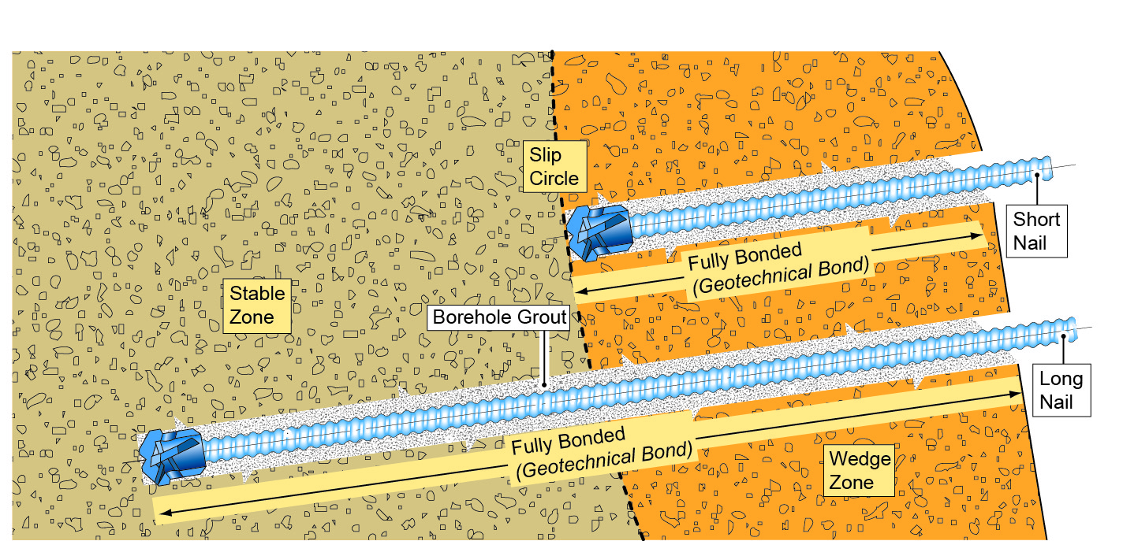
Figure 27. Long and short soil nails, for load comparison test

CONCLUSION

Self-drilled hollow bars are suitable for a wide range of applications, including soil nails, rock bolts, micropiles (tension or compression) and ground anchors, subject to their use being assessed in relation to practicality of installation, load performance (generally not a problem with hollow bars, except in clays, or for slender micropiles in compression), and durability.
Durability of hollow bars throughout their lifespan should be considered in respect of aggressivity of environment, working load, corrosion protection options and risk. Where higher levels of corrosion protection are required, solid threadbar systems or strand systems (for anchors) with factory sheathed protection should also be considered, in order that the risk may be mitigated and the lifespan achieved.
Ease of installation for hollow bars offers significant benefits in loose or collapsing ground conditions over drilled and placed systems, however hollow bars are not always able to offer efficient drilling solutions in wet clays or competent rock conditions.

References:
- European Standard. EN 14490: 2002. Execution of Special Geotechnical Work - Soil Nails.
- TRL. Research report 380. The development of specifications for soil nailing.
- British Standards Institute. BS 8006-2: 2011. Strengthened / reinforced soils, soil nail design.
- European Standard. EN 14199: 2005. Execution of Special Geotechnical Work - Micropiles.
- Deutsche Norm. DIN 4128: 1983. Small diameter injection piles.
- Piling Engineering: Fleming, Weltman, Randolph, Elson. 1992
- European Standard. EN 1537:2013 Execution of Special Geotechnical Work - Ground Anchors.
- Deutsche Norm. DIN 4125: Ground Anchors
- British Standards Institute. BS 8081:1989 British Standard Code of Practice for Ground Anchorages.
- Technishe Universitat Munchen Report No. 2005617, 2005. Rilem RC6 Pull-out test of hollow bars and rebar
- British Standards Institute. BS EN ISO 1461:1999. Hot dipped galvanized coatings on fabricated iron and steel articles. Specifications and test methods.

