MICROPILE LATERAL LOAD TESTING IN
CHARLESTON, SOUTH CAROLINA, USA

William B. Wright, et. al.
ABSTRACT
With increasing frequency, micropiles are being used as a foundation solution within the Charleston, South Carolina area. Typically, micropiles in this region are installed in areas where limited construction space or potential vibrations prevent driven piles as a foundation solution. Micropiles used in the study area consist of a 40/20 continuously threaded, hollow core steel bar (i.e. CTS Titan IBO rod) embedded in a self-drilled hole with a nominal diameter of 6 to 10 inches. The neat cement drilling grout has a high w/c ratio and is replaced with a thicker grout (low w/c ratio) as the final step in the installation process. Micropile lengths typically range from 7.6 to 26 meters (25 to 85 feet), with axial design capacities ranging from 90 to 355 kN (20 to 160 kips). Traditionally, micropile design has been verified using axial load testing; either ASTM D-1143 (Axial Compression) or ASTM D-3689 (Axial Tensile). However, due to seismicity and wind loading in the Charleston area, lateral loading is a significant design consideration. Therefore, lateral load tests (ASTM D-3966) have been used with increasing frequency on micropiles to determine lateral load response characteristics. These characteristics provide a basis of design using site specific p-y curves to model spring constants in an LPILE analysis. Without this analysis and lateral load test results, the use of relatively long steel casings to prevent cracking in the high strength grout and diminished ductility is necessary with lateral loads above 31.2 to 44.5 KN (7 to 10 Kips). This paper will detail case histories in the Charleston, SC area where lateral load testing was used to verify lateral design capacity. For each case history, soil profile information and load test results, and design calculations are presented. Lessons learned during the load testing programs are discussed and recommendations for future micropile research/testing

BACKGROUND
Micropiles are being used with increasing frequently in Charleston, SC, USA due to limited site access and vibration considerations associated with the installation of a driven pile foundation system. The Charleston area consists of many historic homes, buildings and commercial structures that are primarily unreinforced masonry with low strength oyster shell mortar. Foundation rehabilitation of these structures and additions is difficult because of limited access. Many of these structures are set on or near, past salt water marshes which were reclaimed with various undocumented fill throughout the 1800’s and early 1900’s. This reclaimed land is shown on Figure 1. The map is named “The Halsey Map” as it was compiled from various historic maps by Alfred O. Halsey in 1948.

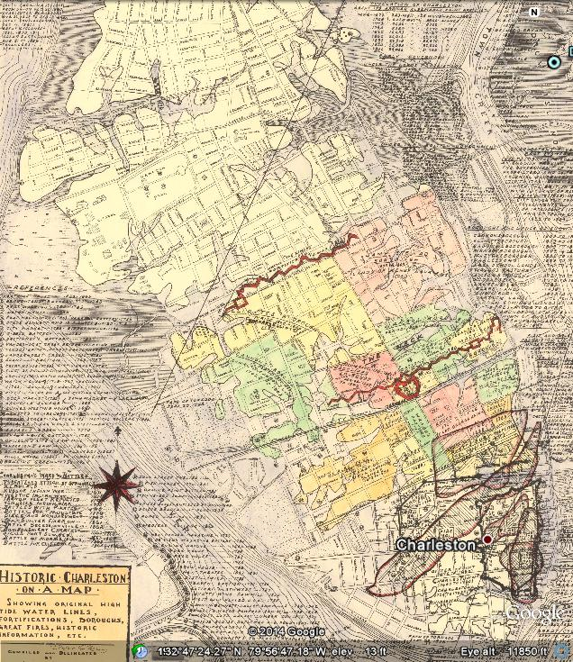 Figure 1 Halsey Map showing “made” land in Charleston Peninsula

Traditionally, micropile design has been verified using axial load testing; either ASTM D-1143 (Axial Compression) or ASTM D-3689 (Axial Tensile). However, due to seismicity in the Charleston area, lateral loading is a major factor for regional engineering design. Lateral load tests (ASTM D-3966) commonly are performed to determine lateral loading response including displacement and moments. The use of the lateral load test provides a methodology for design which can be correlated to modified p-y values used in the LPILE modeling and analysis. Without this lateral load testing and correlated LPILE modeling, the use of relatively long steel casings to prevent cracking in the high strength grout and diminished ductility is necessary with lateral loads above 31.2 to 44.5 kN (7 to 10 kips).

PURPOSE OF STUDY
This study’s intent is to provide an initial understanding of the design factors necessary to provide a safe and economical foundation system when considering lateral loads from wind and seismic forces. To this point, we have performed five case histories in the Peninsula area of Charleston. All were similar Type”E” micropiles with 8 to 10+ inch diameters and lengths of approximately 30 to 85 feet. These case histories provide a starting point for determining lateral resistance of micropiles using both cased and uncased upper sections.

DESIGN METHODS
General
The design methods for Micropiles are based on location conditions. In this study the performance is based on Wind (Hurricane -130+ MPH), Seismic (7.3 design Earthquake) and moment capacity (cracking of the grout section). As part of this study, we performed LPILE design analysis prior to lateral load testing at the start of construction. The differences in the stress-strain were primarily due to the strength of upper soils (top 10-15 feet.) and bonding of grout to the fresh cut face of the upper sandy soils. More specifically, other differences indicate that lateral load testing simulates a free head condition and no axial force is applied to the pile.

Methods and Design Requirements
Acceptable design requirements in South Carolina include the International Building Code and the Federal Highway Administration’s FHWA-NHI-05-039 also known as “Micropile Design and Construction”. Each of the study cases was designed structurally and geotechnically using the FHWA’s methods along with the current applicable IBC Code (2006, 2009, or 2012) and ACI 318. In this case, ACI had no direct reference to micropiles or their specific design. In all cases, significant back and forth discussions between the geotechnical and structural engineer were needed to finalize the pile design.

INSTALLATION
Type, Size and Dimensions
The micropiles installed for testing and production were Type E, where a hollow reinforcing bar is used with an appropriate bit to drill the hole with a lean drilling grout with a higher strength final grout displacing the initial grout. The bar remains in the center of the hole as reinforcement. The micropiles utilized CTS/TITAN IBO Hollow Bars. The installed micropile diameter and length ranged from 8 inches to 9.5 inches and 30 to 85 feet. In each case study, the bar size was 40/20 with a nominal outside diameter of 40 mm (1.57 inches) and an internal diameter of 20 mm (0.785 inches).

Equipment
Depending on the entry and head room, the drilling equipment used was a TEI WD-50 Electric Drill Rig or a Casagrande C-4XP. The grout plant was a Chem Grout CG600 Pneumatic plant that was used for colloidal mixing and pumping the grout. The final grout was designed as a 28 day 5000 pounds per square inch (psi) neat cement grout. Typically, the 5000 psi strength was attained in 3 to 5 days.

Micropile Construction
The grout is injected from the lowest point of the hollow steel reinforcing bar as it is advanced into the drilled hole. The mixer and pump are monitored continually to control the quality and quantity of the grout. When the grouting is completed, the hollow bar remains in the hole and is filled with high strength grout. After attaining 5000 psi, the micropiles can be load tested based on structural design loading. However, due to the variability in the time dependent strength gain or “set-up” of the Cooper Marl Formation (CMF), longer wait times may be necessary above what is necessary from a structural standpoint alone.

MICROPILE CASE HISTORIES
General
This study details case histories where lateral load testing was used to verify lateral design capacity. For each case history, soil profile information, axial and lateral load test results, updated LPILE analyses using correlated p-y values developed based on actual graphical load versus displacement curves are presented.

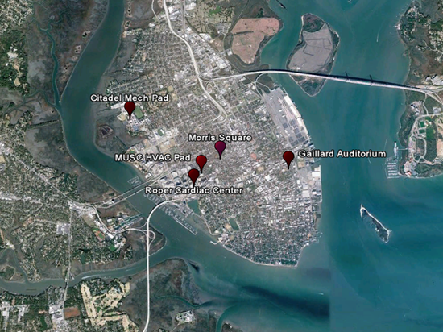
Figure 2 - Case History Locations

Figure 2 provides an overview map of the five Case History locations on the Charleston Peninsula. Figure 3 indicates the overall geology of South Carolina and the general location of the Charleston area. The geologic map indicates the study area is in the Lower Coastal Plain and the upper soils are Pleistocene deposits. The depth to basement bedrock is approximately 3000 feet in the Charleston area.

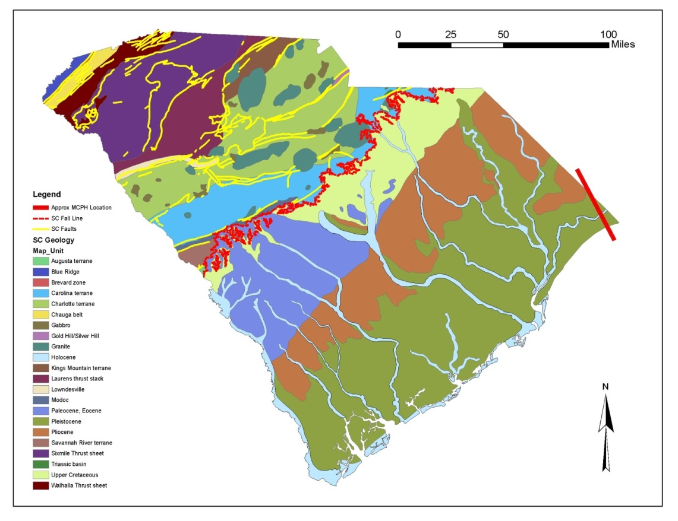
Charleston, SC
Figure 3 - Geologic Map of South Carolina

Table 1 provides an overview of the 5 Case Histories. Briefly, case histories 2 through 5 represent uncased micropiles whereas Case History 1 was cased with a 14 foot long 7 7/8 inch diameter casing (0.375 inch wall thickness). The lateral design loads range from 2 to 7.6 kips for the uncased micropiles and 7.5 kips for the single cased micropile.

Table 1- Lateral Case Study Summary
Case History No. | Project Name | Micropile Information |  |  |  | Surface to 20 feet Soil Conditions | Design Loads |  | Test Results
 |  | Bar Size | Diameter (in.) | Length (ft.) | Cased/  Uncased |  | Axial  Kips | Lateral Kips | Axial  Kips | Lateral Kips
1 | MUSC HVAC Pad | 40/20 | 8.6 | 85 | 7 5/8” steel casing installed to a depth of 14 feet | Medium Dense Sands | 60 | 7.5 | 125 | 45
2 | Galliard Auditorium  Renovations | 40/20 | 8 | 53 | Uncased | Medium Dense to Dense Sand | 80 | 7.6 | 157 | 24
3 | Citadel Mech. Pad | 40/20 | 8.6 | 60 | Uncased | Dense Sand | 22 | 2 | 50 | 10.5
4 | Roper Cardiac Center | 40/20 | 9.5 | 75 | Uncased | Medium Dense Sands | 40 | 2 | 105 | 23
5 | Morris Square | 40/20 | 8.6 | 31.25 | Uncased | Medium Dense to Dense Sand | 30 | 7.6 | 102 | 11.5

Case History 1
The soil conditions at this location indicate an upper sand crust to approximately 15 feet with soft to very soft organic clays to about 74 feet with a dense layer from approximately 30 to 40 feet (as seen in Figure 4). The Cooper Marl Formation (CMF) is encountered below 74 feet and is typically found to depths of 200 to 300 feet. The CMF is often described as a massive calcareous olive green clayey silt and provides significant skin friction for driven and bored piles. This formation underlies the Charleston peninsula and most of the areas within 10 to 20 miles of Charleston.

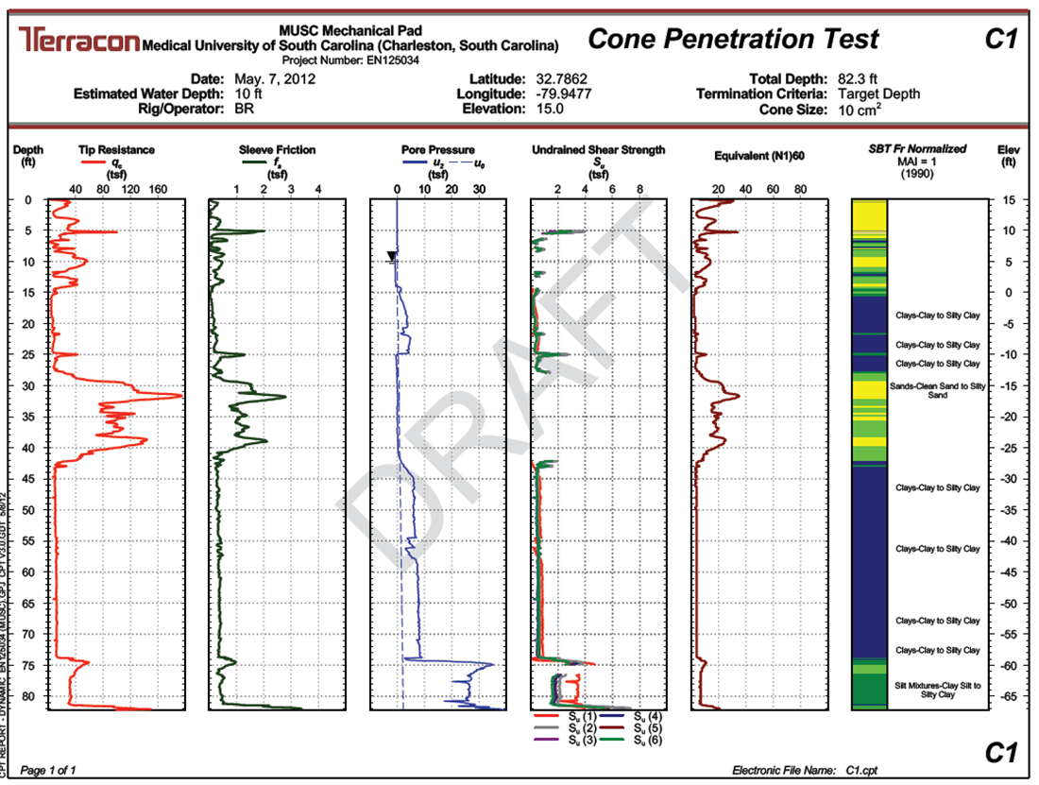
Figure 4- Case1 CPT Record

The results of the lateral load test for the cased micropile indicate a 45 kip load generated a less than 1 inch of lateral deflection with the micropile having a net rebound of 0.15 inches after unloading. Figure 5 provides a graphical overview of the Load/Deflection curve. The maximum load was limited to 45 kips due to unsafe movement of the reaction system.

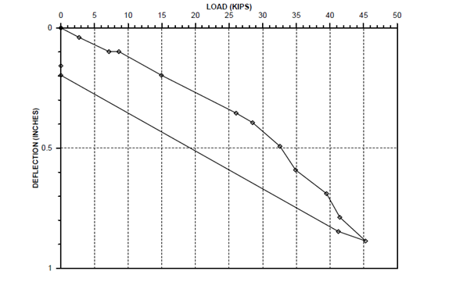
Figure 5- Case 1 Load-Deflection Graph

Case History 2
These soil conditions are similar to Case 1, however the upper soil conditions to 50 feet are mostly loose to medium sands and clay mixtures as seen in CPT record presented in Figure 6. A dense 5 to 10 foot cemented sand layer is encountered below 50 feet. The CMF is encounter below the dense sand based on other logs in the area.

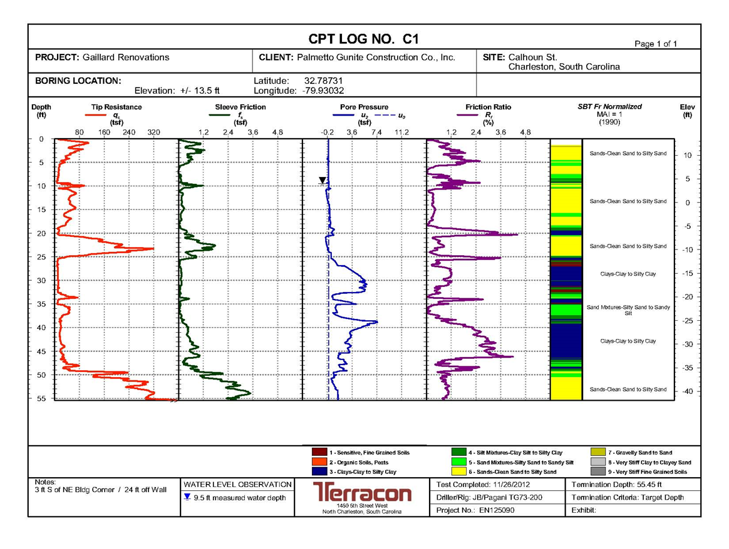 Figure 6- Case 2 CPT Record

The results of the lateral load test of an uncased micropile indicate that the maximum applied load of 24 kips generated 0.65 inches of deflection. Once the load was removed, the net rebound was less than 0.30 inches. Figure 7 provides a graphical overview of the Load/Deflection curve. Movement indicated the test micropile was undergoing failure and the test was stopped since the lateral load needed was only 7.6 kips. The micropile appeared to be failing due to a combination of structural ( cracking of the grout) and geotechnical failure modes.

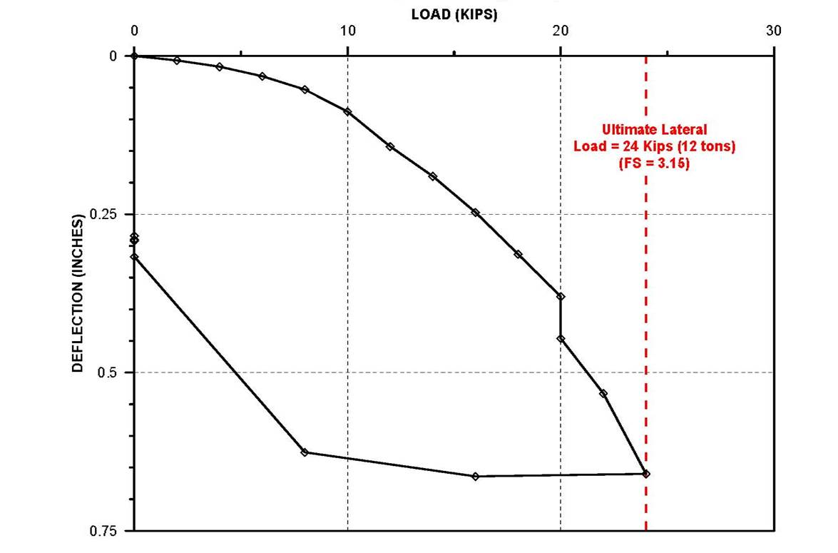
Figure 7- Case 2 Load-Deflection Graph

Case History 3
These soil conditions are similar to Case 2 as seen in Figure 8 and are significantly stronger in the upper 20 feet with a Tip Resistance q_{t} averaging 100 tons per square foot (tsf). A dense 3 to 5 foot cemented sand layer is encountered below 50 feet. The CMF is encounter below the dense sand at a depth of 56 feet.

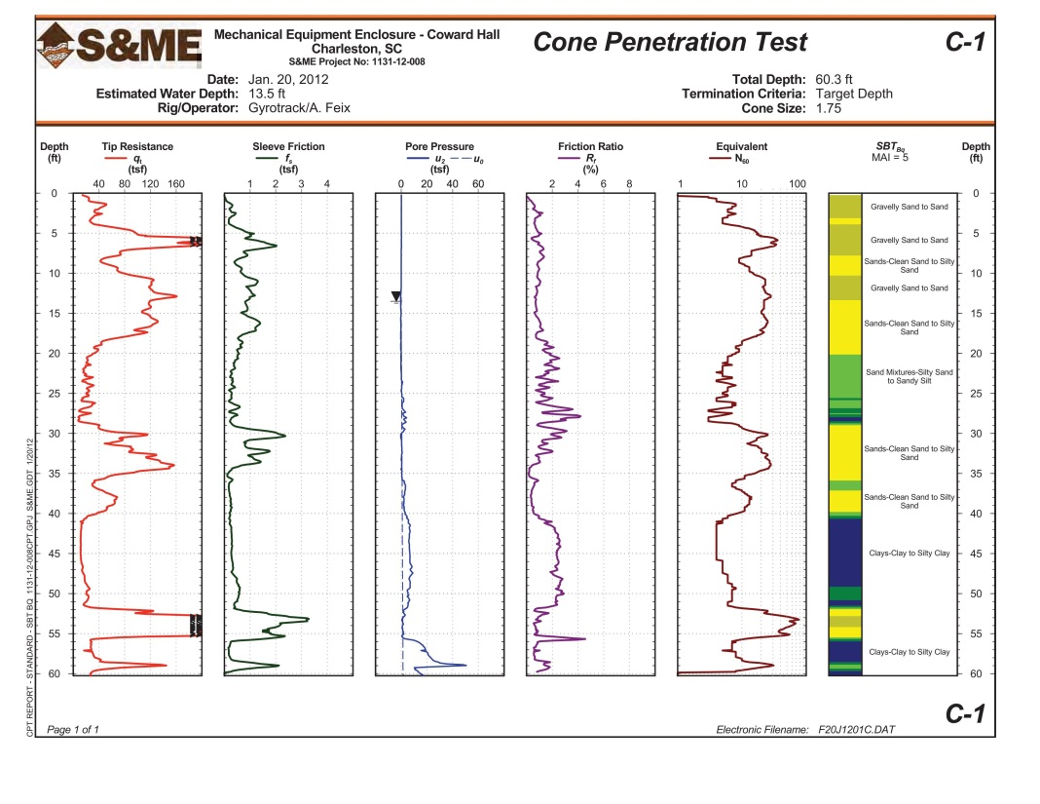
Figure 8- Case 3 CPT Record
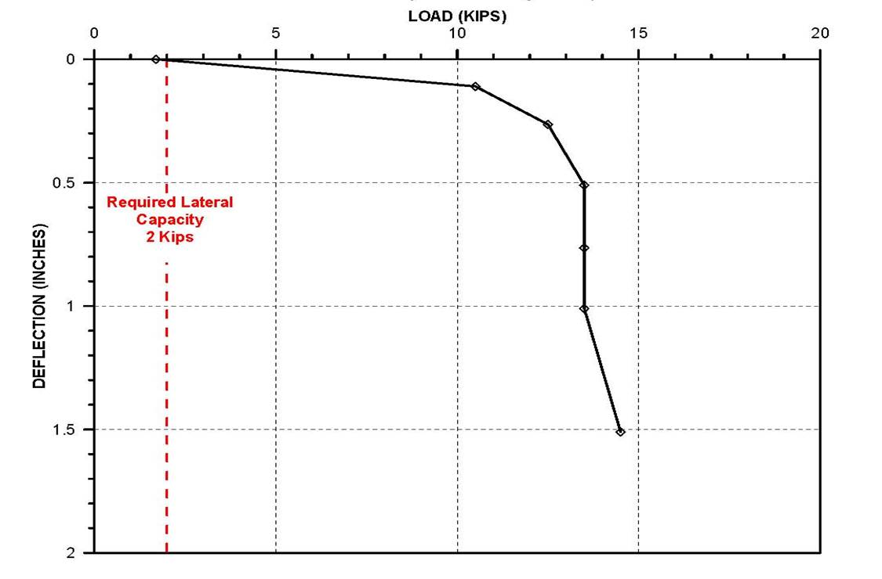
Figure 9- Case 3 Load-Deflection Graph

The results of the lateral load test indicate the load vs deflection curve was linear up to an applied load of 10.5 kips prior to abruptly failing at a load of approximately 13 kips. The 10.5 kip load generated about 0.12 inches of deflection. The net rebound after unloading is estimated to be less than 0.05 inches. Figure 9 provides a graphical overview of the Load vs Deflection curve. The abrupt failure is most likely associated with an initial geotechnical failure and subsequent structural grout cracking and bending of the 40/20 bar. Although not shown in the graph, the net rebound at the end of the test was estimated in the field to be about 1 inch.

Case History 4
These soil conditions are similar to Case 1 with less than 5 tsf of Tip Resistance encountered between 10 and 33 feet. Soils below 33 feet to 62 feet are sand - clay mixtures that become denser with depth. The CMF is encounter below the dense sand at a depth of 63 feet. CPT log for this case study is presented in Figure 10.

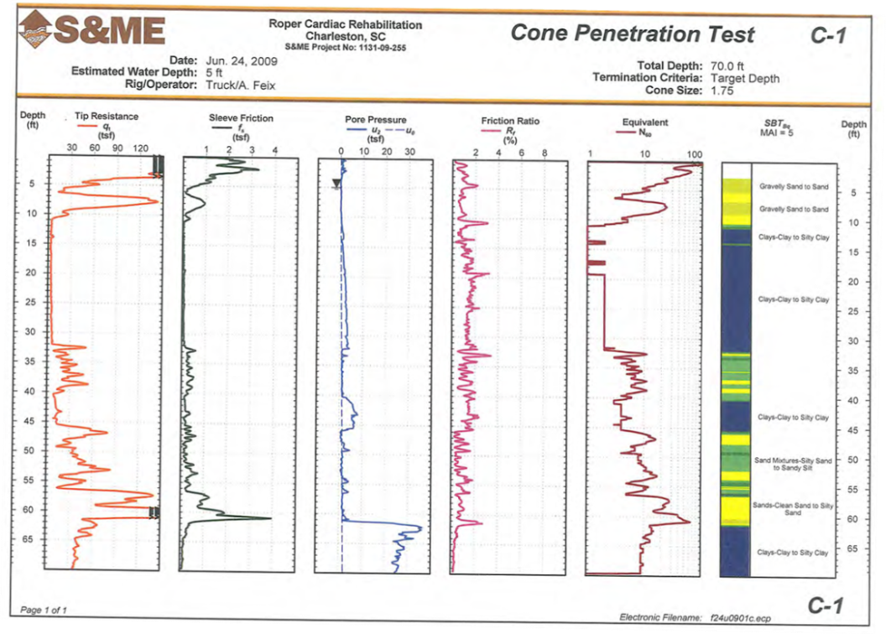
Figure 10- Case 4 CPT Record

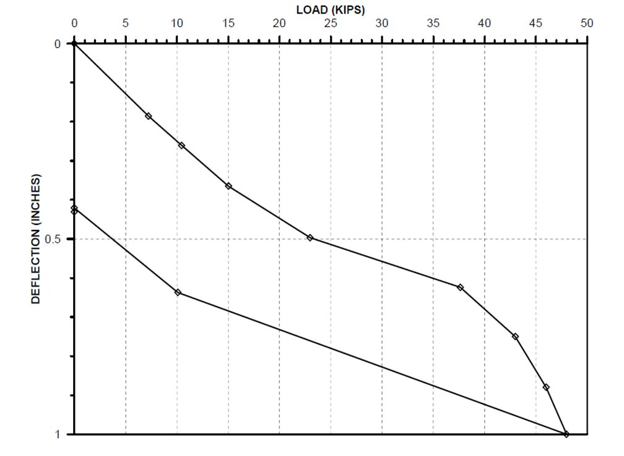
Figure 11 - Case 4 Load-Deflection Graph

The results of the lateral load test indicate a 48 kip load generated 1 inch of lateral deflection. Once the load was removed, the net rebound was approximately 0.42 inches. For this case study, the load/deflection curve was generally linear until approximately 23 kips. The net rebound at that load was estimated to be less than 0.10 inches. Figure 11 provides a graphical overview of the Load vs Deflection curve for this case study. The micropile was undergoing a geotechnical failure from about 37 to 48 kips. The test was stopped due to safety concerns.

Case History 5
These soil conditions are primarily medium to dense sands to a depth of 36 feet. Soils below 36 to 62 feet are a mixture of sands and clays that become denser with depth. The CMF is not encountered below the sands and clays.

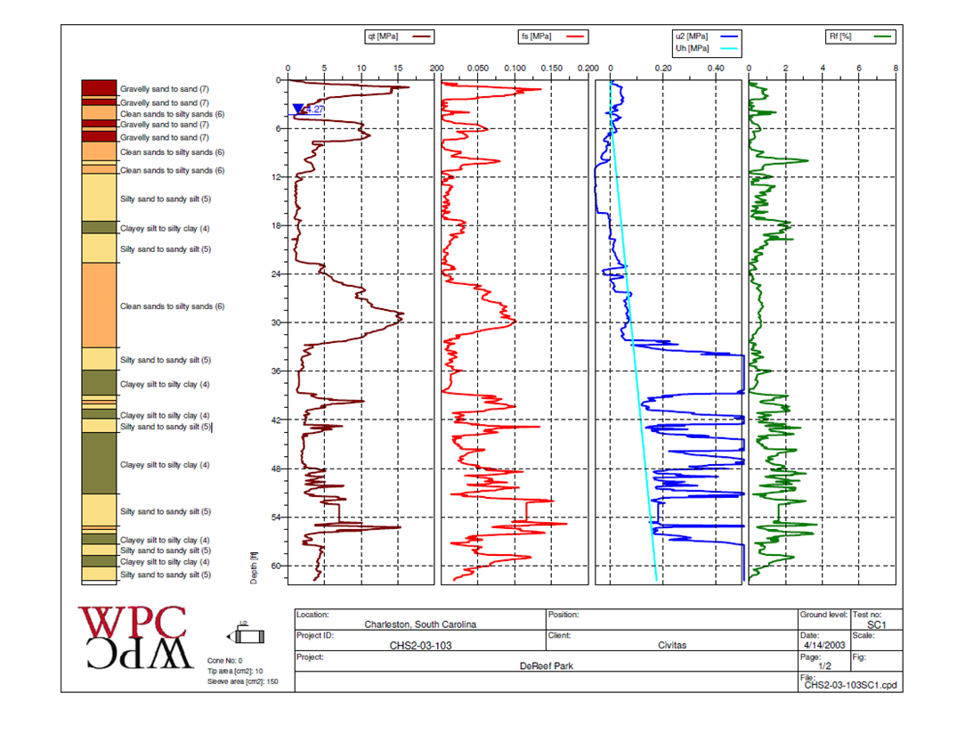
Figure 12-Case 5 CPT Record

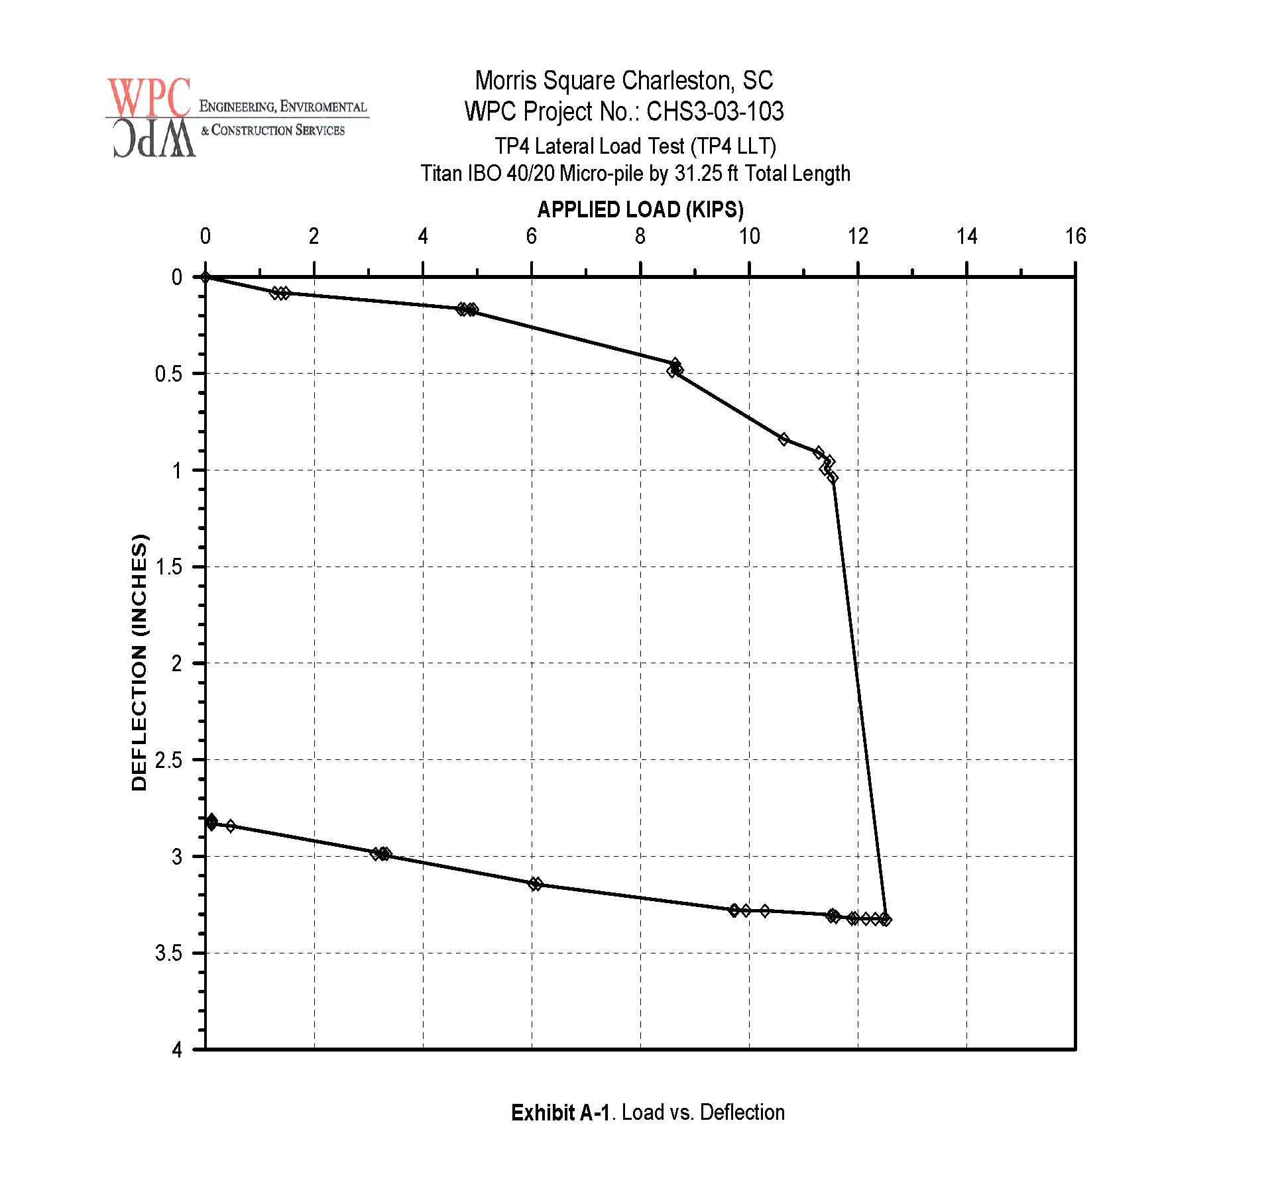
Figure 13 - Case History 5 Load-Deflection Graph

The results of the lateral load test indicate a 11.5 kip failure load deflected approximately 1 inch. The load-deflection curve, in this case, was generally linear until about 11.5 kips. The net rebound at that load is estimated to be less than ¼ inch. Figure 13 provides a graphical overview of the Load/Deflection curve. Visual indicators in the field indicated the bar was bending and undergoing primarily structural failure. Safety issues stopped the test with 3.3 inches of deflection. The net rebound after unloading was 2.8 inches.

CONCLUSIONS
Geotechnical Considerations
Normally, micropile design includes an unbonded section with a steel casing. The casing allows elastic elongation of the reinforcing bar (lift–off) during load application to create a load on the bonded section. When a micropile is used as a compression member only, the design does not consider shear or moment. However, when a design process includes lateral forces from wind or seismic events, a steel casing strengthens the upper section of the micropile and prevents cracking of the grout. This strengthening allows interaction of the shear and moment forces with the soil. However, our study indicates that when the shear forces are relatively low, a steel casing may not be required or when a casing is used, significantly more shear capacity is available. Our initial conclusions are as follows:

- Depending on soil conditions, our four lateral load test results for uncased sections (Cases 2 through 5) indicated that shear loads of 10.5 kips to 25.0 kips occurred with relatively linear displacements and net rebound after unloading ranging from 0.29 inches to less than 0.1 inches.
- Movements at the prescribed design loads were less than 0.1 inches in 3 cases (Cases 2,3,5) and 0.4 inches in Case 4 .
- Our single lateral load test for a cased section (14ft. long by 7 5/8 inch dia.) indicated a maximum shear load of 45 kips at a deflection of 0.9 inches.
- Movements at the prescribed design load of 7.5 kips were 0.1 inches.
- In general, we believe that lateral loads up to 10 kips are available for uncased sections and up to 25 kips for the cased sections.
- Our findings in these five case studies indicate the displacements associated with the design shear loads (ranging from 2 to 7.6 kips) were relatively linear and recoverable at total displacements less than ½ inch.

These test results use the site specific p-y curves obtained from the lateral load tests to provide a higher lateral capacity than normally assumed or calculated using traditional LPile analysis. In the same manner, a significant increase in lateral capacity of cased sections using lateral load test results is possible. Of course, these results are dependent on the upper soil conditions.

Structural Considerations
In research of the various applicable codes and design procedures, the following
was found.

The International Building Code (IBC) indicates in section 1810.8.1
the following: “Micropiles shall consist of a grouted section reinforced with steel pipe or steel reinforcing. Micropiles shall develop their load-carrying capacity through a bond zone in soil, bedrock or a combination of soil and bedrock. The full length of the micropile shall contain either a steel pipe or steel reinforcement.”

Further, the IBC in Section 1810.8.4.1 seismic reinforcement indicates: “Where a
Structure is assigned to Seismic Design Category D, E or F, the pile shall be considered as an alternative system. In accordance with Section 104.11, the alternative pile system design, supporting documentation and test data shall be submitted to the building official for review and approval.”
The American Concrete Institute’s Building Code Requirements for Structural Concrete (ACI 318) and Commentary (ACI 318R) have no direct references to micropiles.
Thus, we understand that design as an alternative system with testing is possible. Also, compression and tension provide no significant design problem. However, lateral forces induce flexural stresses including bending. ACI 318 indicates in section 10.2.7.3 the following: “The relationship between concrete compressive stress distribution and concrete strain shall be assumed to be rectangular, trapezoidal, parabolic, or any other shape that results in prediction of strength in substantial agreement with results of comprehensive tests.”
Also, ACI 318, Section 10.2.7.3 indicates: “Using equation a=B₁ c for fc’ between 2500 and 4000 psi, B₁ shall be taken as 0.85 for fc’ above 4000 psi, B₁ shall be reduced linearly at a rate of 0.05 for each 1000 psi of strength in excess of 4000 psi, but B₁ shall not be taken less than 0.65.”
Basic reinforced concrete design indicates there are two failure modes: compression where concrete crushes or tension where steel yields. For these two failure modes, compression yields a catastrophic failure and tension a more desirable ductile failure. Designs where compression failures occur are considered over-reinforced and designs where tension failures occur are considered under-reinforced. A balanced failure occurs when the concrete crushes at the same loading as the reinforcing yields. Since micropiles are typically over-reinforced, the grout sections are generally too small to force a ductile failure mode. Thus, if we limit the area of reinforcement to something less than that, we can get closer to a balanced failure.
In summary, from a structural perspective, we can be conservative and limit the steel cross section considered to less than balanced conditions and restrict steel yield stress to 80 ksi per ACI. Finally, it is important to perform lateral testing routinely for any given project.

FUTURE TESTING AND RESEARCH
This study is but a beginning to develop lateral micropile information in our coastal region. Our goal is to develop engineering and construction methods to routinely use vertical micropiles to provide significant lateral resistance for wind and earthquake loads. This is particularly helpful in coastal areas having relatively poor soils that must be designed for both hurricane and earthquake loadings.

As Winston Churchill said, “Now this is not the end. It is not even the beginning of the end. But it is, perhaps, the end of the beginning.”
Potential research we plan to continue in the future is as follows:

- Test the effect of oversizing the upper 20 feet of the grout column.
- Test the containment effect of modified low cost, easily installed casings.
- Fully instrument micropiles with strain gages to better understand the failure mode(s).
- Further research using a computer program such as FLAC3D, MidasGT 3D, or similar FEM or FDM software to model the potential results of design changes from a geotechnical and structural standpoint.
- Run load tests and excavate upper 10-20 feet to review cracking of grout versus lateral load.
- Utilize in situ testing methods (such as DMT) to define site specific design parameters.
- Perform cyclic lateral load tests of micropiles in which the amplitude of loading is varied to ascertain the effects of fatigue and fracture propagation. Testing could be done utilizing various materials to determine the effect of confinement on fracture propagation.

William B. Wright, PE, Senior Consultant, Terracon Consultants, Inc., 1450 Fifth Street West., North Charleston, SC, 843-884-1234 Theodore G. Padgett, PE, Senior Structural Engineer, Charleston, SC Bryan Shiver, PE, Geotechnical Department Manager, Terracon Consultants, Inc. 1450 Fifth Street West, North Charleston, SC, 843-884-1234 Kenneth Zur, PE, Geotechnical Engineer, Terracon Consultants, Inc. 1450 Fifth Street West, North Charleston, SC, 843-884-1234 William L. Snow, President, Palmetto Gunite Construction Co., Ravenel, SC
Micropile Designed Construction Reference Manual, Publication No. FHWA NHI-05-039, December 2005
Hollow Titan Bar, Con-Tech Systems Ltd.
Manufactured by TEI Rock Drills Co; Montrose, CO, USA 5 Manufactured by Casagrande, S.P.A.
CPT Log from S&ME’s Geotechnical Exploration, Mechanical Equipment Enclosure, Coward Hall – The Citadel dated January 20, 2012, Job# 1131-12-008
CPT Log from S&ME’s Geotechnical Exploration, Roper Cardiac Rehabilitation Renovations, dated July 7, 2009, Job# 1131-09-255

