**MICROPILE FOUNDATIONS FOR VERTICAL AND HORIZONTAL LOADS-**

**DESIGN EXAMPLES AND LOAD TEST RESULTS**

Dipl.-Ing. Ernst F. Ischebeck

Dipl. Wi.-Ing. Björn Ischebeck

**ABSTRACT**

The European Standard for micropiles is EN 14199:2005 Execution of special geotechnical works – Micropiles. This standard is mandatory in 30 member countries within the European Union. It is typically understood that micropiles are only loaded by axial loads, compression or tension.

The aim of this paper is, to present design examples of installed micropile foundations, which have been designed for axial and lateral loads and static or cyclic loads

1. Precast foundations for solar-carports - deep foundations with two TITAN 40/20 micropiles which are pre-stressed to resist horizontal loads (wind and impact) by utilising skin friction.
2. Modelling and analysis of simple raft micropile foundations to support vertical and horizontal loads for highway sign gantries.
3. Mono-micropiles with 1.5m shear casing, to achieve additional horizontal loadings of up to 5 % of the vertical loads determined from load test results from Prof. Dr. Ing. Herrmann of the University of Siegen.
4. Micropile groups in very soft clay layers (undrained shear strength ) designed for horizontal loads of 10kN. Load test results from University of Hannover Prof. Dr.-Ing. Blümel Akz. 10/90.
5. Offshore micropiles installed to improve the bearing capacity of driven monopiles and address horizontal loads and scouring.

Keywords: micropile, direct drilled and grouted micropile, raft-micropile foundation, horizontal resistance of micropiles, load-settlement-curves of mono-micropiles.

**INTRODUCTION**

Micropiles are very small piles but are more efficient in terms of stiffness than all other types of piles. According to the European Standard EN 14199 “Micropiles” are defined as drilled and pressure grouted composite piles which consist of a load bearing element and grout, with a diameter of up to a maximum 300 mm.

Micropiles are characterised by the following:

* 90 % of the axial load is transferred by skin friction
* Higher skin friction and smaller displacement than all larger diameter piles such as drilled shafts or driven piles.
* Efficient load performance in both tension and compression, without pretension
* The micropiles ductile load bearing element has the same requirements of ductile rebar - class B (Uniform elongation Agt ≥ 5%), to allow elastic/plastic design calculations.
* Load transfer distribution correlates to the crack width distribution within the grout, in relation to the pull-out-capacity within different soil layers.
* Corrosion protection is achieved by the grout cover, as with reinforced concrete.

The design of drilled shafts for axial and lateral loads is standard and Figure. 1 shows a typical load-displacement diagram for lateral loads (H).

A drilled shaft D = 600 mm can take a horizontal load H = 120 kN

 =  =  a horizontal displacement of δ = 3 mm is estimated.

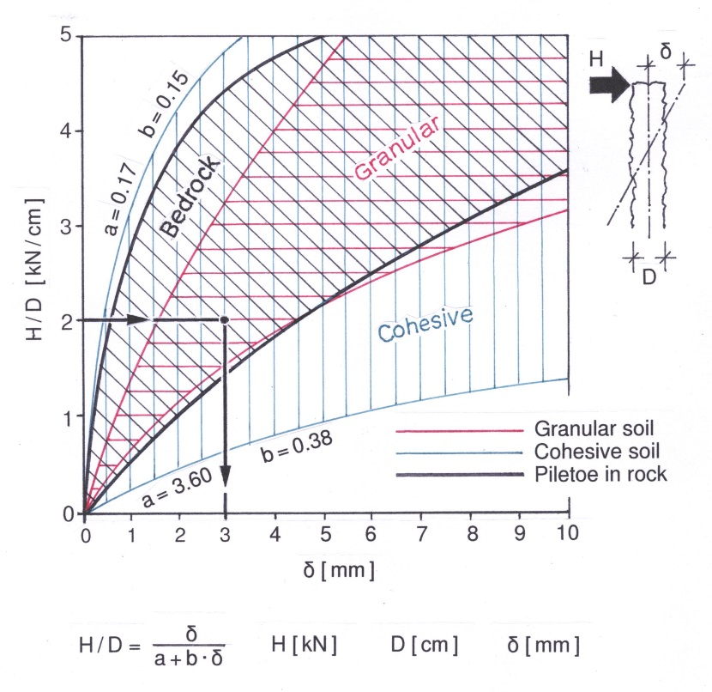

Figure 1. Horizontal load-settlement curves for drilled shafts in different ground conditions *Source: Dr.-Ing. H.G. Schmidt, Pfahl-Symposium 1992, TU Braunschweig*

This also applies to driven piles and design calculations for the horizontal loads of monopiles (p-y-curves) are available from the American Petroleum Institute (API).

Micropiles, mono-micropiles and raft-micropile foundations possess low flexural stiffness for additional lateral loads, which results in a different design approach.

Usually micropiles are designed for axial load cases, such as compression or tension loads. The aim of this presentation, is to demonstrate some design examples for installed micropile foundations, which have been designed for axial, lateral, static and cyclic loads.

1. Precast footings for solar carports - prestressed with 2 micropiles TITAN 40/20

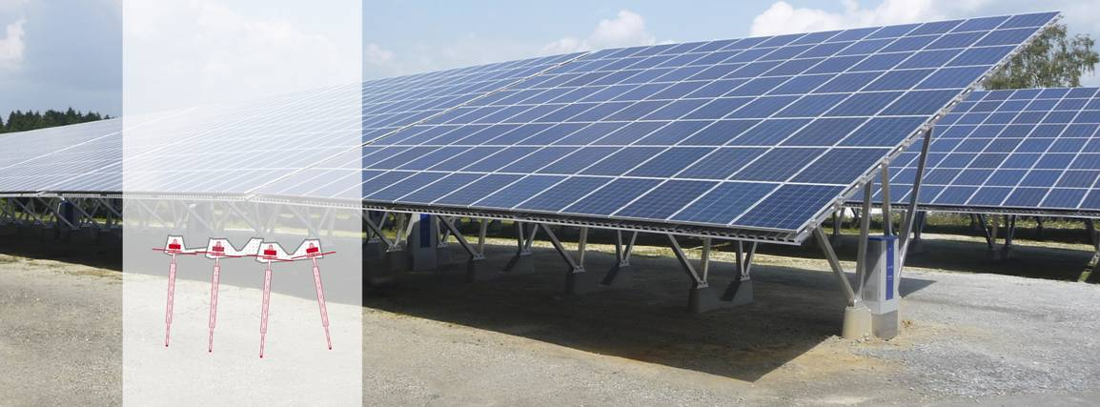

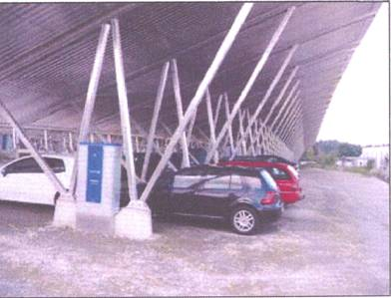

Figure 2. Solar Carport with deep foundation using

drilled and pressure grouted TITAN 40/20 micropiles

Figure 2 shows a typical application of a precast footing for solar-carports. The installation of the solar panels, allows the existing parking space to “double up” as parking for cars, whilst generating renewable solar energy. This is achieved without constructing footings for the shelters, by installing two drilled and grouted TITAN 40/20 micropiles through the precast footing. They are designed and pre-stressed to take compression and tension loads, for example heave from the effect of freezing/thawing and horizontal impact caused by cars. Sometimes the micropile is used as an electric earth to protect the steel shelters against the effects of lightening.

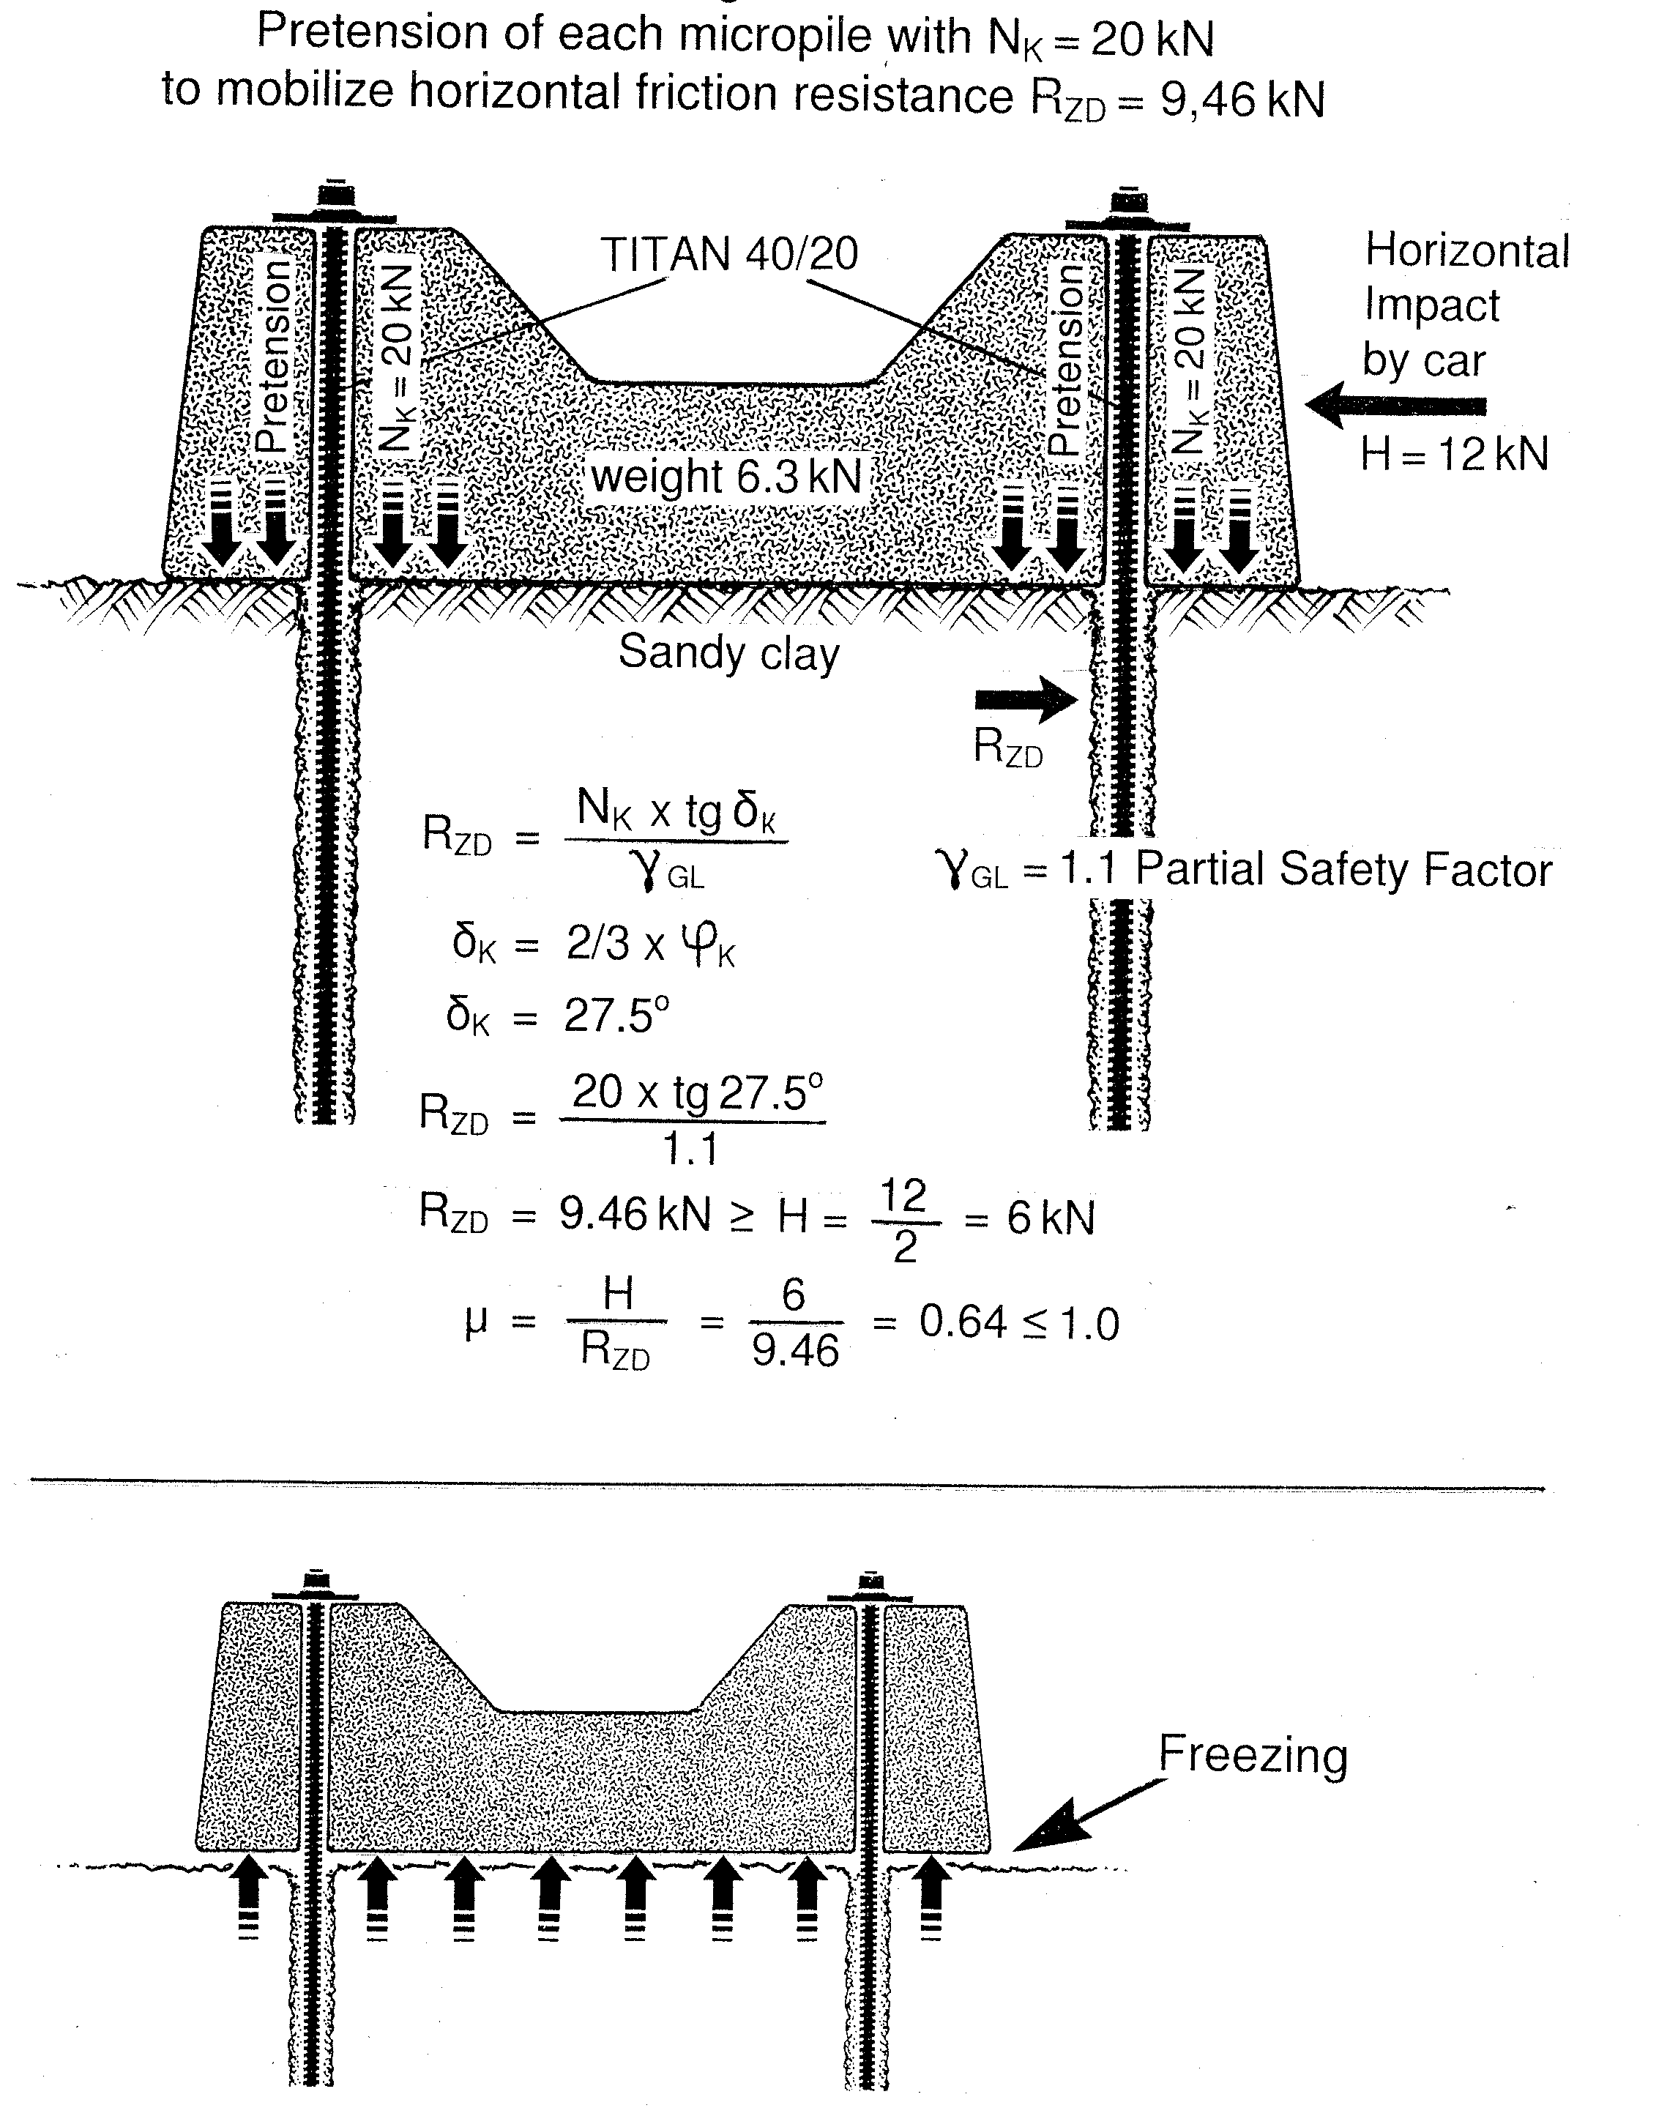

Figure 3. Pre-tension of each micropile with Nk = 20 kN to mobilise

horizontal resistance RZD = 9,46 kN

2. Raft-Micropile-Foundation

Traditional raft-micropile analysis is based on a static model shown in Figure 4.

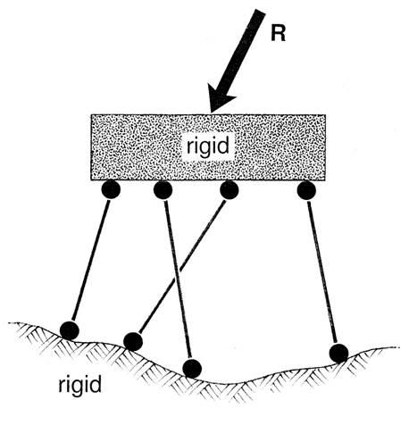

Figure 4. Raft-Micropile System and boundary conditions

Assumptions are:

* Micropiles are hinged columns with bearings at the head and the toe
* The toe bearing is fixed
* The micropiles are adopted as elastic elements
* The flexibility of the load bearing ground is incorporated within the pile
* The flexural stiffness of the raft or the superstructure is large in comparison to the pile stiffness.
* The stiff raft distributes the loads according to the linear elastic stiffness  of the micropiles.

Figures 5 and 6 - Examples of raft-micropile analysis for a micropile foundation, designed to support compressive and horizontal loads from a highway messaging gantry.

Bild2

Figure 5. Highway Gantry, Motorway M4, UK founded with Micropiles

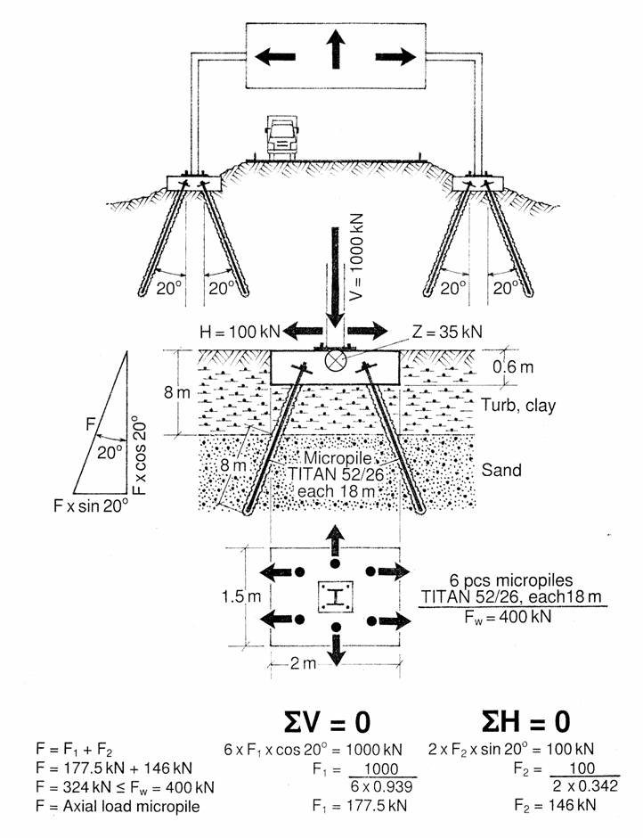

Figure 6. Messaging Gantry with Raft-Micropile Foundation

The original design concept as shown in Figure 7 and 8 is based on drilled shafts within the highway embankment.

Specific site conditions are:

* installation with minimal disruption to traffic
* difficult access to the site
* upper soft layer consists of approximate 8m of cohesive material
* existing utilities

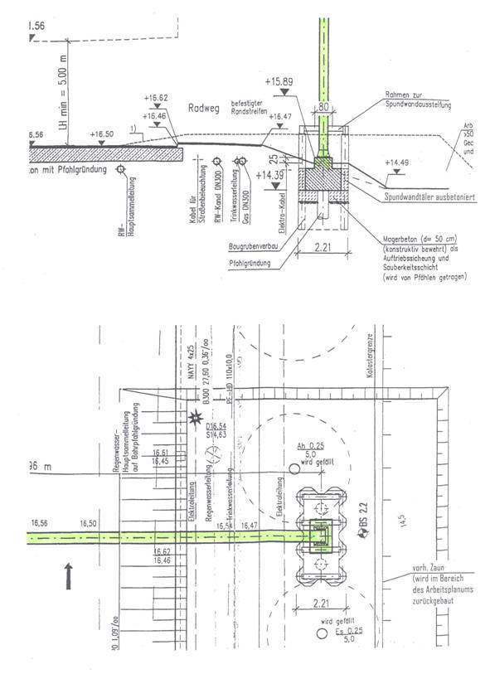

Figure 7. Original design concept with drilled shafts installed

in to the highway embankment

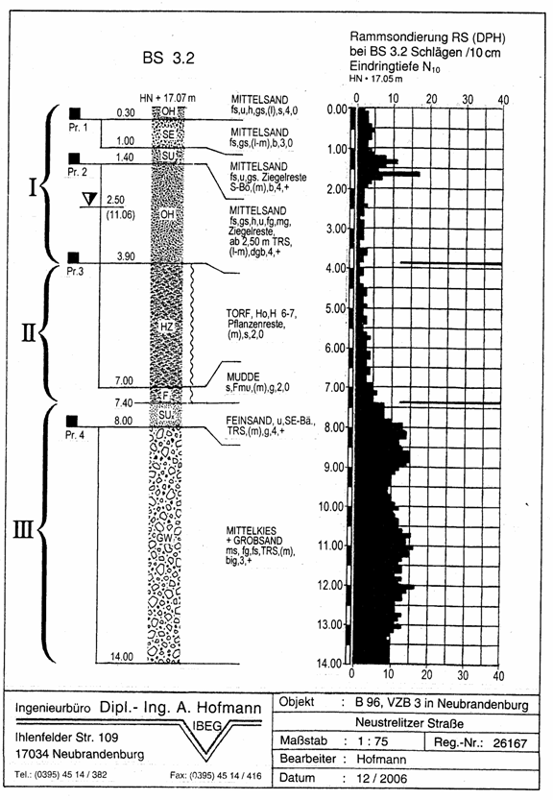

Figure 8. Foundation Site for traffic sign gantry

3. Mono Micropiles with Permanent shear casing additional Horizontal loading up to 5% of vertical loading.

## 3.1. Load test results:

Usually mono-micropiles are said to be loaded by axial loads only, compression or tension.

Occasionally mono-micropiles can be exposed to additional load cases such as horizontal loads, shearing or eccentric loads.

To counter these additional loads TITAN micropiles can be protected and reinforced at the head of the micropile with a plastic, smooth HD-PE tube or a steel tube, both about 0.5m in length. The main benefits of this system is the protection of the grout body at the top of the micropile, during pile cap construction and the protection of the hollow bar from potential cracking caused by eccentric loading.

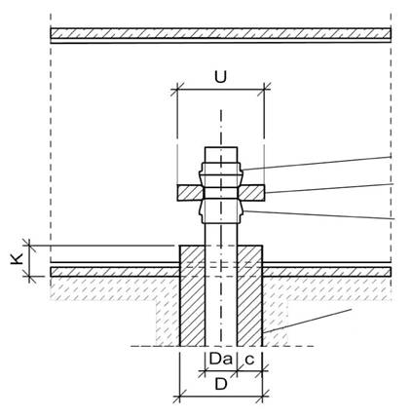

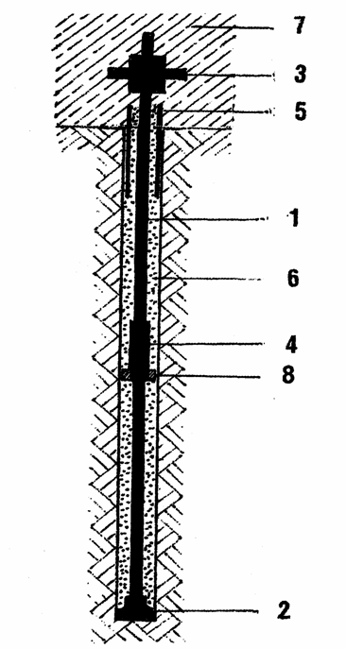

**1** Load bearing element –

hollow–core bar

**2** Drill bit

**3** Anchorage

**4**  Coupler

**5**  Pile neck protection tube

**6** Cement grout

**7** Structure

**8** Spacer

Spherical collar nut

Headplate

Spherical collar nut

Pile neck protection tube

Steel S 235 JR

K = 100 mm

Figure 9. Design of pile head according to

National Technical Approval No. Z-34.14-209

This system has been used on mono-micropiles on several different applications. One example is on the foundations of avalanche protection barriers. A larger diameter steel tube or permanent shear casing was installed to increase the flexural stiffness and horizontal load capacity of the pile.

Now, for the first time Prof. Herrmann of the University of Siegen and I have examined load tests results to determine the optimum diameter and length of the permanent steel shear casing.

Figure 10 - 13

* Show the different sand layers and the cone resistance (qc) results of CPT tests.
* In total 2 x 3No. TITAN 40/20 micropiles and 2 x 3No. TITAN 73/53 micropiles were installed, each 10m in depth and with three different steel shear casings.
* All steel shear casings were 1.5 m in length, similar to the load tests carried out by Schnabel Engineering Consultants Inc. and TEI Rock Drills in Montrose, USA in 2011.

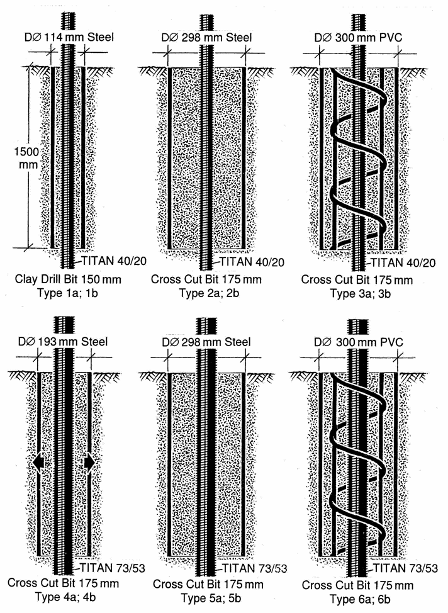

Figure 10. Six test cases - Micropiles with permanent steel shear casing

at the top of the pile

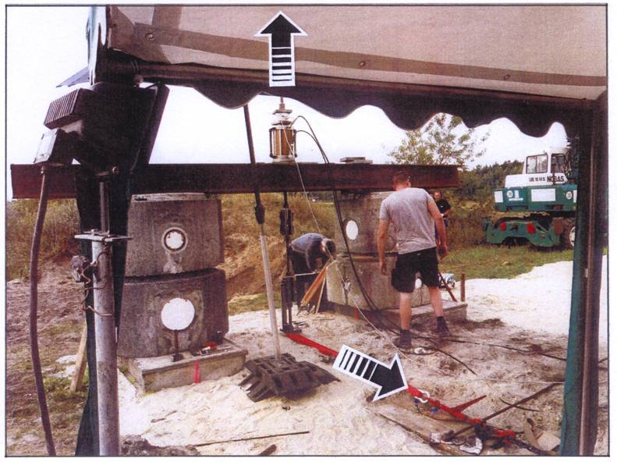

**vertical tension load**

**horizontal load**

Figure 11. Test site showing a Mono-Micropile with a permanent shear casing designed to take additional

horizontal loading of up to 5 % of the vertical load

*Testfield University of Siegen, Prof. Dr. Ing. Herrmann*

## Figure 11Figure 10

Figure 12.1. Various sand layers Figure 12.2. Cone resistance (qc)

CPT-test

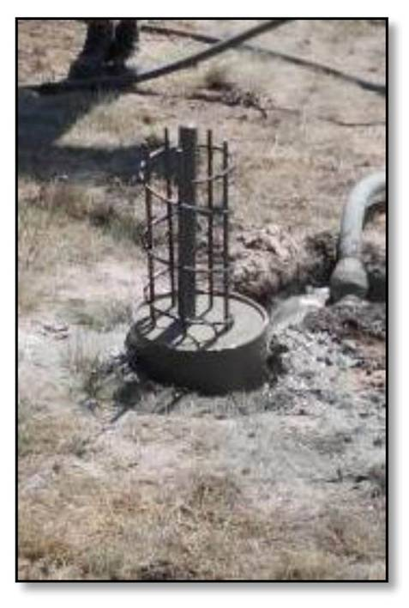

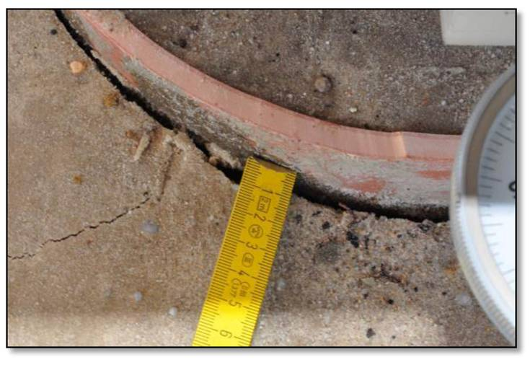

Figure 13.1. Pile head with Figure 13.2. Cracks behind PVC tube

D ∅300 mm PVC and steel D = 300 mm reinforcement

## 3.2. Summary of test results:

* The horizontal load capacity of a mono-micropile is increased by a factor 4 when a permanent 1.5m shear steel casing is used on top section of the micropile. Additional horizontal loads of up to 5% of vertical load are achieved (Figures 14 to 19).

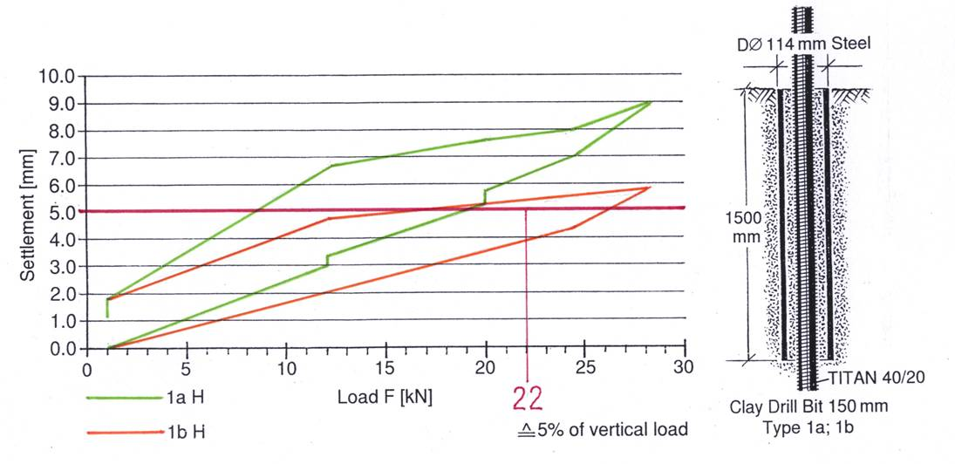

Figure 14. Pile Type 1 - Horizontal Load v Settlement Curve

* Type 2 and type 5 Mono-micropiles (Fig. 15 and Fig. 18) which were installed with a 1.5m x 298mm diameter permanent steel casing, performed the best in terms of horizontal load and minimal settlement.

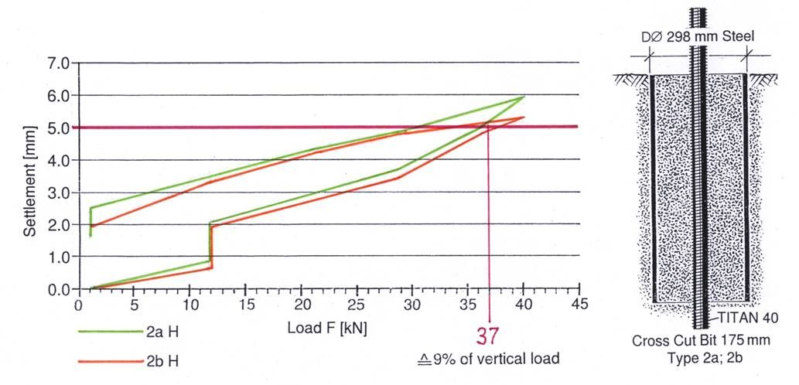

Figure 15. Pile Type 2 - Horizontal Load v Settlement Curve

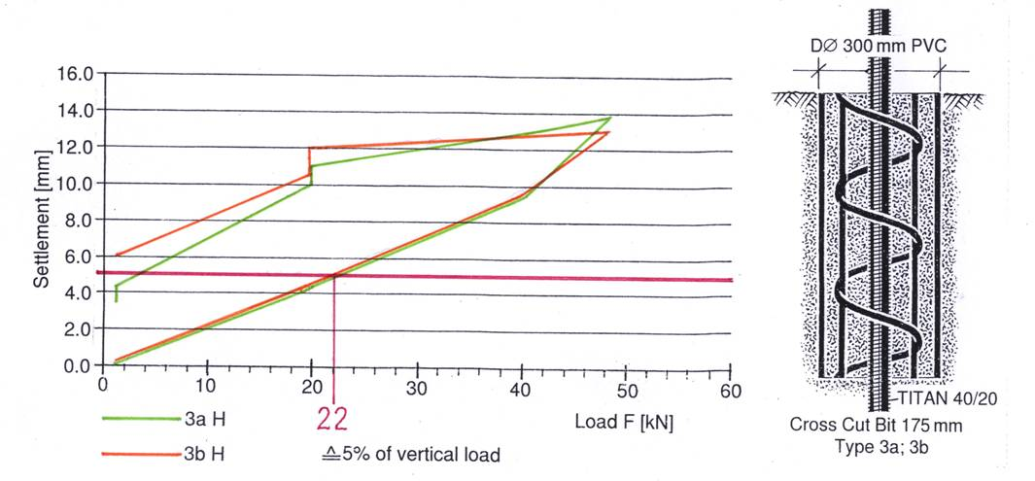

Figure 16. Pile Type 3 - Horizontal Load v Settlement Curve

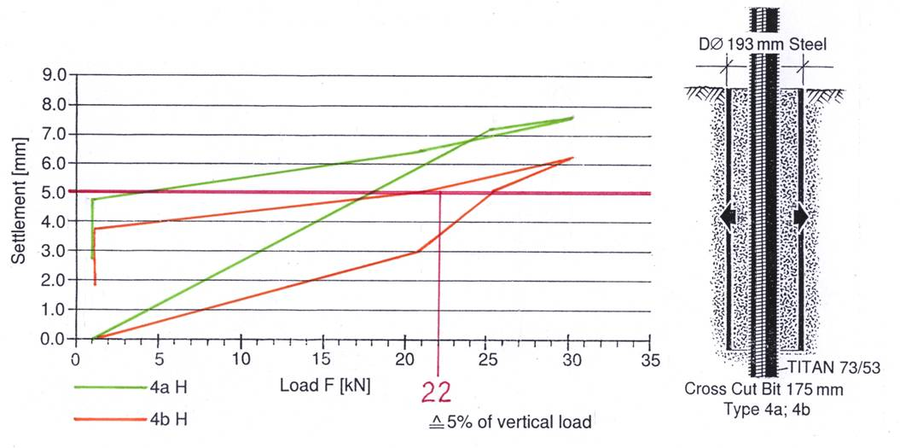

Figure 17. Pile Type 4 - Horizontal Load v Settlement Curve

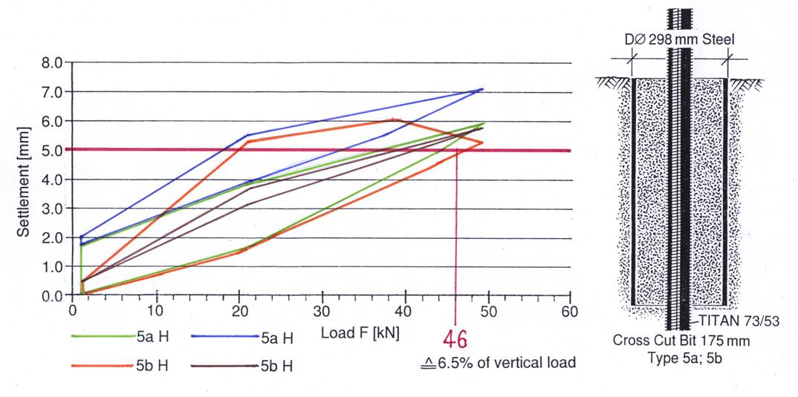

Figure 18. Pile Type 5 - Horizontal Load v Settlement Curve

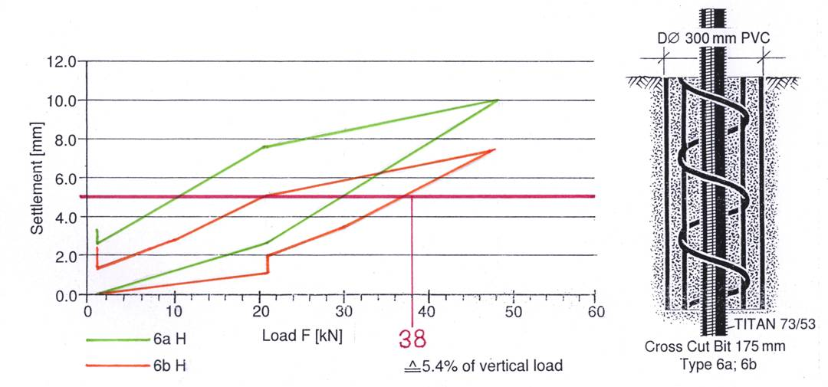

Figure 19. Pile Type 6 - Horizontal Load v Settlement Curve

* Results of the horizontal load and horizontal settlement confirm the onsite bedding modulus - estimated by EAB, table 102 (Fig.20- 21).

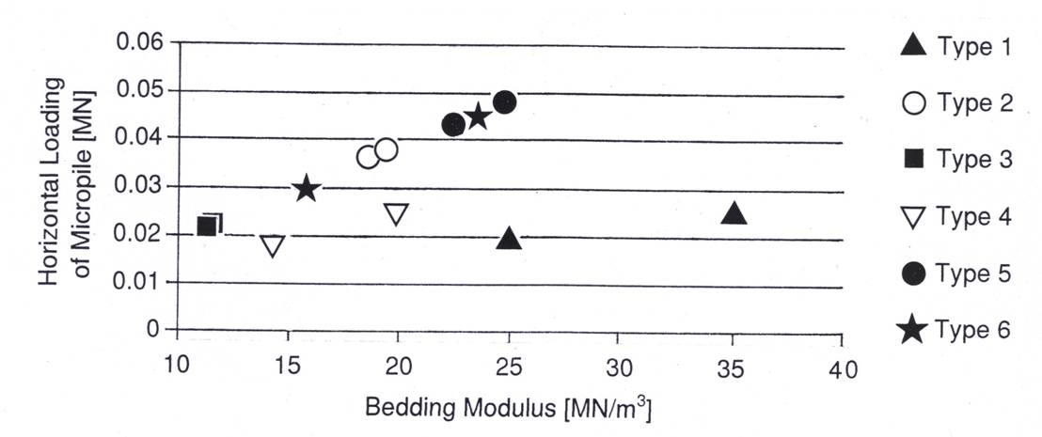

Figure 20. Bedding Modulus for 5mm horizontal settlement of the micropile head

Bedding Modulus Ks is determined by:-



H = horizontal load

A = contact surface D x 1,5 m

S = 5 mm settlement

Back analysis carried out on the results of the horizontal load (H) and horizontal settlement confirms the estimated values according to table EAB 102-1. Recommendations of working group DGGT - EAB 2012. (Baugruben).

Table 1. EAB 2012 Bedding modulus below the water table

|  |  |  |  |
| --- | --- | --- | --- |
| **Granular Soil**  **Consolidation** | | | |
| **loose** | **medium dense** | **dense** | **very dense** |
| 1 - 4 MN/m³ | 3 -10 MN/m³ | 8 - 15 MN/m³ | 12 - 20 MN/m³ |

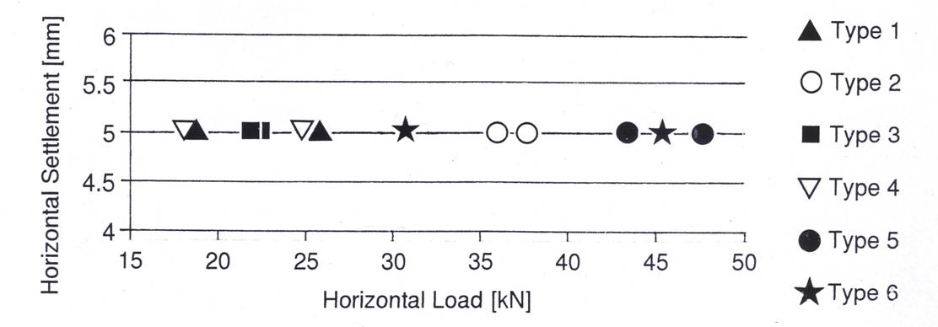

Figure 21. Horizontal load for maximum 5 mm horizontal Settlement

4. Micropile groups in very soft clay layers *(Cu = 10 kN/m²)* to support vagabonding horizontal loads in the range of 10 kN.

**4.1. Load test results University of Hannover Prof. Blümel Akz. 10/90**

When installing driven piles the ground becomes compacted as a result of the installation process. So much so that when driven piles are installed at close centres, it is said, that to “drive the last pile” is nearly impossible.

What happens with a group of micropiles that are installed at close centres?

Research was compiled from micropile foundations for transmission pylons founded on very soft clay layers, close to the delta of large rivers or in rice fields.

Horizontal loads, caused by wind, with changing directions, are called “vagabonding horizontal loads”. The question is, can a group of micropiles as a unit, support horizontal vagabonding loads, independent of the configuration of the micropiles as a group.

The CPT - diagram (Figure 22) shows 10m very soft clay layers with 100 to 500  and a high water table.

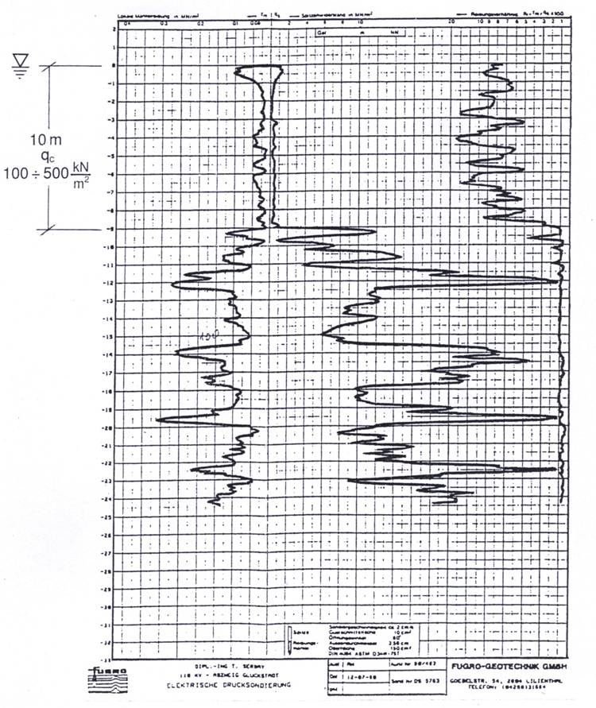

Figure 22. CPT - Sondation

Two groups of micropiles were installed within these soft layers:

Group 1 A total of 3 x TITAN 73/53 (Fig. 23)

Group 2 A total of 6 x TITAN 30/11

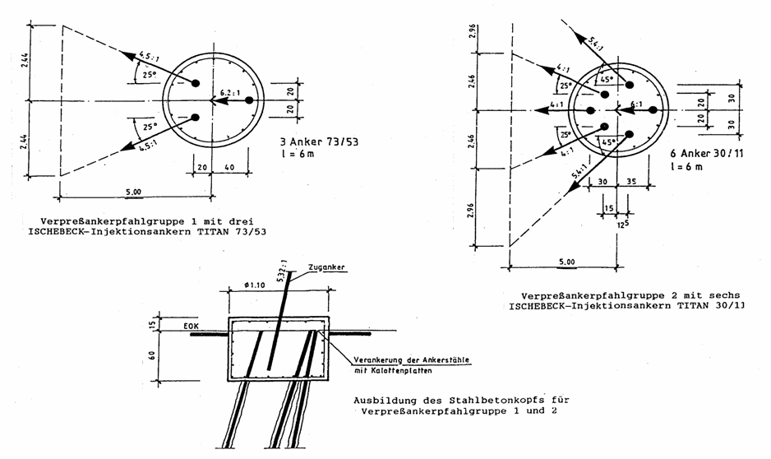

Micropile group 1 with

3 micropiles TITAN 73/53

Micropile group 2 with

6 micropiles TITAN 30/11

Figure 23. ABB Leitungsbau Mannheim, Vertical and horizontal

Tension tests with micropile group 1 and 2

*University of Hannover, Prof. Dr. Ing. Blümel*

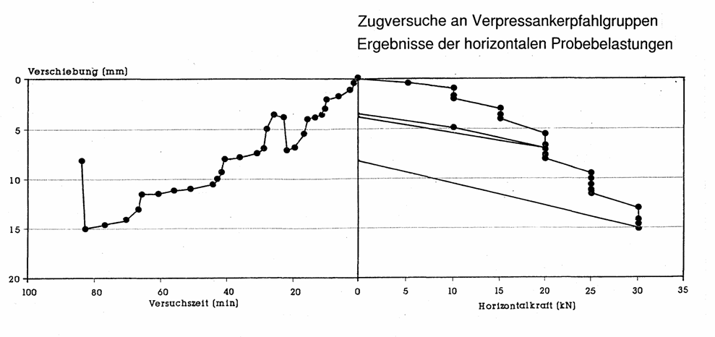

horizontal settlement [mm]

Tension test with micropile group 1

Horizontal Load / settlement curves.

Time [mm]

horizontal load [kN]

Figure 24. ABB Leitungsbau Mannheim, Time-settlement curve

and horizontal load-settlement curve for micropile group 1

*University of Hannover, Prof. Dr. Ing. Blümel*

Both groups were initially tested in compression only.

Results: ultimate loads

Group 1 189 kN

Group 2 220 kN

Afterwards the horizontal loads were tested:

Group 1 15 kN

Group 2 15 kN

The results found that the elastic and plastic deformations are similar.

## 4.2. Summary:

Micropile groups in very soft clay layers () are able to support vagabonding, small horizontal loads in the range of 10kN

5. Offshore application of micropiles - reinforcing the bearing capacity of driven monopiles against horizontal loads and scouring

Large diameter steel tubes or monopiles are often used for offshore foundations for dolphins, seamarks and harbour construction. Typically monopiles are vibrated to their design depth, with less environmental impact, using much smaller equipment. They are vibrated to refusal with hydraulic powered vibrators. One or more self synchronized vibrators are used and clamped hydraulically to the steel tube wall. Vibration is stopped as soon as there is an increased resistance caused for example by boulders. After vibration, a minimum of three inclined micropiles are drilled, if possible down to bedrock. Afterwards the steel tube is filled with concrete to enable the load transfer from the monopile to the micropiles.

Installing three drilled micropiles in conjunction with the monopile improves the horizontal load performance of the system compared with the driven pipe pile (allows for only bending and bedding).

Advantages of this technology:

* Smaller and lighter equipment
* Pull out resistance of the micropiles can be determined before concreting
* Faster installation
* Stiffer bearing capacity than driven pipe piles (Figure 25 and 26)

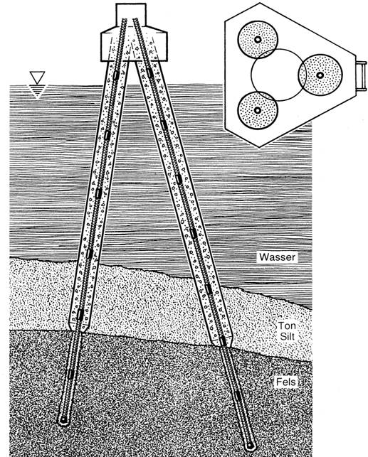

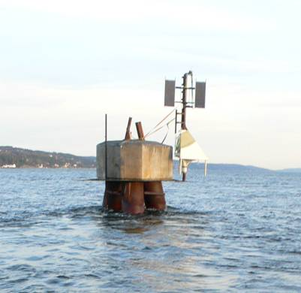

water

clay

silt

deposits

bedrock

Figure 25. Navigational Aid founded on driven pipe piles, which are

reinforced with TITAN 73/45 micropiles

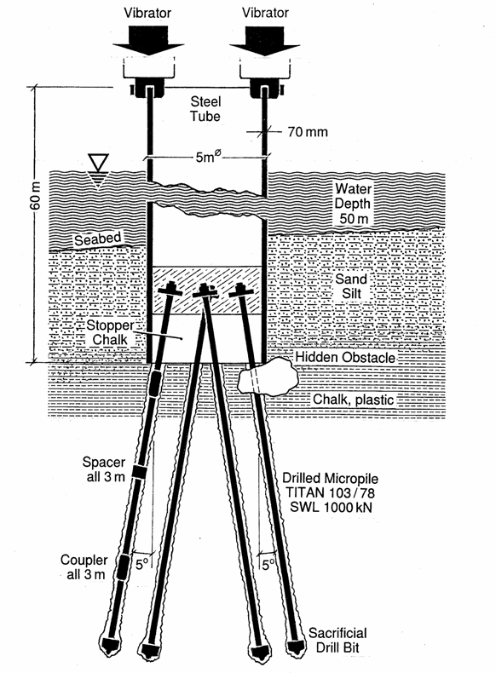

Figure 26. Vibrating and micropiling replaces monopiles

* A faster installation

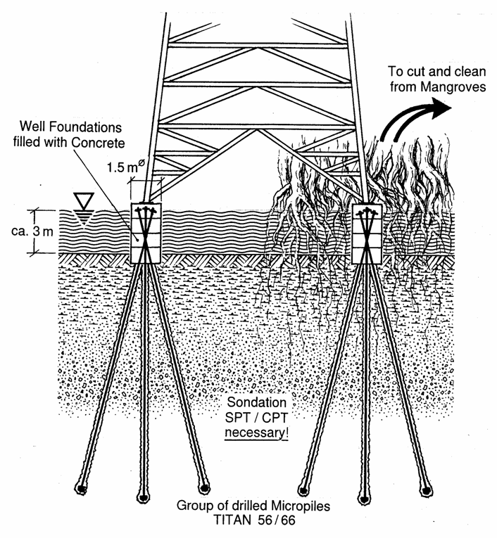

Figure 27. Transmission Pylons for 34.5 kV

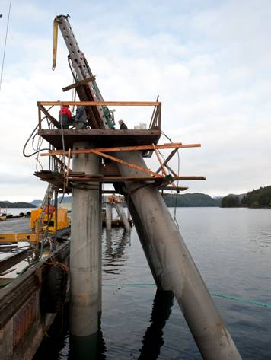

Figure 28. Dolphins from driven pipe piles – reinforced

with drilled TITAN 103/51 micropiles

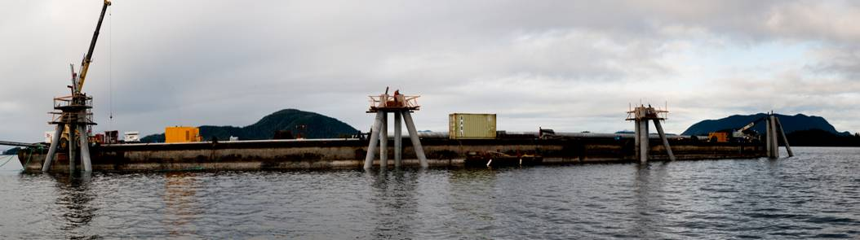

Figure 29. Jetty with Dolphins - reinforced with drilled TITAN 103/51 micropiles

6. Conclusions

Other than with drilled shafts or driven piles micropiles are very sensible against additional lateral loads and bending. Micropiles are capable axial compression or tension loads.

Standard foundation design with micropiles is based on the well-known concept of raft-pile foundations. A stiff raft, which balances and distributes only axial loads according to the axial stiffness E x A of the micropiles.

**Modelling and analysis of simple raft-micropile-foundation for highway sign gantries is presented in detail**

Beside the most usual raft-micropile design four special applications are presented:

* **Precast footing for solar-carports**

Placed on the ground and fixed by two micropiles to balance horizontal impact loads, freezing loads etc.

* **Micropiles, reinforced by a pile neck protection tube**

(lost steel casing 300 mm diameter, 1.5 m long) to support horizontal loads in the range of min. 5 % of the axial load.

* **Micropile groups in very soft clay layers**

(undrained shear strength $Cu=10\frac{kN}{m^{2}}$) to support “vagabonding” horizontal loads as a group in the range of $H=10 kN$ (SWL).

* **Offshore application of micropiles**

Used for a reinforcement of driven monopoles, well rings etc. to improve the loading capacity, the ductility and performance of the foundation.