USING ENERGY MICROPILES IN UNDERPINNING PROJECTS – THROUGH HOLES IN LOAD TRANSFER STRUCTURES
Rauli Lautkankare, Vesa Sarola, Heli Kanerva-Lehto

ABSTRACT
The biggest challenge in the utilization of energy micropiles in underpinning projects is related to the through holes for geothermal energy collector pipes in the load transfer structures. In the FIN-C2M project (Case 2 Micropile Research Project in ISM collaboration) several technical solutions were studied and the most suitable load transfer structure cases for the use of energy micropiles were defined. There are thirteen known load transfer structure cases and energy micropiles can be used with nine of them. In five of the cases, the through holes for collector pipes can be made as found in new buildings. In the other four cases, where pretensioning is achieved by jacking directly above the micropile, the construction of through holes needs further development . There are already some possible solutions and the challenge is to bypass the jack.

USING DEEP FOUNDATIONS AS GROUND HEAT COLLECTORS
The first projects where openings in pile casing were used to install heat exchange piping are from the early 21st century. The research for energy piles started the late 1990’s. (Bourne-Webb & Amatya & Soga, 2009, 315-316; Ma & Grabe, 2009, 334.) All the cases have been large new construction projects where the load bearing soil layer has been several metres beneath the surface. These projects include Zurich Airport terminal E and Main Tower in Frankfurt (Pahud & Hubbuch 2007; Ebnöther 2008).
In this article the recovery of ground heat in underpinning projects is studied. The focus is on load transfer structures transferring the load from old to new foundations, the through holes of ground heat collector piping and their technical implementation in these load transfer structures. (Lautkankare & Kanerva-Lehto & Sarola, 2014a.) This study is part of FIN-C2M project. FIN-C2M project is part of Case 2 Micropile Research Project in International Society for Micropiles collaboration.
Current technology and research results make the use of energy piles possible in certain cases. There are altough limitations and possibilities related to energy piles that need to be taken into account when estimating the energy production investments and life cycle of buildings. Two such limitations are mean distance between the piles and the length of piles. This is vital for ensuring the ground thermal balance. (Pérez Cervera, 2013).

If the underpinning project will be carried out in any case, it might be reasonable to consider energy piles. Also hybrid energy micropiles are one possibility as well (Lautkankare & Kanerva-Lehto & Sarola, 2014b). Any piles large enough for the ground heat collector piping are suitable as energy piles. These include steel pipe piles and concrete piles with holes. Of these two only steel pipe piles have been used in underpinning projects in Finland (Lehtonen 2011).

ENERGY PILES AND LOAD TRANSFER STRUCTURES
One of the challenges using energy piles in underpinning projects is the load transfer structures, specifically the through holes for ground heat collector pipes. In the FIN-C2M project this is studied on the basis of load transfer cases by examining which types of load transfer structures are suitable for energy piles (Lautkankare & Kanerva-Lehto & Sarola, 2014a). There are thirteen recognized load transfer cases (Lehtonen, 2011) and according to the studies nine of these are suitable for use with energy piles.
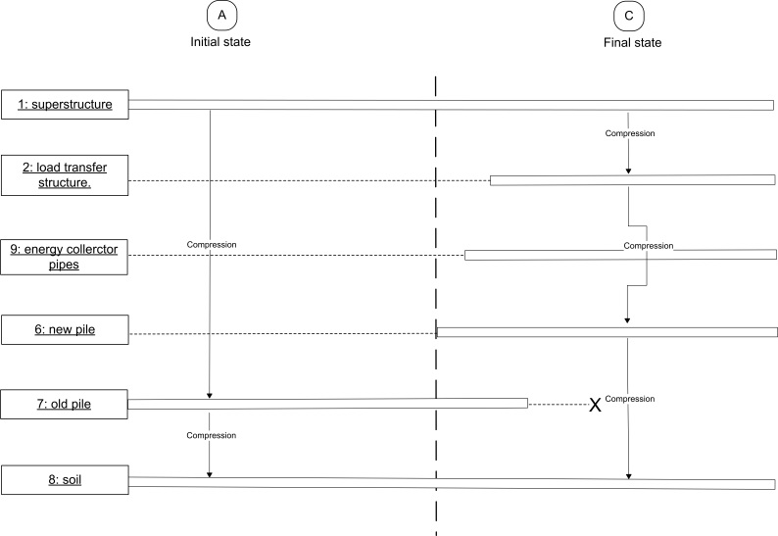
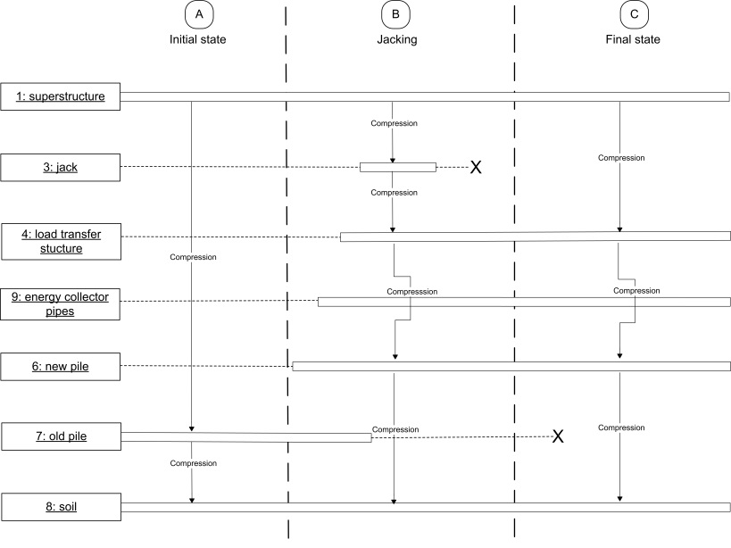
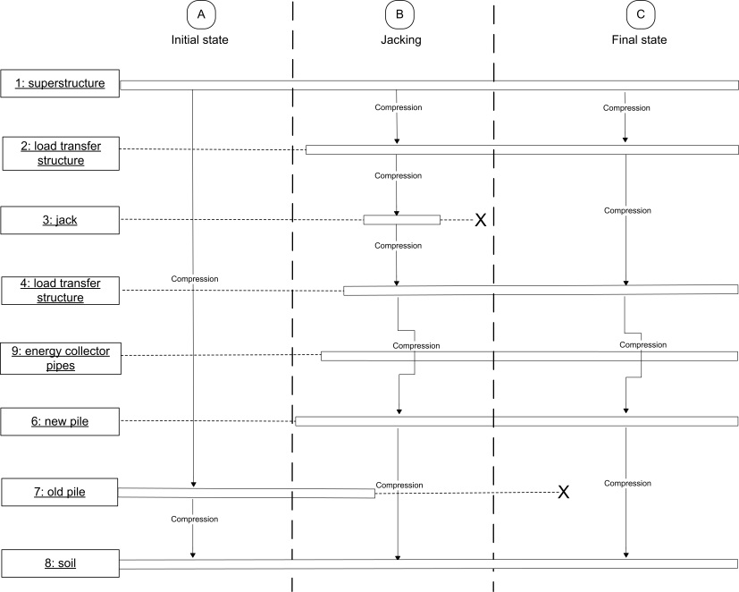
CASE 2
CASE 3
CASE 5

Figure 2. Load transfer cases where the ground heat collector pipes can be led directly through the pile cap. Cases 2, 3 and 5. (Lautkankare & Kanerva-Lehto & Sarola, 2014.)
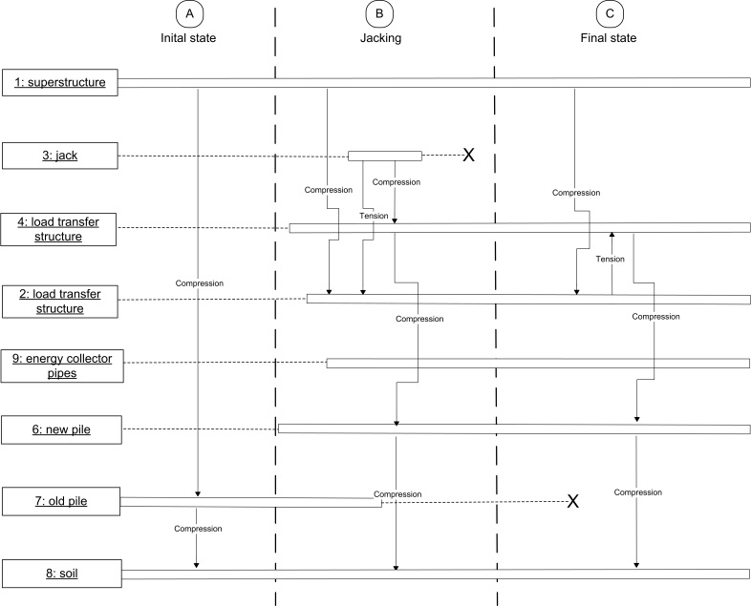
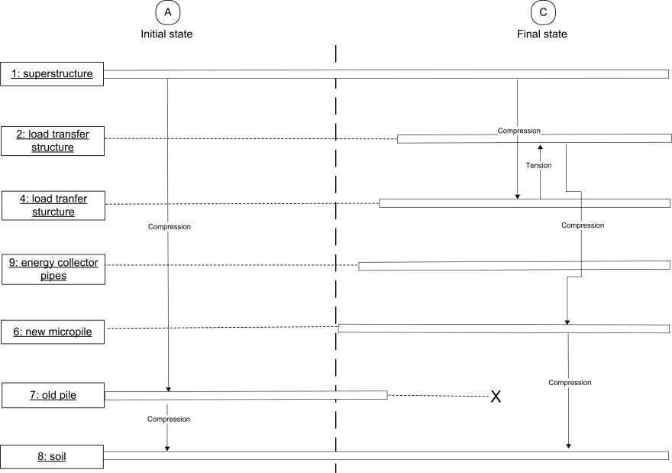
CASE 8

CASE 7

Figure 3. Load transfer cases where the ground heat collector pipes can be led directly through the pile cap. Cases 7 and 8. (Lautkankare & Kanerva-Lehto & Sarola, 2014.)

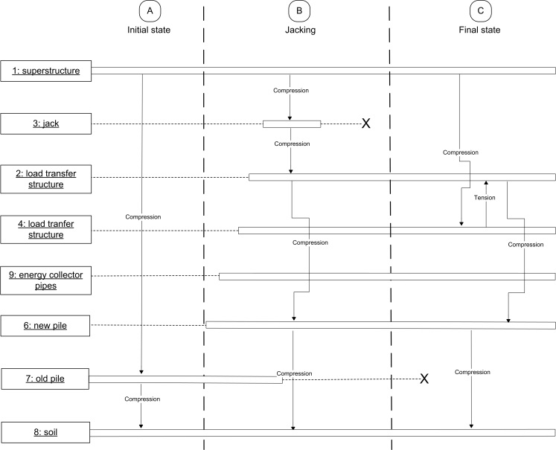
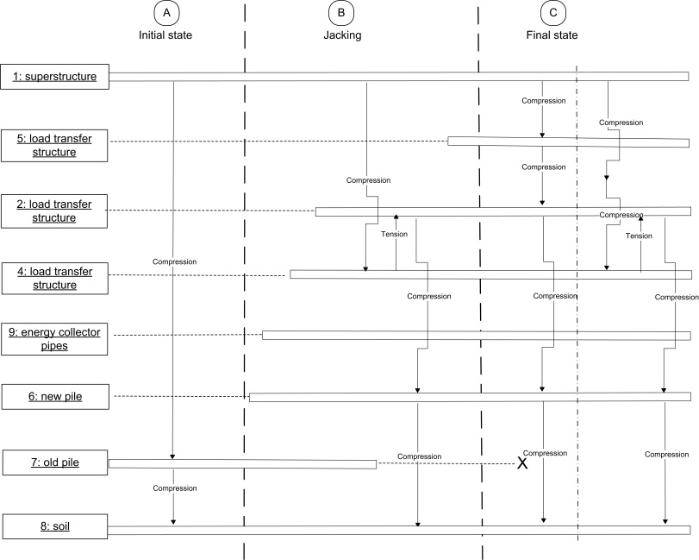
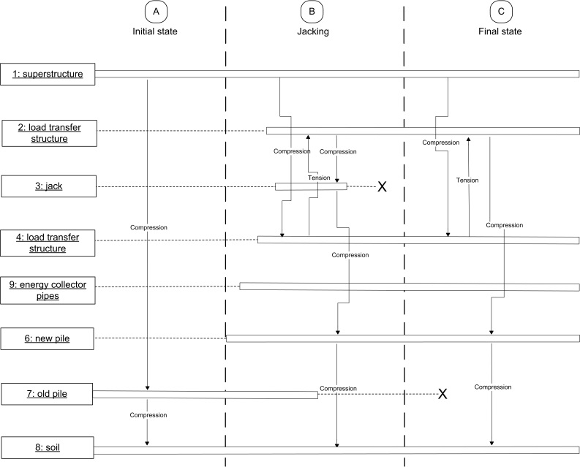
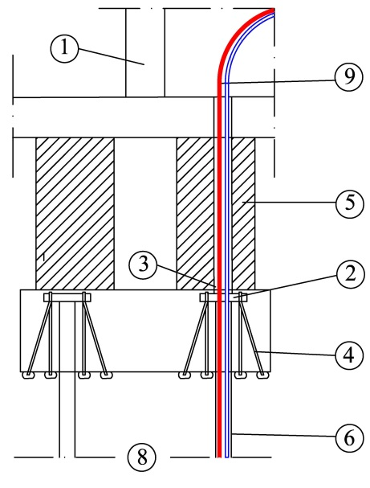
CASE 11

CASE 10
CASE 9

Figure 4. Load transfer cases where pipes have to be led out through the side of the pile before the pile cap or to use the special jack system. Cases 9, 10 and 11 (Lautkankare & Kanerva-Lehto & Sarola, 2014a.)
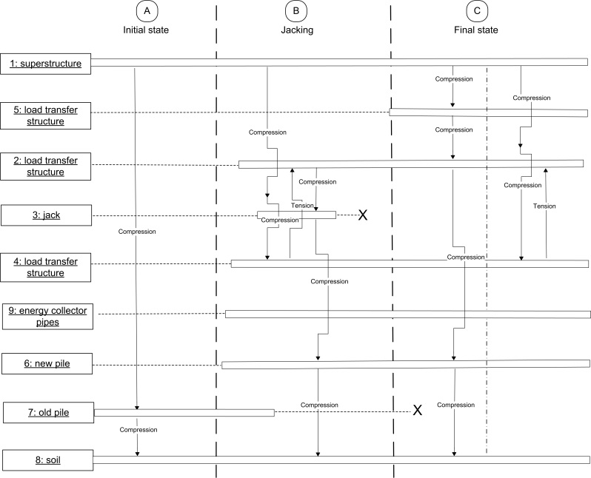
CASE 12

Figure 5. Load transfer cases where pipes have to be led out trough the side of the pile before the pile cap or alternatively use the special jack system. Case 12. (Lautkankare & Kanerva-Lehto & Sarola, 2014a.)

As a rule energy piles can not be used with jet grouted columns. All things considered the through holes for ground heat collector pipes need to be designed in case by case basis even when using types of load transfer structures that are immediately compatible with energy piles. Regardless of that, some general principles can be presented. (Lautkankare & Kanerva-Lehto & Sarola, 2014a.)
In five of the load transfer cases the ground heat collector pipes can be led directly through the pile cap. With reinforced concrete beams or encasings it is enough to case the pipes. Implementations in new constructions are based on this technique. In load transfer structures where a steel beam is centered right on top of the pile cap, one possibility is to lead the collector pipes from the pile through the load transfer structure by using a double-web steel beam and leading the pipes through the holes in flange or by using two or more steel beams so that the pipes are led through a gap left directly on top of the pile. (Lautkankare & Kanerva-Lehto & Sarola, 2014a.)
If a solution where a steel beam is right on top of the pile is desired, the pipes can be led out trough the side of the pile before the pile cap. Same principle can be used in structures where the pile pretension is achieved by jacking directly on top of the pile cap. It has to be remembered also that a through hole can weaken the load bearing capacity of the pile, and thus the pile might need reinforcement around it. (Lautkankare & Kanerva-Lehto & Sarola, 2014a.)

Table 1. Suitability for energy piles of the load transfer cases.
Load Transfer Case | Suitability for Energy Pile | Justification
Case 1 | No | Energy piles can not be used with jet grouted columns.
Case 2 | Yes | The ground heat collector pipes can be led directly through the pile cap
Case 3 | Yes | The ground heat collector pipes can be led directly through the pile cap.
Case 4 | No | Energy piles can not be used when the jack is between the pile and the load transfer beam.
Case 5 | Yes | The ground heat collector pipes can be led directly through the pile cap.
Case 6 | No | Energy piles can not be used when the jack is between the pile and the load transfer beam.
Case 7 | Yes | The ground heat collector pipes can be led directly through the pile cap.
Case 8 | Yes | The ground heat collector pipes can be led directly through the pile cap.
Case 9 | Yes | The ground heat pipes have to be led out of the side of the pile before the pile cap or alternatively use the special jack system. The system needs further development.
Case 10 | Yes | The ground heat pipes have to be led out of the side of the pile before the pile cap or alternatively use the special jack system. The system needs further development.
Case 11 | Yes | The ground heat pipes have to be led out of the side of the pile before the pile cap or alternatively use the special jack system. The system needs further development.
Case 12 | Yes | The ground heat pipes have to be led out of the side of the pile before the pile cap or alternatively use the special jack system. The system needs further development.
Case 13 | No | Anchor in the middle of the pile. The system needs further development.

INSTALLATION OF GROUND HEAT COLLECTOR PIPES INTO PILE
When the heat collectior pipes are fed into the energy pile, the procedure and techniques is a combination of installing pipes into heat wells and installing piles. In regarding the filling material, in Finland piles are typically filled with concrete. The use of concrete is supported by its good thermal conductivity and the way it bonds with steel pile to form a load-bearing composite structure. The selection of filling material has a great significance in the long run as the increased thermal conductivity affects the energy gain positively throughout its life cycle. Then why is concrete not used always although it has better thermal conductivity than water? Water filling has its own advantages as the pipes can be replaced more easily if they break or reach the end of their life cycle. (Lautkankare & Kanerva-Lehto & Sarola, 2014a).
As pipe installations performed alongside underpinning projects are usually done in cramped basements, the chance of breaking the pipes is much higher when compared with the usual piping of heat wells outside the actual building. Pipes can also break due to other causes than weakening by age. During transportation, moving at the construction site, storage or installation, precision is important as plastic pipes scratch easily and are then unusable. Nowdays constructions are generally designed with 100-200 year service life and the heat collectior pipes may well need replacement during that period. (Lautkankare & Kanerva-Lehto & Sarola, 2014a.)

CONCLUSIONS
As a result of this research it was found possible to find technical solutions to combine energy micropiles and groud heat collector pipes with nine load transfer structure cases. In five cases the work can be done as in new building. There is also a special solution if steel beams have to used. In four cases the pipes have to be led out trough the side of the pile before the pile cap or alternatively to use special jack system. The system allows installing collector pipes right after piling phase and jacking after piping without breaking the pipes.
There are certain challenges and questions, especially concerning the installing process, that have to be researched and tested. The energy micropiles are one solution to produce heat from the ground and furthermore one way to reduce the greenhouse gas emissions in energy production.

REFERENCES
Bourne-Webb, Peter & Amatya, Binod & Soga, Kenichi. (2009). A Framework fo Understanding Energy Pile Behaviour. Darmstadt Geotechnics No. 18. International Conference on Deep Foundations – CPRF and Energy Piles. 15.5.2009. Frankfurt am Main. Institute and Laboratory of Geotechnics, Darmstadt, Germany. 315-324.
Ebnöther, Alfons. (2008) Energy Piles, The European Experience. GeoDrilling 2008 Confernce. <http://www.gshp.org.uk/conference2008.html>
Lautkankare, Rauli & Kanerva-Lehto, Heli & Sarola, Vesa. (2014a). Energy piles in underpinning projects. DFI Journal, Volume 8, Issue 1, April 2014. Deep Foundation Institute.
Lautkankare, Rauli & Kanerva-Lehto, Heli & Sarola, Vesa. (2014b). Hybrid energy piles in underpinning projects. IWM International Workshop on Micropiles, June 11-14 2014, Krakow, Poland. Submitted 17.1.2014.
Lehtonen, Jouko. (2011). Underpinning project; owners’ views on technology, economy and project management. Aalto University publication series, Doctoral dissertations 80/2011. Espoo: Aalto University.
Ma, Xiaolong & Grabe, Jürgen. (2009). Influnence of Groundwater Flow on Efficiency of Energy Piles. Darmstadt Geotechnics No. 18. International Conference on Deep Foundations – CPRF and Energy Piles. 15.5.2009. Frankfurt am Main. Institute and Laboratory of Geotechnics, Darmstadt, Germany.
Pahud, Daniel & Hubbuch, Markus. (2007). Measured Thermal Performances of the energy Pile system of the Dock Midfield at Zürich Airport. Proceedings European Geothermal Congress 2007. <http://www.geothermal-energy.org/pdf/IGAstandard/EGC/2007/195.pdf>
Pérez Cervera, Carles. (2013). Ground thermal modelling and analysis of energy pile foundations. Master’s Thesis. Espoo: Aalto University.

Lecturer, MEng, Turku University of Applied Sciences, rauli.lautkankare@turkuamk.fi
Planner, BEng, Senior Consultant, glapas@pp.inet.fi
Project Researcher, MEng, MA, Turku University of Applied Sciences, heli.kanerva-lehto@turkuamk.fi

