12th International Workshop on Micropiles
June 11th to 14th, 2014
Krakow, Poland

Foundation on micropiles of SCR-installation at Siekierki Power Plant in Warsaw

Przemysław Wójtowicz

Keller Polska Sp. z o.o.,ul. Poznańska 172, 05-850 Ożarów Mazowiecki, Poland
E-mail: pwojtowicz@keller.com.pl

ABSTRACT

The development plan of the Siekierki Coal Combustion Plant in Warsaw included modernization of the existing gas treatment system with a new Selective Catalytic Reduction installation (SCR). Because of space limitations within this facility, the new installation had to be placed between the existing turbine set, electro filter gas ducts and catalytic reactors, lifted 35 meters above ground level. Consequently, a unique supporting structure founded on micropiles was necessary.
Micropile installation locations were dictated by access restrictions and subsurface obstacles. A number of elements crucial to power plant operations, such as cable ducts, dredging and sewer, were located underground and could not be shut off or relocated. Placement of micropiles needed to be designed around these elements. Restricted headroom, combined with a maximum allowable settlement difference of 5 millimetres between the footings necessitated a special geotechnical solution. Taking into account the confined space and the ability to drill in variable directions and angles to avoid collisions with underground elements, micropiles were the technology of choice.
The design calculations, comprising all possible load combinations, were carried out using Robot software. The 51N Gonar self-drilling hollow bars were chosen as optimal. In cases of hitting the unexpected obstacle, Down the Hole Hammer (DHH) was incorporated. For the entire project, 4560 lineal meters of micropiles were used and installed. Quality assessment included four static load tests.
The paper will focus on the design and execution aspects specific for this kind of project, starting from identification of the client’s needs, through the selection of the best design solution, and ending with execution and lessons learned. The main problems encountered throughout the project were: challenging conditions and load schemes, requiring sophisticated 3D analysis for the majority of the micropiles, difficult access to some of the drilling locations, and shortcomings of the self-drilling bar system.
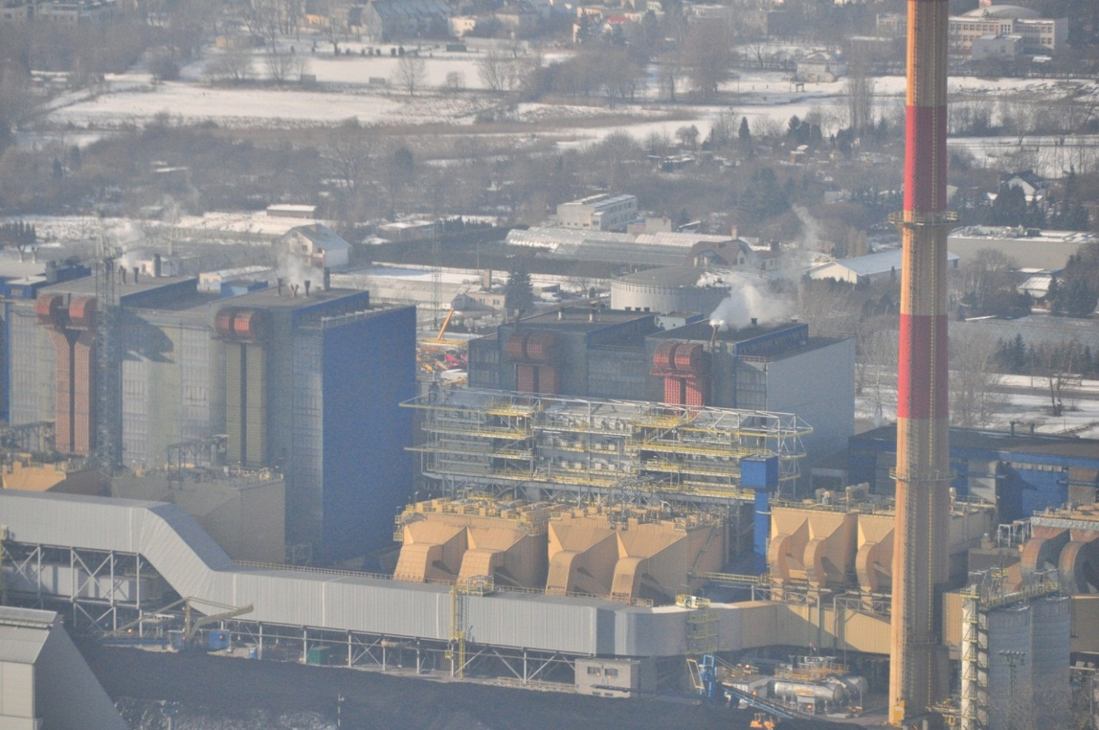
Figure 1. Aerial photo of the construction site (source M. Wójtowicz)

Problem and Solution
Coal combustion power plants are the main (over 90%) source of energy and heat in Poland. Most of them were built more than 30 years ago, utilizing old exhaust gas treatment standards. Currently, as the regulations become more strict and demand for clean air increases, the process of retrofitting plants with more sophisticated installations is on-going.
The Siekierki power plant, with the first unit opened in 1961 and last in 1978, is no exception. It is also important to notice the location: only 10km from the center of Warsaw in the urban housing area. The four power units built in late 70’s were equipped with electrofilters and desulphurization systems that have recently been modernized, but current legislation requires additional nitric oxide treatment. Aside from the standard technical issues associated with the Selective Catalytic Reduction installation (SCR) design, limited available space is also a factor. The original layout did not consider the potential for additional installations, so no room was left next to existing structures. The only possibility was to expand upward, and place the catalytic reactors above the electrofilter ducts, 35 meters above ground level. This solution introduced the new challenge of having to fit pylons and footings between existing ducts.
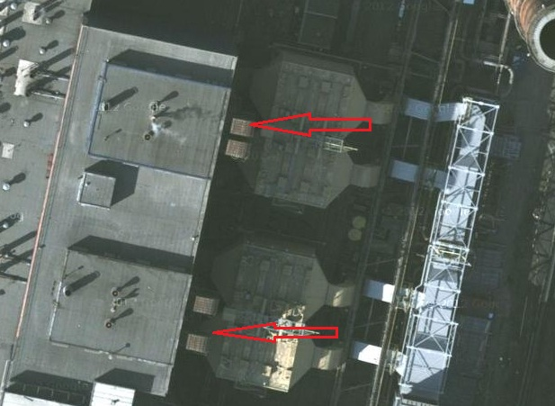
Figure 2. The possible location of SCR seen from above (source Targeo)
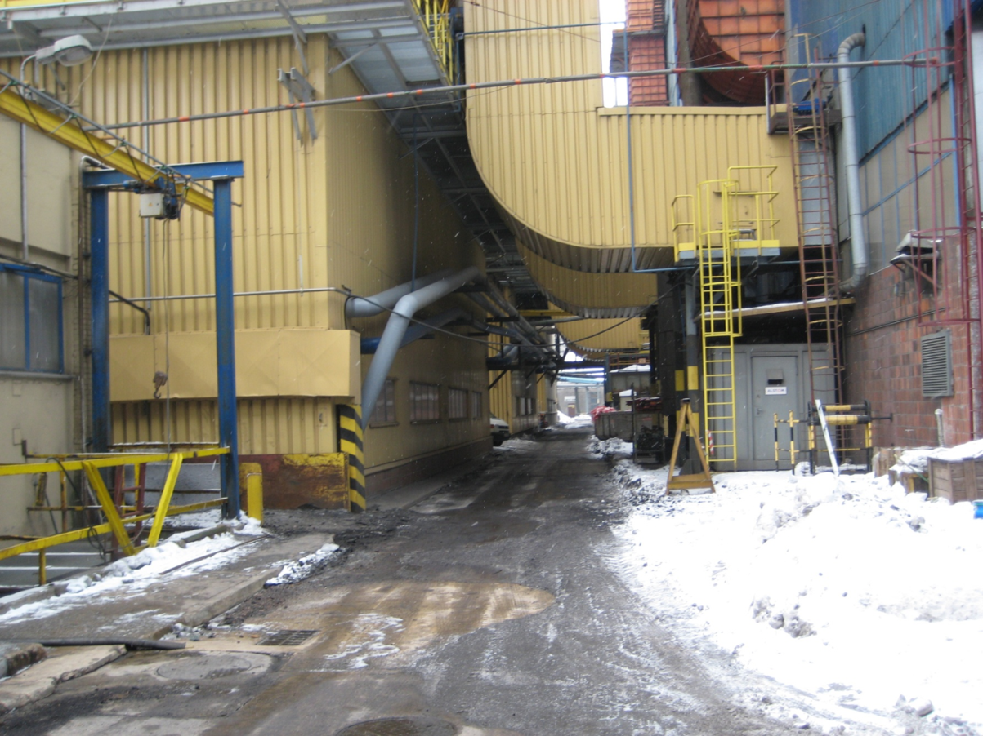
Figure 3. The same area seen from the ground level
The General Contractor (GC), required a design-build foundation solution giving supporting structure with fixed load transfer points. This part was awarded to Keller.
Multiple factors had to be taken into account, such as:
- Power units constantly running during work hours
- A number of elements crucial to power plant operations, such as cable ducts, dredging and sewer, were located underground and could not be shut off or relocated
- Limitation of available space, with overhead clearance of only 4 meters and narrow access to drilling points
- Multiple load cases: vertical forces up to 6000 kilonewtons, horizontal up to 650 kilonewtons per footing, and maximum allowable settlement difference of only 5 millimetres between the footings [6]
- Footing layout allowed to be reworked, providing it did not interfere with vital structures
- High possibility of subsurface obstacles (construction leftovers, old concrete structures not shown on plans, etc.)
- Necessity to keep vibration to minimum so as not to trigger vibration sensors that would result in disconnecting the turbines.
Considering the above-mentioned aspects, two potential solutions became clear: micropile installation or reinforced jet grouting, using the small rigs only. After some discussion with the GC, micropiles became the technology of choice.
The main reasons for this were:
- Risk of grout penetration to the existing underground structures during high pressure grouting was deemed unacceptable
- Wide Jet-Grouting body would interfere with some of the installations
- Micropiles would provide better load transfer due to ability to be installed at various angles
- Micropiles provided for easy spacing of individual elements to avoid underground structures

- Design
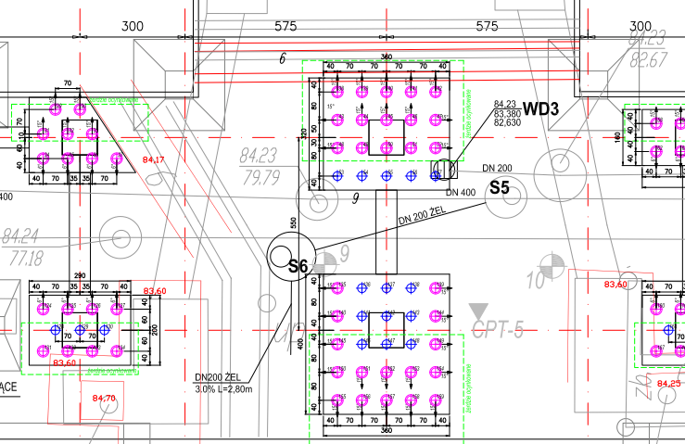
Figure 4. Part of the project showing micropile layout with visible underground installations and structures [3], [5].

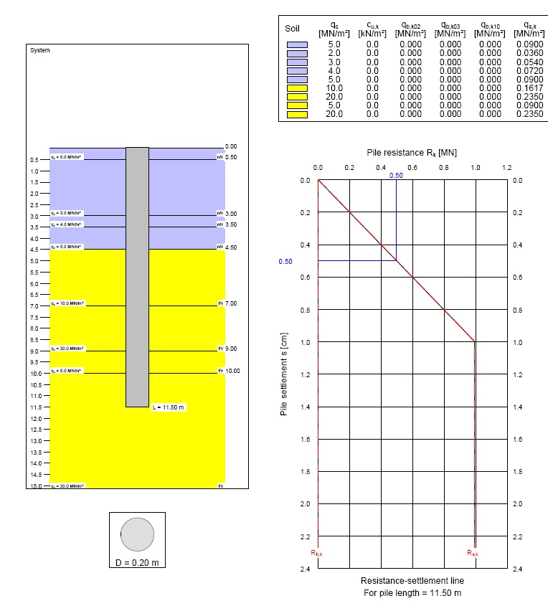
Figure 5. Micropile bearing capacity calculation using GGU
Micropile bearing capacity was determined based on CPT test investigation using GGU-AXPILE from GGU Software. The power plant is located next to a river, on alluvial sand layer, so the majority of the micropiles were installed in sand with a minority drilled into underlying clay [1], [2]. The typical soil cross-section together with soil parameters and bearing capacity calculation are visible on Figure 5.
Regarding various design, equipment and economic issues, the 51N Gonar self-drilling rods were chosen. In addition, to increase system rigidity the Ø159/4mm 3m steel pipes were added to the elements with highest horizontal loads (magenta pile colours on Figure 4).
Footing level was considered 1.5 meters below platform level. The designed length of micropiles was 11.5 meters from footing level.
To check the foundation displacements and forces in each element, the Autodesk Robot Structural Analysis v.2011 was incorporated using 3D modeling. The soil-micropiles interaction was considered by adding flexible horizontal supports based on generalized method acc. to Kosecki [4].

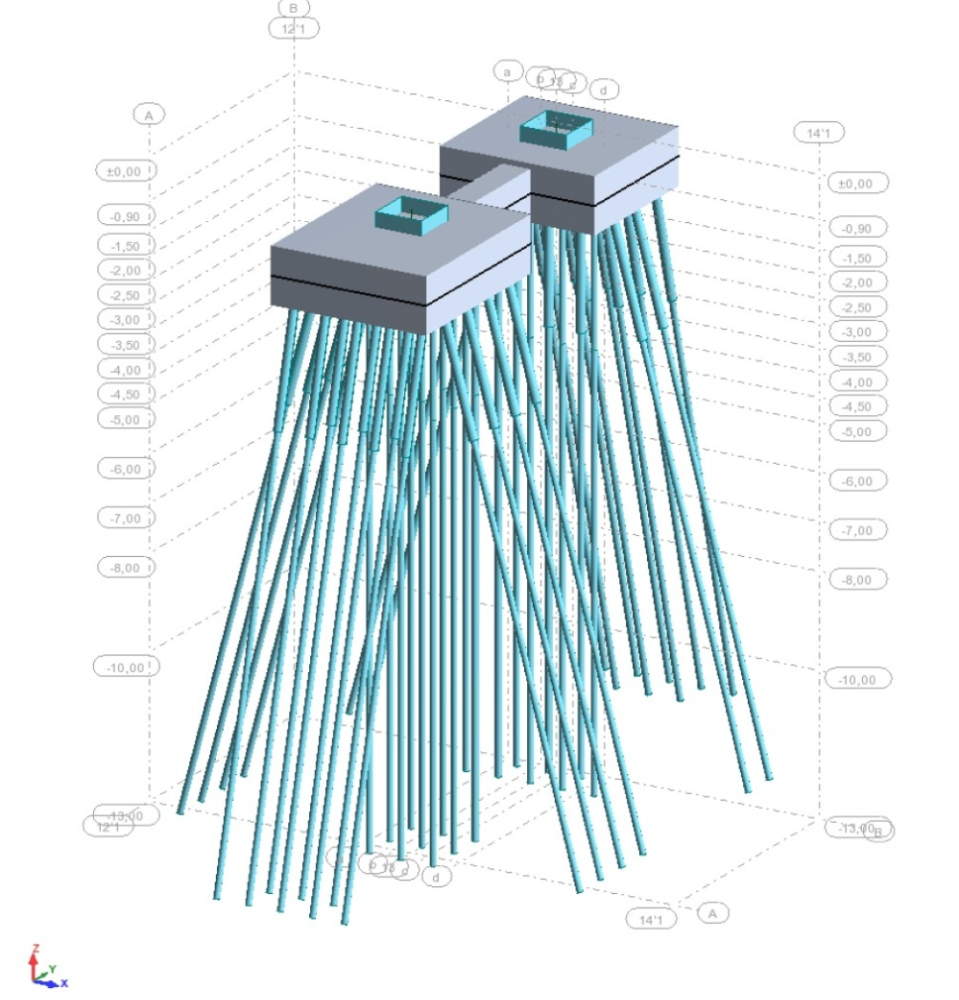
Figure 6. 3d model for calculations
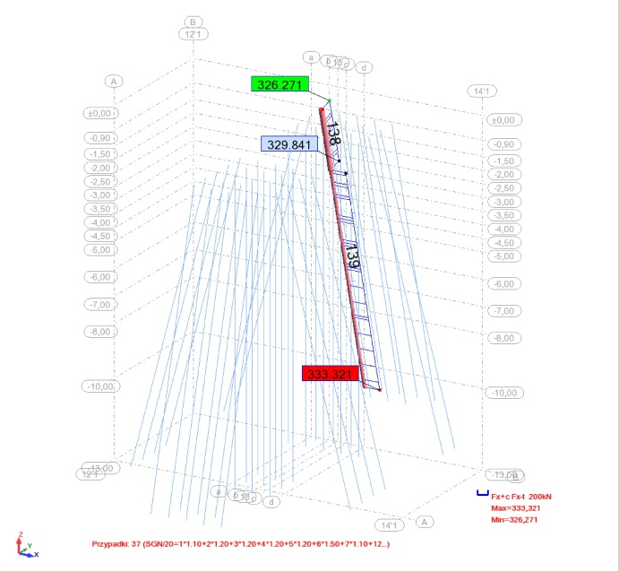
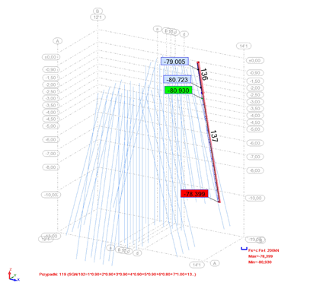
Figure 7. Minimal and maximal forces for a micropile in kilonewtons
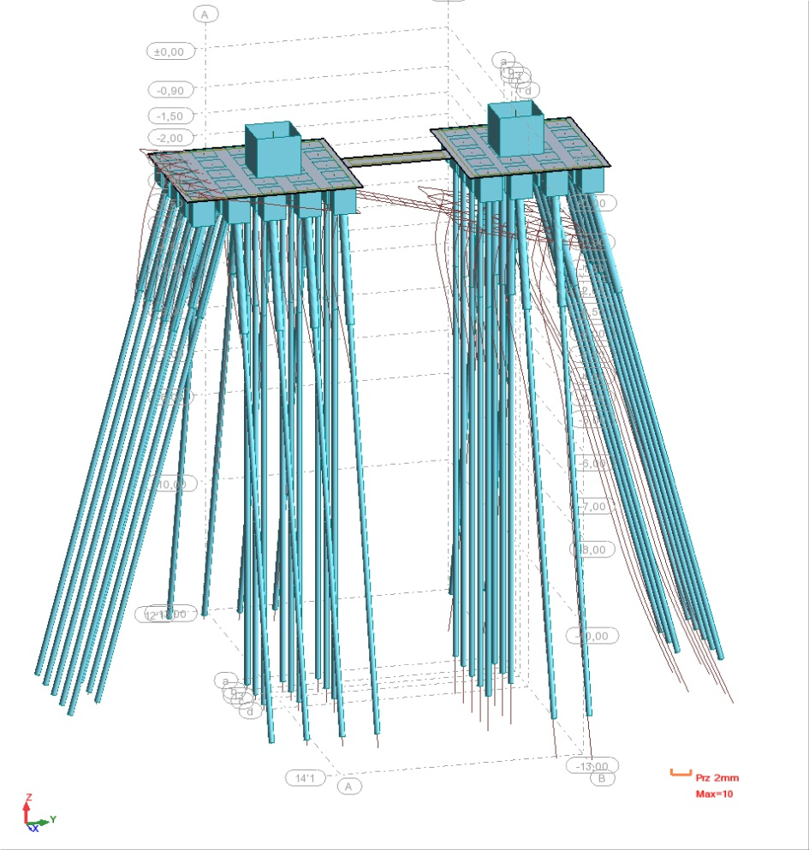
Figure 8. Displacements visualisation
Finding the optimal solution was challenging and time consuming, as every option had to be run through multiple load cases, resulting from climate induced (wind, snow) changeable loads [6]. Majority of elements were compression piles however for some there was also a possibility of tension, depending on the load case. The initial footing and foundation beam layout had to be reworked due to an issue with displacement from horizontal loads, which is common in micropile design. Despite multiple optimizations of layout, calculated settlement differences between some footings reached 7 millimeters, exceeding the predefined limit of 5 millimeters. After further analysis, those values were accepted by the structure designer.

- Execution
The work scope included foundation of two separate catalytic reactor installations. 380 micropiles of 12 meters in length each were installed, totaling 4560 linear meters. For the elements that could potentially work as tension piles, galvanized rods were used.
A Keller KB-0 Jet-Grouting rig was used, as it provided access to narrow locations and could be fitted with a 4 meter mast to enable the use of 3-meter 51N rods. Another advantage is that it could be fitted with 88.9-millimeter JG rods without a need to change adapters, so DHH conversion could be done instantly. The standard drilling bits were also modified to larger diameter.
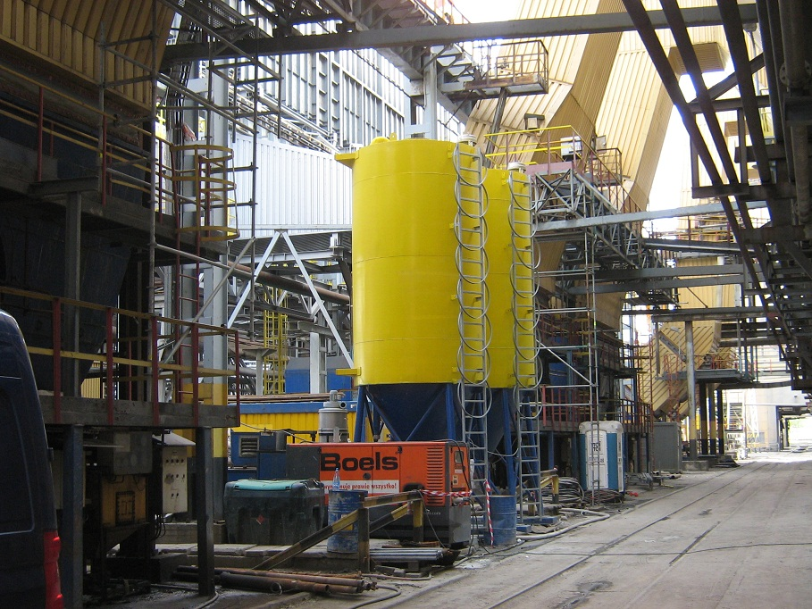
Figure 9. Batch plant installation
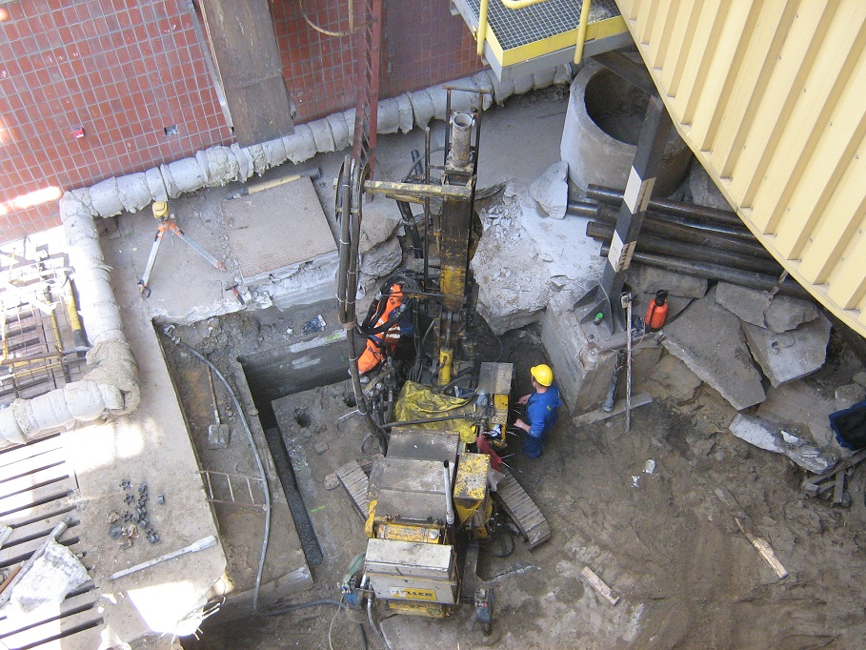
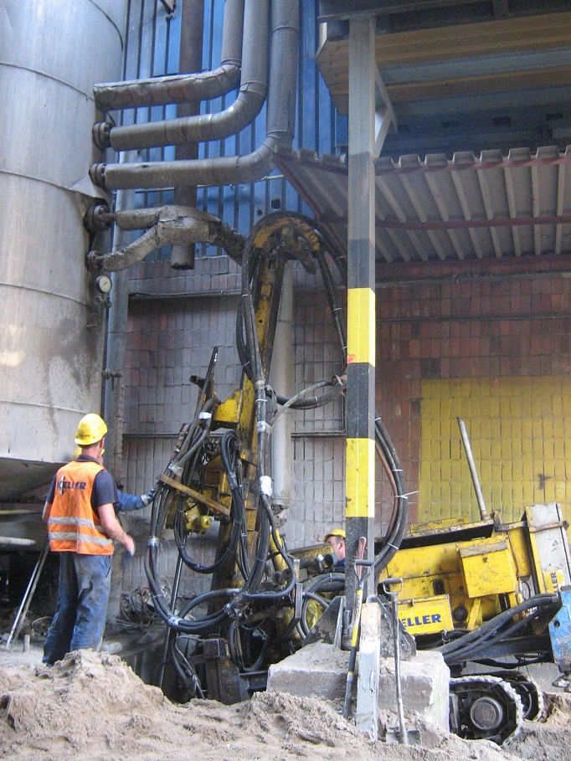
Figure 10 and 11. Drilling
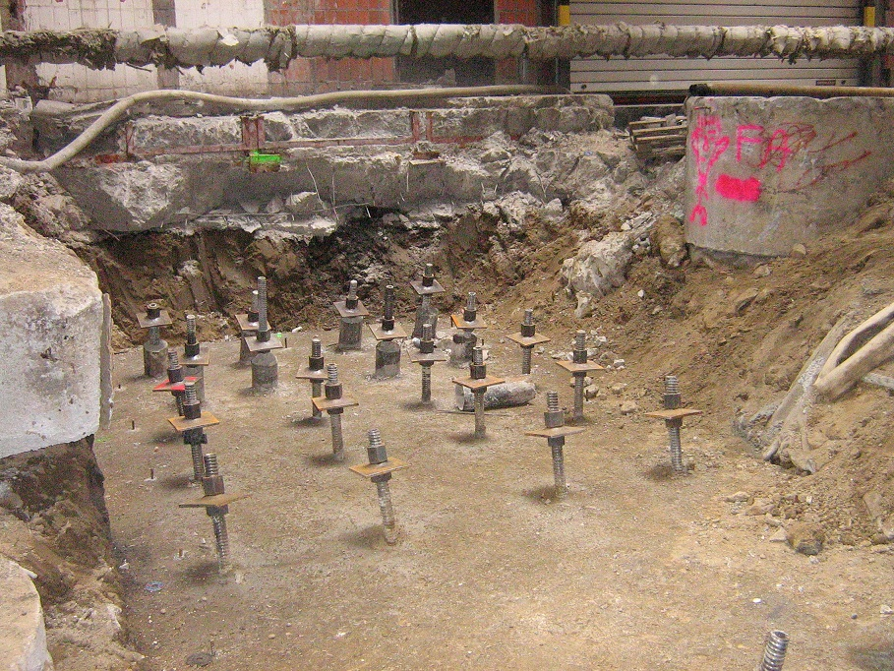
Figure 12. Finished micropiles
Five static load tests were carried out. The loadings were done in two cycles with forces 100%Qr = 336 kN and 125%Qr = 420 kN accordingly, where Qr is the factored maximal design load. The data acquired during the tests are listed in table below:

Micropile nr. | Cycle | Load [kN] | Qr [%] | Settlement [mm]*
 |  |  |  | Maximal | Permanent
22 | I | 336 | 100 | 5,37 | 2,27
22 | II | 420 | 125 | 6,91 | 2,62
170 | I | 336 | 100 | 5,08 | 2,39
170 | II | 420 | 125 | 11,21 | 4,72
201 | I | 336 | 100 | 5,00 | 1,83
201 | II | 420 | 125 | 11,15 | 3,01
202 | I | 336 | 100 | 5,54 | 2,15
202 | II | 420 | 125 | 11,69 | 3,55
203 | I | 336 | 100 | 5,00 | 1,62
203 | II | 420 | 125 | 9,19 | 1,97
*) average from 4 readings.
Table 1. Load test results

The acquired settlements for design loads were between 5.00 and 5.54 millimeters, so the results proved that assumptions and selected method were appropriate.
During the execution, two serious problems were encountered and both were time and money consuming.
In general, the first and most important aspect of the execution was to find a rig capable of meeting logistical challenges within the site. The bar type was chosen as compromise between the micropile performance (from this point of view solid bar would be better) and rigs drilling system capabilities (favoring the medium range hollow bars). Having in mind the low stiffness of hollow bar, it was decided to use DHH when drilling through obstacles. The shortcoming of this approach was that it was necessary to change to Jet Grouting rods every time the problem was encountered. At the beginning, the rig operators tried, not knowing the size of obstacle, to drill threw without retooling, often damaging the bars or making them very hard to unscrew. This was solved by personnel training and setting the limit for push force, at which retooling was mandatory.
Second issue was the existing infrastructure installations and associated as-built information. It was often found that the actual location of installations varied from what was shown on the plans. Such a situation is presented on Figure 4, where the gray lines represent as-built position and red lines show the real situation. This imposed the need of frequent changes to micropile layout. As there were many construction works on the power plant through the years, some installations (especially cables) where not even present at the plans. When such interfering cable was encountered and had to be removed, it took long time to determine the user and get a permission for removal.

- Lessons learned

- When working in an area with existing infrastructure, the as-built information may not be accurate
- The hollow bars are not designed for crushing obstacles, and employing a hammer quickly after contacting an obstacle will allow for cost and schedule savings
- Prior to commencing operations, ensure that you are familiar with the surrounding properties and operators
- Thoroughly vetting designs prior to construction will help to avoid schedule delays
- Good interaction between the designer and experienced site personnel is key to a successful project.

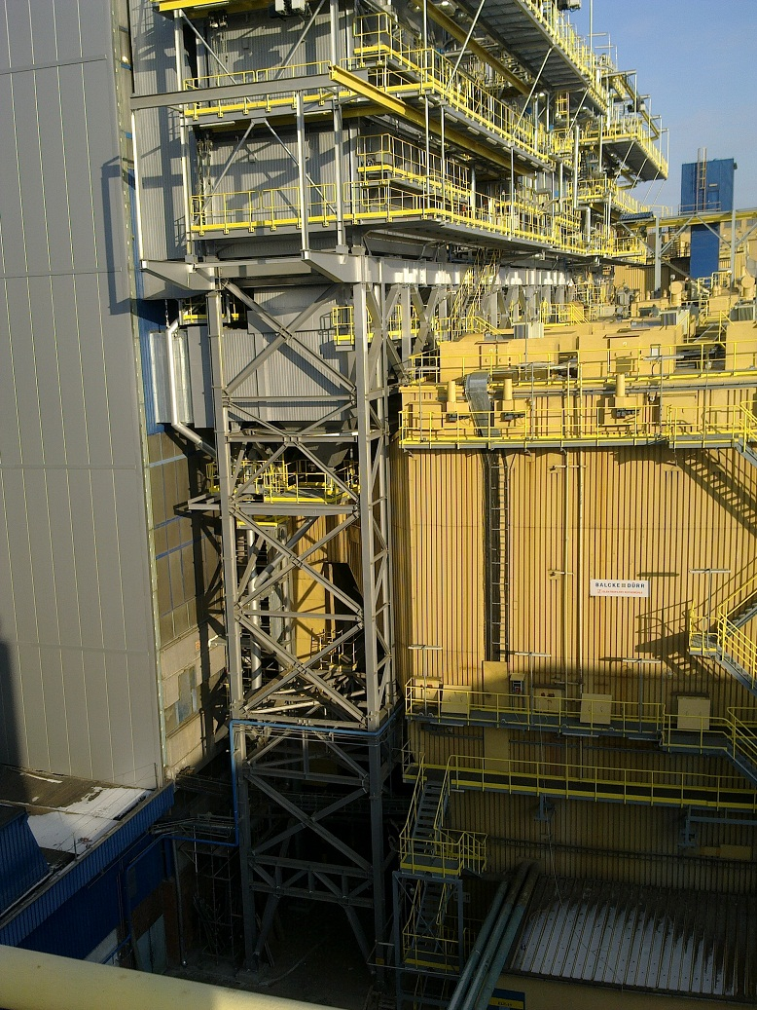
Figure 13. Ready SCR installation

REFERENCE:

[1] Geoprojekt Sp. z o.o., Dokumentacja geotechniczna dla projektowanego obiektu w rejonie elektrofiltrów blokowych, Lipiec 2009r.
[2] Geoteko Serwis Sp. z o.o., Sprawozdanie z badań geotechnicznych wykonanych na terenie Elektrociepłowni Siekierki w Warszawie, Listopad 2010r.
[3] Keller Polska Sp. z o.o., PROJEKT WYKONAWCZY posadowienia konstrukcji wsporczej reaktorów kotłów K10 i K11 w polu A-B/1-8 w EC Siekierki w Warszawie.
[4] Kosecki M., Statyka ustrojów palowych. PPH ZAPOL, Dmochowski, Sobczyk sp. j., Szczecin 2006r.
[5] Poltegor-Projekt Sp. z o.o., Projekt Wykonawczy. Branża sanitarna. Budowa katalitycznych instalacji odazotowania spalin (SCR) dla kotłów blokowych typu: OP-430 nr K-10, K-14 i K-15 oraz OP-380 nr K-11 w Elektrociepłowni Siekierki w Warszawie. GU. Układy pomocnicze. Przebudowa istniejących sieci kanalizacji deszczowo-przemysłowej i sanitarnej w rejonie konstrukcji wsporczych reaktorów. Wrzesień 2010r.
[6] Sadowski G., Radziszewski Z. Założenia dla projektu posadowienia konstrukcji wsporczej reaktorów kotłów K10 i K11 w polu A-B/1-8 w EC Siekierki. Wartości reakcji podporowych. Stan na 23.12.2010r.

Product Line Manager, Keller Polska Sp. z o.o., ul. Poznańska 172, 05-850 Ożarów Maz., Poland pwojtowicz@keller.com.pl

