dr inż. Marcin Blockus

INGEO Sp. z o.o.

Mobile: +48 505 24 38 37

E-mail: [blockus@ingeo.com.pl](mailto:blockus@ingeo.com.pl)

The use of micropiles as a form of underpinning of existing commercial buildings – development of IKEA hall in Gdańsk

Increasing the load capacity of the foundations of existing commercial buildings and warehouses using micropiles enables the buildings to remain operational during construction works. Micropiles were used to strengthen existing foundations and to construct the new foundations during the implementation of the development of IKEA commercial buildings in Gdańsk (works executed in 2007-2008). The applied micropile installation technique allowed for a minimized area of impact of the works and to execute them during normal business hours. This project was a special challenge because of the difficulty of the drilling and the scope of work itself – commercial space was increased from 12 000 square meters to 31 000 square meters (mostly as a result of additional storey above the working shop and warehouses).

Fig. 1 shows a plan of the shopping center with an indication of the area of the investment. Special geotechnical works which were performed can be divided into three main groups:

* underpinning of the existing foundations inside retail constructions,
* deep foundation of selected elements,
* execution of the anchored excavation support.

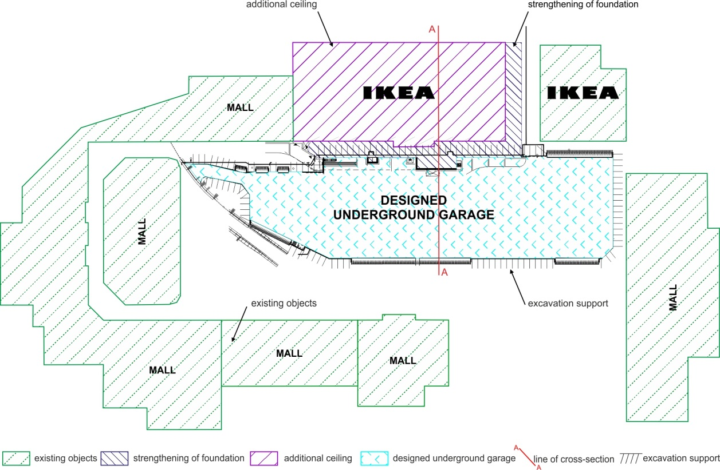

**Fig. 1** Plan of the rebuilding of the shopping center – scope of the works

Injection micropiles were the most important of the above-mentioned solutions. Underpinning existing foundations from inside the building was a very difficult task. Analysis of the existing design documentation of the hall foundation indicated the use of three types of footings to found the hall construction. The basic assumption of remodeling was to obtain additional retail space by creating an additional ceiling between the existing floor and the roof of the hall. The existing height of rooms (810 centimeters) allowed for this kind of change while preserving all applicable laws. The height of the rooms on the ground floor, measured from the floor to the beams of the new ceiling, equaled 450 centimeters, while the upper storey height 300 centimeters (Fig. 2). Construction of the ceiling is supported by a system of new precast reinforced-concrete columns, located in the immediate vicinity of the existing ones.

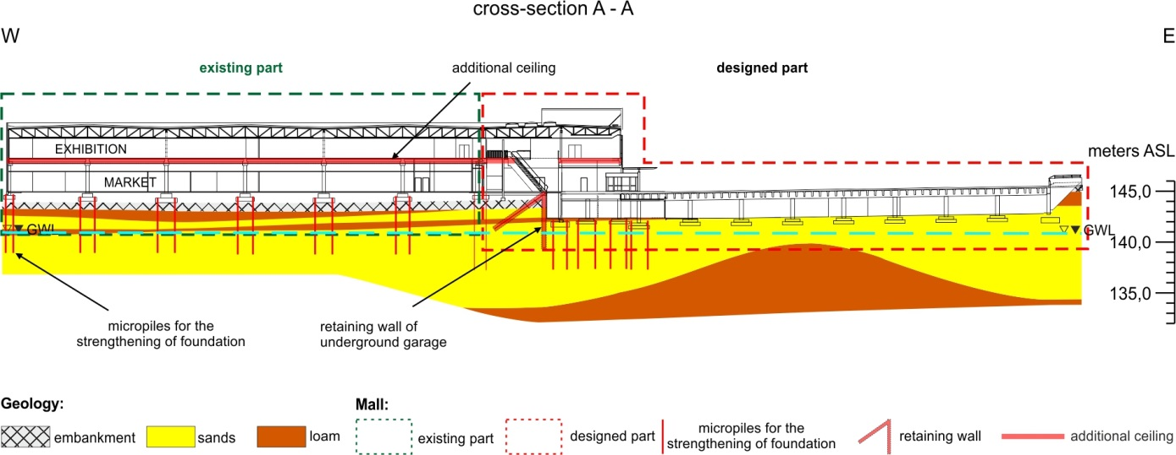

**Fig. 2** Typical cross-section through the remodeled building

Impossibility of interruption of work of the shopping center was associated with the need to apply ceilings that do not require the formwork or temporary working supports. For such conditions, a solution based on pre-stressed concrete was adopted: beams in the shape of the letter "T", based on substrings with a height of 30 centimeters and placed at a spacing of 12 meters. Dimensions of the existing footings were too small due to the considerable dead weight and expected large live loads that would be created by the addition of the new level. Structural calculation showed that The Serviceability Limit State would be exceeded for all of the footings, and The Ultimate Limit State would be exceeded at the most heavily loaded structures. Therefore, the existing foundation capacities needed to be increased. At the preliminary design stage, various technologies were considered, inter alia, extension of the geometry of foundations or jet-grouting injections. Finally, in agreement with the Contractor, as the most optimum technology was adopted the solution based on the transfer of additional loads by injection micropiles of the Titan system – Ti103/78 and Ti52/26 with total length of the rod of 12 meters, with a diameter of boring crowns of 220 millimeters and 175 millimeters.

Due to the variability in construction of existing footings, transferring of additional loads would be performed by a system of micropiles installed in and around existing foundation blocks. Footings with larger loads utilized special frames of steel beams placed over existing foundations. First installations proved necessary to change assumptions about the geometry of the existing foundations, the differences related to their shapes and depths of the foundation. Instead of the pre-assumed three types of underpinning, it was necessary to perform the project with 13 different support systems. According to the assumptions of the design, the added floor would be supported on a system of new columns set on the existing foundations strengthened by micropiles (Fig. 3, Fig. 4 and Fig. 5) or using independent system of steel beams transferring loads to the micropiles (Fig. 6 and Fig. 7).

Micropiles were also used to ensure the compatible settlement characteristics of the foundations in the area adjacent to the new part of the building. In this case, all the drilling works related to the micropiles were performed outside the building (Fig. 8).

Drilling works inside the building were performed by equipment with hydraulic drive (Fig. 9). A set of hydraulic pumps with their drive was located outside the commercial and warehouse hall.

Such technology allowed to the fulfillment of the basic requirement enforced by the Owner of the building - uninterrupted work of the shopping center. The small dimensions of the drilling rig and its quiet work made it possible to perform a relatively small exclusions from the operation of the commercially used surface. The disadvantage of this solution was the need to prepare rods of the micropiles with length of 1 meter, matched to the height of the drill mast.



**Fig. 3** Scheme of the micropiles installed in the existing foundation

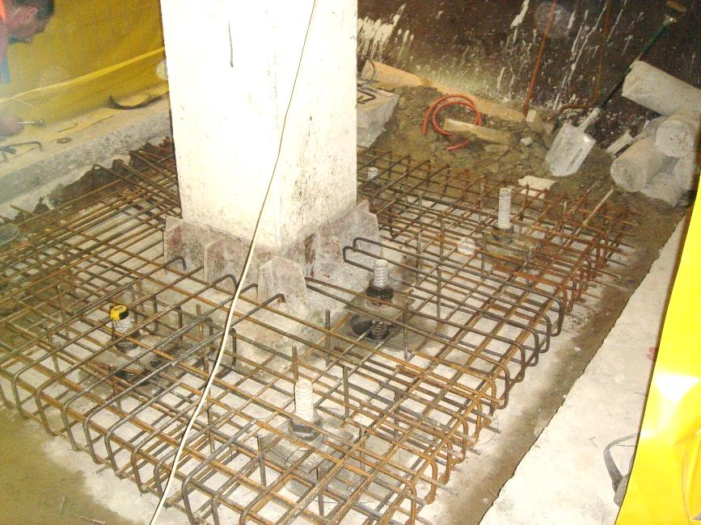

**Fig. 4** Micropiles installed in the block of existing foundation

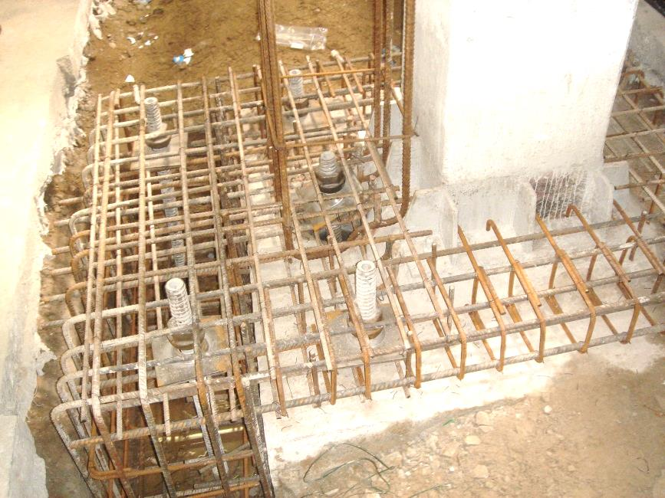

**Fig. 5** Scheme with additional supports beyond the block foundation, apparent mounting irons of the additional precast column

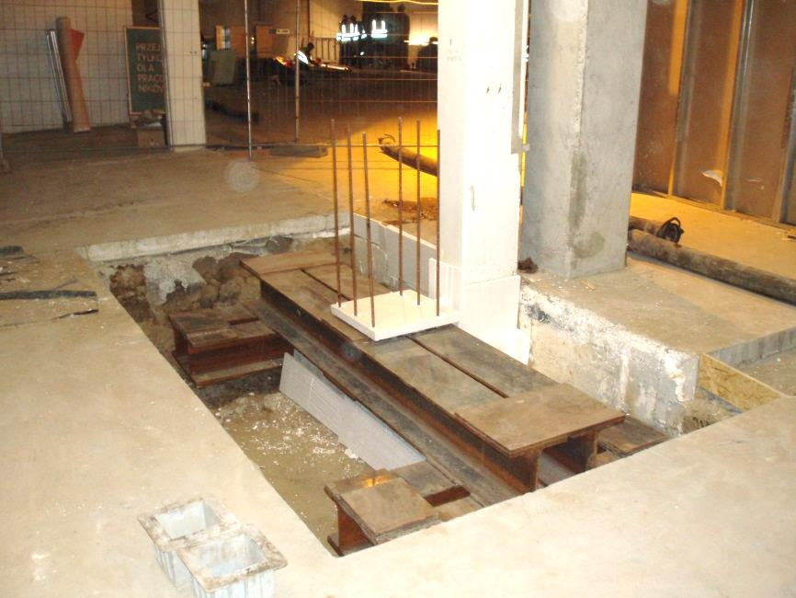

**Fig. 6** Transfer of the loads to 4 micropiles (Ti52/26), independent of the existing foundation

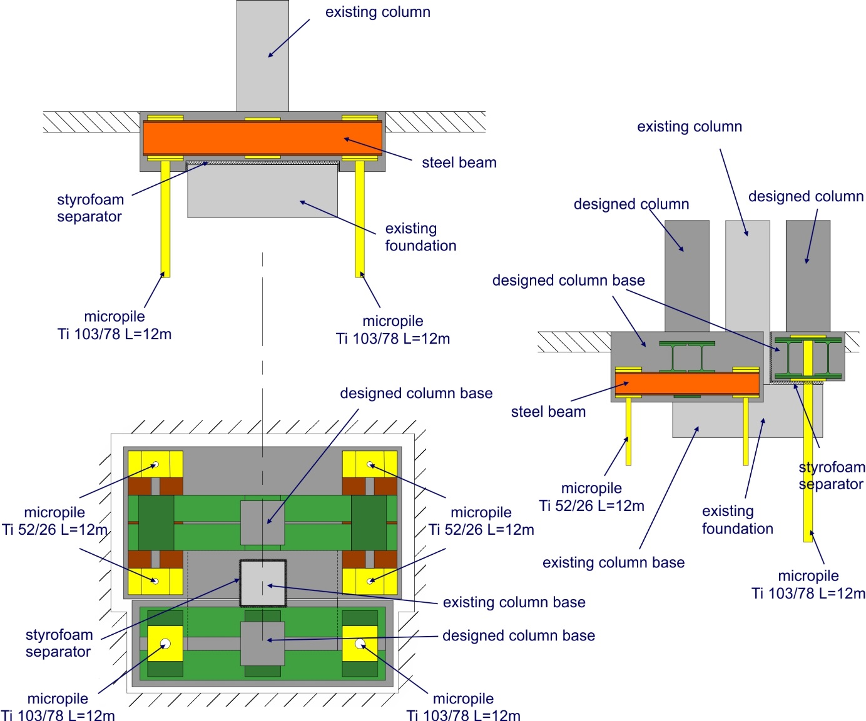

**Fig. 7** Scheme of the construction of independent support of the columns

Despite the initial concerns about the efficiency of the drilling rig resulting from its relatively low technical parameters, it turned out that obtained results should be assessed as more than satisfying. During one working shift, 2 micropiles with a diameter of boring crown of 220 millimeters and a length of 12 meters were performed, or 3 up to 4 micropiles with a diameter of boring crown of 175 millimeters and with the similar length. This is particularly beneficial result given the geological conditions. Micropiles were embedded in soils composed primarily of fine and medium sands with medium dense and dense soil compaction (ID=0,5-0,7) and loams and sandy silts with stiff state of consistency (IL≤0,2).

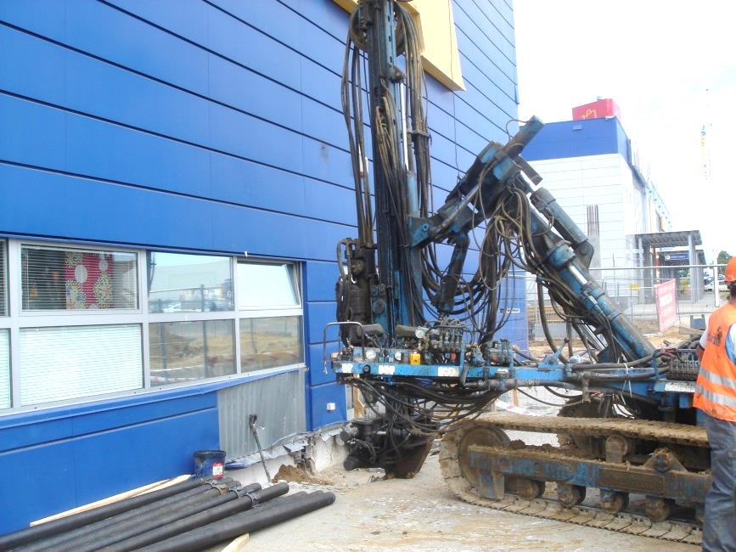

**Fig. 8** Executing of the micropiles Φ=220 mm (Ti103/78 rod),

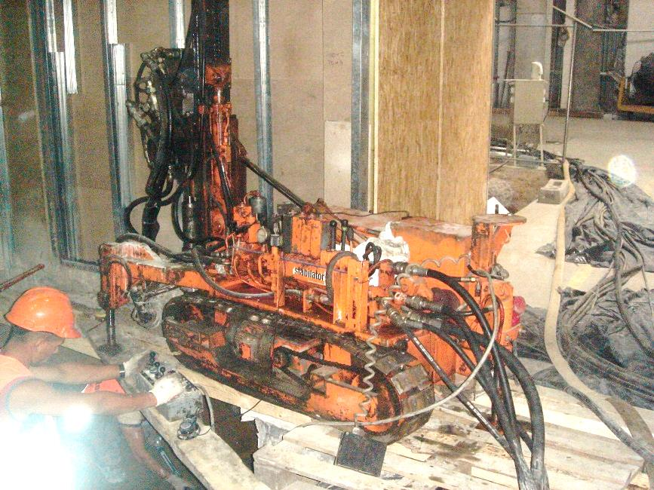

**Fig. 9** Injection micropiles inside the building with the use of miniature drilling rig

In addition to the described uses of injection micropiles for new foundations and underpinning existing ones, they were also used to anchor the support of the excavation of the underground parking, positioned in the immediate vicinity of the developed building (Fig. 2 and Fig. 10). As in the case of other foundation works, the realization of this task did not caused even temporary interruptions of the mall operations. Relatively fast construction and commissioning of the sectors of aboveground parts of parking were possible due to the use of a precast concrete elements. Fig. 10 shows the finished section of parking deck (near the shopping center building) adjacent to part involving earthworks. Construction works began from the execution from the existing ground level (surface parking) bored pile wall being earth-retaining structure of the underground storey of the parking. Piling works were performed by sections to reduce the surface occupancy. Construction of the bored pile wall was based on drilled CFA piles with the diameter of 400 millimeters and length of L=8,0 meters. Due to the anchoring of the retaining wall (anchors Ti40/20, L = 9,0 meters, diameter of the boring crown of 150 millimeters, the average spacing of 4 meters) it was possible to perform wall of alternately reinforced and unreinforced piles. First, the unreinforced piles were performed, and then shortly after - reinforced piles. Anchor micropiles were executed after partial dug out of the bored pile wall and ending piles by a reinforced-concrete pile cap. Such prepared construction of the retaining wall allowed to start the earthworks in the designated working sector.

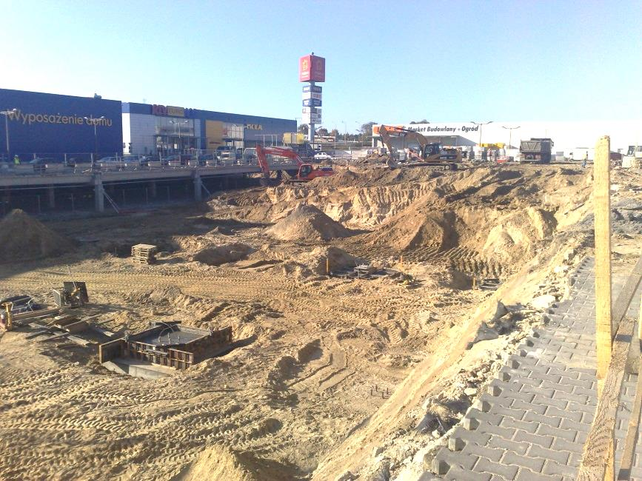

**Fig. 10** Earthworks during execution of the underground parking

The scope of works and the use of technical solutions adapted to the encountered problems allowed for efficient and fast implementation of the investment. Strengthening of the foundations using other techniques would have been difficult taking into account the requirement of continuous operation of large commercial space.

Within one investment, injection micropiles were used both as underpinning and as entirely new foundations, as well as anchoring of retaining structures of the underground parking. The use of micropile foundations was an optimal solution allowing for continuous operation of the shopping center – which was the main aim of the Investor.