**APPLICATION OF MICROPILES TO THE STABILIZATION OF A DEFLECTED OLD TENEMENT HOUSE**

Krzysztof Sternik[1], Tomasz Blejarski[2]

**ABSTRACT**

The old tenement house in a city of Upper Silesia (Poland) is deflected as a result of non-uniform settlement on the compressible ground. Low bearing capacity of the ground has been exceeded several times. The mining activity in the area has also contributed to the total settlement of the building.

In order to stabilize the building and protect it from further tilting, underpinning of the foundations has been designed. Due to the dense urban building and difficulties in accessing the foundations three technologies have been proposed: drilled micropiles, jacked micropiles, and jet-grouting columns. The design has been made which is currently under execution. Finally, all three technologies have been substituted by drilled jet-grouted micropiles.

The paper presents load distribution, ground conditions, assumed solutions as well as first stages of underpinning execution.

# introduction

In densely built city centre there is located four-storey old tenement house, which over the years has a tendency to lean out. The building’s height changed in the late 60's as a result of adding a storey, which resulted in increased pressure on the subsoil and activated uneven subsidence. Measurements carried out systematically since March 2008 did not show a marked increase of displacements. The reasons for the building’s vertical deflection can be sought in both the non-uniform lowering of the mining area and in the foundation on weak soils of variable thickness.

At the request of the building’s owner, underpinning of the building has been designed. Due to the need of strengthening the foundations within virtually the entire plan of the building and limited access to some of them, it was necessary to apply three technologies: drilled ([2], [3], [5], [6]) and jacked micropiles [9] and jet-grouting columns ([1], [4], [7]).

# Structure and condition of the building

The tenement house was built as a single block masonry structure without dilatation. It is a four-storey building with a basement (Fig. 1). The floors above the basement are made of steel I-beams and arched vaults made of bricks. Basement floors are made of concrete or paved with bricks, without damp proof course. The thickness of basement’s bearing walls is around 1 m. The walls are made of bricks. Condition of the building in the ground floor and the basement is good, shows no damage other than that of a normal long-term service. Due to occurring mining deformations the structure of the building is anchored in two directions at the level of each floor.

Generally, with the exception of one spot, no traces of moisture in the basement nor flooding by groundwater were found. There is a sump pump installed in the basement floor which is to remove water from accidental flooding.

The building is founded on the strip foundations. Foundation depth is varied and ranges from approximately 3.5 m to 4.4 m below the ground level, while the level of the basement floor is at about 2.5 to 3.0 m below the ground level.

In the past, the building has been subjected to numerous modifications aimed at changing the function and size of the basement. At the moment, most of the space in the basement is not used. The ground floor is designed for commercial activities, on the upper floors there are apartments and offices.

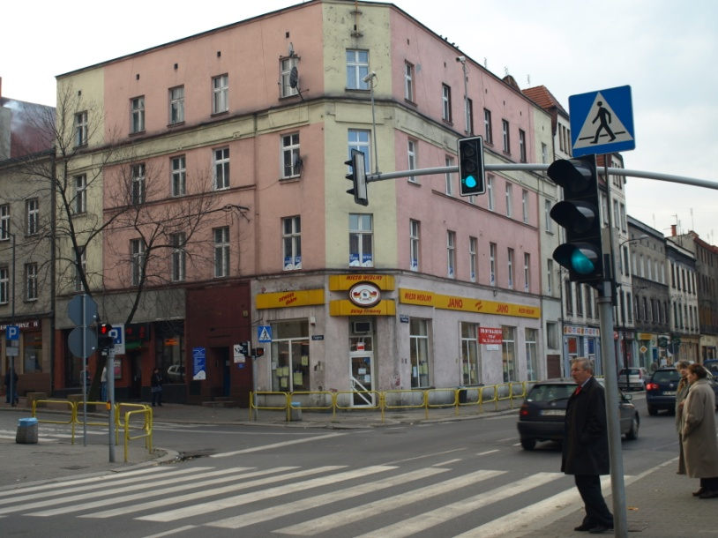

Fig. 1. View of the façade of the tenement house

# displacements of the building

The building tilts unevenly, mainly in the north. The average deflection measured on the northern elevation is 20.4‰ in the north and 2.9‰ - 7.8‰ in the west. The results of the measurements carried out in May 2010 are shown in Fig. 2.

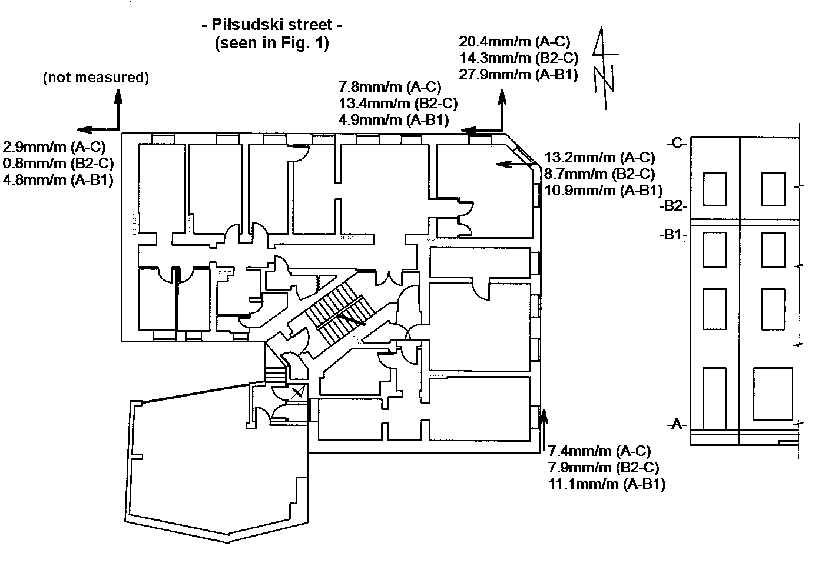

Fig. 2. Measured deflection of the building (after [8])

# geotechnical characteristic of the subsoil

The subsoil was investigated with four boreholes to the maximum depth of 4.5 m below the level of the basement’s floor. Relative densities of cohesionless soils were determined on the basis of light dynamic soundings (DPL) carried out in the vicinity of the boreholes at the bottom of the pits made in the basement’s floor. Locations of boreholes are shown in Fig. 3. Selected geotechnical cross section showing the structure of the strata is given in Fig. 4.



Fig. 3. Layout of basement walls with location of boreholes and geotechnical cross sections

The subsoil is mainly built of quaternary deposits made of uncontrolled man-made fill of variable thickness and Pleistocene clay, silt and silty sand underlaid by sands and gravels of the third European glaciation. In addition, within the contour of the building’s foundations there were found alluvial organic soils under the northern wall of the building. There is a local, probably erosive, depression of the stratum of granular glacial deposits there. The depression has been filled with soils of an abandoned meander type:

* in the bottom part of filling sediments there are found medium and fine sands (stratum IIa in Fig. 4),
* upper part of the meander profile consists of cohesive soils (silt, silty clay, clay) of grey, dark gray and gray-brown colour with a considerable admixture of organic matter (stratum Ic in Fig. 4),
* in the ceiling zone of the filling deposits their origin changes into lacustrine – black soft organic clay (mud) with inserts of peat (stratum Ib in Fig. 4).

According to the profile of borehole No. 4 the sediments filling the erosion depression are at least partially covered with silty clay of Baltic glaciation (stratum Ia in Fig. 4). The average values of soil parameters for all strata are given in Table 1.

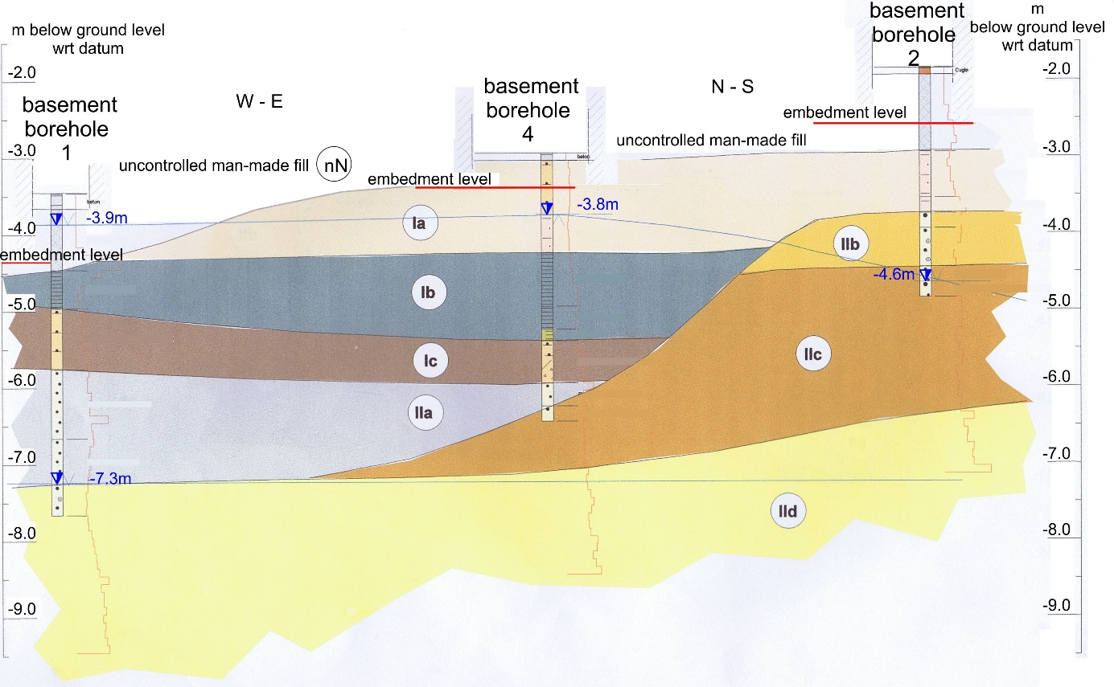

Fig. 4. Geotechnical cross section 2-2’. Strata descriptions (e.g. Ia, IIb) and average soil parameters are outlined in Table 1.

Two aquifers have been found in the subsoil. First, the upper one, is fed by the infiltration of rainwater and leaking yard drains. Its level is at the depth of 4.1 to 4.7 m below the ground level. The other aquifer (with ground water table) has been found in the borehole 1 at the depth of about 7.3 m below the ground level in IId layer. The ground water table is about 3 m below the deepest foundation level.

Table 1. Mean values of geotechnical parameters

|  |  |  |  |  |  |  |  |
| --- | --- | --- | --- | --- | --- | --- | --- |
| Soil | Symbol | Natural water content  [%] | Liquidity index IL / Relative density ID | Bulk density    [t/m3] | Friction angle  '   [°] | Cohesion  c’  [kPa] | Modulus of elasticity E [MPa] |
| clay / silt with sand | Ia | 21,1 | 0,44 | 2,05 | 11 | 10 | 12,5 |
| organic clay | Ib | 82,4 | 0,46 | - | - | - | - |
| organic clay | Ic | 31,7 | 0,47 | - | - | - | - |
| medium sand | IIa | 23,1 | 0,65 | 1,90 | 34 | 0 | 100 |
| coarse sand and gravel with sand | IIb | 8,8 | 0,68 | 1,90 | 37 | 0 | 140 |
| medium sand | IIc | 21,7 | 0,68 | 2,00 | 34 | 0 | 105 |
| gravel with sand | IId | - | 0,73 | 2,10 | 40,5 | 0 | 185 |

# bearing pressure calculations

The scheme of foundation walls is shown in the layout of the building in Fig.3. The bearing pressure applied by the foundations to the subsoil has been calculated using the finite element method. These values taken at 1 m long strip footings were calculated without taking into account the interaction of the building with the subsoil and related redistribution of the bearing pressure. In fact, the bearing pressure on the subsoil may be up to 30% less than the calculated. FEM model of the basement storey of the building is shown in Fig. 5. The values of loads are summarized in Table 2.

Table 2. Bearing pressure values

|  |  |
| --- | --- |
| Wall | Pressure [kN/m] |
| A-A | 342 to 501 |
| B-B | 426 to 491 |
| C-C | 372 to 579 |
| D-D | 384 to 580 |
| G-G | 342 to 552 |
| H-H | 331 to 749 |
| I-I | 241 to 603 |
| J-J | 293 to 586 |
| K-K | 101 to 451 |
| L-L | 149 to 361 |

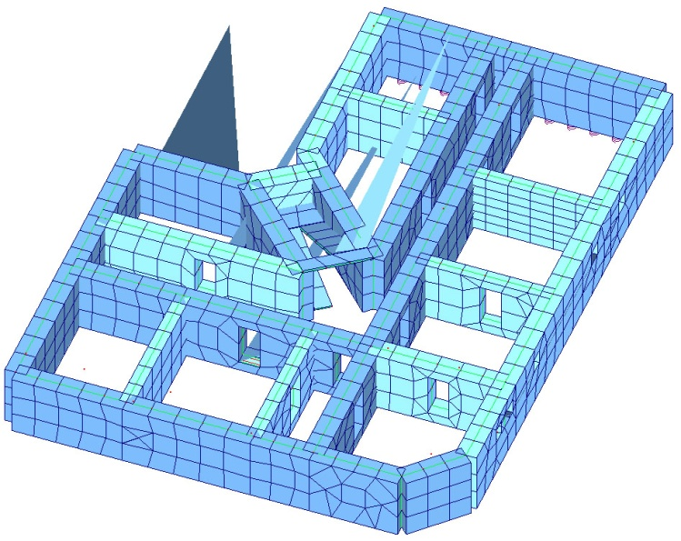

Fig. 5. FEM model of the basement storey

It should be noted that the loads higher than 500 kN/m occur locally in areas where the dead weights of walls without window openings add up. Therefore, it can be concluded that reliable bearing pressure taken to the underpinning design is 500 kN/m. Example load distributions, comprising the maximum value of ground reaction under the building of 749 kN/m, is shown in Fig. 6. Locations of the walls H-H and I-I are identified in Fig. 3.

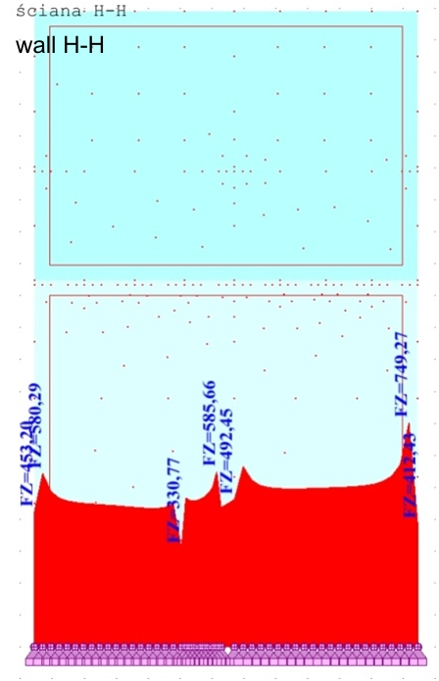 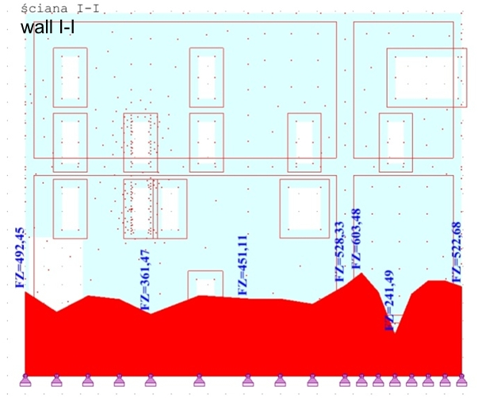

Fig. 6. Subsoil reaction under the walls H-H and I-I (wall loads shown in kN/m)

# reasons for deflection of the building

There are two reasons for the deflection of the building. One is the non-uniform settlement due to increased pressure on the subsoil of highly variable compressibility and the other is the uneven subsidence of the area located over the operating coal mines. In extreme cases deflections of buildings observed in Upper Silesia (Poland) exceed 120mm per 1m of building’s height.

The convex curvature of the ground surface due to mining exploitation can cause damage to the underground part of a structure as well as decrease of bearing pressure leading to partial detachment from the subsoil and cracking walls.

The concave curvature of the ground surface can lead to detachment of the inner sections of foundations from the subsoil and penetration of outer parts of a structure into its interior.

The tenement house in the northern part (roughly half of the building’s layout) is resting on the superficial zone of weak soils (soft silts and clays at liquidity index IL  0.5). Design parameters for these soils can be taken as for layer Ia:

’ = 20.5 kN/m3, c’ = 10 kPa, ' = 11

The design bearing capacity of a strip foundation can be calculated according to the formula suggested in Eurocode 7 [10]:

 (1)

The minimum depth of foundation has significant impact on the bearing capacity. In the case being considered it is the distance from the level of the floor in the basement to the foundation embedment depth. Foundation embedment depth is varied within the range D = 0.7 - 1.1 m. This results in bearing capacity ranging from 95 to 111 kN/m.

Compared to the calculated loads transmitted from the building onto the ground, locally reaching up to 750 kN/m and ranging from 350 kN/m to 450 kN/m on average, it should be noted that the bearing capacity is exceeded. Controversial is the magnitude of the excess of the bearing capacity. In the building there was no damage in the form of cracks in walls nor ceilings, so it is not certain that the bearing capacity of the ground has been exceeded five times (seven times in the extreme case). Let us recall that the construction of the building is masonry with arched vaults of bricks over basement. Surely, the good condition of the building is also affected by its bracing at the level of each floor. Steel anchors in walls encompassing the building protect it against distortions caused by mining deformations.

The principal cause of the deflections of the building is its foundation in complex ground conditions. The southern part of the building is placed on the fill and a stratum of silt in a plastic state not more than 1 m thick underlaid by dense sands and gravel, whereas the northern part is founded on a stratum of soft organic clay with thickness varying from 1.6 m to 2.4 m, underlaid by medium dense sand.

# proposed solution for strenghtening the foundation of the building

Due to the uneven subsidence and leaning to the north-west, initially three technologies of underpinning were assumed in the project: drilled micropiles, jacked micropiles and jet-grouting columns:

* drilled jet-grouted micropiles under pressure of 15 MPa executed from the ground surface outside the building along the northern and eastern wall, and partly in the courtyard,
* jacked micropiles carried out in niches cut in the basement walls.

Generally, micropiles were designed in regions where peat was found in the subsoil. Under the part of the building, where organic clays and peat were not found, jet-grouted columns were designed. Placement of all the underpinning elements is shown in Fig. 7.



Fig. 7. Placement of micropiles and jet-grouting columns under the building

# drilled micropiles as the final solution

Mining activity may cause concave or convex shape of the ground surface what results in changing bearing pressure under foundations. In the extreme case foundations may be detached from the ground. To ensure good stabilization underpinning must resist both compressive and pulling out forces. Underpinning elements must be well anchored in the structure of the building.

Finally, it has been decided that underpinning be carried out using micropiles drilled through foundation walls with high pressure grouting to enlarge the diameter of the grout body. Ischebeck Titan system was chosen as the micropiling system.

Usually Titan micropiles are performed using a standard rotary-percussion drilling equipment. While drilling grout injection is carried out, a hollow steel bar serves as a conduit and remains as reinforcement. The end of the bar is equipped with a drill bit, selected according to the type of soil. Bars with a continuous thread allow for ready cutting and combining them. For coupling the bars system couplers are used.

During drilling preliminary injection is carried out. Thin cementitious grout is pumped through the hollow stem at pressure 0.5 - 2 MPa and water/cement ratio (w/c) around 0.7. Grout is extruded through openings in the drilling bit.

Grout migrating in soil stabilizes the walls of the borehole, eliminating the need for casing. It has the ability to penetrate into the soil which results in a roughened bonded length, well connected with the ground. Penetrating grout further strengthens soils and rocks around a micropile.

After reaching a predetermined depth the final injection is performed. With the constantly rotating bar grout with a water/cement coefficient w/c  0.4 is pumped. A borehole is grouted from the bottom to the top. This ensures proper filling of the borehole. Coupled bars inserted into the borehole remain there as the reinforcement for a micropile.

Underpinning of the tenement house assumed execution of micropiles with the following parameters:

* Titan hollow bars 52/26 ,
* drill bits  130mm HPI-clay bit for jet-grouting,
* injection pressure not less than 15 MPa (150 bar) to form at least 300 mm grout body diameter,
* grout of the secondary phase of w/c = 0.5 on the basis of Portland cement CEM I or CEM II 42.5 R class.

It has been assumed that micropiles will cross the basement walls through drillings of 140 mm diameter. In order to ensure firm connection between the wall and micropile, the drilling lengths in walls should be at least 2 m.

Micropiles are designed for compression force of *N*=500 kN/m. Micropile spacing along the walls is 1.0 m. The diameter of the grout body due to high pressure jet-grouting has been assumed as *D*=0.3 m.

The load bearing length in coarse sand and gravel underlying uncontrolled man-made fill and organic soils is determined as



where



*qsk*= 150 kPa = unit grout-to-ground bond strength (skin friction) for sand

In the above the factor of safety 2 has been taken.

The calculated load bearing length is *Lb*= 7.07 m and the bond length of 8,00 m has been assumed.

For checking the structural capacity the following assumptions were made:

* 28 days grout compressive strength *fc* = 40 MPa,
* Titan 52/26 yield strength: *Fy* = 730 kN,
* load taken by the grout body exceeding the diameter of 130 mm (diameter of the drill bit dbit) is additional capacity to the calculated one, not included in calculations.

Compression piles were calculated as composite piles on which the load is spread over the steel section and the grout body. Structural strength can be calculated in various ways.

According to Ischebeck company guidelines [5] load taken on grout and steel, Pc, is:



According to FHWA guidelines [2] load taken on grout and steel, Pc, is:



The value calculated by the formula given in Ischebeck guidelines is smaller than required service load 500 kN, but it is determined without taking into account the enlarged diameter of the grout body due to jet-grouting at 15 MPa. Considering both values of the allowable load it can be said that it is sufficient to take the service load.

# execution of underpinning

Underpinning works started at the end October 2013. Titan bars were introduced into the subsoil through the foundation walls at the inclination of 2°-5°.

Drilling was preceded by cutting niches in walls. After installation of micropiles the niches were filled with concrete.

Due to confined space drilling was performed by a manual operated drill mounted on a stand (Fig. 8a). Grout was delivered by a conduit from a mixer situated in the courtyard of the building. Micropiles were drilled with 1 m sections of Titan bars. The niche with the head of a micropile is presented in Fig. 8b.

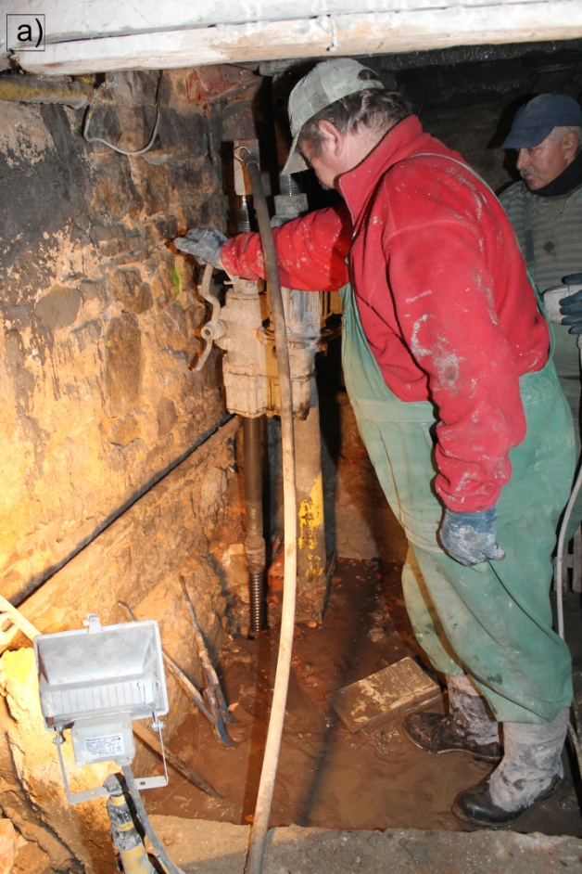 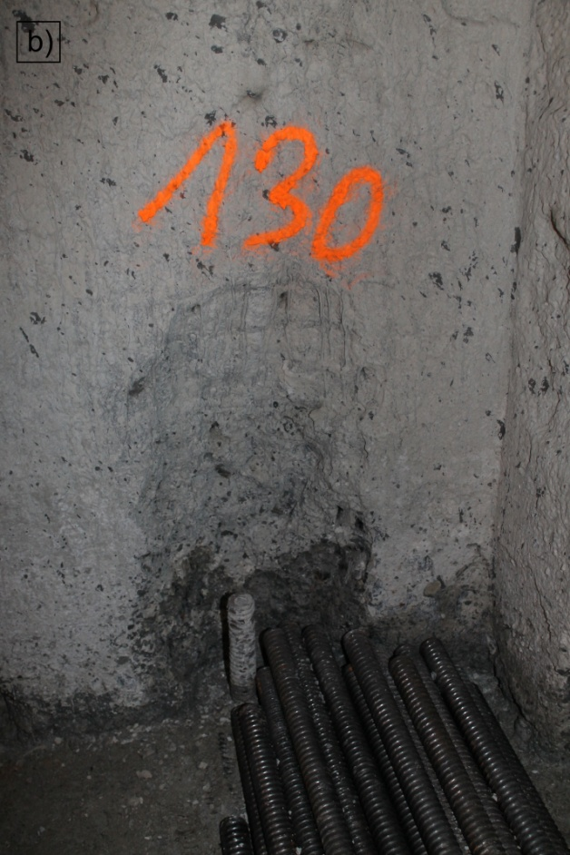

Fig. 8. Drilling of micropiles in the basement

# summary

Silesia in Poland is an industrial region that is experiencing mining deformations causing structural damage and uneven movements. In the case considered there are two causes of deflection of the old tenement house. Uneven settlement occurred due to increased pressure on the subsoil after constructing the additional storey. The building is partly founded in soft organic clays. Additional deflection was caused by the mining subsidence.

The structure of the building has been well protected against the mining subsidence. Horizontal steel anchors have been installed at the level of each floor. That is why the building tilted as a rigid body, without suffering damage.

The proposed underpinning of the foundations with 157 jet-grouted Titan micropiles aims to protect the building from further tilting in the future. The total length of each micropile is adjusted to the ground condition to get the bond length of 8 m. The longest micropiles are 13 m long. The distance between micropiles is 1 m drilled alternately from both sides of each foundation wall. At the time of writing the paper the project was under execution.

**REFERENCES**

1. Bzówka, J.: FEM analysis of interaction of jet grouting column with subsoil. Sci. Conf. on Natural and Technical Problems of Environmental Engineering – Soil parameters from in-situ and laboratory tests, Poznań, 27-29 Sept, 2010, pp. 445-455.
2. FHWA NHI-05-039, Micropile Design and Construction, Reference Manual, 2005.
3. FHWA-RD-96-016/019, Drilled and Grouted Micropiles, State-of-Practice Review
4. Geo-Institute of ASCE Grouting Committee Jet grouting Guideline, ASCE, 2009.
5. Ischebeck Titan Design Guidelines.
6. Liew S.S., Fong C.C.: Design and Construction of Micropiles, Geotechnical Course for Pile Foundation and Design, Ipoh, 29-30 Sept. 2003.
7. Modoni, G., Bzówka, J., Pieczyrak, J.: Experimental investigation and numerical modelling on the axial loading of jet grouting columns. Architecture, Civil Engineering, Environmental Journal, Vol. 3, No. 3, 69-78.
8. Sternik, K., Gromysz, K.: Underpinning as a way for stabilization of a deflected building. Proc. Sci.-Techn. Conf. Structural Failures 2013, in Polish, Szczecin-Międzyzdroje, 2013, pp. 425-432.
9. Tomlinson, M.J.: Pile Design and Construction Practice. E&FN SPON, 1994.
10. EN 1997-1, Geotechnical design - Part 1: General rules

1. Dr, Silesian University of Technology, ul. Akademicka 5, 44-100 Gliwice, Poland, tel. 0048 32 2372319, fax. 0048 32 2372873, Krzysztof.Sternik@polsl.pl
2. Dr, Biuro Projektów - Tomasz Blejarski, ul. Jana Kużaja 29A, 41-922 Radzionków, tel. 0048 508 225 443, fax. 0048 32 389 16 40, biuro@bptb.pl