DESIGN-BUILD-TEST PROCESS FOR HIGH CAPACITY MICROPILES:
CONSTRUCTION CASE STUDY ON DUTCHESS RAIL TRAIL BRIDGE FOUNDATIONS, POUGHKEEPSIE, NEW YORK

James Barron, P.E., Thomas Hattala, P.E., Daniel Kasprowicz,
and Daniel Barron, E.I.T.

ABSTRACT

Innovative design methods and materials are making micropiles a cost effective solution for many foundations. However, there is a methodical design process to ensure each micropile has the capacity to support the required loading. A construction case study was performed on high capacity micropiles that were designed, constructed, and tested by Buffalo Drilling Company, Inc. The micropiles serve as the deep foundations for various abutments and piers for a bridge in Poughkeepsie, New York. The project was part of the “Rails to Trails” program interconnecting pathways used by hikers and bicyclists. Fundamental geotechnical and structural concepts combined with load test results were essential in designing each micropile effectively. Testing procedure followed the New York State Department of Transportation Geotechnical Control Procedure Static Pile Load Test Manual (GCP-18) Quick Load Test. Failed load test results of test micropiles required redesign and retesting. The failed micropiles contained a center steel pin surrounded by high strength grout. After the load test results were analyzed, it was determined failure occurred due to lack of lateral support at the top of the pile, possibly due to an induced moment during testing. Redesigning the micropiles containing steel casing, to transfer the full loading to bedrock, resulted in passing load test results. The case study outlines the design process, the construction process, and interpretation of load testing results. A combination of shale bond stress, end bearing capacity, lateral soil stability, pile stability, and side friction were analyzed to produce micropile designs. Final applied loadings for the five test micropiles that passed were 6,000 kN, 5,200 kN, 5,345 kN, 6,327 kN, and 2,000 kN respectively.

INTRODUCTION

Buffalo Drilling Company, Inc. designed, constructed, and tested micropiles for the “rails to trails” project located in Poughkeepsie, New York. A new pedestrian bridge required a foundation including grouped piles at various locations. For the micropiles, a general design guideline was presented with load and placement specifications. This type of micropile project for a drilling contractor is commonly called a design-build-test contract. Meaning, the contractor designs the micropile to meet the specifications presented, and then constructs the micropiles. After construction, load tests verify the capacity of the micropiles to ensure the foundation design capability. These type of contracts offer the owner efficient construction, saving both time and money. Open communication and engineering ethics play a large role in moving the project forward. Success on these projects has increased the requests for bids concerning Design-Build micropiles.
Geotechnical soil borings were conducted prior to construction and determined the overburden soil consisted mainly of sand with some clayey silt. Bedrock was encountered at varying elevations of 3-16 meters (10-50 feet) below ground surface and was determined to be a hard to medium hard Shale. The foundation loads were decided to be transferred to the bedrock using groups of micropiles at each abutment. Various abutment foundations were placed for pedestrian bridges to connect the Dutchess Rail Trail. The Dutchess Rail Trail is a 13 mile rail trail that travels through Poughkeepsie and ends at the walkway over the Hudson. The trail is a shared use trail for both pedestrians and bicyclers.

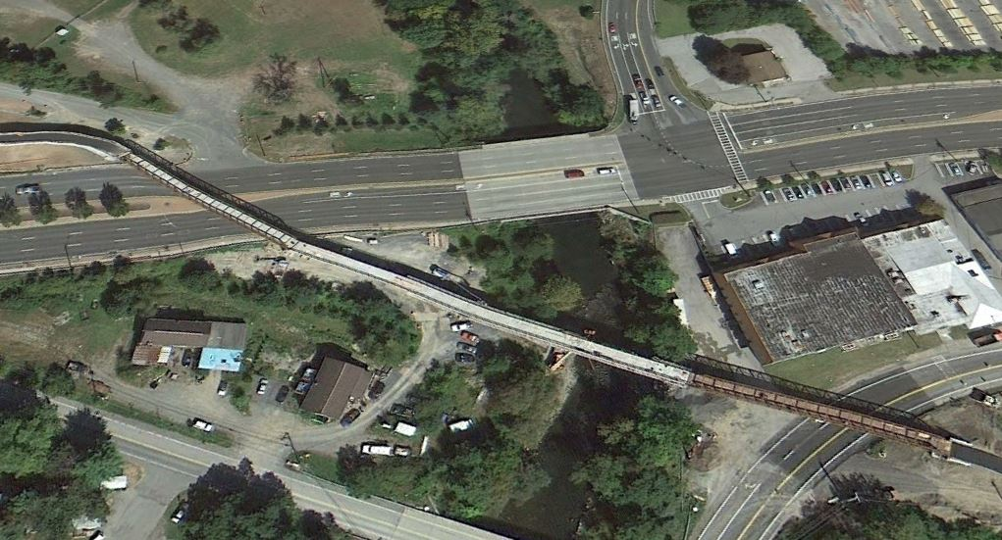

Figure 1. Aerial view of completed pedestrian bridges in Poughkeepsie, New York.

GEOTECHNICAL PARAMETERS

Boring logs B23 and B23A can be seen below. These soil borings were taken at the location of the end abutment, which is the main micropile analysis throughout the paper. The bedrock elevation changed drastically at different locations of the site. The soil was predominantly sand, with layers of silt and clay, and a till layer present before shale bedrock. Conservative geotechnical parameters design values were determined from the subsurface logs below.

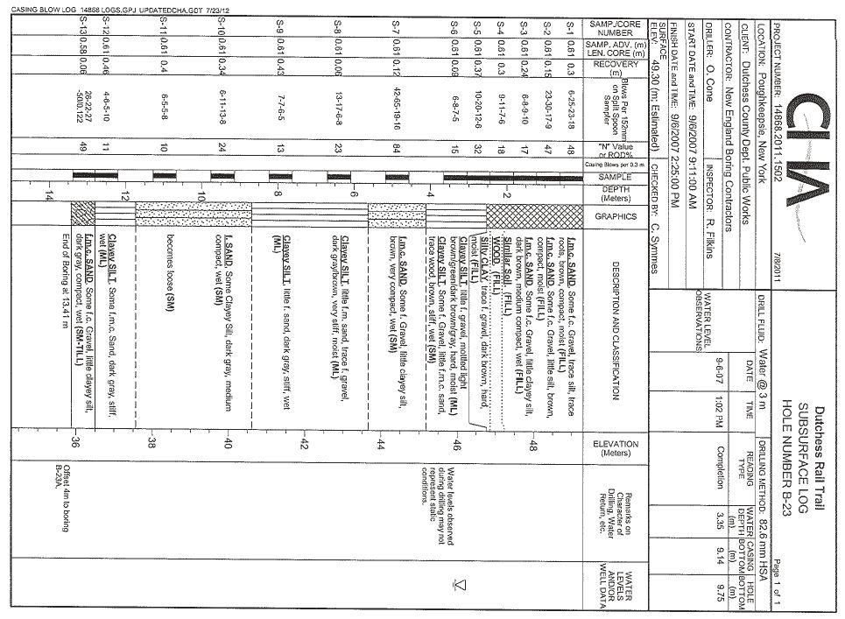
Figure 2. Subsurface logs taken at the end abutment.
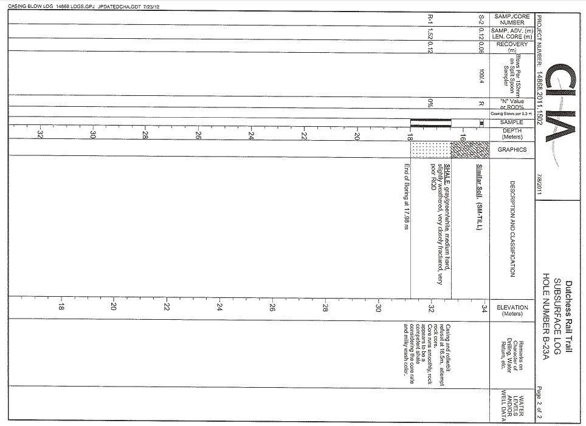
Figure 3. Subsurface logs taken at the end abutment showing the location of shale bedrock.

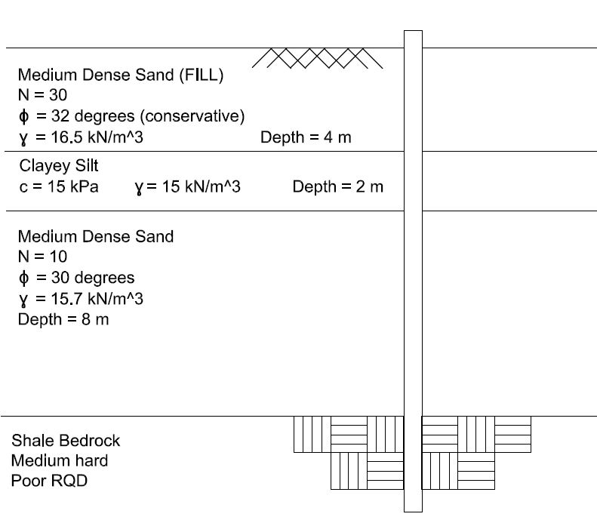
Figure 4. Comparison of micropile expected length and relevant geotechnical parameters used for design.

From these values the geotechnical design was done using the Bond Strength Method. The most important parameter determined for this method is the bond strength. Tables provided by the Federal Highway Administration (FHWA) contains various typical bond values for different soil types (Federal Highway Administration, 2005). Using the subsurface logs, past experience, and these tables the bond values are determined to use for design.

INITIAL DESIGN AND INITIAL LOAD TESTING

The initial design required the following loadings for each micropile location can be seen in the table below. Capacities for the micropiles placed at each location were designed to meet these requirements. The New York State Department of Transportation Geotechnical Control Procedure Static Pile Load Test Manual (GCP-18) Quick Load Test was used to determine the service and ultimate capacity of the constructed micropiles. Utilizing this design-test process serves to ensure the capacity was sufficient for the specification as well as support the theoretical design calculations performed.

Table 1. Micropile required strength and service states as stated in specifications.

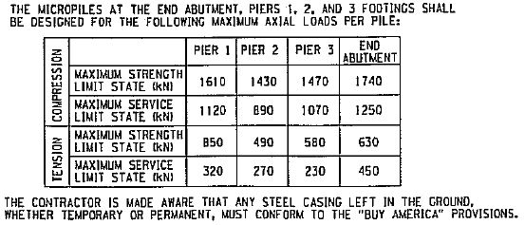

The micropiles were designed using the Bond Stress Method. The initial micropile design consisted of threaded bar and high strength grout fully bonded over the length of the micropile. These design calculations can be seen below. This design led to stability problems when the micropiles were tested resulting in load test failures seen in Figures 5 and 6. Testing procedure followed the New York State Department of Transportation Geotechnical Control Procedure Static Pile Load Test Manual (GCP-18) Quick Load Test. It was concluded that the top of the micropile mobilized first during loading and resulted in high stress concentrations at the top of the pile. The stress concentrations caused the test micropile to fail. Due to failed load tests, the micropiles had to be redesigned and retested.

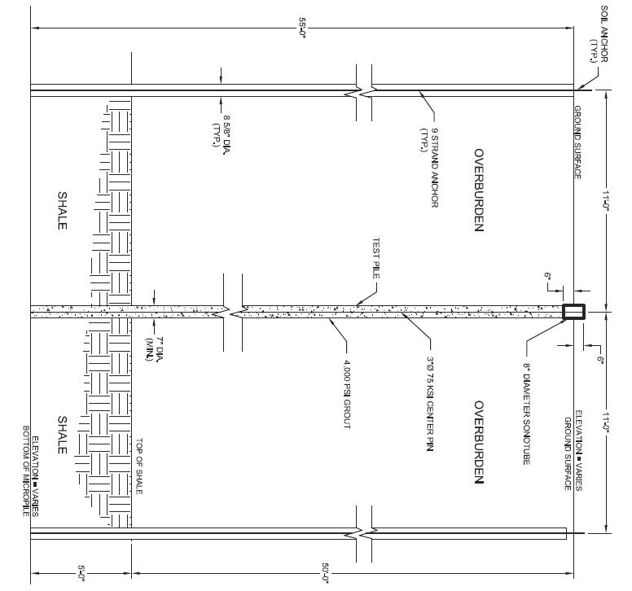
Figure 5. Initial uncased design is shown above for the End Abutment which failed the load test. Also shown are the reactionary soil nails required during compression load testing.

The End Abutment theoretical capacity will be demonstrated using the Bond Strength Method and compared to the load test results. This was the geotechnical design method used to design the micropiles. Each layer has a bond strength that corresponds to the grout-soil bond formed when injecting grout into the pile. Starting with Equation 1,

$P_{G-allowable}= \frac{α_{bond}}{FS}\left(πD_{b}L_{b}\right)$ (Eq. 1)

The known parameters are:

α _{bond} = Bond Strength, 500 kPa (80 psi) for shale rock, 100 kPa (15 psi) for Sand with some silt, and 50 kPa (5 psi) for Silt and Clay with some sand.
D_{b} = Diameter of Micropile 0.178 m
L_{b} = Length of Bond, 4 m for top sand (fill), 2 m for the clay layer, 8 m for the bottom sand layer, and 1.5 m for the shale rock socket
FS = 1 for ultimate capacity

$$P_{G-allowable (no casing)}= 671 kN \left(sand\right)+419 kN \left(shale\right)+56 kN (clay)=1146 kN$$

Structural axial capacity of the micropile was calculated to be much larger than the applied loading and should not be a factor. Thus, soil skin friction failure was expected. Previous studies verified the top of the micropile mobilizes first and may have failed before transferring the load to the rest of the pile. In this case, the result was failure in the micropile. Since it was assumed the load never reached the bond zone in the bedrock for the initial design, added casing was expected to effectively transfer the load to the shale bedrock (Buffalo Drilling Company, Inc., 2012).
When analyzing the structural components of the micropile, the combination of steel and grout determines the axial capacity. Compression design can be calculated by the following basic equation.

$Q_{w}=g f_{c}^{1} A_{c}+s f_{y}A_{y}$ (Eq. 4)

Where:

Q_{w} = allowable design axial load
g and s = partial factors depending on material (depends on ASD or LRFD method)
f_{c}¹ = unconfined compressive strength of grout
A_{c} = area of micropile grout
f_{y} = yield stress of reinforcing steel
A_{y} = area of steel reinforcement

For the initial design including grout with a steel rod, the structural capacity was determined below. The structural miropile capacity was determined from a drilled hole diameter of 7 inches, 28 grout strength of 5000 psi, and a 3 inch diameter 75 ksi steel rod placed in the center. This structural design was the same for each micropile.

$$Q_{w (no casing)}=g f_{c}^{1} A_{c}+s f_{y}A_{y}=584 kips or 2,600 kN$$

The calculated allowable structural axial capacity was greater than the service load of the micropiles, however structural failure was occurring during load testing.

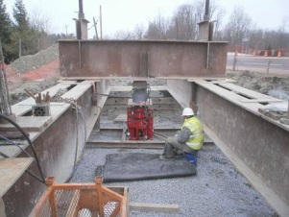

Figure 6. Picture of micropile load test setup

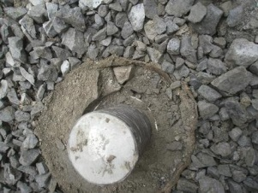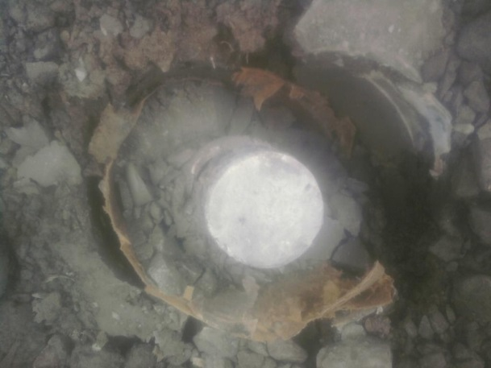

Figure 7 and 8. Pier 3 (left) and End Abutment (right) test micropiles after failure.

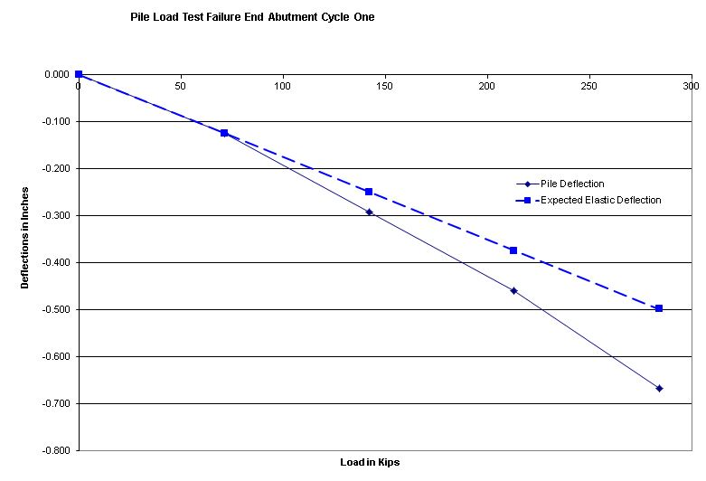
Figure 9. Failed pile load test for the End Abutment.

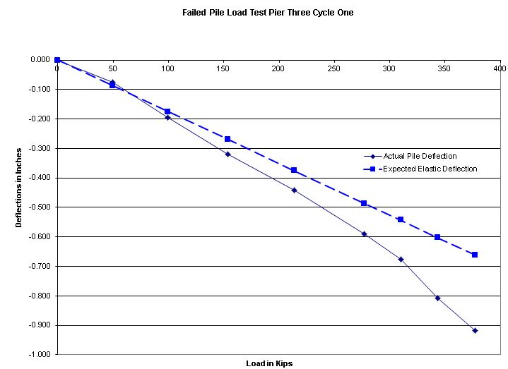

Figure 10. Failed pile load test for Pier Three.
For each separate location a test micropile was required to verify design. Since the specifications required the micropile be tested in compression, soil anchors were required on either side of the test pile to resist the resulting upward load from the jack. The soil anchors can be seen in Figure 9. A picture of the load test set up can be seen below in Figure 4. During the load test, deflection readings were recorded and the integrity of the micropile observed.

FINAL DESIGN AND FINAL LOAD TESTING

It was determined that in order to successfully transfer the loading to the bedrock casing was required. The Bond Stress Method calculations and the structural calculations both change. Due to the lack of bond between steel-soil the resistance between these two materials is not considered. This makes, theoretically, all of the loading transferred to the shale bedrock. In order to account for this the rock socket was increased to 6.5 meters into the shale. The final geotechnical and structural capacity for the cased micropiles was determined to be 1817 kN all contributed to the shale rock socket..
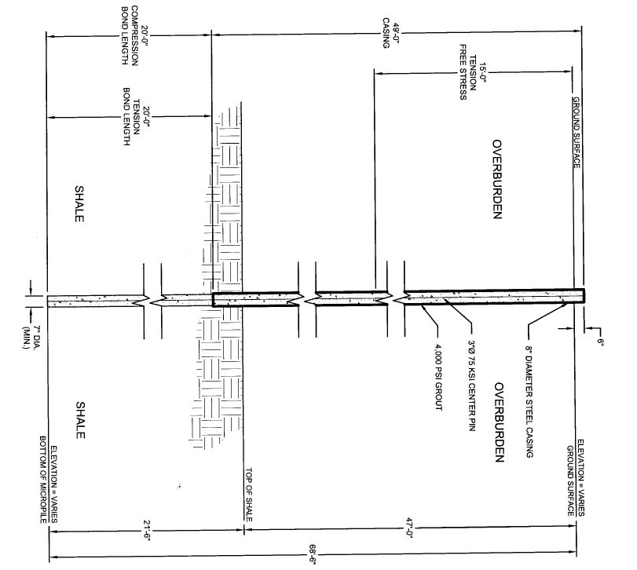
Figure 11. Final design for the end abutment that consisted of steel casing down to bedrock.
Adding 8-5/8” steel casing with a thickness of ½” allowed for additional structural capacity. With the steel casing of 50 ksi the structural capacity of the micropile becomes:

$$Q_{w(casing)}=g f_{c}^{1} A_{c}+s f_{y}A_{y}=1126 kips or 5,010 kN$$

This change in structural design allowed the micropiles to be tested without structural failure. Even with an additional moment, the added steel casing will withstand the added stress and transfer the load to competent soil stratum below.
Verification from passed load tests allowed for the construction of production micropiles. Many phone calls and open communication lines were essential through the testing process. Keeping everyone that was involved informed of what was going on made the redesign successful. The final design of the End Abutment followed by passing load tests can be seen below.

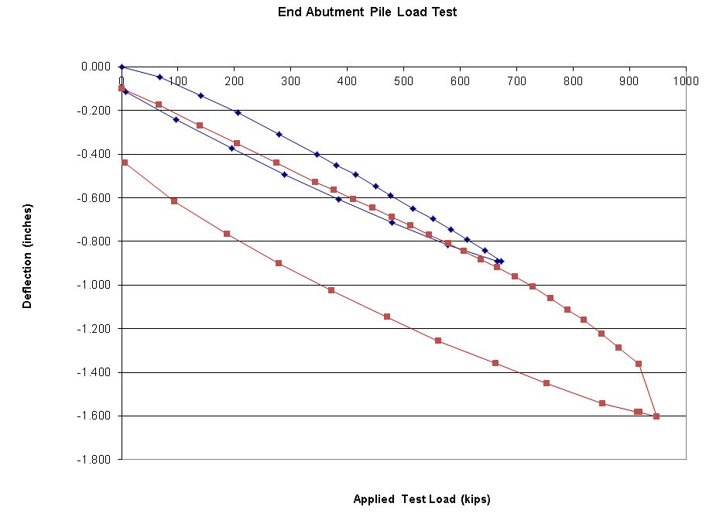
Figure 12. Successful load test for the End Abutment micropile. The final design consisted of outside steel casing. Notice the plastic failure that occurs at the end of cycle two.

POSSIBLE CAUSES OF FAILURE

Due to the size of the jack apparatus being larger than the micropile, it was discussed that a possible moment may be induced at the top of the micropile. This would cause bending at the top of the pile putting some of the pile grout in tension and additional stress in compression. The low tensile strength of grout may have led to cracking. With the large loads being applied to the micropile, any loading applied off center could become eccentric. The importance of centering the jack on the micropile was further discussed with the field testing technicians and further caution was taken with subsequent micropiles. It must be noted that due to the large loadings required for a high capacity micropile any off center applied loading can result in large moments induced.

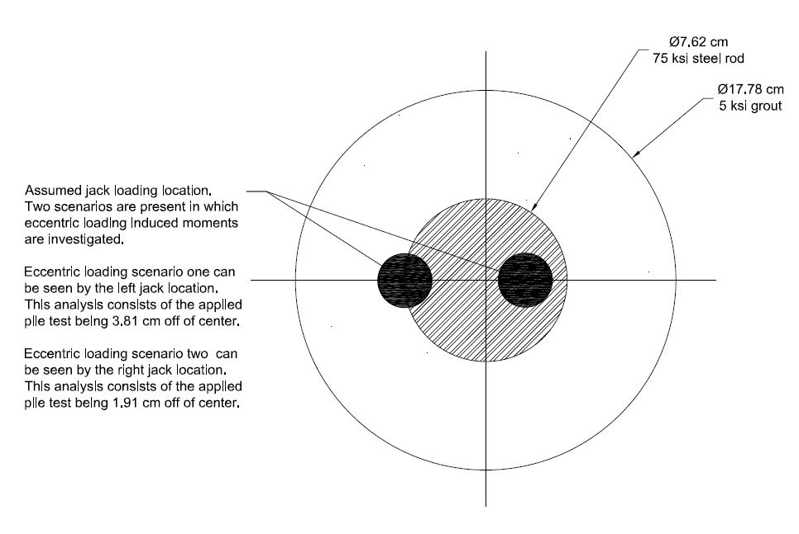
Figure 13. Eccentric loading scenario during pile load test.

An expected eccentric loading and the influence it may have on failed test results can be seen in the analysis below. An idealized elastic column with the cross section above reaches the maximum compression according to the following equation.

$f_{cu}= \frac{P}{A}+\frac{My}{I}$ (Eq. 2)

Where:

F_{cu} = maximum compression stress
P = axial load
M = positive applied moment
y = distance from centroidal axis
A = area
I = moment of inertia of the cross section

The analysis for the failed micropile test is conducted for the end abutment load test. A service limit of 1250 kN is required for this micropile. As per GCP-18 the pile must be loaded up to 200% of the service load as well as deflect no more than 0.15 mm per kN (1/32” per kip). However, only 1263 kN was applied before failure occurred. Notes from the load test technician indicate the pile shifted 10.16 cm (4 inches) westward during the beginning of the test. This may be due to the misalignment of the jack. After removing the jack it can be seen in Figure 6 the damage done to the micropile. Using the applied jack loading and the dimensions of the pile a theoretical calculation for added stress due to bending can be seen below. Assuming case one and case two as presented in Figure #. A sample calculation for case one is calculated first.

$$f_{cu}= \frac{\left(1263kN\right)}{\left(248.28{cm}^{2}\right)}+\frac{\left(1263kN\right)\left(3.81cm\right)\left(8.89cm\right)}{\left(4905.65 {cm}^{4}\right)} \\ f_{cu}=138,073 kPa or (20 ksi)$$

The location of the determined stress, y, is greatest for the concrete at location 8.89 cm from the center of the micropile. Table 3 below shows various analyses conducted for case one and case two.

Table 2. Summary of theoretical additional stresses added during the end abutment failed load test expected from eccentric loading.
Material | Compressive Strength | Case One  Greatest Stress | Case Two  Greatest Stress | Failure Expected | Failure Occur
Grout | 34,474 kPa  (5 ksi) | 138,073 kPa  (20 ksi) | 94,590 kPa  (13.7 ksi) | Yes | Yes
Steel Rod | 517,107 kPa  (75 ksi) | 88,243 kPa  (12.8 ksi) | 69,610 kPa  (10.1 ksi) | No | No

The eccentric loading analysis shows expected failure from the grout. This supports the pictures taken after the failed load test for the end abutment. It is concluded the lack of steel at the outside edges of the micropile causes large stresses in the grout. Adding casing to the design will alleviate these additional stresses on the grout allowing the successful transfer of the load into the rest of the micropile. It has been determined the cause of failure of the micropile is due to bending from an unexpected eccentric loading during testing. It should be noted the free head scenario presented during testing is not representative of the fixed head scenario typical of a pile cap system and should be kept in consideration during testing and design. Also, this problem has not been present before due to the large loadings applied to the high capacity micropiles for this specific project.
In addition to an induced moment, incorrect positioning of the jack may have caused point loading on the micropile. Instead on the load being distributed evenly over the surface area of the pile, the jack may have stressed a small location on the pile putting most of the load on one side. This puts a larger stress than anticipated on one side of the pile and may have led to the load test failure.
When tremie grouting a pile sometimes groundwater and soil debris may mix with the grout and be present at the top of the pile. This could have occurred during construction resulting in a reduced compressive strength of the grout at the top of the pile. However, due to the large additional stresses from an eccentric loading, construction methods are not considered a cause of the pile load test failure.

CONCLUSION AND FUTURE CONSIDERATIONS

This case study presents the process involved with design, build, and test micropiles. Load tests ensure the micropile can withstand the designated load. When failed load tests occur, redesign is necessary. The outcome of this project provided the owner with sufficient micropiles for the design, and reinforces the necessity for micropile load tests. Final applied loadings for the five test micropiles that passed were 6,000 kN, 5,200 kN, 5,345 kN, 6,327 kN, and 2,000 kN respectively. Buffalo Drilling Company, Inc. is investigating the possible causes of the load test failures, from design to construction methods, to prevent load test failures in the future.

Conclusions from the case study are as follows:

- Load testing techniques must be precise for high capacity micropiles
- Load testing scenarios may differ from actual applied service loads (fixed head vs. free head condition)
- Micropile load transfer mechanisms vary based on design and geotechnical parameters. Current micropile design theories, such as the Bond Stress Method, don’t fully investigate these components.
- Structural and geotechnical components both need deep consideration
- Loading of high loads off center results in large moments and eccentric loadings
- A combination of rod, casing, grout are needed for most high capacity micropile applications, effective design looks at the best combination of these to successfully transfer the load to competent soil stratums
- Quality and methods of load testing and relation to actual conditions

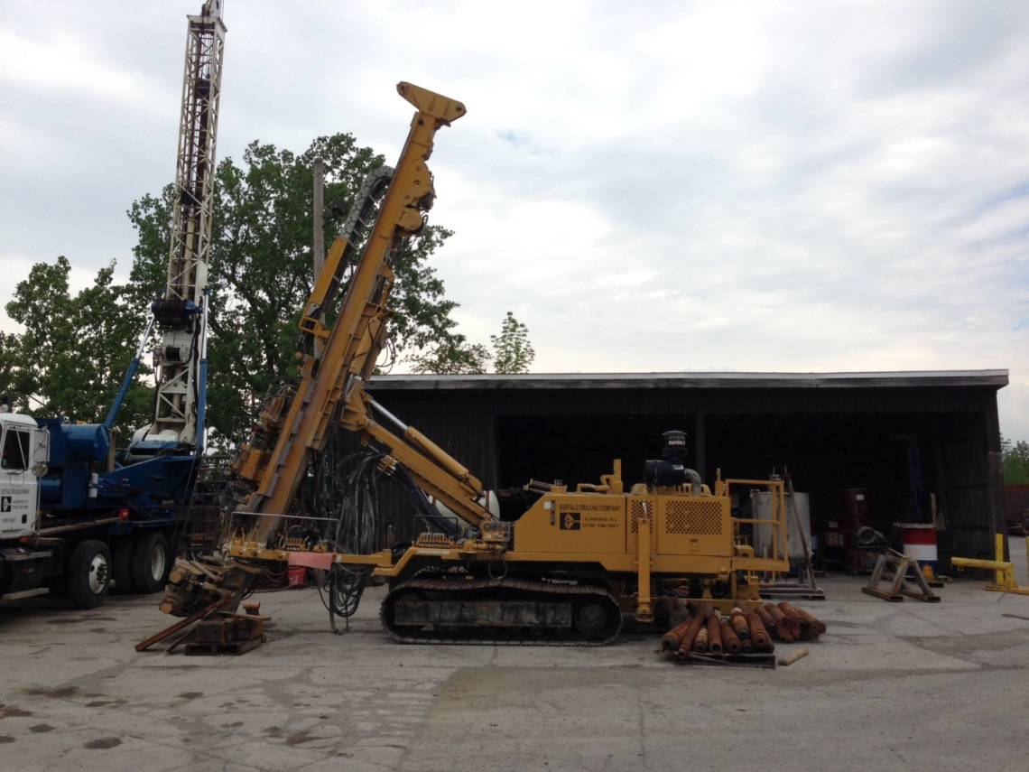
Figure 14. Davey Kent 725 drill rig used for the micropile construction owned by Buffalo Drilling Company, Inc.

Considerations include adding sensors in the micropiles of future load tests to determine how the load is distributed among the pile. This will give additional information of how the pile is interacting with the soil allowing for effective redesign if necessary. Design-build-test micropile project success is dependent on open communication and active discussion among parties involved.

Ackowledgements:

City of Poughkeepsie
Dutchess County
Shultz Construction
University at Buffalo

References

Bruce, D., & Juran, L. (1997). Drilled and Grouted Micropiles: State-of-Practice Review, Volume I-IV. McLean, Virginia: U.S. Department of Transportation: Federal Highway Administration.

Buffalo Drilling Company, Inc. (2012). Micropile Installations Dutchess Rail Trail (Stage 4) Poughkeepsie, New York. Buffalo, New York.

(1992). Canadian Foundation Engineering Manual, 3rd Edition. Canadian Geotechnical Society.

Federal Highway Administration. (2005). Micropile Design and Construction: Reference Manual. Washington, D.C.: U.S. Department of Transportation.

Lindeburg, M. (2012). Civil Engineering Reference Manual for the PE Exam, 13th Edition. Belmont, California: Professional Publications, Inc.

Shong, S., & Chung, F. C. (2003). Design and Construction of Micropiles. Kuala Lumpur, Malaysia: Gue and Partners Sdn Bhd.

Sivakugan, N. (2010). Geotechnical Engineering: A Practical Problem Solving Approach. Fort Lauderdale, FL: J. Ross Publishing, Inc.

Turan, A., Naggar, H., & Hinchberger, S. (2008). Lateral Behavior of Micro-pile Groups under Static and Dynamic Loads. Quebec, CA: Canadian Conference on Geohazards.

President and Geotechnical Engineer, Buffalo Drilling Company, Inc., 10440 Main Street, Clarence, New York 14031, Phone: (716) 759-7821, Fax: (716) 759-7823, Email: JBarron@BuffaloDrilling.com
Civil Engineer and Construction Manager, Buffalo Drilling Company, Inc., 10440 Main Street, Clarence, New York 14031, Phone: (716) 759-7821, Fax: (716) 759-7823, Email: THattala@BuffaloDrilling.com
Civil Computer Aided Design Drafter, Buffalo Drilling Company, Inc., 10440 Main Street, Clarence, New York 14031, Phone: (716) 759-7821, Fax: (716) 759-7823, Email: DKasprowicz@BarronandAssociatesPC.com
Civil Engineer, Buffalo Drilling Company, Inc., 10440 Main Street, Clarence, New York 14031, Phone: (716) 759-7821, Fax: (716) 759-7823, Email: DBarron@BuffaloDrilling.com Geotechnical Engineering Teaching Assistant, Department of Civil Engineering, University at Buffalo, 212 Ketter Hall, Buffalo, New York 14260, Email: Dmbarron@Buffalo.edu
The Bond Stress Method utilizes the soil to grout bond strength to determine the capacity of the micropile. Depending on the soil, a maximum bond value is chosen and the required length of the micropile is determined accordingly (Federal Highway Administration, 2005).

