Assessment of Soil – Micropile interface parameters using three – dimensional numerical modeling.

Maciej Szczygielski∗

Abstract

Plan of the research on assessment of soil - micropile interface parameters is presented in this work. Example of three - dimensional numerical model constructed in aim to accurately describe micropile behavior in soil is shown, and the further plans for the research are listed.

Introduction

Micropiles are nowadays well known and widely applied technique of constructing deep foundations. Due to specific technology of making micropiles, based on pali radice idea developed by Mr. Fernando Lizzi, micropiles scheme of work in ground is strictly related with connection parameters between grout of the pile and surrounding ground. Because of that main parameter in micropile vertical bearing capacity is the side friction stress. A statistically processed results of filed load tests gives information about value of this parameter for each type of soil. There are specially prepared guides for designers provided by micropiles manufacturers which allows to properly evaluate the micropile bearing capacity. In case of assessing displacements of micropiles this data is not enough and it is necessary to find more parameters which are describing mechanical behavior of soil-micropile interface. Analytical methods and numerical modeling used in assessing displacements of micropiles presents different mechanical models expressing the interface between soil and micropile. Mechanical model where interface is characterized as set of springs and sliders with specific stiffness and failure criterion is commonly used and considered as sufficiently precise (Misra et al., 2004) (Yang, et al., 2011). Knowing parameters of described above sets is than equal to knowing parameters of soil - micropile interface. For today this parameters are very rarely presented in literature, and there are no clear guidelines how to evaluate them. Lack of the information about interface parameters leads to situation when designer have to conduct back analysis of field load tests to obtain interface parameters for every project where they need to assess the micropile displacements (Nunez et al., 2013). In this circumstances, it is necessary to perform micropiles load tests before the design stage of the investment, what because of the additional costs of this procedure, is hardly ever carried out.
Method of assessing the soil - micropile interface parameters is presented in this paper. Method is currently under development, the aim is to find correlation between mechanical properties of the soil surrounding the micropile and parameters of soil - micropile interface. Analysis is going to be done with usage of three - dimension numerical modeling, in detail with application of finite differences method code Flac3D by Itasca. To conduct the numerous analysis needed for statistical and iterative processing of the results, database management systems will be used. Entry data for the research, in specific field load tests documentation, are provided by Titan Polska company.

REasearch outline

Research is based on the back analysis of axially loaded test piles, with usage of three - dimensional numerical modeling. It is essential, for the research to prepare clearly constructed and functional model reflecting the load test. Flac3D Itasca software is used in this purpose. Three separate elements of the model can be described: soil, micropile and interface elements between them. In effect three group of parameters have to be known: parameters of the soil which will be obtained from a documentation of the pile load tests, mechanical parameters of concrete and steel which can be obtained from the manufacturer of the micropiles, and finally the parameters of the interface element which are not known and the point of the back analysis is to obtain them in the calibration process of the model. The hypothesis of the research is that the interface parameters can be correlated with the mechanical parameters of the soil surrounding micropile. In that approach interface parameters are presented as function of soil parameters.
Calibration process goes in following manner: the modeled micropile is subjected to the axial force with the same value as in the field load test, then the settlements of the modeled pile are compared with settlements from the load test. The interface parameters are than adjusted and model is calculated again, this step is repeated until the settlements of the modeled pile are equal to settlements of the tested pile. Sample numerical model is presented in the next section of this paper. The main disadvantage of this approach is that the results for a single back analysis of micropile load test in layered soil are inconclusive, which mean that for the different set of interface parameters it is possible to get the same settlements values. That's why a large number of analysis have to be done, and results need to be compared.
In aim to optimise the process of conducting back analysis, two procedures are planned to be implemented. Firstly the construction of the model is going to be automatise by employing data base management systems which will allow to generate entry data file for Flac3D software, for specific ground conditions. Secondly the process of model calibration will be controlled by a FISH function which is a programming language implemented in the Flac3D software structure. This two features will decrease time effort of making single models for axial load test back analysis, and make this method more available for people with basic knowledge of numerical methods and 3D modeling.
In order to avoid the problem of inconclusive results, the comparison between parameters from different analysis will be carried out. Statistical and iterative methods will be used to correlate the results.

Sample 3D Numerical Model of axially loaded pile

Geometry, initial conditions and material assignment

3D numerical model is prepared with use of the Flac3D Itasca software. Usage of symmetry features reduced the size of the model, and analysis can be conducted on the half of the micropile. To reduce the effect of the boundary condition on the accuracy of the results, lateral boundaries are located at a distance equal to 50 diameter of micropile. Depth of the model is two times the longitude of the pile (Ghorbani et al., 2014). In effect model in shape of brick with dimensions 30 m x 15 m x 30 m was created. Model consist of 24000 zones. The displacement boundary condition were assumed for numerical calculations. The roller boundaries were placed on four sides of the model (horizontal x-axis and y-axis). The bottom of the model was fixed in all directions to simulate stable subsoil. Such boundary conditions are most suitable for analysing the interaction of micropile with surrounding soil mass.
As described above three elements can be specified in the model. First element is the soil surrounding the pile modeled with Coulomb - Mohr plasticity constitutive model. Second element is the micropile modeled as elastic concrete cylindrical structure with a steel beam in the center of it. Third element is the group of the interface elements located between pile and soil that are characterized by Coulomb sliding and tensile and shear bonding. Interfaces have the properties of friction, cohesion, dilation, normal and shear stiffnesses, and tensile and shear bond strength. Parameters of the interface should consider irregular structure of micropile and increased cohesive forces caused by grout injection. In order to install the interfaces, the grid representing soil is created first and the interfaces are attached to the zone faces at the boundary with the pile. The pile grid is created separately and then moved into contact with interfaces (Itasca Consulting Group Inc., 2013). Figure 1 shows the geometry of the model with all elements in detail.

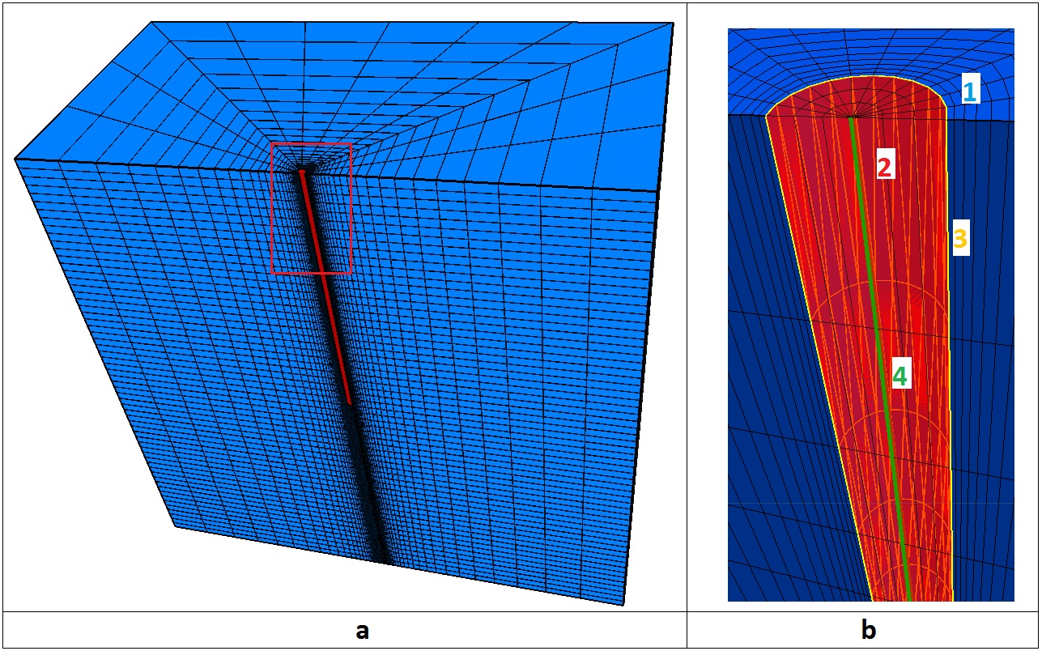
Figure 1: a) geometry and meshing; b) Model elements: 1 - Soil, 2- Micropile concrete grout, 3 - Interface elements, 4 - Micropile steel core;

Properties of materials

Soil properties assumed for calculations are presented below in table 1, parameters are obtained from geotechnical documentation of the overpass project, described more in details in the next part of this paper. Because of grout migration into the soil mass surrounding micropile, the region of higher mechanical ground parameter was assumed. Parameters equal to interface mechanical parameters are assigned to annular volume of soil mass around micropile with width of half diameter of micropile. Across this specified volume, parameters decreases to the soil mass mechanical parameters value.

Table 1 Soil properties used in calculations
Name of soil layer | Depth | Density | Angle of friction | Cohesion | Bulk Modulus | Shear Modulus
 | z [m] | r [$\frac{kg}{m^{3}}$] | f [°] | c [kPa] | K [MPa] | G [MPa]
Fine Sand | 0 | 1900 | 30 | 2 | 48,96 | 22,60
 | 7
Silt Sand | 7 | 2000 | 32 | 3 | 67,71 | 31,25
 | 30

Micropile is modeled as elastic concrete region with steel beam in the center of it. Connection between steel and concrete is set to be rigid. The parameters of micropile are described in table 2.

Table 2 Micropile parameters
Concrete grout
Diameter | Poisson ratio | Elastic modulus
d [m] | m | E [GPa]
0.3 | 0.2 | 30
Steel rod
Diameter | Poisson ratio | Elastic modulus
d [m] | m | E [GPa]
0.1 | 0.3 | 210

Soil - micropile interface is consider to be stiff in comparison with surrounding material, but can slip in response to the anticipated loading. In this case it is needed to provide a means for one sub - grid to slide relative to another sub - grid. The friction, cohesion, tensile strength and dilatation are important but the elastic stiffness is not. (Itasca Consulting Group Inc., 2013) Failure criterion parameters are assumed to be equal to grout parameters. Axial test load to which following numerical model corresponds was prepared for loads lower than bearing capacity of the pile. Because of that it is assumed that no yield occurs in soil - micropile interface, and there was no opportunity to validate the failure criterion parameters of the interface. Those parameters needs to be validate in test loads where loadings higher than baring capacity of micropile. However this sample micropile model confirms the stiff connection assumption, and gives information about micropile behavior in soil before the yielding occurs. Interface parameters are presented in table 3.

Table 3 Interface parameters
Shear/ Normal Stiffness | Cohesion | Friction | Tensile strength
k_{n,s} [$\frac{MPa}{m}$] | c [kPa] | f [°] | T_{s} [MPa]
100 | 1100 | 55 | 0,750

Model verification

Entry data for 3D numerical model construction was a part of documentation from overpass project, constructed in 2009 for express road S3 in Poland. Due to unfavorable soil conditions, the design scheme assumes micropiles as a foundation of the props. Every prop was based on group of 50 micropiles.
Test loads of one micropile in each prop have been conducted in aim to verify design assumptions. Designed bearing capacity of projected micropile was 1120 kN, and this was maximum value of test load force. Test load was conducted in 3 stages. Settlements were measured at 560 kN, 840 kN and 1120 kN. This results were used to present characteristics of micropile work in soil. Final conclusion from test is that the pile have been constructed properly and covered designed bearing capacity. Measured settlements are used again in 3D numerical model to verify correctness of its design. Comparison between measured and modeled settlements of the pile is presented in table 4.

Table 4 Settlements form test load and form numerical model
 | Force
 | 560 [kN] | 840 [kN] | 1120 [kN]
Settlements from test load | 3 [mm] | 6,7 [mm] | 15,66 [mm]
Settlements from numerical model | 1,31 [mm] | 4,87 [mm] | 18,12 [mm]

Summary

Outline of the research in aim to assess the micropile - soil interface parameters is presented in this paper. First step of the research is construction of three dimensional numerical model which properly simulate the micropile behavior in soils. Sample numerical model described in paper might be precise enough to achieve this requirements. To ensure this thesis further analysis must be conducted, firstly to check accuracy of emulating micropile behavior with no yielding, than to properly assess parameters connected with failure criterion of interface elements. Those actions will validate correctness of the numerical model presented in this paper.
When model verification step is completed, next planned actions are automation of constructing the model, which will be possible because of the clear base numerical model construction in form of the easy to edit text file, and statistical comparison of the results. Those all procedures are necessary to achieve the goal of the research.

Refrences

- Ghorbani, A., Hasanzadehshooiili, H., Ghamar, E., & Medzvieckas, J. (2014). Comprehensive threedimensional finite element analysis, parametric study and sensitivity analysis on the seismic performance of soil–micropile-superstructure interaction. Soil Dynamics and Earthquake Engineering 58 , 21-36.
- Itasca Consulting Group Inc. (2013). FLAC3D, Fast Lagrangian Analysis of Continua in 3 Dimensions. Theory and Background. Minneapolis, Minnesota: Itasca Consulting Group Inc.
- Itasca Consulting Group Inc. (2013). FLAC3D. Fast Lagrangian Analysis of Continua in 3 Dimensions. Example Applications. Minneapolis, Minnesota: Itasca Consulting Group Inc.
- Misra, A., & Chen, C.-H. (2004). Analytical solution for micropile design under tension and compression. Geotechnicaland Geological Engineering 22 , 199-225.
- Nunez, M., Briancon, L., & Dias, D. (2013). Analyses of a pile-supported embankment over soft clay: Full-scale experiment, analytical and numerical approaches. Engineering Geology 153 , 53-67.
- Yang, M.-h., Zhang, X.-w., & Zhao, M.-h. (2011). A simplified approach for settlement calculation of pile groups coniering pile-to-pile interaction in layered soils. Journal of Central South University of Technology , 2131-2136.

∗ M.Sc. Eng. Maciej Szczygielski, Department of Geomechanics, Civil Engineering and Geotechnics, Faculty of Mining & Geoengineering, AGH University of Science & Technology, Al. Adama Mickiewicza 30, 30-059 Kraków, +48 12 627 42 13, mszczyg@agh.edu.pl

