**HIGH CAPACITY MICROPILES IN WEAK DOLOMITIC LIMESTONE FOR CRANE FOUNDATION SUPPORT – A CASE HISTORY IN TEMPORARY FOUNDATIONS**

Terence P. Holman, Ph.D., P.E.[1] and Brian D. Barkauskas, P.E. [2]

**ABSTRACT:** A major combined nuclear and coal-fired power plant, located in the southeastern United States, has undergone multiple upgrades in recent years to increase power output and enhance environmental controls. Construction of new elements within the existing plant structure required working in highly congested conditions and heavy crane lifts with large picking radii. The largest crane pick involved the use of an 1800 metric tonne capacity Mammoet PTC ring crane for a single long-radius, high altitude lift of a precipitator unit. Original bid tender documents had called for drilled shaft foundation support, but the presence of many critical utilities and unfavorable conditions for cost effective drilled shaft construction led specialty contractor Moretrench American Corporation to propose an alternate foundation. Micropiles were proposed to the utility owner on the basis that high capacities could be achieved in the weak limestone geology and that the smaller size of micropiles would allow for more surgical installation in the utility-congested areas.

This case history will describe the design and construction of high capacity micropiles for the value engineering alternative and the crane foundation for this critical lift. Sixty eight (68) micropiles were employed to support the Mammoet ring crane, with each micropile supporting a working compression load of 1.78 MN. Each micropile was founded in a competent dolomitic fossiliferous limestone unit at typical depths of 23 m below existing ground surface. The design engineers selected a conservative working bond resistance because of a lack of experience with high capacity micropile design and constructability in the weak limestone bedrock along the western coast of Florida. Strain gauge instrumented load testing was used to validate the geotechnical design parameters and resulted in the finding that the entire test load was being carried in the upper half of the bond zone. Construction of the production micropiles required numerous relocations due to utility conflicts and local reanalysis and redesign of the 1.2 m thick reinforced concrete ring beam cap. Crane foundation performance for the single high load, long radius pick was satisfactory and the effective life of this temporary foundation was only 6 months before decommissioning and demolition.

**INTRODUCTION**

Crane foundation support represents one of the riskier problem areas in geostructural and construction engineering. The development of safe, constructible, and economic solutions to allow for assembly, support, and operation of large cranes and equipment for heavy construction projects is a specialized hybrid function of geotechnical, structural, and construction engineering. Existing power plant and other critical industrial facilities are among the most difficult environments to plan and conduct crane lifts due to the aerial congestion of pipe racks, stacks, towers, etc., frequent clearance limitations closer to ground level, and the dominating presence of underground utilities. Foundation design for heavy lifts in this environment mandates the use of flexible, maneuverable construction techniques such as those afforded by micropile systems.

A major combined nuclear and coal-fired power plant, located near the Gulf Coast in the southeastern United States, has undergone a series of important upgrades in recent years to increase power output and enhance environmental controls (i.e. reducing emissions). The most recent series of upgrades, valued at nearly $1.4B USD involved the fast-track construction of selective catalytic reduction and flue-gas desulfurization systems during the period from 2009 to 2010. Construction of new and upgraded elements within the existing plant structure required working in highly congested conditions and necessitated heavy crane lifts with large working radii.

The largest crane pick for this upgrade cycle involved the use of an 1800 metric tonne capacity Mammoet PTC ring crane for a series of long-radius, high altitude lifts for refurbished precipitator units and other equipment. The largest pick load was 230 metric tonnes. The Mammoet ring crane, similar to that shown in Figure 1, required a stable foundation with an outside diameter of 27.3 m. Moreover, the crane had to be situated within an area congested with below ground utilities, many of whose precise locations and characteristics were unknown.

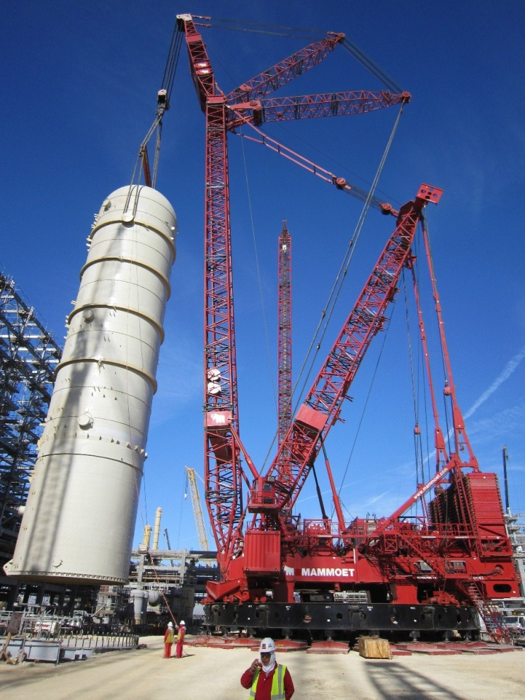

Figure 1. Photo of typical usage and setup for a Mammoet PTC35 ring crane (photo courtesy of Mammoet).

Ring cranes of the size necessary for this project typically require the use of a dedicated foundation to distribute their heavy loads and to limit detrimental movements under load. The base of the Mammoet ring crane is supported on 24 steel mats, to which tracks supporting the wheeled bogies are connected. Each mat is 2.40 m wide by 5.68 m long and is arranged in a radial pattern with a spacing of 15 degrees as shown in Figure 2. The design loading on each steel pad is 4.02 MN, for a total of 96.51 MN. The adjustable slewing radius of the counterweight stack maintains all loading on the crane foundation in compression.

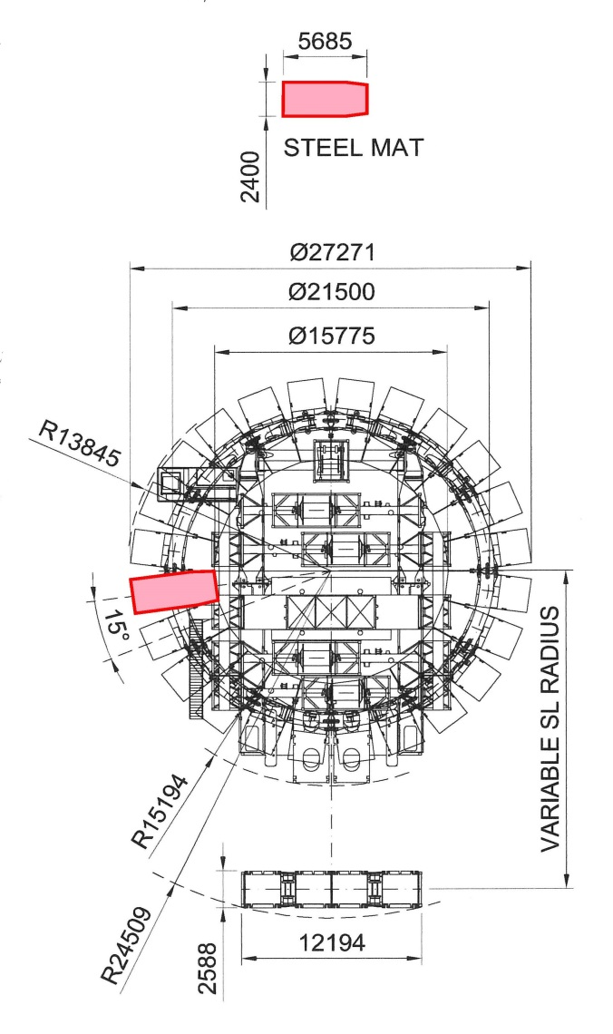

Figure 2. Crane layout and dimensions (in mm) for a PTC35 ring crane (image courtesy of Mammoet).

The project owner’s engineer developed a foundation design comprising a reinforced concrete ring beam supported by 38, 0.91 m diameter drilled shafts, advanced into the underlying limestone (limerock) layers. However, limited access and the presence of a significant number of unknown utility lines and duct banks made drilled shaft construction impractical. In addition, recent experience with drilled shaft construction on plant property and within the limerock, which contain numerous weak zones and significant voids, had been problematic, time-intensive, and costly. Based on these recent experiences, the owner was willing to consider value engineering alternatives for support of the PTC ring crane.

**DEVELOPMENT OF CONSTRUCTIBLE SOLUTIONS**

Moretrench American Corporation (Moretrench), a design-build geotechnical specialty contractor, evaluated the feasibility of installing the recommended drilled shaft foundation and concluded that a consistent pattern of shaft locations was not possible due to utility interferences. Moretrench’s evaluation of the subsurface conditions, access, and utilities indicated that a micropile foundation solution would be more constructible and would result in cost and schedule savings. High capacity micropiles, installed in a more surgical manner among the utility lines and in regular radial patterns in unimpacted areas, could be used to substitute for drilled shafts at a 2-to-1 ratio or better. An additional benefit of more closely spaced micropiles was the reduction in span length compared to drilled shafts, allowing consideration of a reduction in the design thickness of the ring-shaped pile cap needed to support the 24 steel pads and crane rails.

The preliminary design of the micropile alternative centered on choosing a realistically achievable and constructible micropile section, length, and layout. The typical subsurface profile at the project site, consistent in the two closest test borings, is illustrated in Figure 3. Previous micropile installation experience by Moretrench at another part of the power plant had indicated that the soft, porous Ocala Formation limestone degraded easily as a result of drilling, losing its rock-like structure; accordingly, it was decided to bypass the Ocala limestone altogether and develop the bond length in the Avon Park Formation, a compact, carbonate dolomitic limestone unit. This unit, characterized by Standard Penetration Test (SPT) refusal, was more stable than the Ocala and could sustain the type of drilling typical for micropile construction without destructuring.

Based on Moretrench’s experience with developing high capacity micropiles and in recognition of the project needs and subsurface conditions, a target working load of 1.78 MN was selected as the basis of the alternate to drilled shafts. This working load, when coupled with the need for a 1.22 m thick, reinforced concrete ring with outer radius and inner radius of 14.1 and 7.4, respectively, resulted in a minimum requirement for 62 micropiles. With an allowance for additional piles and relocations due to utilities, a design layout was developed for 68 micropiles as shown in Figure 4. The preliminary micropile casing tip elevation was established as 0.3 m below the top of the Avon Park Dolomitic Limestone, approximately 19.5 m below existing ground surface. A 244 mm casing outside diameter (OD) was selected for the initial design of the piles.

**DESIGN OF MICROPILE SUPPORT FOR THE RING CRANE**

***Structural Design of the Micropile***

Structural design considerations for the micropiles included development of cased and socket cross sections to safely the working load of 1.78 MN, with consideration for applicable building codes and general practices such as the International Building Code (IBC 2006) and general practices described by Sabatini et al (2005). Allowable stress design (ASD) methods were used to evaluate the required structural characteristics of the micropiles.

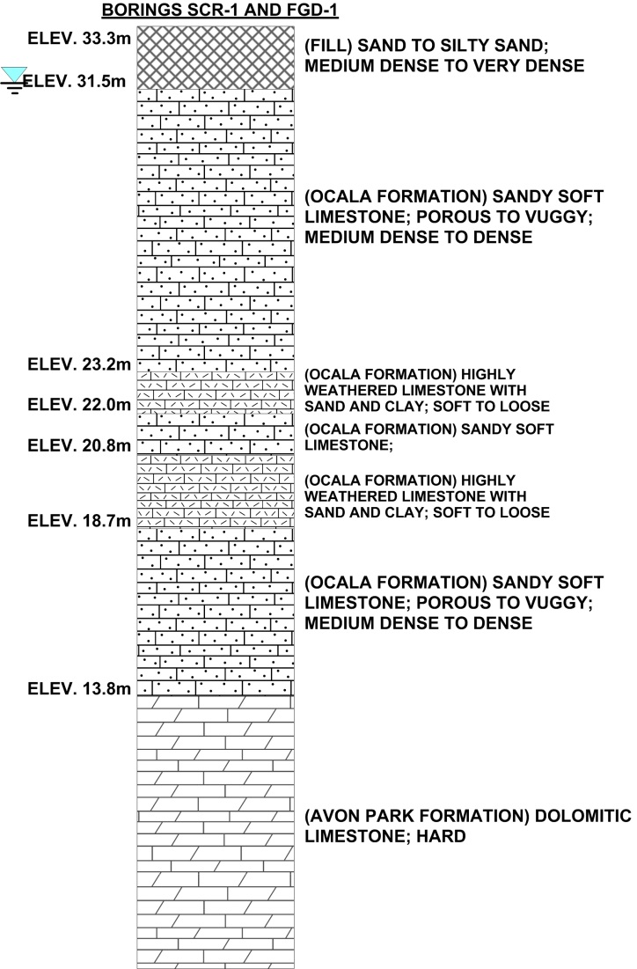

Figure 3. Typical subsurface conditions in the vicinity of the Ring Crane, test borings FGD-1 and SCR-1.

For constructability and drilling string rigidity, a 244 mm OD casing with 13.8 mm wall thickness was selected. This flush-joint casing was available in minimum yield strength Fy of 552 MPa. Figure 5 illustrates a vertical section through the design micropile section. A 44 mm diameter, Gr. 520 (ASTM A615) reinforcing bar was used in the cased portion of the micropiles to provide continuity into the bond length using a transition coupler. For the rock socket, assumed to be 216 mm in diameter, the reinforcing bar was required to be a 63 mm Grade 1034 (ASTM A722) threadbar assuming that the design compressive strength f’c of the neat cement grout was 34.5 MPa. For the micropile cased and uncased zone (i.e. rock socket) described above and used in the preliminary design, the working structural resistances of the micropile segments are:

Cased Length

 (Eq. 1)

Rock Socket

 (Eq. 2)

In Eq. 1 and Eq. 2, Cc, Cb, and Cg are allowable stress coefficients for casing, reinforcing bar, and grout, respectively; Ac, Ab, and Ag are cross sectional areas of casing, bar, and grout, respectively; and Fyc, Fyb, and f′c are the yield strength of the casing, yield strength of the reinforcing bar, and 28-day compressive strength of the grout, respectively.

The structural design of the cased length and rock socket assumed a high level of confinement for the centralized reinforcing bar; accordingly we have used a higher allowable stress coefficient for the reinforcing bar in consideration of the fact that it functions as a heavy steel core (based on the high strength steel occupying an area ratio of 8.6% of the rock socket) and accounting for a planned instrumented, compression load test. In addition, we used high strength reinforcing steel with an ultimate tensile strength of 1035 MPa. Based on previous, published instrumented load test and research data (Holman and Barkauskas, 2007; Bentler and Yankey, 2006) there is no practical reason to conform to the “strain compatibility” concept wherein the maximum usable failure stress for a reinforcing steel material is limited to that calculated from the assumed failure strain of 0.003 in concrete or grout materials. Confinement of the grout within a high stiffness rock or soil unit has been documented to increase the apparent ductility of the grout, extending the range of failure strains to beyond 0.005 to 0.01 (Li et al, 2005; Mander et al, 1989).

***Geotechnical Design of the Micropile***

The geotechnical design of the micropile centered around determining the required rock socket length to support the entire axial compression Strength Limit load of 1.78 MN. Conservatively, no side resistance was accounted for in the 19.2 m of Fill and soft Ocala Formation limestones. The rock socket geotechnical resistance was developed in side shear or bond to the very hard Avon Park limestone. Previous micropile tension load tests at this power plant had indicated that a unit side shear resistance, or bond stress b, of 690 kPa could be safely sustained in this rock unit with limited permanent upward movement. For confirmation, Moretrench also considered the unconfined compression and split tensile test data from samples in the Avon Park limestone. Based on methods of predicting skin friction values for drilled shafts in Florida limestones reported by McVay et al (1992), we estimated the unit bond stress to range from a lower bound of 1,060 kPa to an upper bound of 4,000 kPa. This estimation is based on the split tensile and compressive strengths of intact rock cores or samples. Limited experience with design and construction of micropiles in the Avon Park Formation led MORETRENCH to use the more conservative 690 kPa unit bond stress for preliminary design. The working (design) geotechnical resistance for the selected 9.14 m long rock socket, incorporating a factor of safety of 2.25, was

 (Eq. 3)

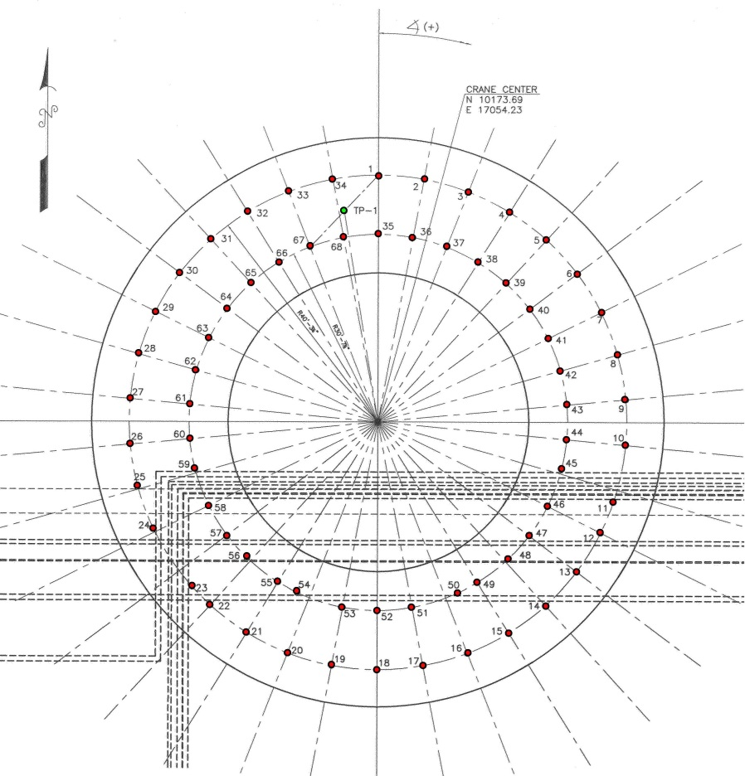

Figure 4. Original micropile layout for 68 piles.



Figure 5. Typical micropile design profile view.

***Structural Design and Detailing of the Cap***

Structural design of the reinforced concrete ring cap was performed by Civil and Structural Engineers, Inc. (CASE) of Lafayette, LA. CASE resolved the outrigger pad loads into an equivalent radial (line) load of 1,396 kN/m at the midpoint of the pad, located at a radius of 11 m from the centerpoint of the crane. When distributed to the two concentric rings of micropiles, situated at radii of 9.33 m and 12.27 m from the crane center, the resultant line loads are 823 kN/m and 626 kN/m respectively. Application of these line loads to a continuous member spanning between micropiles causes the critical span and moment to develop over the outer radial ring. Based on a factored maximum negative moment of -2,445 kN-m, the required flexural reinforcement in the 6.70 m wide cap was 8,450 mm2, which was distributed through the cross section as shown in Figure 6. The transverse flexural reinforcement of 1,884 mm2/m was designed to resist a factored moment of 760 kN-m/m.

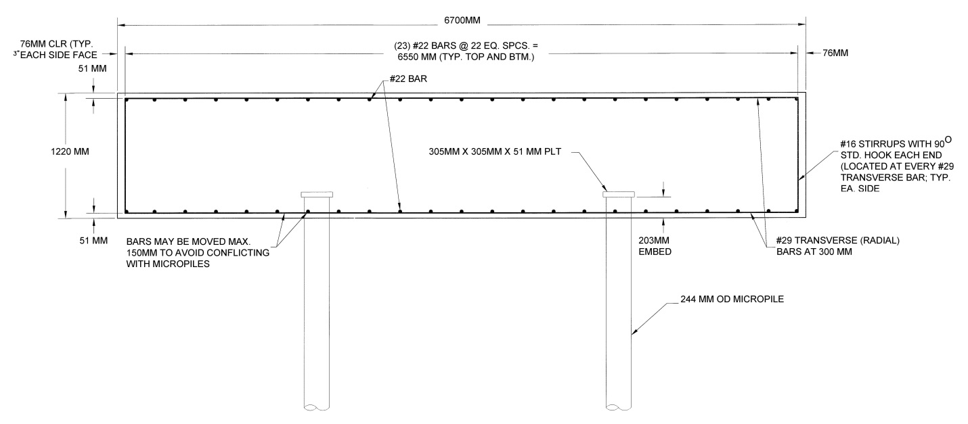

Figure 6. Reinforced concrete ring beam reinforcement layout and typical section.

**COMPRESSION LOAD TESTING**

***Test Pile Installation and Test Setup***

A compression load test was warranted because of the value-engineering nature of the micropile alternative, and because there was little experience on the Gulf Coast of Florida with high capacity micropiles, particularly those supporting large, critical crane loads. A sacrificial test pile was installed within the cap footprint using 244 mm OD casing size with 13.8 mm wall thickness and yield strength greater than 700 MPa. A Comacchio MC1500 hydraulic drill rig was used for installation of the test pile and all production piles. A conventional duplex drilling system with hard formation roller bit and water flush was employed to advance the test pile casing through the fill, overburden soils, and Ocala limestones to reach the competent Avon Park limestone. The driller noted little difficulty in drilling through the Ocala limestones and encountered thick sand seams within the rock, confirming suspicions that the Ocala was not likely to be capable of sustaining the high loads. After reaching the rock surface, the inner drill rod and roller bit were advanced below the bottom of the casing to drill the 9.14 m long rock socket. Seven Geokon Model 4911 sister bar-type vibrating wire strain gauges were installed within the test pile to allow for additional information to be obtained on the pile performance during load testing.

The reaction system for the specified cyclic compression load test to 2.0 times the design (working) load of 1.78 MN, equal to 3.56 MN, consisted of two tension reaction piles and a double wide-flange test beam. This load testing criteria is typical for practice in the United States and is in general accordance with ASTM D1143-07. The tension reaction piles were installed in the exact same manner as the test pile, but their reinforcing consisted of full length 63 mm Grade 1034 MPa reinforcing bars socketed 9.14 m into rock. The reaction beam comprised a heavily stiffened pair of W840 × 329 wide-flange beams strapped together for composite action and with a split-spacing of 152 mm. The minimum yield strength of the test beams was 345 MPa. After setup of the loading frame, the tension reaction anchors were proof-tested to 2.14 MN to ensure that they had adequate capacity and then locked-off at 100% of their anticipated loading during the load test, equal to 1.78 MN each.

Four dial gauges were used to measure downward movement of the test pile under the load increments. The dial gauges were mounted to an independent reference frame system. A piano wire and machine scale were also used as backup optical monitoring methods for the test. Two dial gauges were used for measuring the upward deflection at the butt of the tension reaction piles. The dial gauges were graduated in US-unit increments of 0.001 in (0.0254 mm).

***Performance of the Load Test***

The compression load test was conducted on 15 October 2009 in accordance with the Quick Method of ASTM D1143-07. Loads were applied to the compression test pile TP-1 in increments of 5% of the design (working) load with the load maintained for 4 minutes at each increment. The load increment at 100% of DL (i.e. 1.78 MN) was maintained for 30 minutes. The maximum test load of 3.56 MN, 200% of DL, was held for 60 minutes. At the conclusion of the loading sequence, the pile was unloaded in 4 decrements of 50% of the maximum applied test load, and then held at zero load for 60 minutes. Final rebound readings were taken 10 hrs after the completion of the load test.

Loads were applied using a calibrated hydraulic test jack, pressure gauge, and electric pump. The jack and pressure gauge were the primary load-application and measuring devices for the load test. A vibrating-wire load cell was also employed for this load test. Upon receipt of the load cell in the field, it was observed that 2 of the 6 internal strain gauges in the load cell were not operating properly even though the load cell had just been calibrated and all channels were seen to be working properly. The calibration data was adjusted in an attempt to remove the influence of these two faulty internal strain gauges, but the load cell performance was still considered suspect and the test was conducted on the basis of pressure gauge readings.

***Load Test Results and Analysis***

A plot of pile top load versus settlement is presented in Figure 7. The performance of the test micropile verified that the preliminary design was appropriately conservative. The measured settlements at design load (i.e. 1.78 MN) and test load (i.e. 3.56 MN) were 15.5 mm and 32.5 mm, respectively. Upon unloading back to zero load at the completion of the test, the permanent net settlement of the test pile was 5.7 mm, allowing that the gross load-deformation behavior to be classified as pseudo-elastic. Based on average elastic stiffnesses (i.e. EpAp) of 3,152 MN and 1,471 MN for the cased length and rock socket, it can be approximated that the load transfer in the test pile was limited to the upper 25 to 30% of the rock socket. Plots of the strain at each gauge level versus pile top load and a strain distribution with depth confirm this assessment; refer to Figures 8 and 9.

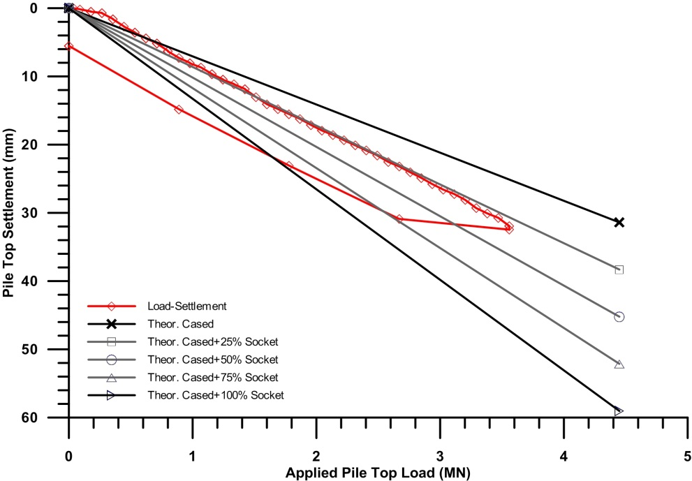

Figure 7. Load-settlement data from axial compression load test, including approximate elastic compression curves.

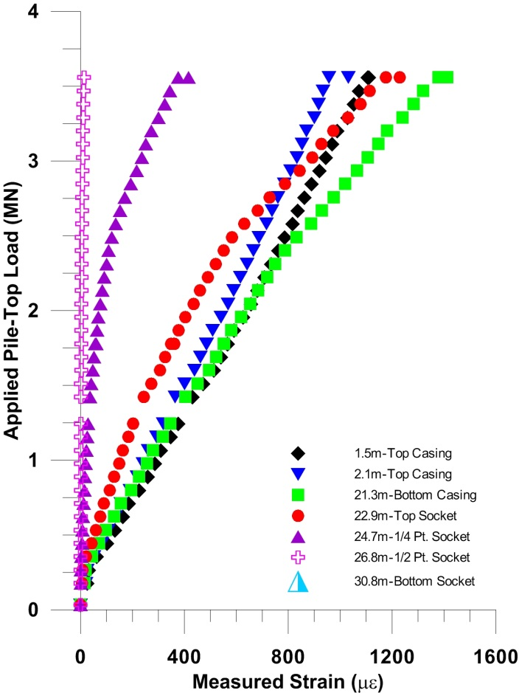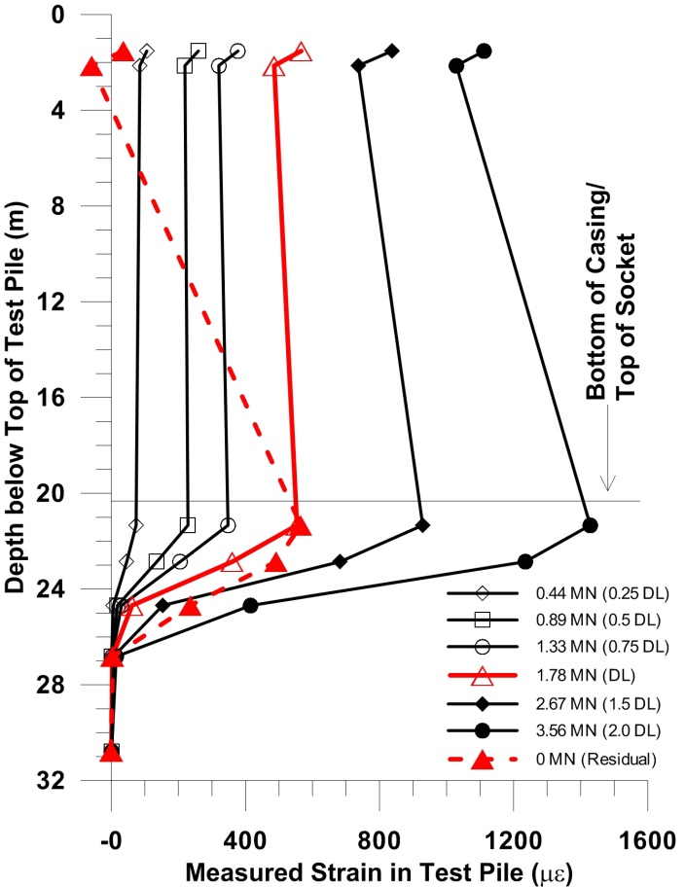

Figure 8. Measured strains at each gauge level versus pile top load.

Figure 9. Strain distributions in the test pile at selected pile top loads.

The strain distribution within the test pile was used to estimate mobilized load transfer and unit bond stresses. As documented by Fellenius (1989), Holman (2009), and Kai (2006), composite deep foundations comprising steel and grout or concrete have nonlinear stress-strain behavior, with the result that tangent and secant moduli used to describe the axial compression response are not constant values. The general trend observed is that interpreted secant moduli Ep, and the pile axial stiffness EpAp decrease with increasing strain levels. For micropiles, composite members with different cross sections and materials between the upper cased length and lower bond length, the decrease in stiffness has to be modeled for both sections of the pile (Holman, 2009). These procedures were followed for this project, and at each strain gauge level the load was estimated from

$P=εE_{p}A_{p}$ Eq. 4

Between strain gauge levels, where the pile load decreases through load transfer to the geomaterials, mobilized unit bond stresses mob were calculated by

Eq. 5

where P is the decrease in load in the pile segment, d is the segment diameter, and L is the segment length. Figure 10 shows the interpreted pile load distribution and mob in the micropile for various pile top loads. The maximum mobilized bond stress was 1,620 kPa in the upper ¼ of the rock socket; this value is almost 2.5 times greater than the ultimate value assumed in the preliminary design. The load distribution indicates that effectively zero load transfer and unit bond stresses were mobilized below the midpoint of the rock socket at 26.8 m below ground surface. Upon unloading of the test pile, significant residual compression loads remained in the rock socket, with an interpreted average unit bond stress of 545 kPa still mobilized. The presence of residual loads is qualitative evidence that some level of permanent displacement occurred in the rock socket relative to the surrounding limestone.

Based on the better than satisfactory performance of the test pile, and the apparent high degree of conservatism in the preliminary micropile design, it was apparent that reductions in rock socket length were possible. In the interest of accelerating the production pile installation schedule, it was decided to move forward with the original design lengths. In addition, Moretrench suspected that the uncertainties of utility location below the crane pad site might lead to localized load increases in the working pile loads, further justifying the level of conservatism in the micropile design.

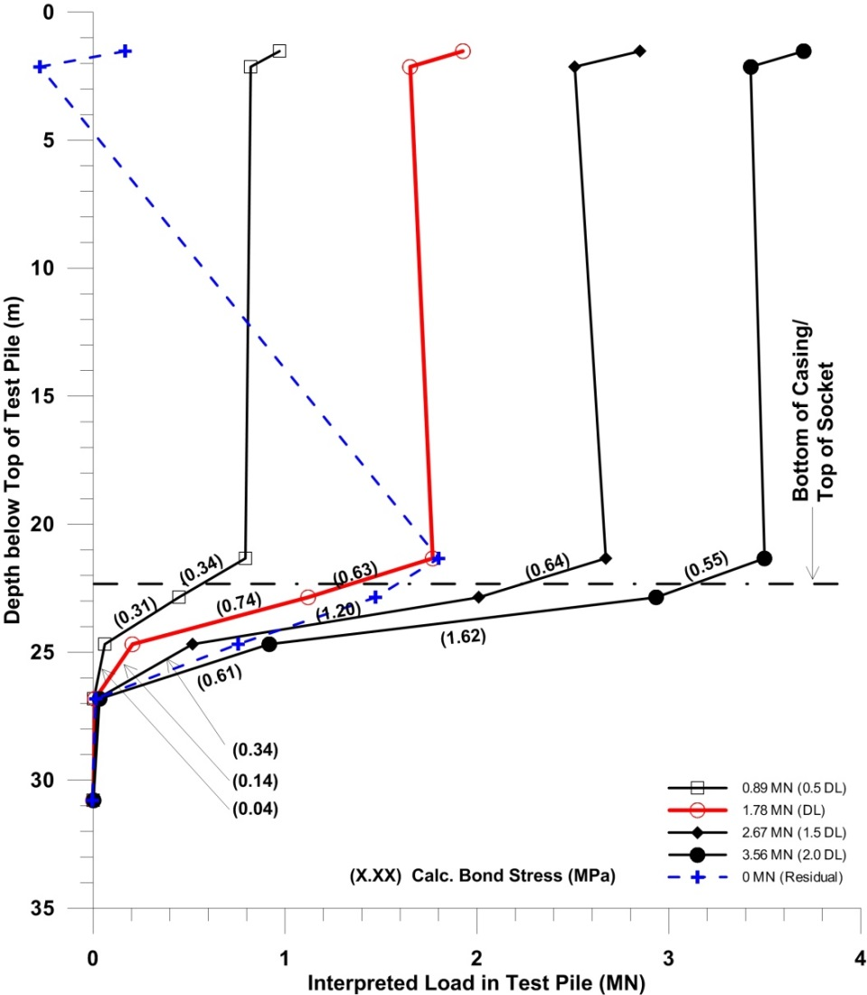

Figure 10. Load distribution and mobilized unit bond stresses in test micropile.

**PRODUCTION PILE CONSTRUCTION AND CHALLENGES**

Construction of the 68 proposed production micropiles was initiated immediately after successful completion of the compression load test using the same MC1500 drill rig and tooling setup. The installation process was the same as that for the test and reaction piles, with typical casing installation depths of 22.2 to 22.4 m below ground surface. No issues were encountered in the drilling of the rock sockets to the same diameter and length as for the test pile. All production piles were completed during the period from 19 October 2009 to 28 October 2009. Partial installation of many casing sections had been initiated during the curing period for the test and reaction piles and used as a method used to accelerate the construction process.

Moretrench exposed all of the utility lines within the vicinity of the crane pad. As anticipated, there were many conflicts between the planned micropile locations and the buried utilities. Figure 11 depicts one of the many utility excavations. An additional five micropiles were installed as a result of utility issues and the need to reduce spans between piles to make the pile cap thickness and reinforcement work. Figure 12 shows the final as-built pile layout, including the five additional piles. Even with the additional piles, extra reinforcement was required in many areas to allow the planned 1.22 m thick cap to be sufficient.

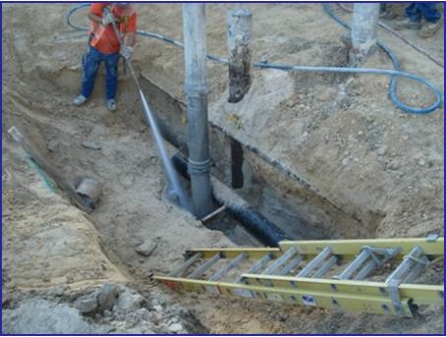

**Figure 11. Micropiles surgically installed to clear existing utilities.**

.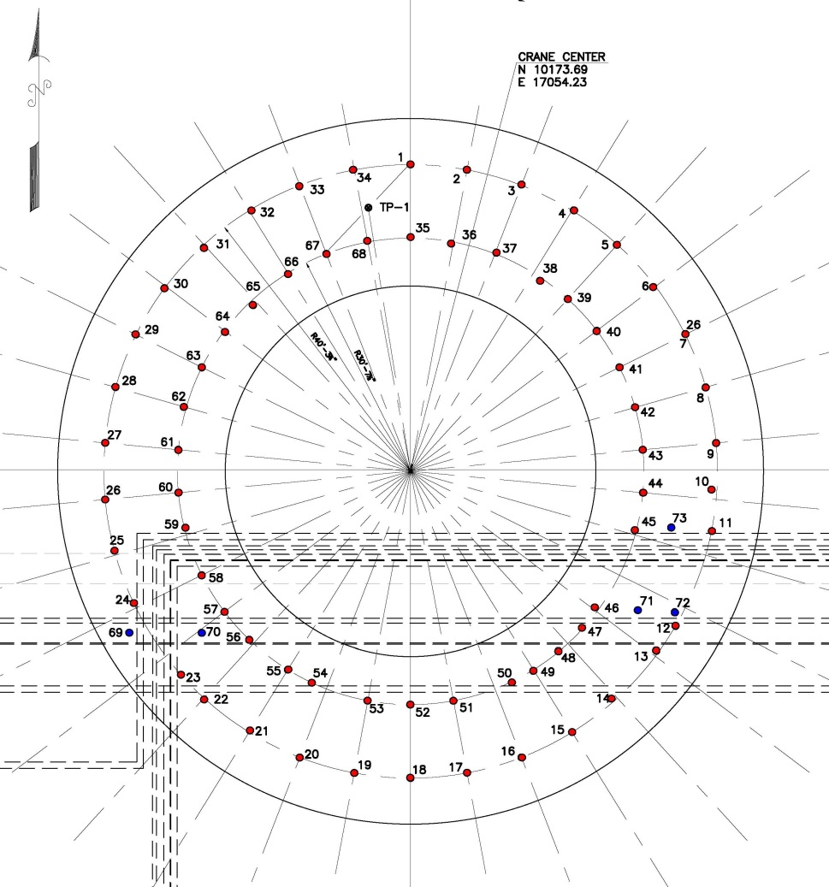

**Figure 12. As-built arrangement of 73 micropiles including 5 additional piles installed to span utilities.**

Based on the as-built micropile configuration, some localized overloading of the piles was anticipated due to longer spans. For example, working loads in the southeast quadrant were expected to reach 2.16 MN, a 22% overstress. In the southwest quadrant, the overstress was less than 5%. Based on the rigidity of the cap and the additional load-carrying capacity based on the load test results, the overstress was considered acceptable.

The ring beam pile cap reinforcement and formwork was constructed and concrete placement occurred on 24 November 2009. An in-progress photo of the reinforcement and formwork placement is shown in Figure 13. The design concrete strength of 34.5 MPa was reached in three days and a compressive strength of 41.4 MPa or higher was measured at seven days.

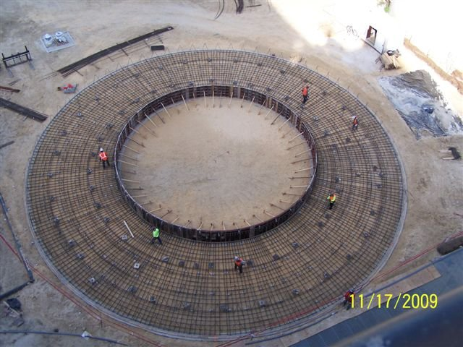

**Figure 13. Placement of bottom mat of reinforcing steel and concrete formwork.**

**PERFORMANCE OF THE RING CRANE FOUNDATION**

The Mammoet 1800 metric tonne ring crane was assembled during December 2009 and January 2010. No issues were encountered with pile cap and foundation performance during the initial construction. During assembly and operation of the crane, on-board instrumentation did not indicate any deformations that were out of the range of safe operation. Active crane use began in February 2010 and continued until late May 2010. Figure 14 shows a photo of the ring crane during operation at the end of February 2010. The crane was dismantled during the period from May to June 2010; the foundation, including the micropiles, was demolished in June 2010.

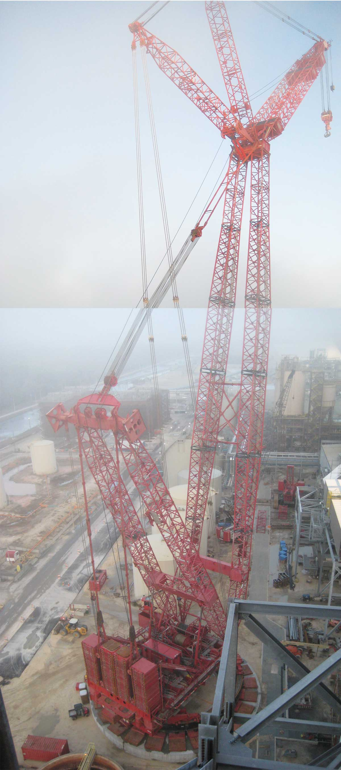

**Figure 14. Mammoet PTC ring crane in operation, supported by the value-engineered micropile foundation.**

**CONCLUSIONS**

This case history demonstrates the significant advantages that micropiles had over larger diameter drilled shaft foundations for support of a heavily loaded ring crane in difficult conditions. The micropile alternative, with a replacement ratio of slightly more than 2-to-1 over drilled shafts, offered the ability to adapt to the complex buried utility system, develop very high working loads in a limited cross section within weak limestone rocks, reduce the concrete cap thickness, and accelerate schedule. A system of 68 micropiles, with a 1.78 MN working load each, were designed to support a Mammoet PTC 1800 metric tonne ring crane exerting a foundation load of 96.51 MN, not including the dead load of a ring beam pile cap. Micropile locations were established to span over buried utilities and with the understanding that adjustments or near-surgical installation were possible; this is very difficult for large-diameter foundations like drilled shafts. Extension of the micropile casing down to the stable Avon Park dolomitic limestone allowed for the development of load transfer within a competent stratum that did not degrade during rotary drilling. Measurements during the compression load test indicated that the unit bond stress selected for preliminary design, based on previous tension load tests at the plant site, were very conservative. Given the time to revise our design and submit it for approval, reductions in rock socket length of up to 3 m would have been feasible. A total of 73 production micropiles, over 31 m long each, were installed in a period of less than 20 calendar days with no quality control issues. The crane and micropile-supported foundation, only in operation for about 4 months, performed well.

**ACKNOWLEDGEMENTS**

Moretrench American Corporation was the general contractor for this crane foundation project and their design consultant was Civil and Structural Engineers, Inc. of Lafayette, LA. Many thanks go to Moretrench field engineering and skilled labor personnel for their efforts in constructing these micropiles and conducting the load tests with great professional skill and care. The authors also wish to thank the executive management of Moretrench and Geosyntec Consultants for supporting internal research and development efforts for the purpose of advancing the state of the art in micropile analysis, understanding, and innovative use.

**REFERENCES**

Bentler, D.J., and Yankey, G. (2006). “Grout confinement influence on strain compatibility in micropiles,” *Technical report to the ADSC/DFI Joint Micropile Committee-Micropile Strain Compatibility Research*, Fuller, Mossbarger, Scott, and May Engineers, Inc., Lexington, 251 pp.

Fellenius, B. (2001). “From strain measurements to load in an instrumented pile.” Geotechnical New Magazine, Vol. 19, No. 1, 35-38.

Fellenius, B. (1989). “Tangent modulus of piles determined from strain data.” *Proc. of the Congress on Foundation Engineering: Current Principles and Practices*, ASCE, Vol. 1, 500-510.

Holman, T.P. (2009). “Pseudo-elastic performance and response of micropiles.” *Proceedings of the 9th International Workshop on Micropiles*, London, United Kingdom, May 10-13, 19 pp.

Holman, T.P. and Barkauskas, B. D. (2007). “Mechanics of micropile performance from instrumented load tests,” American Society of Civil Engineers, Geo-Institute, *7th Intl. Symposium on Field Measurements in Geomechanics*, Boston, 14 pp.

Kai, L.S., Kian, L.T., and Huat, T.A. (2006). “Analysis of strain-dependent concrete modulus from mass instrumented test pile samples.” *Proceedings of the 10th Intl. Conference on Piling and Deep Foundations*, Deep Foundations Institute/EFFC, Amsterdam, 684-689.

Li, Y-F., Chen, S-H., Chang, K-C., and Liu, K-Y. (2005). “A constitutive model of concrete confined by steel reinforcements and steel jackets.” *Canadian Journal of Civil Engineering*, Canadian National Research Council, Vol. 32, 279-288.

Mander, J.B., Priestley, M.J.N., and Park, R. (1989). “Observed stress-strain behavior of confined concrete.” *Journal of Structural Engineering*, ASCE, Vol. 114, No. 8, 1827-1849.

PTI (2004). *Recommendations for Prestressed Rock and Soil Anchors*. Post Tensioning Institute, 98 pp.

1. Associate Engineer, Geosyntec Consultants, 1420 Kensington Rd, Oak Brook, IL 60524 [tholman@geosyntec.com](mailto:tholman@geosyntec.com) (formerly Senior Engineer, Moretrench)
2. Area Manager, Moretrench, 144 Dexter Drive, Monroeville, PA 15146, [bbarkauskas@mtac.com](mailto:bbarkauskas@mtac.com)