Experimential Study of Load Transfer Characteristics of Reinforcing Piles

Seonghun Cho, Changho Choi

ABSTRACT

Architectural retrofits that vertically expand condominiums are accompanied by an increase in gravity load, and as such, it is necessary to install additional piles to support the increased gravity load. Condominium buildings in Korea are generally supported with a strip or mat foundation lying on precast concrete piles. The additional piles, which are micropiles in general, are designed to support the amount of load increased by connecting to the existing foundation, but there is a lack of knowledge on how the increased load transfers to the new piles. In this study, analysis by construction stage is introduced to understand how the additional load transfers to existing and reinforced foundations, and a laboratory device was developed to understand the load transfer phenomenon of such additional piles during architectural retrofit. Preliminary tests were performed and the results show the additional pile does not exactly get its design load from added floors.

1. Introduction
Recently, the Korean government has reported a real-estate policy encouraging the vertical expansion of residential buildings. Vertical expansion with additional floors causes gravity load to increase. But as the existing foundations were not originally constructed in consideration of such load increment due to additional floors, the installation of an additional foundation is required. Micropile can be applicable for extend a building to reinfoce the foundation. At the design step of reinforcement, generally, existing and reinforcing foundations are assumed to support the load from the existing structure and additional floors. However, there is a lack of understanding of how the additional loads transfer into the reinforced micropile foundation. KICT(2013) has introduced construction staged-analysis from the structural perspective, and noted how the pile reaction force differs from that of the conventional analysis method. The conventional analysis assumed that the structure after vertical expansion is a new building. It thus postulates that old and additional piles take the loads with even distribution. However, construction staged-analysis considers the existing structural load applied on old piles and the additional load due to vertically expanded floors applied both on old and reinforcing piles. Conventional and construction staged analysis can be defined as shown in Fig. 1. P₁ is the load of the existing structure and P₂ is the load of the additional floors. As shown in the conventional analysis, P₁ and P₂ are supposed to be supported with piles n₁ and s₂ in an evenly distributed manner. However, in the construction staged analysis, P₁ is supported with n₁ and P₂ is supported with n₁ and s₂. The means the additional load P₂ is transferred to existing piles, which is not supposed to be the case.
In this paper, laboratory experiments were set up to understand the load transfer phenomenon of additional piles. At the initial stage of loading the load is supported with four piles with a pile cap, and an additional pile is installed on the pile cap. Then, additional load is applied on top of the initial loading. Some preliminary test results showed that additional loads do not properly transfer to the additional pile.

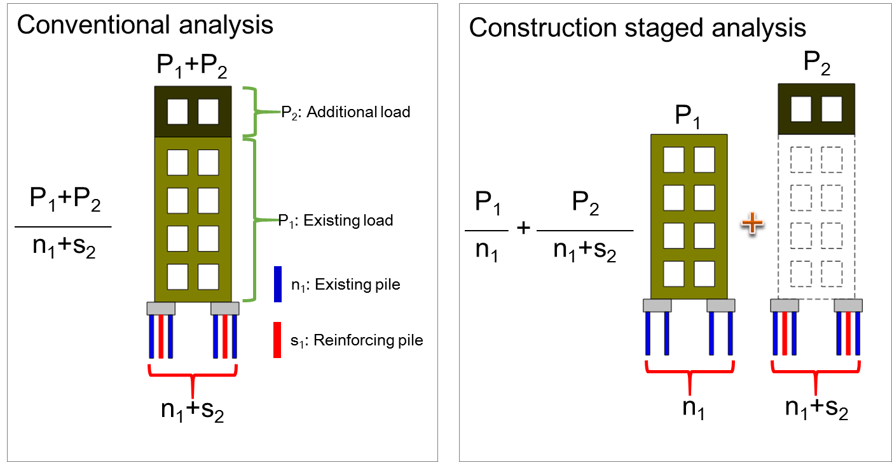
Figure 1. Schematic conventional and construction staged analysis

2. Single pile test
2.1 Laboratory experiment
In this study, conventional analysis and construction staged-analysis were simulated in a proposed laboratory device. The miniature model piles made up of aluminum were hung in a soil container, and then the soil ground was prepared by air-pluviating Joomoonjin standard sand with a relative density of 40%. Table 1 shows the engineering properties of the Joomoonjin sand specimen. The specific gravity of Joomoonjin is 2.65 and the internal friction angle and dry unit weight when the relative density D_{r} is 40% are 35.6˚ and 1.44g/cm³, respectively. Young’s modulus and diameter of aluminum pile are 69GPa and 20mm. Embedded length of the pile is 300mm. For the laboratory test, a special device was developed to describe the load test of a single pile, as shown in Fig. 2. The laboratory device has screw threads in an acrylic pipe. The screw threads create vertical displacement, and push down the pile head located in the center.

Table 1. Properties of Joomoonjin standard sand and aluminum model pile
Joomoonjin Standard Sand |  |  | Model Pile
Specific Gravity($G_{s}$) | 2.65 |  | Material | Aluminum
*Unit weight | 1.44 $g/{cm}^{3}$ |  | E(GPa) | 69
*Internal Friction angle | 35.6 ˚ |  | Diameter(mm) | 20
Max. Unit Weight($γ_{max}$) | 1.66 $g/{cm}^{3}$ |  | Pile length (mm) | 300
Min. Unit Weight($γ_{min}$) | 1.33 $g/{cm}^{3}$
*$D_{γ}=$40% using air-pluviation specimen preparation method
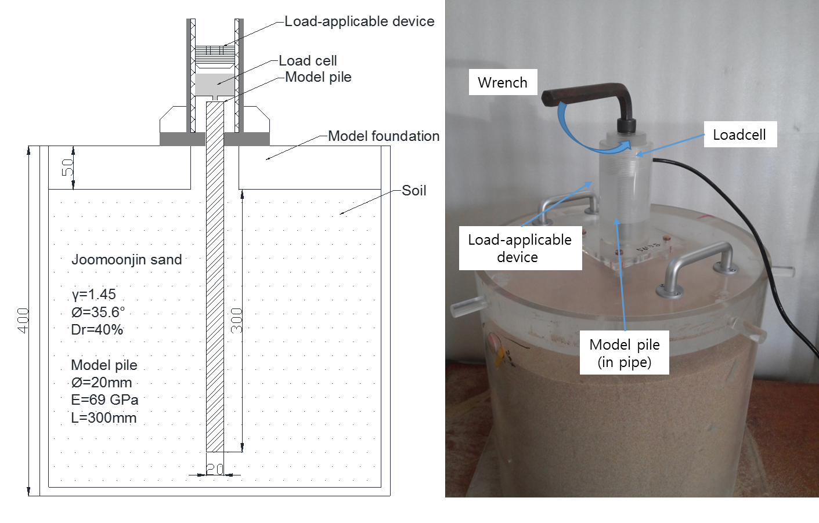
Figure 2. Picture of a laboratory device developed for single pile load test

2.2 Single pile test result
First, an experiment to obtain bearing capacity of single pile was performed. The ultimate bearing capacity of a single pile was obtained under displacement controlled conditions. Figure 3 shows the load vs. displacement curve of a single pile. The average ultimate bearing capacity of single pile was determined as 4.3kgf by applying a hyperbolic extrapolation method (Paikowsky, 1999). Analytical ultimate bearing capacity must be 4.21kgf according to ISO(2007). Considering the test and analytical results, the ultimate bearing capacity of a single pile is 4.25kgf. In addition, its allowable bearing capacity is 2.13kgf, using a safety factor of 2(F.S.=2). The load-displacement curve might be divided into three sections. The first section(A) is an elastic zone that has small settlement along the load increase until it reaches the allowable bearing capacity of a single pile. The second zone(B) falls between the allowable and ultimate bearing capacity, in which the increase rate of displacement changes rapidly. And the last zone(C) is bearing capacity, which reaches to the ultimate state.
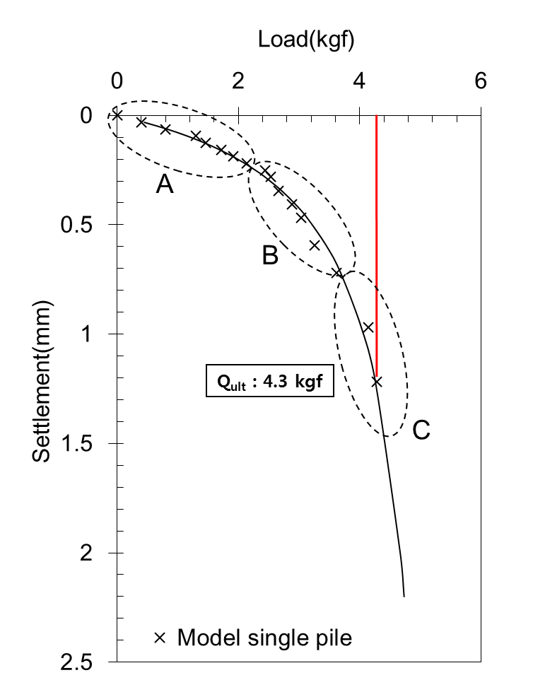
Figure 3. Ultimate bearing capacity of single pile

3. Multiple Pile test
3.1 Laboratory equipment
In order to simulate the construction staged analysis, it is necessary to apply allowable bearing load to the existing four piles and additional loads to the new group comprising the existing piles plus an additional pile. Figure 4 shows multiple pile experimental equipment. The equipment includes four existing piles and one additional pile. Five load cells were installed at the top of individual piles to measure the load distribution. To set up the experiment, we first hung all piles in the soil container and then air-pluviated soil. Second, loadcells and pile caps were installed on the pile heads in sequence. Third, allowable bearing load(P₁) was applied on four existing piles using weight plates. Fourth, load applicable device for additional pile was installed on top of the weight plates(P₁). Finally, additional load(P₂) was applied to the four existing and additional piles. The settlement was measured with a digital dial gauge from the displacement datum point.
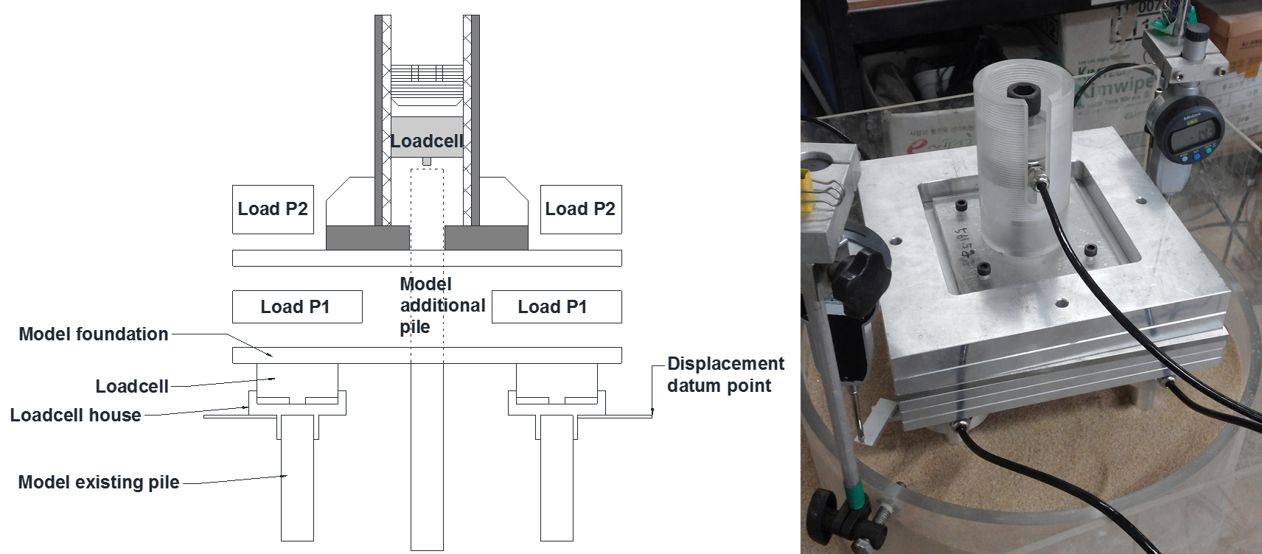
Figure 4. Laboratory device to test construction staged analysis for pile.

3.2 Load stage of multiple pile experiment
With the same soil type described in section 2.1, construction staged experiment was performed under load control conditions. Settlement is measured at the foundation slab denoted as displacement datum point in Fig. 4. Table 2 shows load stage. P1 (existing load) was applied to for existing piles along four load stages. At stage 5, an additional pile was installed with the load-application device. Then, additional load P₂$(21.6kgf)$ was applied to both the existing and additional piles through pile cap. Finally, the accumulated load of 30.31kgf was applied to all five piles. The load was applied beyond the ultimate bearing capacity of five piles to observe the pile behavior at limit state.
Table 2. Load stage of multiple pile experiment
Load  Stage |  | Load applied piles* | ΔP  (kgf) | Acc..  P(kgf) | Remark
P1 | S1 | E | 2.5 | 2.5 | 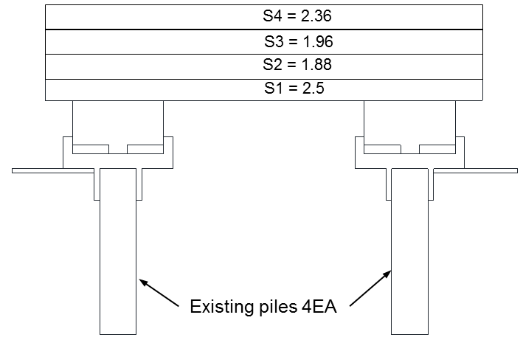
 | S2 | E | 1.88 | 4.38
 | S3 | E | 1.96 | 6.34
 | S4 | E | 2.36 | 8.70
P2 | S5 | E+A | 1.96 | 10.66 | 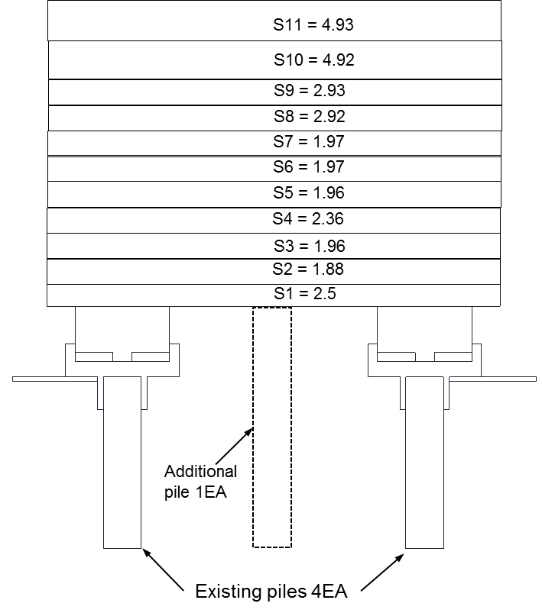
 | S6 | E+A | 1.97 | 12.63
 | S7 | E+A | 1.97 | 14.60
 | S8 | E+A | 2.92 | 17.52
 | S9 | E+A | 2.93 | 20.45
 | S10 | E+A | 4.92 | 25.37
 | S11 | E+A | 4.93 | 30.30
 |  |  |  |  | *E= Existing pile, A= Additional pile
3.3 Multiple pile test result
Figure 5 shows the load-displacement curves of existing (solid line) and additional (dotted line) piles. The load-settlement curve for existing piles was obtained by averaging the loads of four loadcell readings. The curves were fitted by hyperbolic extrapolation. When P₁ was applied to existing piles, ja load ranging from 0.55kgf to 1.92kgf was transfered to the piles. With the application of P₂, the additional pile initially does not take the load at all as shown in point A of Fig.5. As P₂ increases, the added load tends to transfer to the additional pile, as shown in Fig. 5. The test result indicates that additional pile added to existing slab or pile cap does not take its design load. As the settlement develops, the applied load is evenly distributed to existing and additional piles.
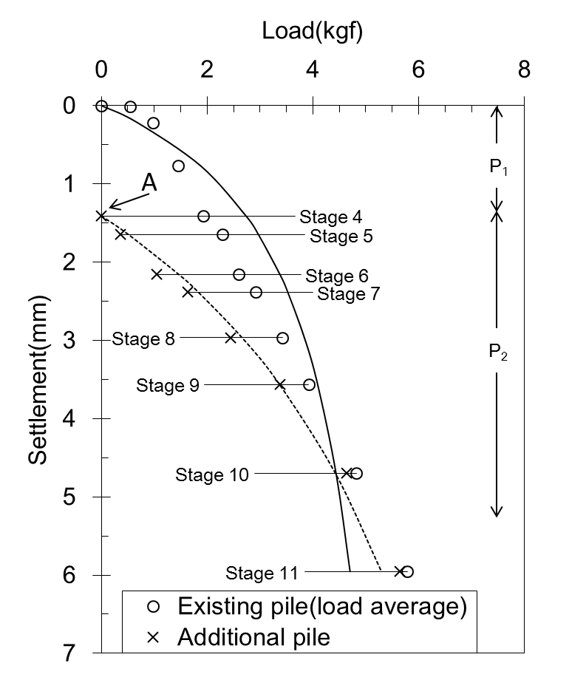
Figure 5. Load-settlement curve of multiple pile experiment
Figure 6 shows the load distribution ratio(LDR) of existing and additional piles with the settlement from slab. The ‘o’ symbol represents the average LDR result of four piles and the ’x’ symbol represents the LDR of the additional pile. The ‘▲’ symbol is the slab settlement with additional load P₂. LDR of existing piles is 25% (four existing piles) when the applied load is P₁(stage 4). As the settlement develops, LDR of existing piles decreases in a linear manner, while LDR of the additional pile is increased. At the start of P₂ loading, LDR of each existing pile is 25%, and then decreases to 20% as it is supposed to. At the beginning of the experiment, the LDR of the additional pile was very low (compared with LDR of the existing pile). As settlement developed, LDR of existing and additional piles converged towards 20% of total load. In other words, the existing pile takes the load at the beginning of the P₂ loading stage, and all piles take the same load when settlement fairly develops.
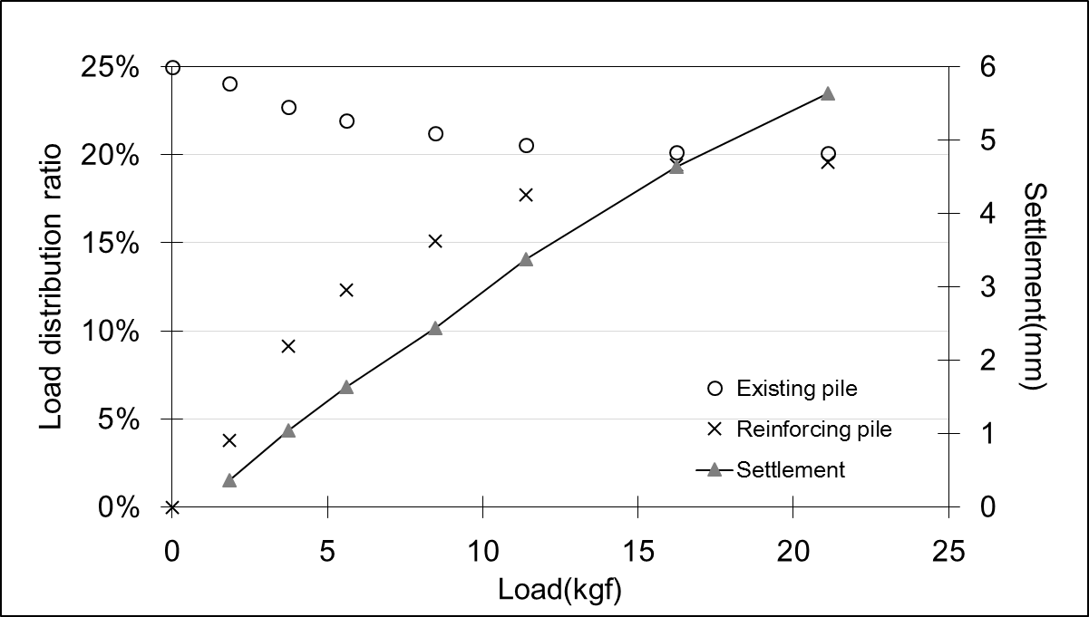
Figure 6. Load distribution ratio and settlement from multiple pile experiment
Existing and additional piles tend to support an equal load when they have enough settlement. Considering this, K-values (i.e., the slope of load-settlement curve in Fig. 5 for existing and additional piles) were further analyzed. K-values for additional and single piles(Fig. 3) were evaluated at each load stage(dP/dS). In Fig. 7, y-axis is the load increment over settlement increment and x-axis is the slab settlement. K-values of the single pile experiment decrease as settlement developed from 14.3kgf/mm to 0.9kgf/mm. K-values from the additional pile decrease from 2.67kgf/mm to 0.8kgf/mm. It is noted that K-values from the additional pile are relatively lower than those of the single pile experiment. It is concluded that the additional pile behaves as if it is located beyond ultimate state, as described in section 2.2, throughout the whole loading history.
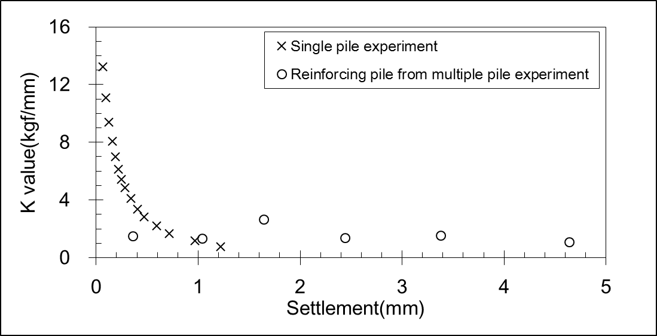
Figure 7. K-value of single pile and additional pile

4. CONCLUSION
The vertical expansion of condominium buildings by adding floors causes an increased gravity load, and for this reason existing foundations require reinforcement. Generally, additional piles are designed to support the amount of the load increase which are micropiles. However there is a lack of knowledge on how the additional load distributes to existing and additional piles. In this study, laboratory experiments were performed using a laboratory device to understand how the additional load transfers to existing and additional piles. The study is summarized as below.
1. The ultimate bearing capacity of a single model pile is determined as 4.3kgf using the hyperbolic extrapolation method, and its theoretical ultimate bearing capacity is 4.21kgf in air pluviated condition. Allowable bearing capacity of a single pile (F.S.=2) is 2.13kgf.
2. Multiple pile experiment was performed with four existing and one additional pile. First, allowable load (P₁) for four existing piles was applied. After that a load-applicable device was installed for the additional pile. Additional load (P₂) was applied to four existing and one additional pile, simultaneously. Finally, we applied load beyond ultimate load (P₂) to all piles to observe pile behavior under limit state.
3. Individual piles support almost equal load (25%) when allowable load P₁ is applied. The existing pile’s load distribution ratio decreased 25% 20% when multiple pile settlement developed. The load distribution ratio of an additional pile increased from 0% to 20% as load increased. At this moment, the foundation system behaves as a unified entity.
4. The K-values (load-settlement slope) of an additional pile from load-settlement curve of multiple pile experiment were relatively lower than those of the single pile test. The additional pile behaves as though it is ultimate state throughout the loading history.
This study showed qualitative load-settlement behavior of an additional pile when the additional pile is installed to an existing foundation slab. Upon foundation retrofitting design, a precise analysis for load distribution between existing and additional piles has to be performed according to the above experimental study.

ACKNOWLEDGEMENT
This study was financially supported by the grant of “Development of Pre-loading Method for Reinforcement Piles of Apartment Remodeling (KICT 2013-0169-1-1)” project of Korea Institute of Construction Technology.
REFERENCE
ISO 19902:2007 (2007). Petroleum and natural gas industries – Fixed steel offshore structures, International Standard Organization, Geneva, Switzerland, 182-190.
KICT (2013), Development of Pre-loading Method for Reinforcement Piles of Apartment Remodeling, Korea Institute of Construction Technology, Report No. KICT2013, Korea. 4-57
Paikowsky, S.G. and Tolosko, T.A. (1999). Extrapolation of Pile Capacity from non-failed load tests, Federal Highway Administration, Report No. FHWA-RD-99-170, Washington, D.C. 22-25.

Graduate Student, Korea University of Science and Technology (UST), Geotechnical Engineering Research Division, 283, Goyangdae-Ro, Ilsanseo-Gu, Goyang-Si, Gyeonggi-Do, 411-712, Korea. Phone: +82-31-910-0237, Fax: +82-31-910-0561, Email: seanlad@kict.re.kr
Research Fellow, Korea Institute of Construction Technology, Geotechnical Engineering Research Division, 283, Goyangdae-Ro, Ilsanseo-Gu, Goyang-Si, Gyeonggi-Do, 411-712, Korea. Phone: +82-31-910-0785, Fax: +82-31-910-0221, Email: chchoi@kict.re.kr

