**REGIONAL RAIL LINK MELBOURNE WIDENING OF RAIL BRIDGE FLYOVER STRUCTURE**

**Tom George (Wagstaff Piling, Melbourne Australia)**

**BACKGROUND**

Rail traffic from Melbourne City out to the Western Suburbs has historically been slow and congested. The RRL (Regional Rail Link) project in Melbourne Australia required two additional new train lines to be constructed in a widened corridor of land from the city centre out to the new developing areas. One of the bridge structures to be widened to allow the two new tracks to cross the interstate rail lines created many challenges due to the extremely limited access combined with the complicated geotechnical profile in the area.

The existing metropolitan train flyover structure carried 2 train lines over the interstate freighting lines. The flyover structure was to be widened to four lines to allow for the two new tracks associated with the new Regional Rail Link. Due to the skew angle it was decided to replace the existing beams with planks perpendicular to the abutments. The two abutments had to be widened within the cutting, and founded to ensure minimal differential settlements as half the bridge would remain on the original abutments and half the bridge would be supported by the new abutments. Due to the variable quality and thickness of the upper basaltic flow a piling solution was required to support some sections of the abutments with some extremely difficult constraints.Only one abutment on each side of the interstate lines could be built at a time and only one line could be shut down for the construction.

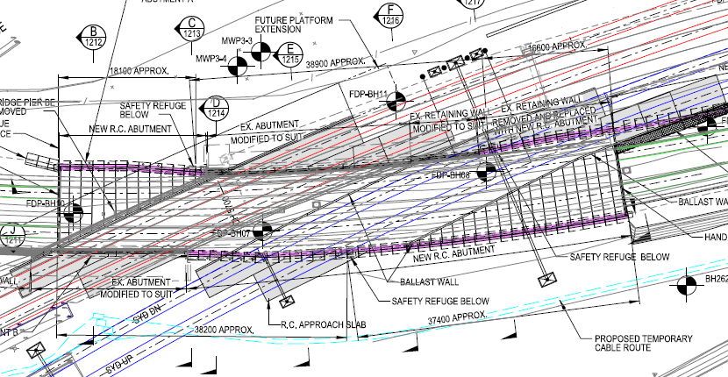

Reinforced Planks for full length of new bridge

Area 1 requiring piling

Area 2 requiring piling

Bridge Widening (2 more lines)

Existing Bridge (@2lines)

Figure 1: General Layout for the Bridge Widening Works

(See Section E Fig2) below,Section B(fig 5) and Section C (fig 6)

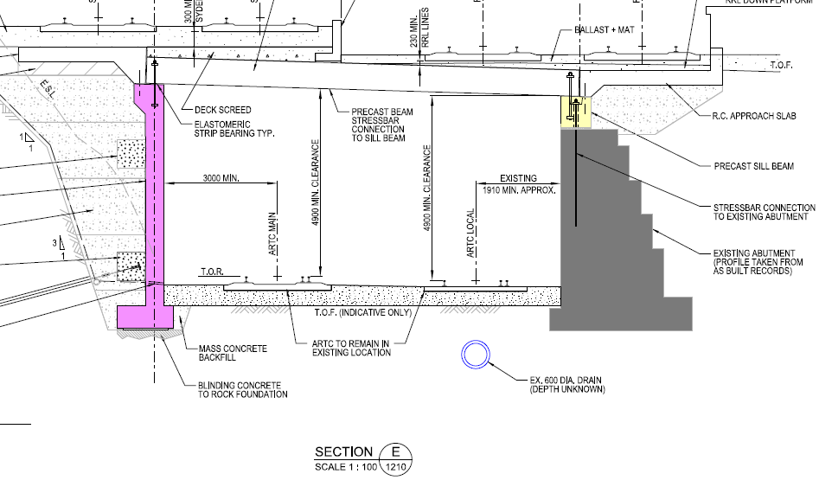

Figure 2: Section E (refer Figure 1)

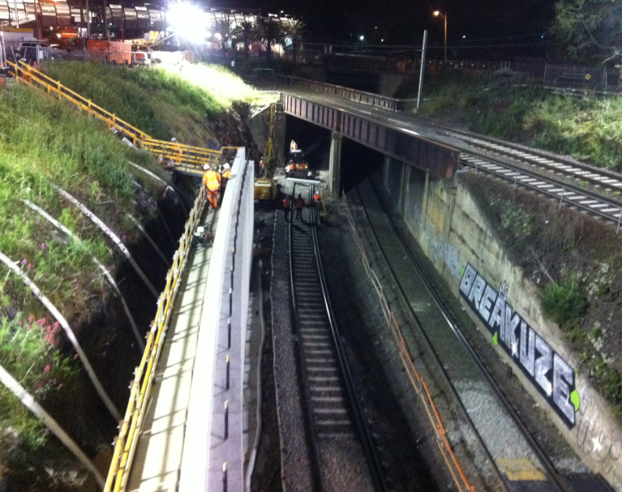(Shows original abutment on right and new abutment on left with the new precast plank bridge above)

Area 2 requiring piling, basalt <3m thick.

Area 1 requiring piling, basalt <3m thick

Abutment not piled as Basalt>3m thick

requiring piling, basalt <3m.

Bridge to be replaced to allow 4 lines.

Figure 3: Looking up the cutting at new abutment

Access constraints imposed on the construction included:

* Work could only start 1 hour after last train and must stop 1 hour before first train. (Windows for working shift ranged from 5hours during the week to 8hours on Saturday night)
* Due to the nature of the shutdowns, flagmen, costs of shutdown, tight program etc only 1 week of access could be provided for the piling at each abutment and if this window was missed the next window would not have been for 3 months.
* One track had to remain open during the night hence only one track could be occupied in a night shift.
* The only access for large plant and equipment was a minimum of 200m away and would require the rigs / equipment to drive along the tracks; this could not be accepted due to any risk associated with damage of the tracks. Only rubber tyres or small rubber tracked rigs were allowed to walk on the rails.
* The height of the cutting was up to 6m high.
* To make room for construction, the cutting was excavated 1m wider to provide a 3m wide working zone outside the tracks, providing enough room for a small rig only.
* The only equipment that could be used had to be capable of being cleared in 20minutes if required by the rail authorityshould the tracks need to be opened.

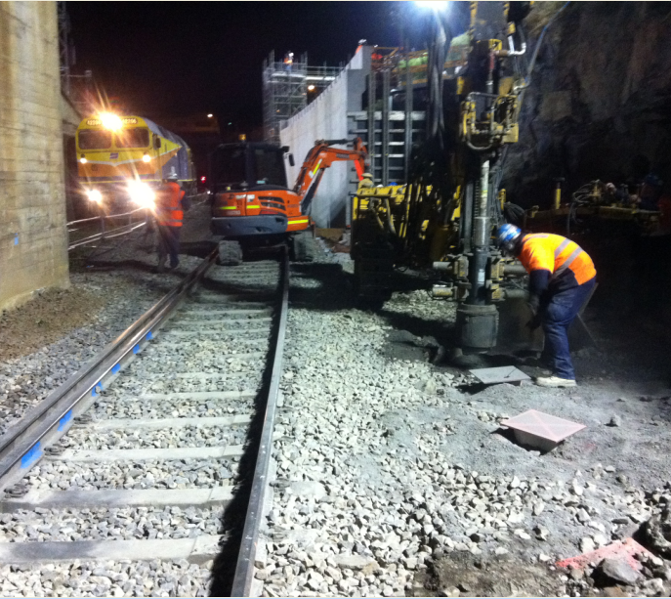

Only 1 line shut down, trains were allowed to run through the night.

Figure 4:Predrilling the upper basalt with a 250mm DTH hammer

**Geotechnical / Design Issues**

* The design life for the structure was 100years.
* Due to the geometry of the bridge and the skewed angle the bridge, decking would be required to sit partially on the existing structure and partially on the new abutments.
* The structure had to comply with the Australian Bridge Design Code and required an arduous process for an independent verification engineer review and approval.
* The site consisted of an upper layer of Newer Volcanic Rock, the thickness of this rock was highly variable as was the weathering profile. Layers of high strength slightly weathered rock ranged from less than 1m up to 7m thick. The quality of this rock was in further question as during construction of the original cutting the effects of the unknown excavation process could not be guaranteed.The full extent and effect of the blasting /excavation process was unknown.
* The upper layer of basalt extended anywhere from 1m to 6m below the underside of the tracks. Where the upper basalt layer was greater than 3m thick, a pad foundation for the abutment would be acceptable.
* Where the upper basalt was less than 3m this layer was not considered suitable for founding the applied loads as differential settlement between the existing structure and new bridge could not be tolerated.Where this thin layer was encountered piling was required to carry the load through the upper basalt.
* Where the upper basalt was not thick enough to support the rails the piling foundation solution would have to pass the load down through the Brighton group consisting of clayey gravel / sandy gravels and clays and then found onto the lower older volcanic basalt. The weathering on this basalt was highly variable and due to the highly fractured nature of this rock the risk of groundwater was also considered possible. In one of the boreholes collapsing gravels were encountered.
* The required axial capacity on each pile was 1,350kN Ultimate Limit State (ULS).

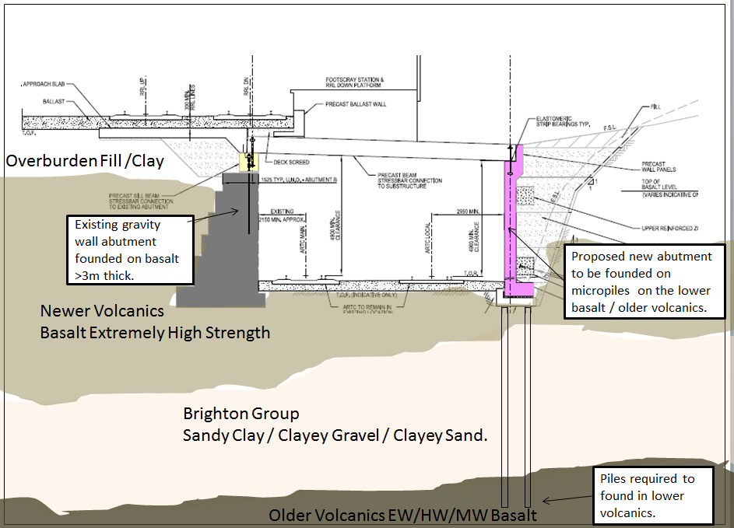

Figure 5: Section B (from Fig 1) Across Bridge showing the existing abutment and new abutment.

In figure 4 above you can see the original abutment on the left founded on a thick layer of basalt while on the right the abutment which was within 10m and section C below required abutments to be piled due to the thin layer of basalt.

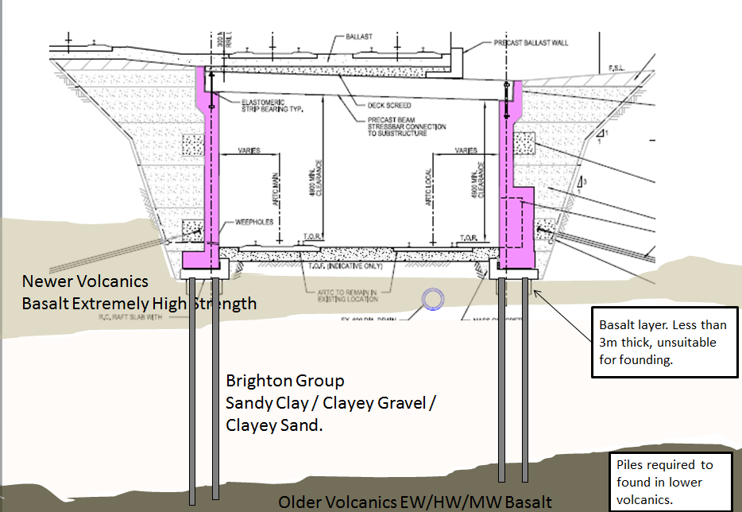

Figure 6: Section C (From fig1) Across Bridge showing both new abutments requiring piling.

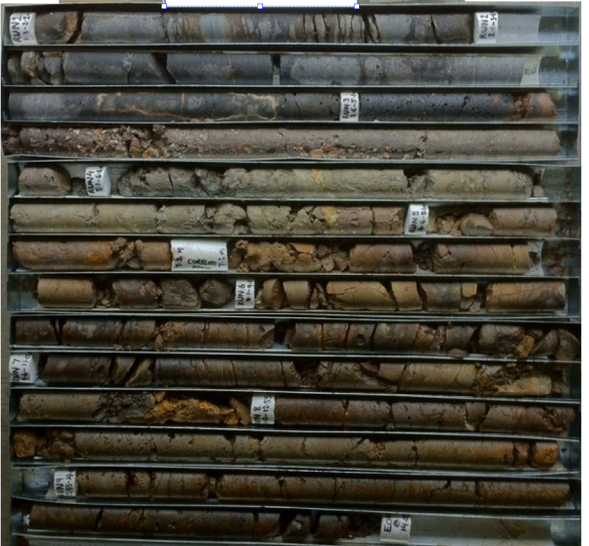

Predrill to here, underside of newer volcanic.

Sandy Gravels Potentially collapsing.

Drive to here (Older volcanics)

Figure 7: Photo of Borehole7 taken at Abutment 1

In figure 7 (Borehole 7) above you can clearly see the high strength basalt layer starting at 1.3m below the ground and finishing around 5.1m below the ground, this would be suitable for founding. In Figure 8 below (Borehole 10) the upper basalt is highly fractures possibly due to blasting (Irregular fractures) and not suitable for founding.

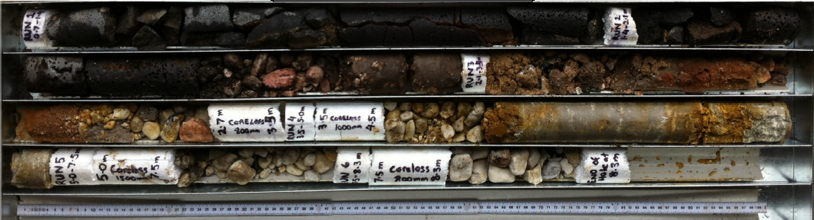

Sandy Gravels which collapsed during drilling.

Predrill to here, underside of newer volcanic.

Drive to approximately here (Older volcanics)

Figure 8: Photo of Borehole 10 taken at Abutment 2

Various options were proposed but the final two bids were based on micropile solutions. The runner up bid was based on traditional drilled and cast micropiles. Our option was based on predrilled driven steel micropiles. Both options were reviewed by the designers and main contractor and the traditional micropile method was rejected for the following reasons:

* Price
* Risk of completing piles within the time allocated. The ancillary costs of rail support were too high to over run the program. Full time train track crew including linesman, flagman, spotters and Rail Shutdown fees have high costs associated for each shift.
* Verification of pile capacity using static testing is not feasible as the time to set up, grout curing time etc. is not available (Verification by static design or logging was not acceptable for micropiles). The Sub Contractor, Clients Engineer and Proofing Engineer all had to sign off on the design.
* Loss in production associated with sleeving if collapsing ground was encountered.

The alternate micropile design was accepted for the following reasons:

* The ability to deliver the project on time.
* Price
* The ability to immediately test the piles given the variable ground conditions.
* No issues with pile integrity as each pile is driven to a set and calibrated against pile capacity verified by PDA.
* No risks associated with collapsing soils or ground water.
* The ability to do most of the work out of the cutting. Clear room away from the live rail was available above the cutting, hence large machinery including cranes, storage of tubes etc. could easily use this area.

**The Final Solution**

Once an area 3m clear of the tracks had had been prepared for the piling, the GKlemm 806 piling rig fitted with a 250mm diameter DTH hammer and 50mm air hose was lifted into the 8m deep cutting.

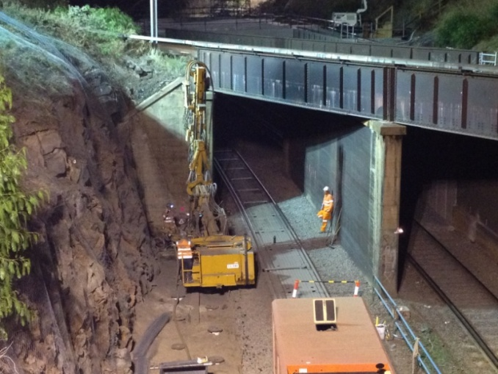

Figure 9: The Klemm predrilling the upper basalt

The 800cfm compressor was located up the top of the cutting and 50m of 50mm diameter air hose run to the rig.

Percussion Drilling was commenced at each of the 18No pile positions on the Abutment 1 and would continue until the upper basalt was penetrated. (The high strength basalt drilled very well and a clear boundary was identified during the drilling.) Once the hole was complete, a hole guard was placed over the hole and the next hole commenced.

On completion of the shift the rig needed to be lifted out of the cutting to allow train services to resume on both tracks.

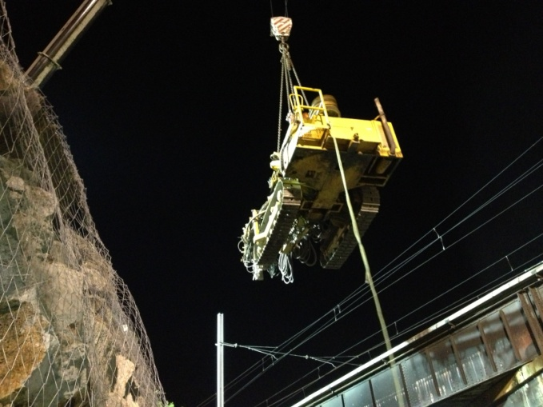

Figure 10:Klemm drill rig being lifted in at start of shift (1hr after last train)

Once all holes had been predrilled, the next shift the crane would start lifting 219mm x 14.3mm wall thickness (yield strength = 500MPa) tubes each approximately 12m long into the predrilled holes.

A small excavator was also lifted into the cutting to assist in holding the tube vertical during driving. If any hard layers were encountered requiring hard driving the lateral support provided during driving from the excavator minimized the shuddering/pile buckling effects under each impact enabling smoother driving. The holes were 250mm diameter and were generally drilled approximately 3m deep. They were “gun barrel” straight hence there was no issue lifting the 219mm tubes into the holes. The annulus was left empty as based on maximum free length of 3m was not a buckling issue. Design for durability was addressed based on corrosion allowance, the tubes were ex oil industry pipes and were supplied epoxy coated which would provide an added durability.

A 4 tonne hydraulic hammer fitted with a bell mouth was then lifted over the tubes from the upper level and driving commenced. This did generate some noise but given the nearest neighbours were not that close and had been used to the train horns, there were no complaints. Surprisingly there were no requirements for noise or vibration monitoring.

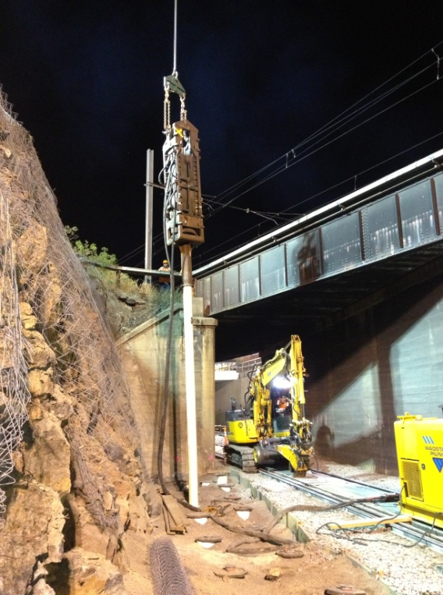

Figure 11: After being lifted into the predrilled hole the hammer is lifted onto the pile for driving.

Piles were driven through the Brighton Group clayey sands and onto the older volcanics starting around 8m depth. End of Drive Sets were taken for each pile and were correlated against a dynamic test (1No at each abutment) and subsequent CAPWAP to ensure capacity had been achieved.Remote testing was undertaken, enabling an engineer to remain at home until the gauges were installed and the PDA connected, the total test was completed within 15min on each abutment.

From the dynamic testing for a 500mm drop from a four tonne hammer, pile with 9.4m penetration, Set of 0.8mm and a temporary compression measured to be 10mm the RMX (max geotechnical resistance) value estimated by the PDA (Pile Driving Analyser) was 2,058kN. The final capacity as predicted by the CAPWAP analysis was Ultimate Geotechnical Resistance (Rtug) = 2,238kN of which 615kN was estimated on the base the remaining 1,623kN was on the shaft. Given the small set of 0.8mm on testing it is likely the base was undermobilised. Shaft frictions in excess of 450kPa were estimated for the bottom 3m of the steel tube by the CAPWAP analysis.

The Design ultimate geotechnical strength (Rdug) required based on a geotechnical reduction factor of 0.7 was 1,857kN (N*=1,350kN Ultimate Limit State). As Rtug>Rdug then the pile has achieved its required capacity in accordance with the code.

On completion of the testing the steel tubes were cut off for incorporation into the abutment by others.

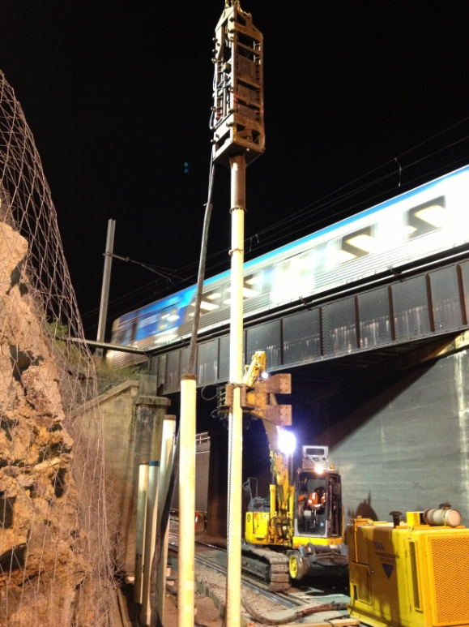

Figure 10: Piles were sequentially driven down until capacity was achieved.

The 18No holes in the first abutment were drilled in the first three night shifts and the steel tubes were driven and completed in the next two nights with one night to spare. Similarly for the second abutment the 17 piles were completed in 4 shifts total. Piles were cut off at the desired cut off level ready for inclusion into the pile cap.

**Conclusion**

While micropiles are often generally considered to be drilled shafts usually ignoring any end bearing capacity due to difficulty associated with cleaning the base, driven piles can also provide a quick cost effective micropile solution. Risk of ground collapse, groundwater and issues associated with verification of pile capacity were removed. Program risks were removed enabling the project to be completed on time and within budget.