HYBRID ENERGY MICROPILES IN UNDERPINNING PROJECTS – COMBINATION OF LOAD BEARING STRUCTURES AND GEOTHERMAL ENERGY FIELD
Rauli Lautkankare, Jukka Rantala Vesa Sarola, Heli Kanerva-Lehto

ABSTRACT
A hybrid energy micropile used in underpinning projects solves two issues: transferring the load of the building and collecting geothermal energy from boreholes under the piles. In this case heat wells are located under the building. Apart from an energy micropile (also called thermal pile) hybrid energy micropiles allow catching energy deeper from soil, up to hundreds of metres.
The amount of hybrid energy micropiles and the depth of boreholes are determined by the energy consumption of the property. The amount is also restricted by the size of the property: the mean distance between the energy wells like the hybrid energy piles according to Finnish national regulations is at least 15 meters.
The challenges using hybrid energy micropiles in underpinning projects are investigated in the FIN-C2M project (Case 2 Micropile Research Project in ISM collaboration).
INTRODUCTION
In this article the term “a hybrid energy micropile” means a combination of load bearing pile and a heat well under the pile. The collector pipes filled with special liquid run through the pile first and then continue deeper inside the borehole to the bedrock. Solutions to lead the pipes through the load transfer structures are represented. The term “through hole” means a penetration or an inlet going through the (super)structure above the pile.
In underpinning projects the hybrid energy micropile combines piling the building and catching geothermal energy from the boreholes made under the piles. In this case heat wells are not located next to the building, they are under the building. Apart from an energy pile it allows catching energy deeper from the soil, up to several hundreds of metres. Additionally deeper in the bedrock the temperature is more stable and thermal conductivity better than in more shallow clay soils utilized in bare energy pile cases. Starting from 15 metres below the soil surface the soil temperature in Finland is independent
The use of energy micropiles is fairly new solution. The hybrid energy micropiles are a new solution also. The difference is that the hybrid energy piles have never been used in real cases, yet. Neither in new building projects nor in renovation projects. The energy piles have been tested in real life even though only in foundations of quite large new buildings (Lautkankare & Kanerva-Lehto & Sarola, 2014a).
The challenge in using energy micropiles in underpinning projects is the through holes for geothermal energy collection pipes in the load transfer structures. In the FIN-C2M project (Case 2 Micropile Research Project in ISM collaboration) technical solutions have been studied and the load transfer structure cases where the use of energy micropiles is possible have been defined. At the moment there are 13 known load transfer structure cases (Lehtonen, 2011) and energy micropiles can be used with nine of them (Lautkankare & Kanerva-Lehto & Sarola, 2014a). The load transfer structures need no changes between energy or hybrid energy pile. That means nine of known load transfer structure cases are suitable for hybrid energy piles also.
In the FIN-C2M project also the ground thermal response was evaluated to energy pile foundations and one of the main objectives were to study ground seasonal heat storage capacity keeping the ground thermal balance in control during seasonal operations like heating and cooling (Pérez Cervera, 2013). The ground thermal balance has to be taken into account also when designing the hybrid energy pile field. The balance is relatively easy to achieve in buildings having both heating and cooling. The ground thermal response is the thing why heat wells, which hybrid energy piles are also, need a certain minimum distance between each others.

A HYBRID ENERGY MICROPILE – PROS AND CONS
So far there are no known projects in the world where energy piles or hybrid energy piles would have been used during renovations. There have been so-called close calls where the whole renovation has been called off eventually. Although plans and designs for underpinning carried out with hybrid energy piles have been almost ready for implementation (Perälä, 2013).
Current know-how and technology make the use of hybrid energy piles possible. There are some specific limitations and possibilities related to hybrid energy piles that need to be taken into account when estimating the energy production investments and life cycle of buildings. One specific limitation is adequate mean distance between the hybrid energy piles. As well the geological risks like radon and a risk to mix salt and fresh groundwater have to be recognised. The through holes have to be radon tight because piles and boreholes make an easier route for radon to access indoor air through clay layers. Additionally different types of groundwaters can be mixed via boreholes as groundwater is naturally pressurized. (Juvonen & Lapinlampi, 2013.)
The amount of hybrid energy micropiles and the depth of boreholes is determined by the energy consumption of the property. The amount is also restricted by the size of the property: the mean distance between the energy wells according to Finnish national regulations is at least 15 metres (Juvonen, & Lapinlampi, 2013.). This distance requirement was earlier 20 metres, but it has decreased recently (Juvonen, 2009). The hybrid energy pile is like the heat well and thus same distance concerns that too. The mean distance means that the piles and the boreholes which could be slightly aligned should fill at least that earlier mentioned distance measured from the half way of the heat wells. There are at least one case in city of Turku where hybrid pile solution is being planned. In that case the building has so small ground floor area that the upper heads of the hybrid energy piles are located 17 metres from each others, the piles are aligned 50:1 (50 m down and 1 m horizontally) and the depth of the heat wells are 300 metres. Thus mean distance from the half way of the heat wells reaches 20 metres, which was the minimum distance until 2013.
Same things relate to collection piping, through holes and load transfer structures in energy and hybrid energy piles. If the construction will be fitted with a deep foundation in any case, it might be reasonable to consider energy piles or hybrid energy piles. Any piles that can fit the ground heat collector piping are suitable for those piles. These include at least steel pipe piles and concrete piles with holes. Of these two only steel pipe piles have been used in underpinning projects.
Almost all of the common steel pile sizes are suitable for both energy pile types. Only the smallest piles are too narrow to fit the heat collection piping. On the other hand, these are not generally used in underpinning projects due to their low load bearing capacity. In larger piles the big distance between the heat collector pipes and the heat source, namely the soil, can become an issue. Most commonly used sizes are 140, 170 and 220 mm micropiles in Finland.
As mentioned earlier the use of renewable energy should be increased significantly. Ground heat is a renewable energy source. It is also local and popular energy source in Finland.

INSTALLING A HYBRID ENERGY MICROPILE
Installation of the hybrid energy micropile starts as installing a traditional load bearing micropile suited for the existing building. The dimensions of the pile can be the same regardless of energy use or just underpinning. After the pile has been drilled to the load bearing soil, there are two possibilities to install the collector pipes to the required depth. The easiest and quickest way is to continue drilling to the required depth with a smaller drill bit (diameter 100-120 mm). The borehole fills or will be filled with water and then it is ready for the collector pipes. Using water as a filling material makes collector pipes changeable if they leak or are damaged during their life span. (Juvonen & Lapinlampi, 2013; Lautkankare & Kanerva-Lehto & Sarola, 2014a)
Other possibility is to install a smaller steel pile (diameter 115-140 mm) inside the first load bearing pile and after that continue drilling to the required depth. The space between the two piles will be filled with concrete so it works as a composite structure (Figure 1). This improves the load bearing capacity and in addition corrosion resistance. The extra corrosion resistance capacity can be reached also by using stainless steel pipe on the upper parts of the pile frame.

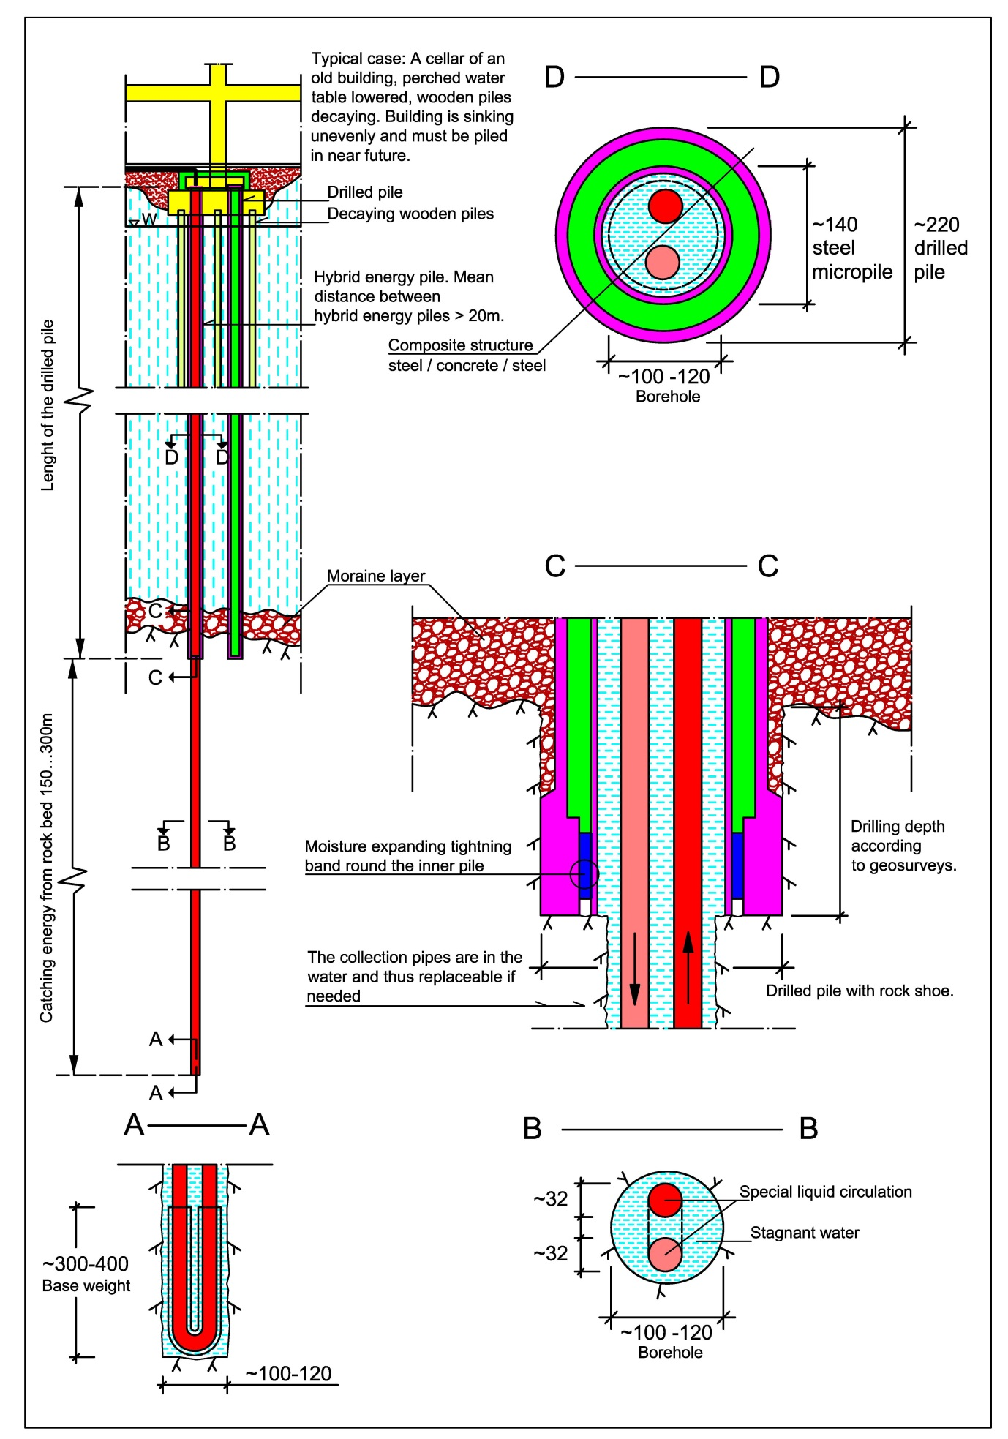

Figure 1. The hybrid energy pile. Extra load bearing capacity and corrosion resistance is gained with a smaller micropile inside the load bearing pile. (Original drawing by Vesa Sarola, edited by Rauli Lautkankare)
LOAD BEARING CAPACITY OF HYBRID ENERGY MICROPILE
Load bearing capacity of a drilled hybrid energy micropile was examined using a basic case where the additional energy heat well (borehole diameter ∅150 mm) was drilled starting from the base of D170 micropile (∅168,3 mm, t = 10 mm, steel grade S440). The toe of the micropile was supported directly to the base of the borehole either via an impact shoe or a ring shoe (Fig. 2). Three different rock strengths were used: σ_{ci} = 10 MPa, 60 MPa or 100 MPa.
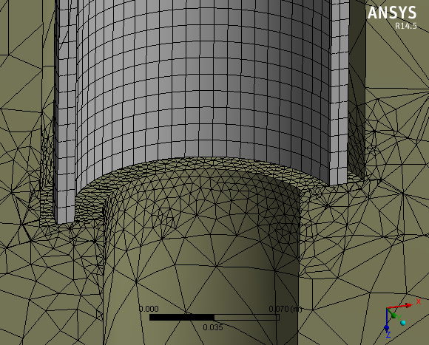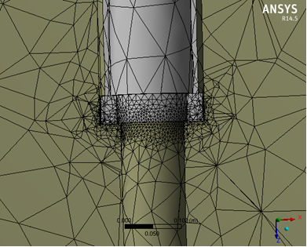
Figure 2. 3D FE -mesh used for the analysis of bearing capacity of hybrid energy pile. Load bearing micropile with an impact shoe (left) or a ring shoe (right).
In the analysis the micropile was loaded with an axial vertical load till failure. Figure 3 illustrates the plastic deformations and the corresponding stress distribution on the rock surface beneath the impact shoe at failure (the strength of the bedrock was σ_{ci} = 60 MPa). The ultimate load bearing capacity of the hybrid energy micropile was N = 907 kN. The failure mode was the breaking of the rock collar beneath the pile shoe (Fig. 3).
Table 1 presents the ultimate bearing capacities of the D170/10 micropiles with ∅150 mm energy borehole drilled from the base of the pile. The variations of two different shoe types (impact or ring shoe) and three different rock strengths were used.

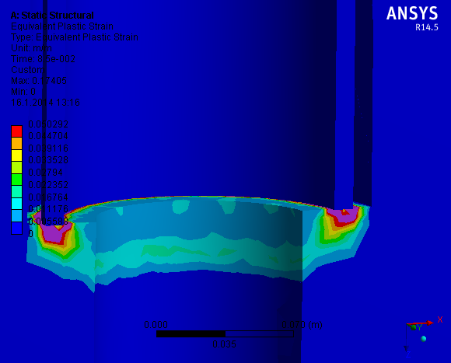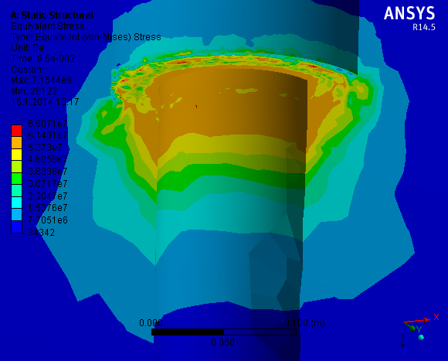

Figure 3. Plastic deformations at the rock surface beneath the impact shoe (left) and the corresponding stress distribution (right). Rock strength σ_{ci} = 60 MPa, the applied axial load N = 907 kN.

Table 1 Ultimate bearing capacities of D170/10 (S440) micropiles with ∅150 mm heat well borehole drilled from the base of the pile.
Case (micropile RD170/10 S440)  σ_{ci} = rock strength | Axial bearing capacity N (kN)
 | Impact shoe | Ring shoe
σ_{ci} = 100 MPa | 1521 | 2220
σ_{ci} = 60 MPa | 907 | 1530
σ_{ci} = 10 MPa | 194 | 277

According to the performed analysis series it is possible to found a lightweight deteched or semi-detached house using hybrid energy micropiles without any additional grouting or strengthening of the pile base. By using a load bearing micropile with an adequate diameter (here D = 168.3 mm) and providing that the strength of the base rock is sufficient enough (σ_{ci} > 60 MPa), a standard ∅150 mm heat well borehole can be drilled from the base of the load bearing micropile without loosing too much of its capacity.

INSTALLATION OF GROUND HEAT COLLECTION PIPES INTO HYBRID ENERGY MICROPILE
For each hybrid energy pile, one coil of pipe is required. The length of the pipe in a coil can be adjusted to the length required. If angle joints are used, the pipe can come in two coils. If the pile is 30 m long and the bore hole 200 m long, the length of the pipe has to be 460 m plus the distance from manifold to pile and back. Empty plastic pipe pair would not weigh much, but as the heat transfer agent is often already in the pipe the total weight could increase up to 1.5 kg/m, making a 230 m long pipe weigh 345 kg with additional weight of 15 kg for the base weight.
At some point of the installation process the filling material has to be installed too. Various filling materials have their own advantages: For example concrete is supported by its good thermal conductivity and load bearing capacity, water filling is good if replaceability is valued. The installation process is precise work where working phase order/agenda and many other things affect to succeeding.
In UK the recommendation for the completion of a closed loop borehole is by backfilling with a low-permeability, non-shrinking, frost-resistant, thermally-enhanced grout from bottom to top of the borehole (Environment Agency, 2011). The way in which boreholes are completed is important to ensure pollution is prevented.

In many countries the space between collector pipes and borehole walls will be filled with bentonite for example. In Nordic countries energy wells are drilled to bedrock and usually the holes are filled with water. (Juvonen & Lapinlampi, 2013.)
In Finland the bedrock is quite crystalline and solid. So it wont become fractured and then leak as easy as the shale soils. If the borehole leaks, it can fill up with soil particles which leads the collection pipes stuck in the hole. Then they are no longer replaceable. (Arola, 2013 interview)
Before the pipes are installed into the pile, they should be tested while filled with liquid with 3 bar pressure over an hour to detect any leaks (Juvonen, 2009).
The collector pipes can come out of the pile different ways (Lautkankare, Kanerva-Lehto & Sarola, 2014a). One possibility is to led collection pipes through the pile cap and pass them by the special jack system. (Lautkankare, Kanerva-Lehto & Sarola, 2014b)
CONCLUSIONS
As a result of this research it was found possible to find technical solutions to combine hybrid energy micropiles and groud heat collector pipes with nine load transfer structure cases. In five cases the work can be done as in new building. There is also a special solution if steel beams have to used. In four cases the pipes have to be led out of the side of the pile before the pile cap or alternatively use the special jack system. There has also been found a possibility to use hybrid energy micropile system to gather energy deeper from the ground – from bedrock -compared with energy piles. The efficiency ratio is better in rock than in clay soils.
There are certain challenges and questions, especially concerning the installing process, that have to be researched and tested. Cramped basement rooms make challenges for installation groups. The hybrid energy micropiles are one solution with many others to get heat from the ground and in that way to reduce the greenhouse gas emissions in energy production. It will compete with other heating forms like district heating. It might need also political haggling over heating forms, because newcomers can challenge current situation where local energy distributors can feel their position threated. New technologies, applications and procedures need to be tested, challenged and measured in real life to see the potential. In long run healthy competition will carry the best to survive. The first underpinning project done with hybrid energy micropiles still waits to see the daylight.

REFERENCES
Arola, Teppo. (2013). Golder Associates Ltd, an interview.
Environment Agency. (2011). Environmental good practice guide for ground source heating and cooling. Bristol, UK. <http://cdn.environment-agency.gov.uk/geho0311btpa-e-e.pdf>
Juvonen, Janne (ed.). (2009). Lämpökaivo – Maalämmön hyödyntäminen pientaloissa. Heat well – ground-source heat in one-family houses. Environment guide 2009. Helsinki: Finnish Environment Institute (SYKE). Available only in Finnish. <http://www.ymparisto.fi/download.asp?contentid=108597&lan=fi>
Juvonen, Janne & Lapinlampi, Toivo. (2013). Energiakaivo – Maalämmön hyödyntäminen pientaloissa. Energy well – ground-source heat in one-family houses. Environment guide 2013. Helsinki: Ministry of Environment. <http://www.ym.fi/fi-FI/Ajankohtaista/Julkaisut/Ymparistoopas_YO/YO_2013_Energiakaivo(24946)>
Lautkankare, Rauli & Kanerva-Lehto, Heli & Sarola, Vesa. (2014a). Energy micropiles in underpinning projects. DFI Journal, Volume 8, Issue 1, April 2014. Deep Foundation Institute.
Lautkankare, Rauli & Kanerva-Lehto, Heli & Sarola, Vesa. (2014b). Using energy micropiles in underpinning projects. IWM International Workshop on Micropiles, June 11-14 2014, Krakow, Poland. Submitted 17.1.2014.
Lehtonen, Jouko. (2011). Underpinning project; owners’ views on technology, economy and project management. Aalto University publication series, Doctoral dissertations 80/2011. Espoo: Aalto University.
Leppäharju, Nina. (2008). Kalliolämmön hyödyntämiseen vaikuttavat geofysikaaliset ja geologiset tekijät. Geophysical and geological factors affecting groundheat applications. Master’s thesis. University of Oulu.
Pérez Cervera, Carles. (2013). Ground thermal modelling and analysis of energy pile foundations. Master’s Thesis. Espoo: Aalto University.
Perälä, Antti. (2013). Engineer office Narmaplan, an interview and drawings.
Uskali, Marko. (2013). Ab MuoviTech Oy, an interview.

Lecturer, MEng, Turku University of Applied Sciences, rauli.lautkankare@turkuamk.fi
Technical specialist, PhD, Ruukki Building Products, Infra, jukka.rantala@ruukki.com
Planner, BEng, Senior Consultant, glapas@pp.inet.fi
Project Researcher, MEng, MA, Turku University of Applied Sciences, heli.kanerva-lehto@turkuamk.fi

